Benchmark Test: 2D prescribed velocity at nodes
written by Francesca Ceccato, 05/11/2018; revised by Kaleigh Yost, 06/08/2021
General description
The benchmark considers the penetration of a footing into the soil. Stresses are initialized with K0 procedure and the foundation penetrates at a prescribed velocity v0. The moving mesh option is applied and the fixed mesh is the portion including the footing. The load multipliers for velocity are applied.
Mesh
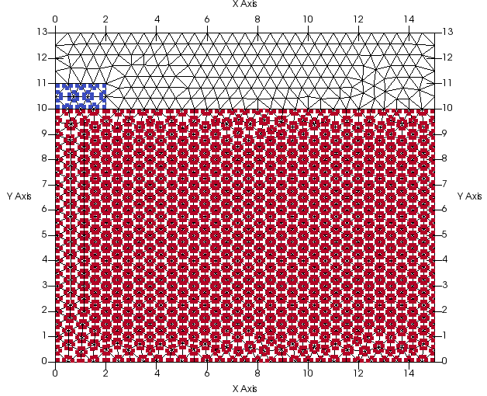
Figure 1 geometry and discretization
Size of elements: 0.5m
$$DIMENSION
2D-plane_strain
$$ELEMENTTYPE
triangular_3-noded
Num. of elements= 910
Num. of nodes=1706
Number of MPs per element: 3 SMPs

Material properties
foundation | soil
$$MATERIAL_TYPE  dry_material  $$POROSITY_SOLID  0.0  $$DENSITY_SOLID  2000  $$K0_VALUE_SOLID  0.0  $$MATERIAL_MODEL_SOLID  linear_elasticity  $$YOUNG_MODULUS  50000  $$POISSON_RATIO  0.33  $$MATERIAL_INDEX  2 | $$MATERIAL_TYPE  dry_material  $$POROSITY_SOLID  0.4  $$DENSITY_SOLID  2000  $$K0_VALUE_SOLID  0.5  $$MATERIAL_MODEL_SOLID  mohr_coulomb  $$YOUNG_MODULUS  20000  $$POISSON_RATIO  0.33  $$FRICTION_ANGLE  30  $$COHESION  0.5  $$DILATANCY_ANGLE  0.0  $$TENSILE_STRENGTH  0.0

Fixities
The left and right boundaries are fixed in the x-direction. The top and bottom boundaries are fixed in the y-direction.
Boundary conditions
The velocity of -0.5m/s is prescribed only in y-direction (x-direction is free) at the material points of the foundation surface.
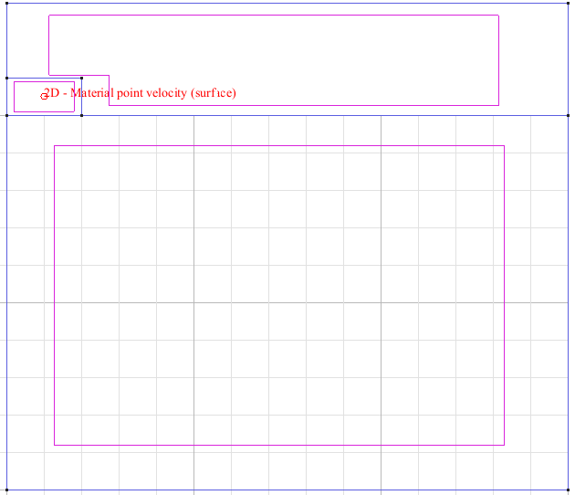
Figure 2 Prescribed velocity specifications
Moving mesh is applied:
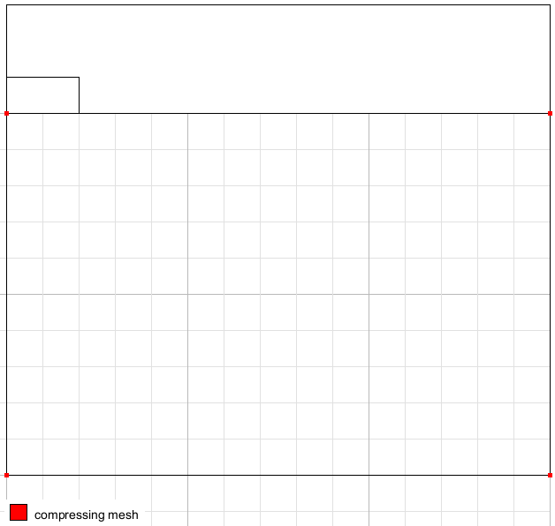 | 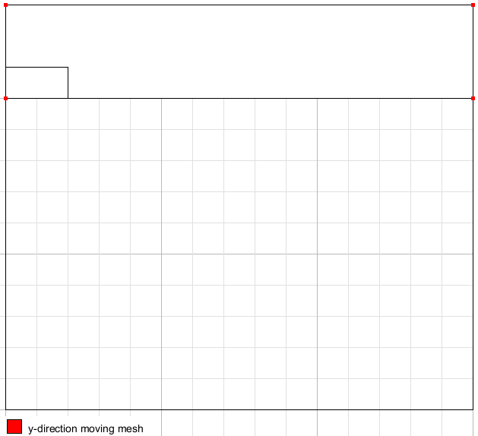
Figure 3 Moving mesh specifications
Loading conditions
No traction is applied, gravity is applied at the first time step.
Calculation parameters:
### Anura3D_2021 ###
$$NUMBER_OF_LOADSTEPS
10
$$TIME_PER_LOADSTEP
0.10
$$TOTAL_TIME
0.0
$$COURANT_NUMBER
0.98
$$COMPUTATION_METHOD
MPM-MIXED
$$GRAVITY_ACCELERATION
9.81
$$GRAVITY_VECTOR
0.0 -1.0 0.0
$$GRAVITY_LOAD
step 1.0 1.0
$$SOLID_TRACTION
off 1.0 100.0
$$LIQUID_PRESSURE
off 0.0 1.0
$$PRESCRIBED_VELOCITY
step 0.0 1.0
$$QUASISTATIC_CONVERGENCE
0
$$TOLERATED_ERROR_SOLID
0.01 0.05
$$TOLERATED_ERROR_LIQUID
0.01 0.01
$$MAXIMUM_TIME_STEPS
10000
$$MASS_SCALING
0 1.0
$$HOMOGENEOUS_LOCAL_DAMPING
0 0.7
$$BULK_VISCOSITY_DAMPING
0 0.06 1.2
$$FIX_SOLID_SKELETON
0
$$STRAIN_SMOOTHING
1
$$CONTACT_FORMULATION
0
$$INITIAL_WATER_PRESSURE
0.0
$$APPLY_POROSITY_UPDATE
0
$$INITIAL_VELOCITY
0
$$RESET_DISPLACEMENTS
0
$$REMOVE_FIXITIES
0 0 0
$$K0_PROCEDURE
1
$$SURFACE_ELEVATION
10.0
$$INITIAL_VERTICAL_LOAD_K0
0.0
$$EXCAVATION
0
$$SUBMERGED_CALCULATION
0 1
$$APPLY_OBJECTIVE_STRESS
1
$$DEGREE_OF_FILLING
0.9
$$NUMBER_OF_ACTIVE_ELEMENTS
0
$$OUTPUT_NUMBER_OF_MATERIAL_POINTS
6
$$OUTPUT_MATERIAL_POINTS
1
50
100
200
300
400
$$END

Solution
Figure 2 shows the vertical displacement of a MP of the foundation (#1). The velocity at MP of the foundation increases stepwise from 0 to -0.5m/s.
The moving mesh moves as expected.

Figure 4 Vertical displacement of a MP of the foundation
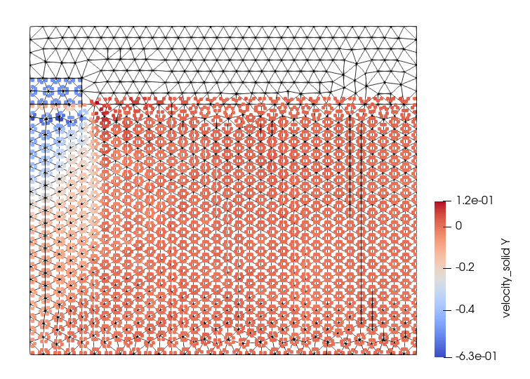
Figure 5 Vertical velocity at t=1s
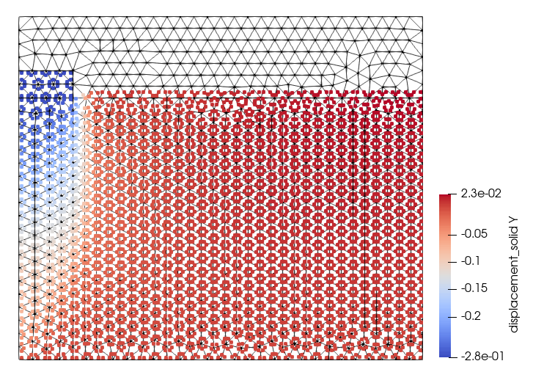
Figure 6 Vertical displacement at t=1s

