Benchmark Test: 2D shallow foundation step load on MPs
written by Kaleigh Yost, 14/07/2021
General description
The benchmark considers the penetration of a footing into the soil. Stresses are initialized with K0 procedure and the foundation penetrates with an applied load on the MPs. The moving mesh option is applied, the fix mesh is the portion including the footing. Load multipliers are applied.
Mesh
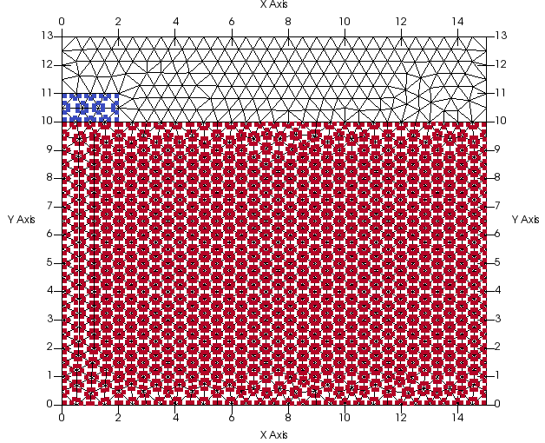
Figure 1 geometry and discretization
Size of elements: 0.5m
$$DIMENSION
2D-plane_strain
$$ELEMENTTYPE
triangular_3-noded
Num. of elements= 910
Num. of nodes=1706
Number of MPs per element: 3 SMPs

Material properties
foundation | soil
$$MATERIAL_TYPE  dry_material  $$POROSITY_SOLID  0.0  $$DENSITY_SOLID  2000  $$K0_VALUE_SOLID  0.0  $$MATERIAL_MODEL_SOLID  linear_elasticity  $$YOUNG_MODULUS  50000  $$POISSON_RATIO  0.33  $$MATERIAL_INDEX  2 | $$MATERIAL_TYPE  dry_material  $$POROSITY_SOLID  0.4  $$DENSITY_SOLID  2650  $$K0_VALUE_SOLID  0.5  $$MATERIAL_MODEL_SOLID  mohr_coulomb  $$YOUNG_MODULUS  20000  $$POISSON_RATIO  0.33  $$FRICTION_ANGLE  30  $$COHESION  0.5  $$DILATANCY_ANGLE  0.0  $$TENSILE_STRENGTH  0.0

Fixities
The left and right boundaries are fixed in the x-direction. The bottom boundary is fixed in the x- and y-directions. The top boundary is fixed in the y-direction.
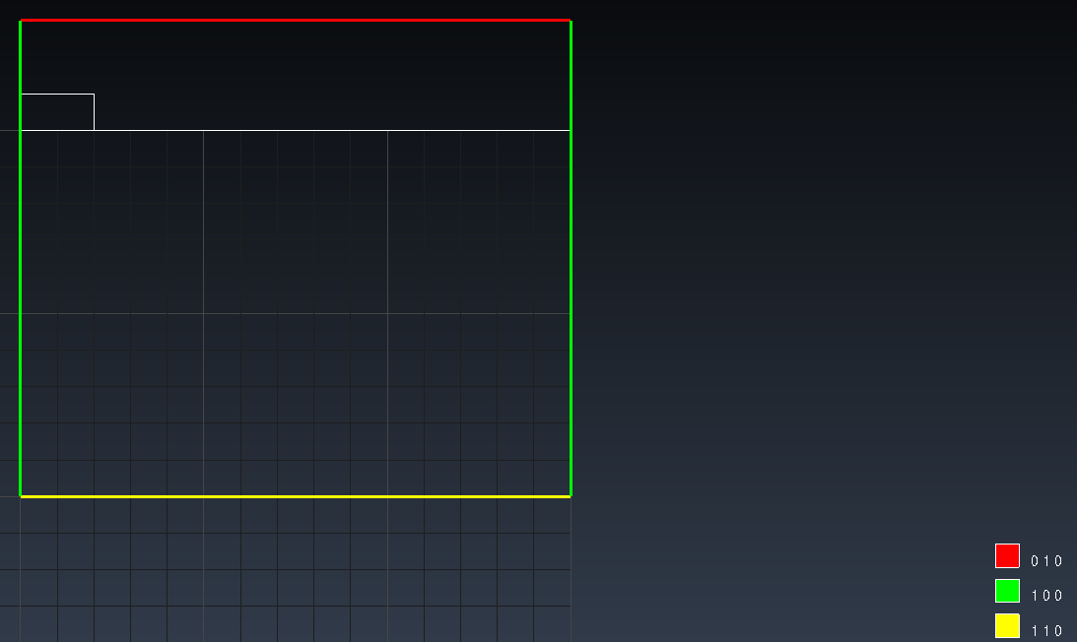
Figure 2 Fixities
Moving mesh is applied:
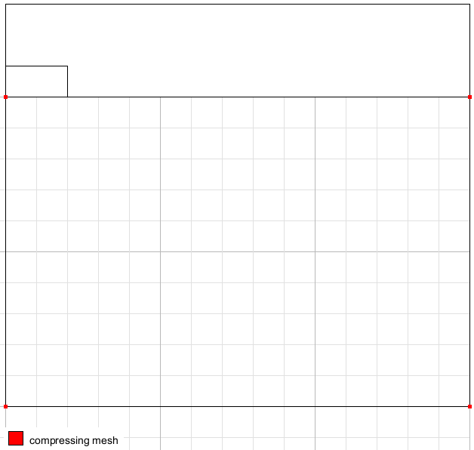 | 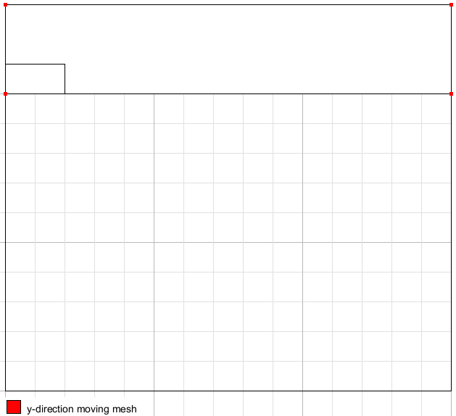
Figure 3 Moving mesh specifications
Loading conditions
Gravity is applied at the first time step. 100 kPa of vertical traction is applied to the MPs on the top of the foundation. Traction is increased via multipliers step-wise over each time step.
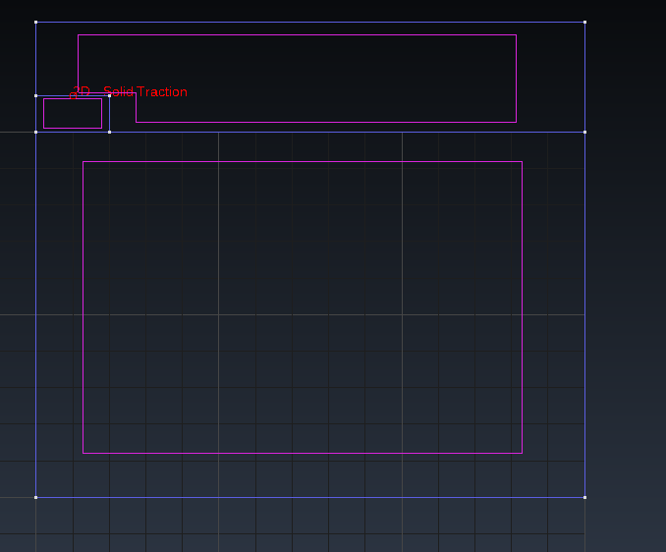
Figure 4. Loading conditions
Calculation parameters:
### Anura3D_2021 ###
$$NUMBER_OF_LOADSTEPS
6
$$TIME_PER_LOADSTEP
1.0
$$TOTAL_TIME
0.0
$$COURANT_NUMBER
0.98
$$COMPUTATION_METHOD
MPM-MIXED
$$GRAVITY_ACCELERATION
9.81
$$GRAVITY_VECTOR
0.0 -1.0 0.0
$$GRAVITY_LOAD
step 1.0 1.0
$$SOLID_TRACTION
step 1.0 10.0
$$LIQUID_PRESSURE
off 0.0 1.0
$$PRESCRIBED_VELOCITY
off 1.0 1.0
$$QUASISTATIC_CONVERGENCE
1
$$TOLERATED_ERROR_SOLID
0.01 0.05
$$TOLERATED_ERROR_LIQUID
0.01 0.01
$$MAXIMUM_TIME_STEPS
10000
$$MASS_SCALING
0 1.0
$$HOMOGENEOUS_LOCAL_DAMPING
1 0.7
$$BULK_VISCOSITY_DAMPING
0 0.06 1.2
$$FIX_SOLID_SKELETON
0
$$STRAIN_SMOOTHING
1
$$CONTACT_FORMULATION
0
$$INITIAL_WATER_PRESSURE
0.0
$$APPLY_POROSITY_UPDATE
0
$$INITIAL_VELOCITY
0
$$RESET_DISPLACEMENTS
0
$$REMOVE_FIXITIES
0 0 0
$$K0_PROCEDURE
1
$$SURFACE_ELEVATION
10.0
$$INITIAL_VERTICAL_LOAD_K0
0.0
$$EXCAVATION
0
$$SUBMERGED_CALCULATION
0 1
$$APPLY_OBJECTIVE_STRESS
0
$$DEGREE_OF_FILLING
0.9
$$NUMBER_OF_ACTIVE_ELEMENTS
0
$$OUTPUT_NUMBER_OF_MATERIAL_POINTS
6
$$OUTPUT_MATERIAL_POINTS
1
2000
2500
3000
3957
4500
$$END

Solution

The vertical displacement of a foundation MP #1 with time is shown in Figure 5. Vertical displacement increases rapidly at the beginning of each load step due to the sudden increase of the applied load, then stabilizes approaching the quasi-static equilibrium.

Figure 6 shows the vertical displacement of the foundation at 6 seconds. Figure 7 shows the reaction forces of the foundation and the soil versus time. The maximum reaction force is 2000 kN/m.

Figure 5. Evolution of vertical displacement for a material point located in the foundation
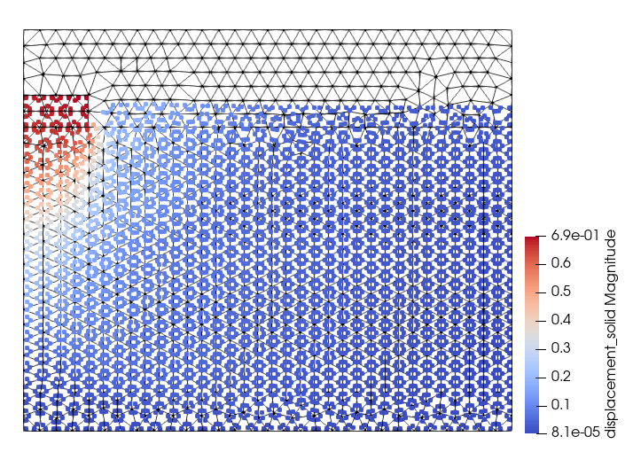
Figure 6 Vertical displacement at t=6s

Figure 7 Reaction forces versus time

