Benchmark Test: prescribedvelocityMP_contact_3D
written by Francesca Ceccato, 25/06/2021
General description
A cube of dry material is placed on the top of a 5m-dry soil column. The top material moves downward with a prescribed velocity (at the MP) compressing the bottom material. The moving mesh option is applied, the fix mesh is the cubical volume of prescribed velocity. The load multipliers for velocity are applied. The contact algorithm is applied.
Mesh
Size of discretized domain: 1 m x 1 m x 7 m
Type of element: tetrahedron
Size of elements: 1m
Num. of Tetrahedra elements=42
Num. of nodes=135
Quadratic meshNumber of MPs per element: 4 SMPs

Material properties
$$MATERIAL_NAME  bottom  $$MATERIAL_TYPE  dry_material  $$POROSITY_SOLID  0.0  $$DENSITY_SOLID  1000.0  $$K0_VALUE_SOLID  0.0  $$MATERIAL_MODEL_SOLID  linear_elasticity  $$YOUNG_MODULUS  1000.0  $$MATERIAL_INDEX  2  $$MATERIAL_NAME  top  $$MATERIAL_TYPE  dry_material  $$POROSITY_SOLID  0.0  $$DENSITY_SOLID  1000.0  $$MATERIAL_MODEL_SOLID  linear_elasticity  $$YOUNG_MODULUS  1000.0  $$POISSON_RATIO  0.0 | 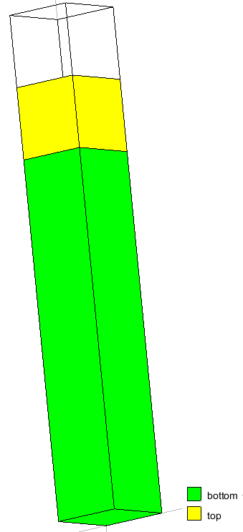

Boundary conditions
The displacement at the boundaries will be ﬁxed in normal direction and free in the tangential directions.  A prescribed velocity of -0.2m/s is prescribed in y-direction at the MP. | 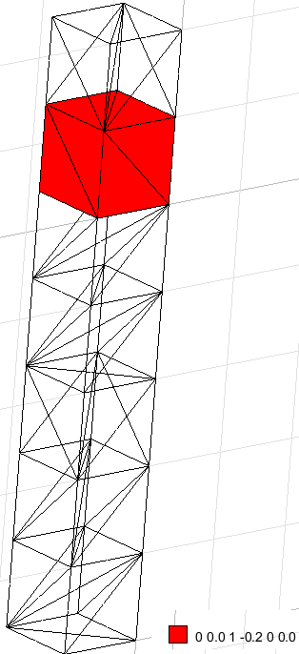
Moving mesh is applied:
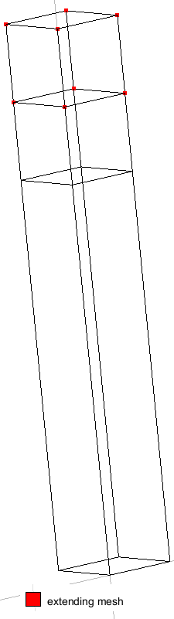 | 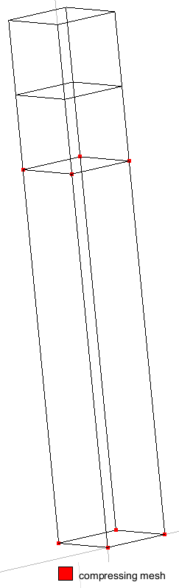 | 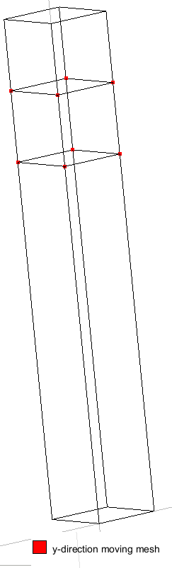 | 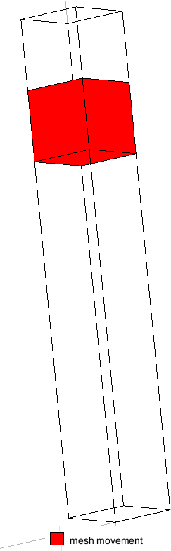

Gravity
Gravity is not applied
Contact
A smooth contact is applied
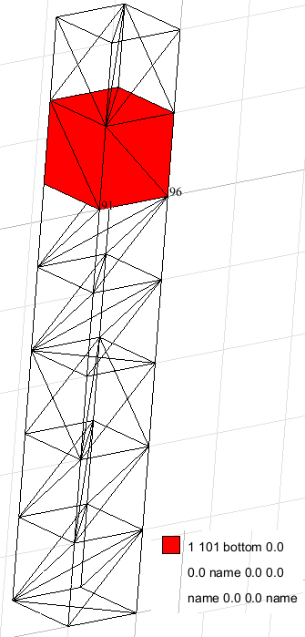
Numerical Solution:
### Anura3D_2018.2 ###
$$NUMBER_OF_LOADSTEPS
5
$$TIME_PER_LOADSTEP
0.1
$$TOTAL_TIME
0.0
$$COURANT_NUMBER
0.98
$$COMPUTATION_METHOD
MPM-MIXED
$$GRAVITY_ACCELERATION
9.81
$$GRAVITY_VECTOR
0.0 -1.0 0.0
$$GRAVITY_LOAD
off 0.0 1.0
$$SOLID_TRACTION
off 0.0 1.0
$$LIQUID_PRESSURE
off 0.0 1.0
$$PRESCRIBED_VELOCITY
step 1.0 1.0
$$STRAIN_SMOOTHING
0
$$CONTACT_FORMULATION
1
$$APPLY_OBJECTIVE_STRESS
0
$$OUTPUT_NUMBER_OF_MATERIAL_POINTS
5
$$OUTPUT_MATERIAL_POINTS
1
9
20
50
60
$$END
Solution
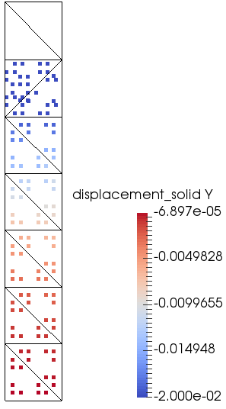  step 1 (t=0.1s) | 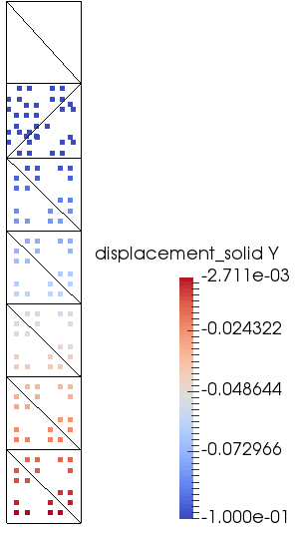  Step 5 (t=0.5s)

Velocity of MP in the prescribed volume is -0.2m/s and the displacement respect the theoretical solution.
The moving mesh moves as expected.

