Benchmark Test: Linear load_1 phase_linear elastic_2D:
written by Francesca Ceccato, 23/06/2021
General description
A dry soil column, with elastic behaviour, is loaded with a vertical load linearly variable along time. Bottom is fixed and the sample can only deform in vertical direction.
Mesh
Size of mesh: 0,1 m x 1,1 m x 0,1 m
Type of element: tetrahedron
Number of element: 66
Size of elements: 0.1
Number of nodes: 207
Number of MPs per element: 4 SMPs

Material properties
$$MATERIAL_NAME
Elastic
$$MATERIAL_TYPE
dry_material
$$POROSITY_SOLID
0.0
$$DENSITY_SOLID
1000
$$K0_VALUE_SOLID
0.0
$$MATERIAL_MODEL_SOLID
linear_elasticity
$$YOUNG_MODULUS
1000.0
$$POISSON_RATIO
0.0
Boundary conditions
The displacement at the boundaries will be ﬁxed in normal direction and free in the tangential directions
Initial conditions
A vertical load of -10 kPa is applied on the upper boundary, but it’s not suddenly applied: a linear increment of the load, till -10 kPa, is imposed in 3 steps each one of 0,05 s.
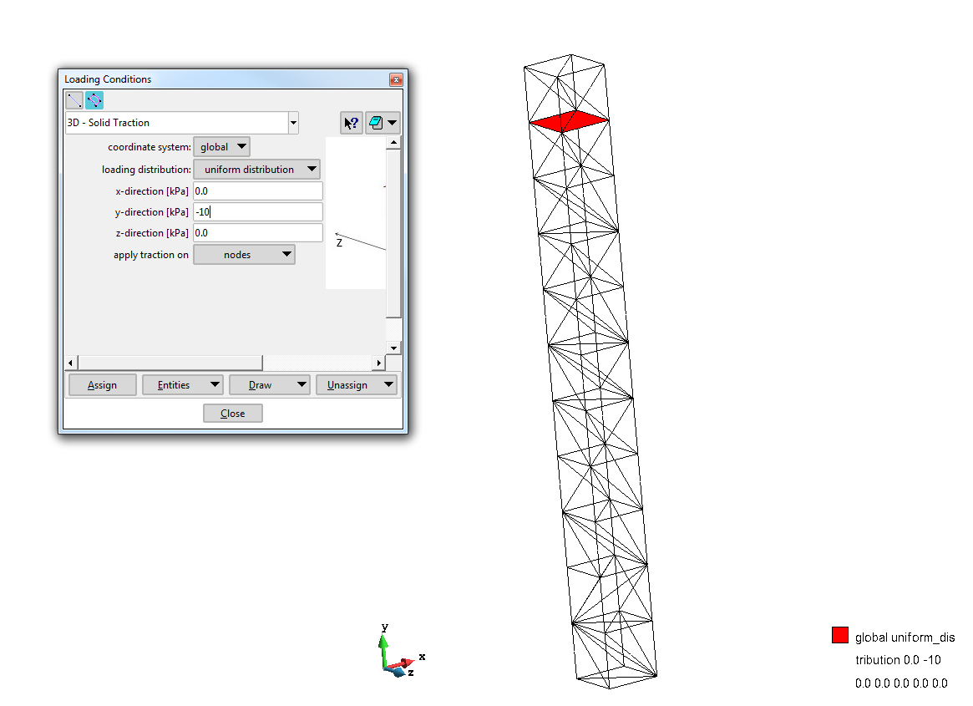
Gravity
Gravity is not applied
Numerical Solution:
### Anura3D_2021 ###
$$NUMBER_OF_LOADSTEPS
3
$$TIME_PER_LOADSTEP
0.05
$$COURANT_NUMBER
0.98
$$COMPUTATION_METHOD
MPM-MIXED
$$GRAVITY_LOAD
off 0.0 1.0
$$SOLID_TRACTION
linear 0.0 1.0
$$MASS_SCALING
0 1.0
$$HOMOGENEOUS_LOCAL_DAMPING
1 0.75
$$FIX_SOLID_SKELETON
0
$$STRAIN_SMOOTHING
0
$$APPLY_OBJECTIVE_STRESS
0
$$DEGREE_OF_FILLING
0.9
$$OUTPUT_NUMBER_OF_MATERIAL_POINTS
1
$$OUTPUT_MATERIAL_POINTS
1
$$END

The output is given for 1 material point; ID of the MP is 1.From the .PAR file it’s possible to plot time steps (or time) versus load multiplier.

Analytical Solution
No analytical solution

