Benchmark Test: ColumnCollapse_PLANE_MC_2Phase_K0_MPM-MP
written by Luis A. Aviles, 09/09/2021
General description
A 2D plane strain saturated soil column is allowed to collapse by self-weight and run out on a rough surface. K0 procedure is used. Damping is not considered. The soil run out in the horizontal direction over a surface. Material point integration is used (MPM-MP) and single-point formulation.
Mesh
Size of mesh: 1,0 m x 1,0 m soil column – 3,0 m x 1,1 m total domain
Type of element: structured triangular_3-noded
Number of elements: 660
Size of elements: 0.1
Number of nodes: 372
Number of MPs per element: 3 MPs

Material properties
$$MATERIAL_NAME
soil
$$MATERIAL_TYPE
saturated_material_coupled
$$POROSITY_SOLID
0.40
$$DENSITY_SOLID
2650
$$DENSITY_LIQUID
1000
$$INTRINSIC_PERMEABILITY_LIQUID
1e-9
$$BULK_MODULUS_LIQUID
10000
$$DYNAMIC_VISCOSITY_LIQUID
1e-6
$$K0_VALUE_SOLID
0.5
$$MATERIAL_MODEL_SOLID
mohr_coulomb
$$YOUNG_MODULUS
1000
$$POISSON_RATIO
0.3
$$FRICTION_ANGLE
30.0
$$COHESION
0.0
$$DILATANCY_ANGLE
0.0
$$TENSILE_STRENGTH
0.0
Boundary conditions
The displacement for solid and liquid at the boundaries will be ﬁxed in normal direction and free in the tangential directions
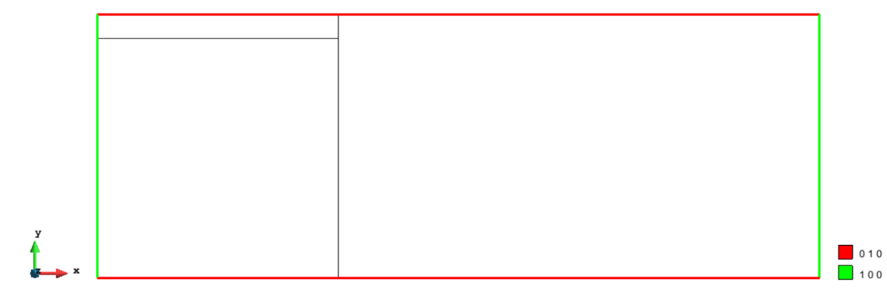
Figure 1 Fixities applied in the model
Initial conditions
No initial conditions
Gravity
Gravity load is applied in the first-time step.
Numerical Solution:
### Anura3D_2021 ###
$$NUMBER_OF_LOADSTEPS
50
$$TIME_PER_LOADSTEP
0.02
$$COURANT_NUMBER
0.98
$$COMPUTATION_METHOD
MPM-MP
$$GRAVITY_LOAD
step 1.0 1.0
$$SOLID_TRACTION
step 0.0 1.0
$$LIQUID_PRESSURE
step 0.0 0.0
$$QUASISTATIC_CONVERGENCE
0
$$MASS_SCALING
0 1.0
$$HOMOGENEOUS_LOCAL_DAMPING
0 0.75
$$FIX_SOLID_SKELETON
0
$$STRAIN_SMOOTHING
0
$$K0_PROCEDURE
1
$$SURFACE_ELEVATION
1.0
$$INITIAL_VERTICAL_LOAD_K0
0.0
$$APPLY_OBJECTIVE_STRESS
0
$$DEGREE_OF_FILLING
0.9
$$OUTPUT_NUMBER_OF_MATERIAL_POINTS
5
$$OUTPUT_MATERIAL_POINTS
433
438
505
538
595
$$END

The output is given for 5 material point. From the .PAR file it is possible to plot time steps (or time) versus load multiplier.
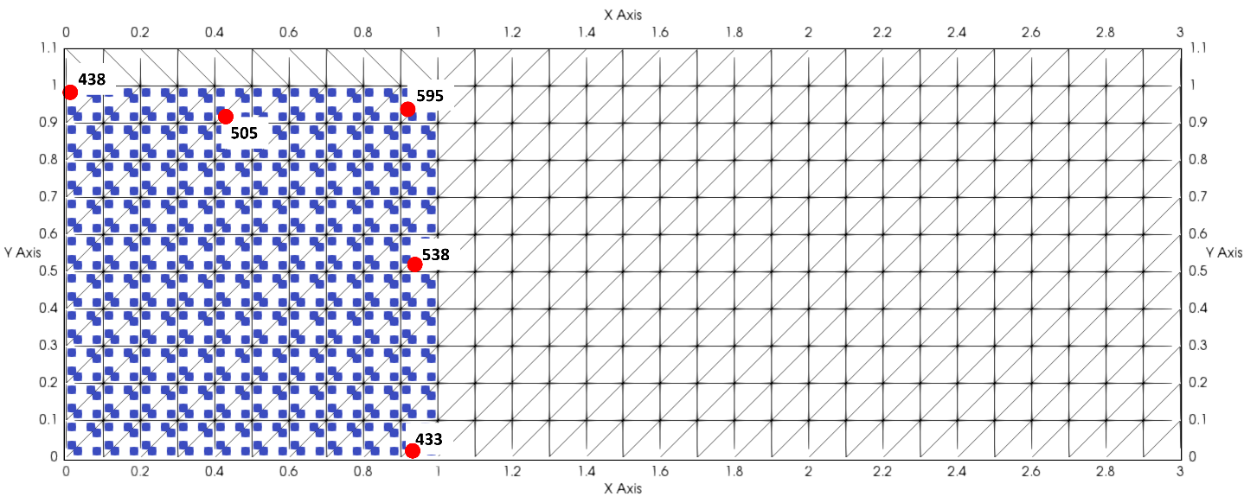
Figure 2 points to control displacements
Figure 3 shows the horizontal displacements of the column.
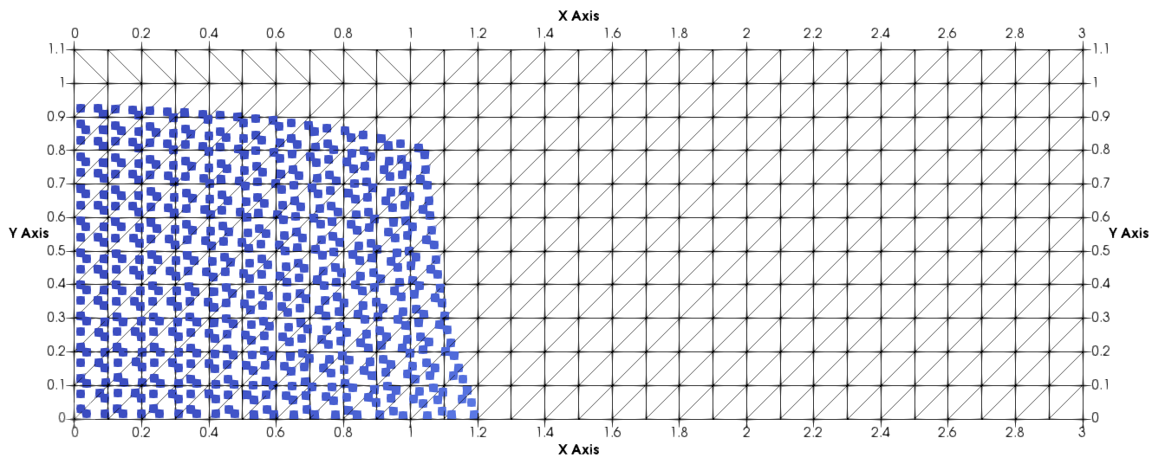
Step 10
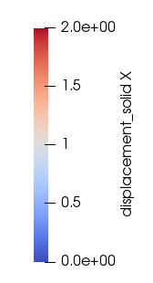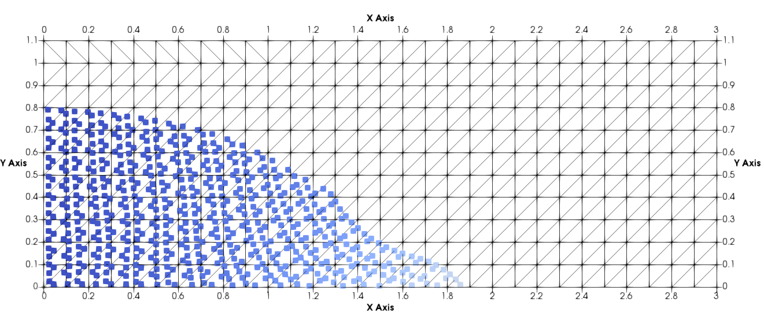
Step 20
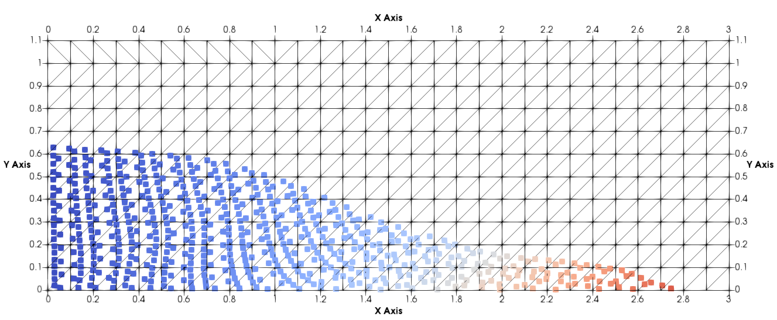
Step 30
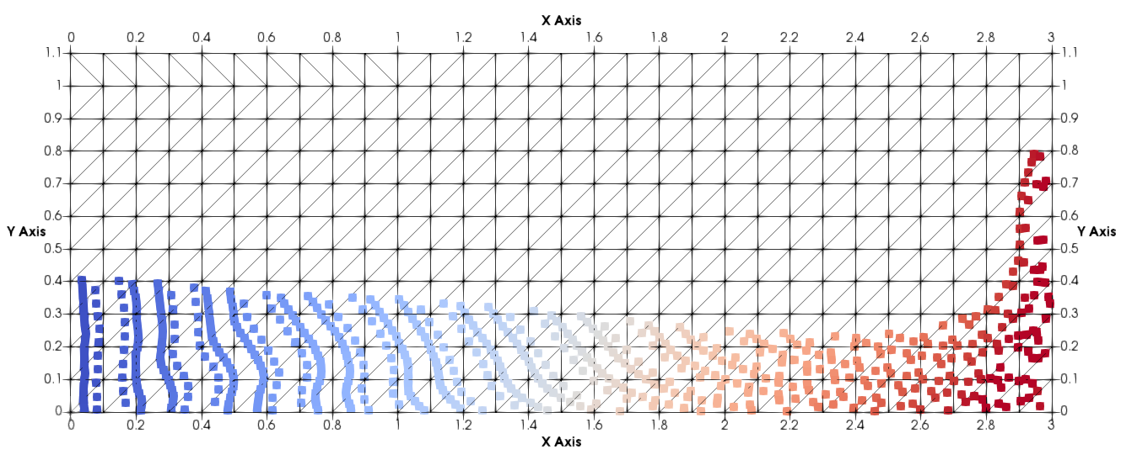
Step 50
Figure 3 horizontal displacements with time

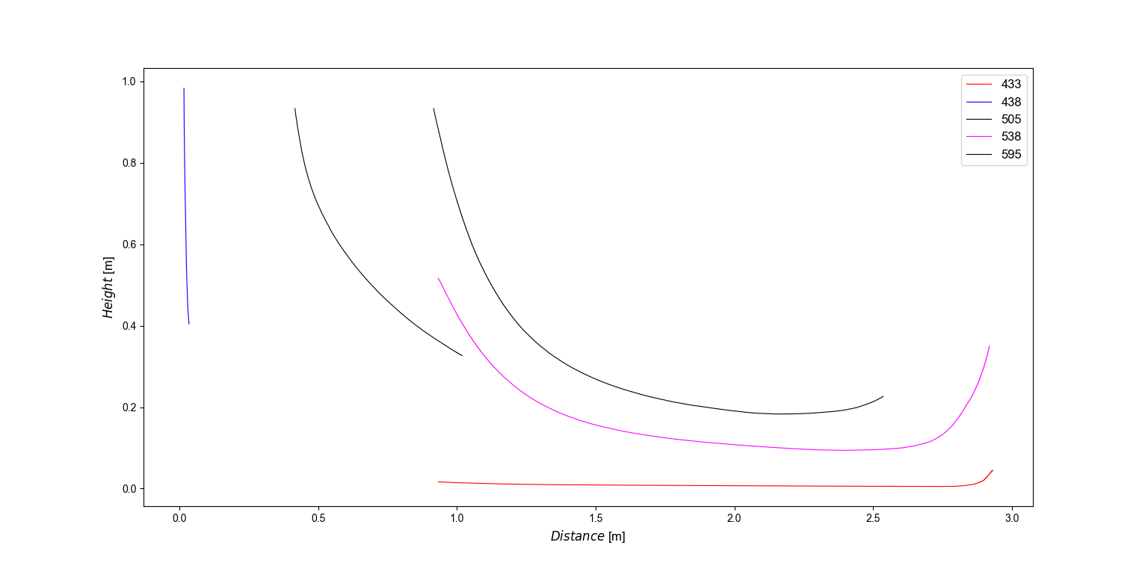
Figure 4 horizontal displacements following the particles selected

Analytical Solution
No analytical solution

