Benchmarks for Unsaturated 2Phase formulation
Written by Veronica Girardi and Francesca Ceccato 17/10/2022
- Initialization with K0
  - Phreatic surface drawn in GID, no max suction threshold
  - Phreatic surface drawn in GID, max suction threshold
  - Phreatic surface read from file, no max suction threshold
General description
In this benchmark initialization with k0 considering 2pHase unsaturated formulation is tested. A 2D section of a slope is considered. Different techniques to initialize the phreatic surface are tested, while the soil surface is always specified while building the geometry in GID. The purpose is checking the correct location of soil and phreatic surface by checking the stress and pressure distributions in the slope at 0s. One step of 0.5s is performed using MPM-MIXED (no quasi-static procedure is used).

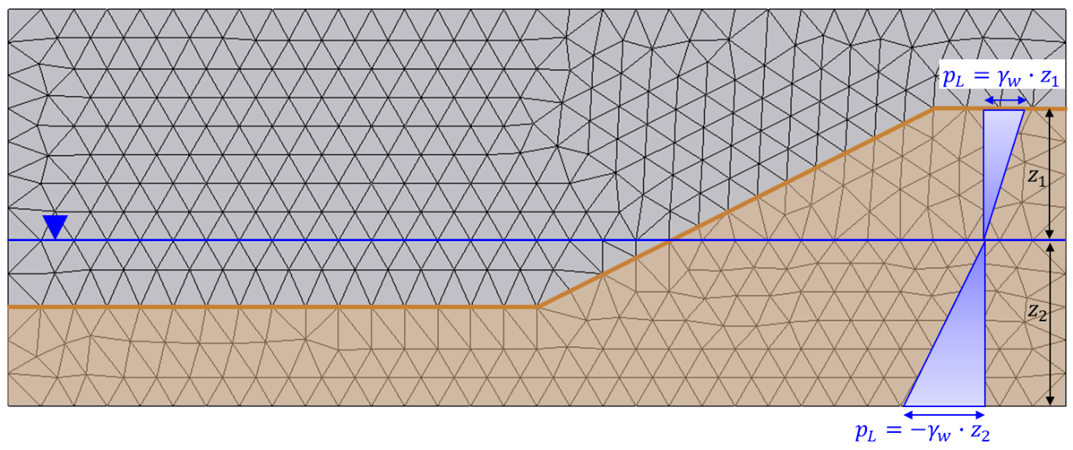
Figure 1. Geometry and mesh of the K0 initialization problem. No suction threshold: suctions are linear above the initial phreatic surface, according to hydrostatic gradient.
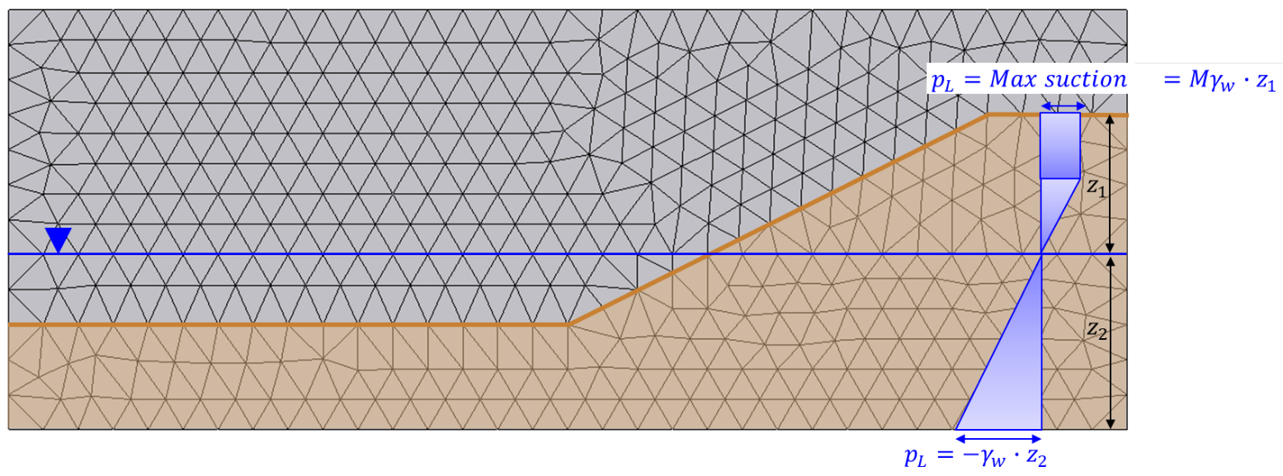
Figure 2. Geometry and mesh of the K0 initialization problem. Suction threshold: above the initial phreatic surface suctions are linear until maximum suctions is reached, then constant. The suction threshold value is specified in CPS.

Mesh
Size of mesh: 0.5 m x 0.05 m
Type of element: triangles
Number of elements: 794
Number of nodes: 442
Number of material points per element: 3

Material properties
Number of phases: 2
Number of layers: 1

Porosity soil: 0.4
Density solid: 2650 kg/m³
Intrinsic permeability liquid: 2x10⁻¹⁰ m²
Density liquid: 1000 kg/m³
Bulk modulus liquid: 60000 kPa
Dynamic viscosity liquid: 1x10⁻⁶ 1/kPa*s
K0: 0.5

Material model solid: linear elasticity
Young modulus: 50000 kPa
Poisson ratio: 0.3

SWRC model: linear with a_{v}: 0.0004 kPa⁻¹
HCC model: constant

Boundary conditions
Solid and Liquid fixities are identical for the three subcases 1.1, 1.2, 1.3
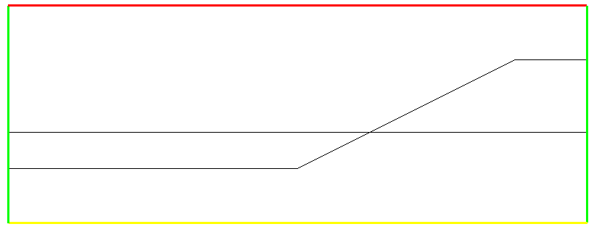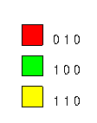
Figure 3. Solid fixities. This geometry is related to problems 1.1 and 1.2 where initial phreatic surface is a geometrical entity drawn in GID.
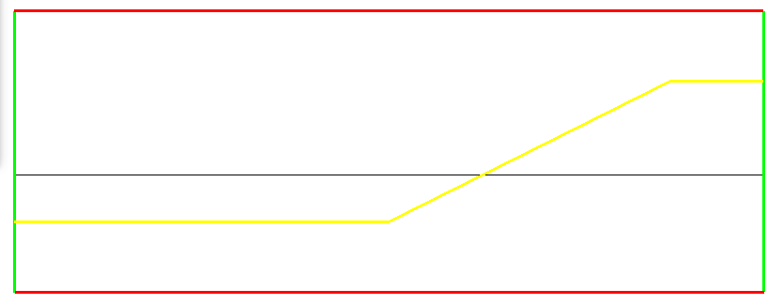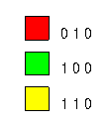
Figure 4. Liquid fixities. This geometry is related to problems 1.1 and 1.2 where initial phreatic surface is a geometrical entity drawn in GID.
Initial conditions
Soil surface specification
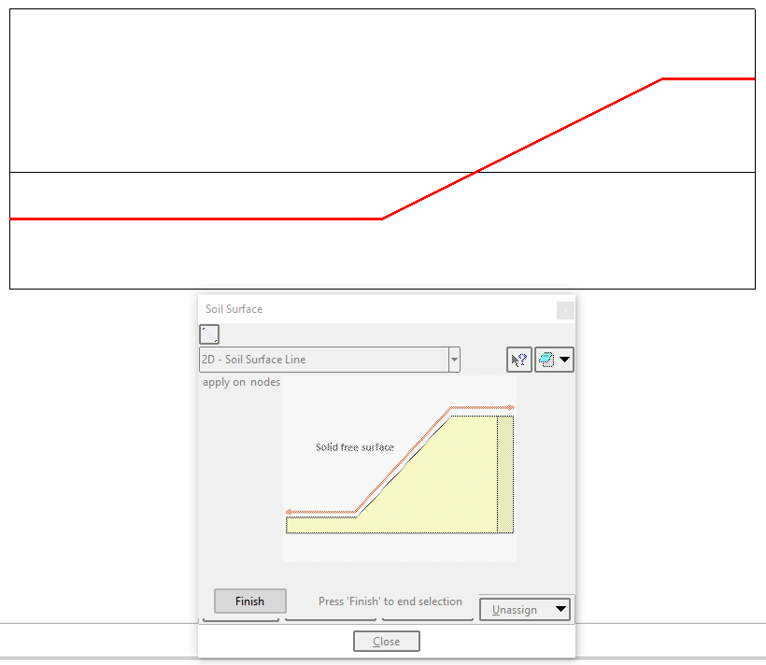

Phreatic surface specification (subcases 1.1 and 1.2)

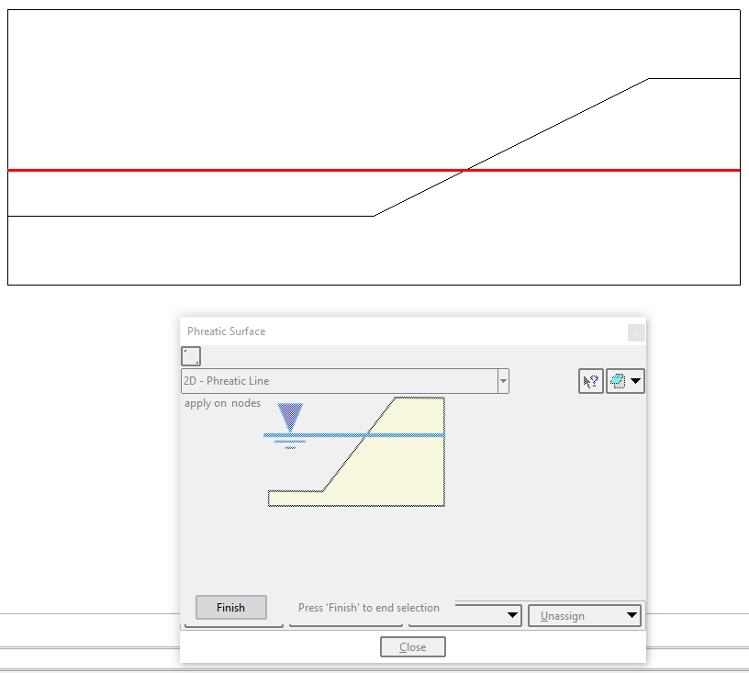

K0 procedure is then turned on in CPS and in case 1.2 a maximum suction should be also specified. In this case max suction= 4kPa is assigned.
In the case of phreatic surface specified from file (subcase 1.3) a new file should be created (a txt file) with coordinates of the phreatic surface and the number of points where the phreatic surface location is known. This file is renamed with the same name of CPS and GOM, and extension .PSF (Phreatic Surface File). The file needs to be in the folder of CPS and GOM and no path of the file needs to be specified anymore in GID (and as a consequence it is not written in GOM). The phreatic surface location from file is identical to the one from GID of the previous cases.

Gravity
Gravity is taken into account (necessary to visualize the correct gradients of stress and pressure).

Results:
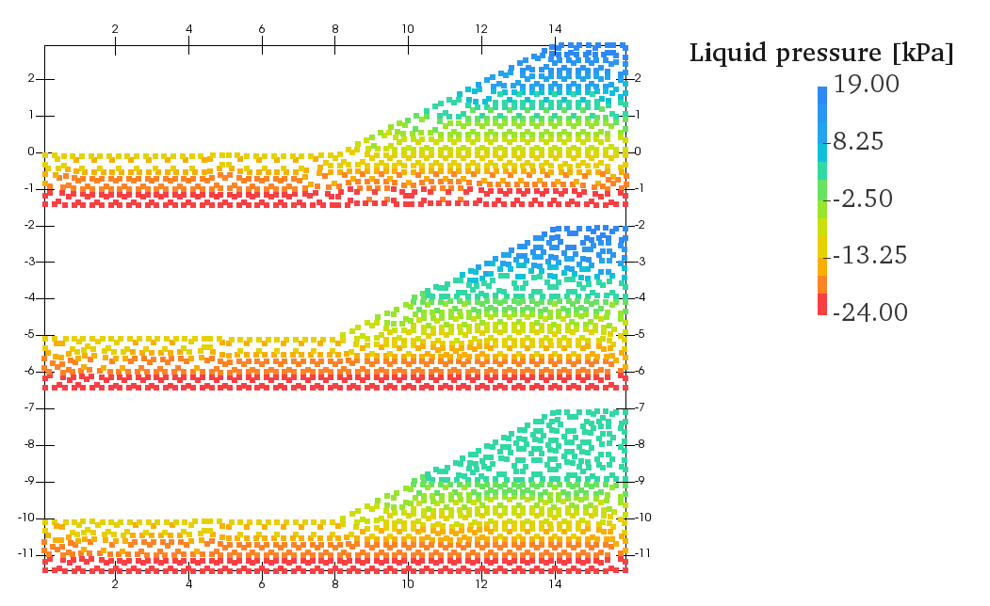
Figure 5. Liquid pressure contour at 0s. Top subfigure is related to case 1.1 (GID phreatic surface and no suction threshold), mid subfigure is related to case 1.3 (file phreatic surface and no suction threshold) and bottom subfigure is related to case 1.2 (GID phreatic surface and max suction threshold).
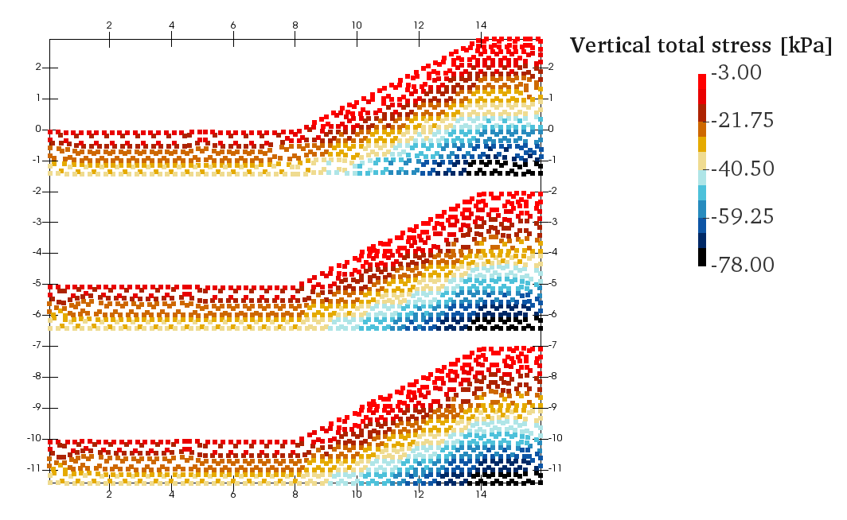
Figure 6. Sigma y total contour at 0s. Top subfigure is related to case 1.1 (GID phreatic surface and no suction threshold), mid subfigure is related to case 1.3 (file phreatic surface and no suction threshold) and bottom subfigure is related to case 1.2 (GID phreatic surface and max suction threshold).
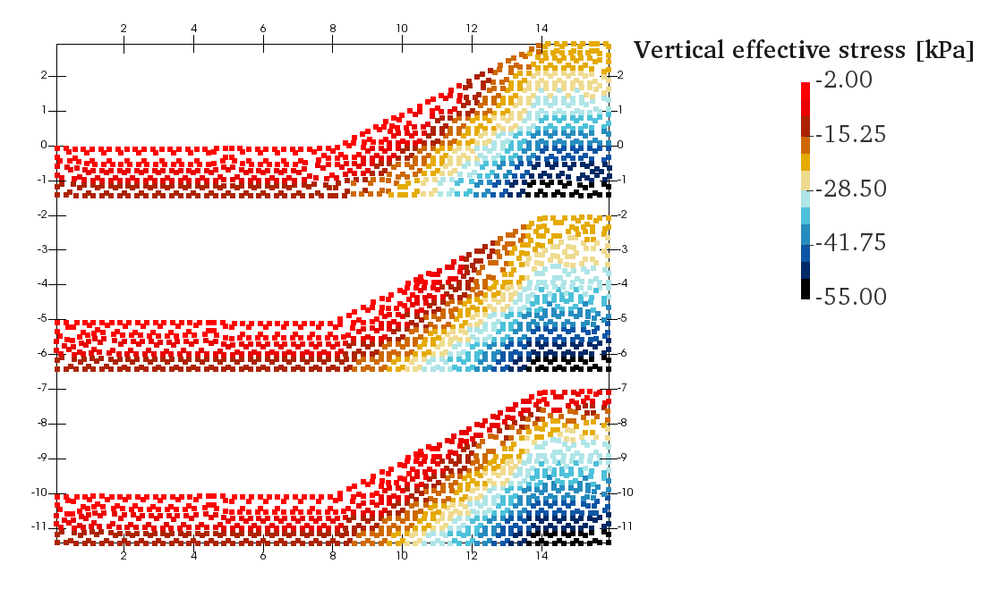
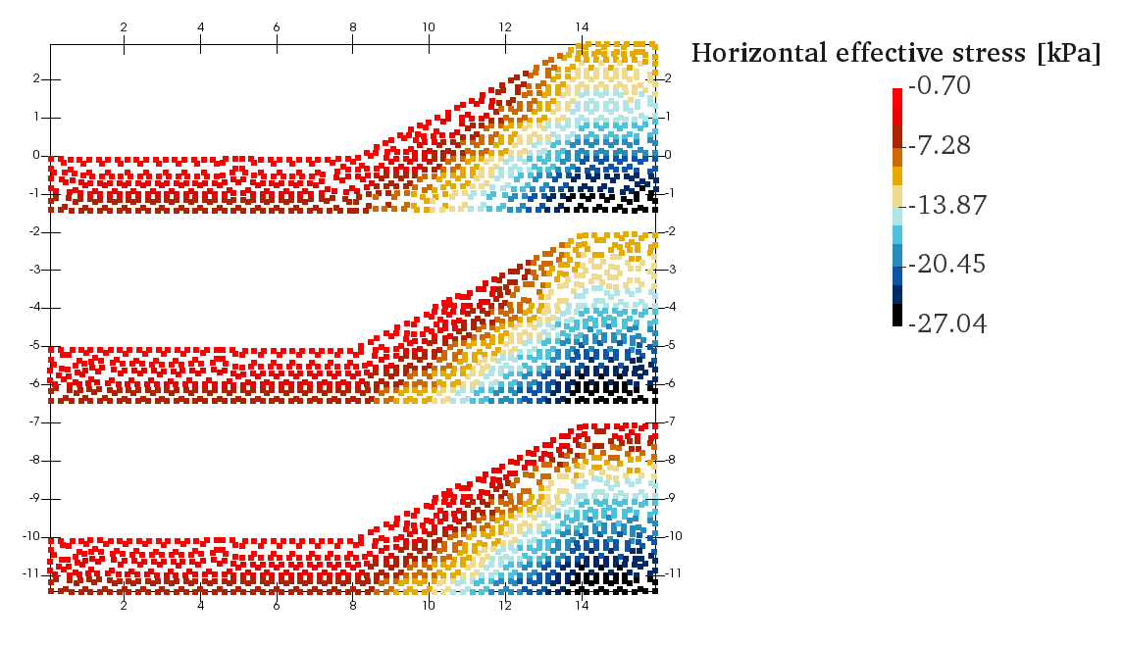
Figure 6. Sigma y and x effective contour at 0s. Top subfigure is related to case 1.1 (GID phreatic surface and no suction threshold), mid subfigure is related to case 1.3 (file phreatic surface and no suction threshold) and bottom subfigure is related to case 1.2 (GID phreatic surface and max suction threshold).

NOTE: gid project for cases 1.1 and 1.2 is the same

