Oedometer_LE_LoadOnMaterialPoints_2D – written by Gaia Di Carluccio, 31-10-2018, updated by Grace Roberts 07-07-2021

General description
In this benchmark a 2D column of soil of 1m height is loaded at the top with a vertical load of 100kPa. The soil consists of 1-phase (solid) with a linear-elastic model.
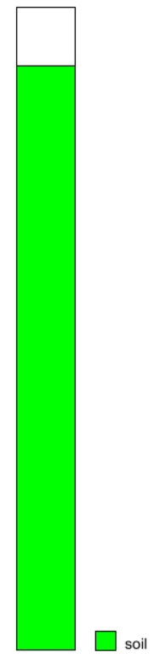
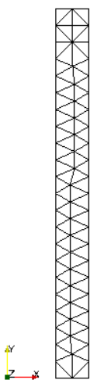
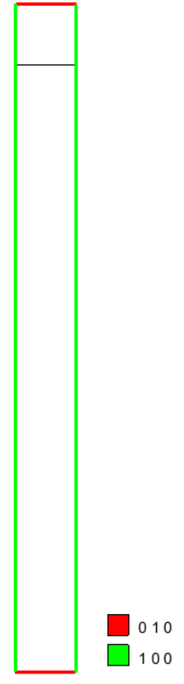
Mesh
The initial soil column is 0.1 m x 1 m. The empty area is 0.1 m x 0.1 m – thus the total column height is 1.1 m. The volume is discretized with an unstructured mesh of 86 triangular-3 nodes element and 68 nodes (size equivalent to 0.05). Each element initially contains 3 material points.

Material properties
Material type: dry_material
Porosity soil: 0.0
Density solid: 2000 kg/m³

Material model solid: linear elasticity
Young modulus: 500 kPa
Poisson ratio: 0.2

Boundary conditions
The top of the column is fixed in y direction, the bottom is fixed in x and y directions and the sides of the column are fixed in lateral direction.

Gravity
Gravity is neglected.

Oedometric compression
A vertical load of 100 kPa is applied at the top line of the soil column. The dynamic calculation is performed in 50 steps by using a damping coefficient of 0.05. The time per calculation step is 0.05 and there are 50 calculation steps. The solid traction loading is applied Stepwise, with intial value of 0.0 and final value of 1.0.

Numerical solution:
The problem is solved with MPM-MIXED without any additional features and with a Courant number of 0.98.

Analytical solution:
The results correspond to the point with material point ID equal to 1.

Stress-strain curve and comparison with theoretical oedometric modulus: $E_{oed}= \frac{1-ν}{(1+ν)(1-2ν)}E$:
