Oedometer_LE_LoadOnMaterialPoints_2D – written by Grace Roberts 07-07-2021

General description
In this benchmark a 2D column of soil of 1m height is loaded at the top with a vertical load of 100kPa. The soil consists of 1-phase (solid) with a linear-elastic model.
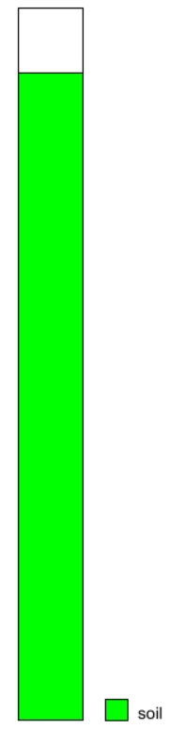
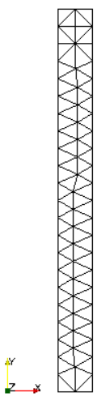
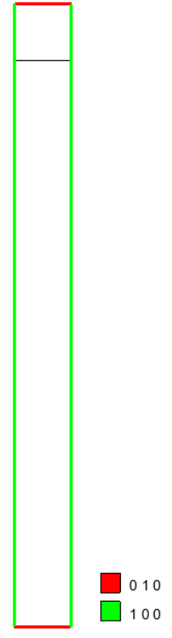
Mesh
The initial soil column is 0.1 m x 1 m. The empty area is 0.1 m x 0.1 m – thus the total column height is 1.1 m. The volume is discretized with an unstructured mesh of 86 triangular-3 nodes element and 68 nodes (size equivalent to 0.05). Each element initially contains 3 material points.

Material properties
Material type: dry_material
Porosity soil: 0.4
Density solid: 2650 kg/m³

Material model solid: linear elasticity
Young modulus: 100 kPa
Poisson ratio: 0.3

Boundary conditions
The top of the column is fixed in y direction, the bottom is fixed in x and y directions and the sides of the column are fixed in lateral direction.

Gravity
Gravity is applied stepwise from 1.0 to 1.0.

Absorbing Boundaries.
The absorbing boundary is applied on the bottom horizontal line, solely in the y-direction, the alpha value is 1.5 and the delta value is 15 m.
The time per calculation step is 0.05 with 20 calculation steps. The gravity data is assigned with acceleration of 9.81 with a multiplier of -1.0 in the y-direction. The gravity loading is applied Stepwise, with intial multiplier of 0.0 and final multiplier of 1.0. As per the original benchmark both Solid Traction and Liquid Pressure have been applied stepwise with initial multiplier of 0.0 and final multiplier of 1.0

Numerical solution:
The problem is solved with Standard FEM without any additional features and with a Courant number of 0.5.

