Benchmark Test: Oedometer_TopLoadCompression_2phase_2D_1point
written by Luis Aviles, 05/11/2021
General description
The benchmark consists of an elastic column under saturated conditions which is under a traction load of 100 kPa applied to the top nodes (see figure 1). No gravitation loads are considered.
Mesh
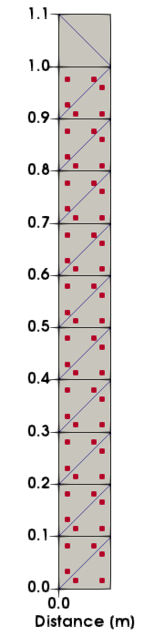
Figure 1 geometry and discretization
$$DIMENSION
2D-plane_strain
$$ELEMENTTYPE
triangular_3-noded
number of MP per element = 3

Material properties
soil
$$MATERIAL_NAME
Soil
$$MATERIAL_TYPE
saturated_material_drained
$$POROSITY_SOLID
0.43
$$DENSITY_SOLID
2650
$$DENSITY_LIQUID
1000
$$K0_VALUE_SOLID
0.5
$$MATERIAL_MODEL_SOLID
linear_elasticity
$$YOUNG_MODULUS
10000
$$POISSON_RATIO
0.3

Boundary conditions
Liquid and solid fixity in x and y direction are applied as shown in Figure 2

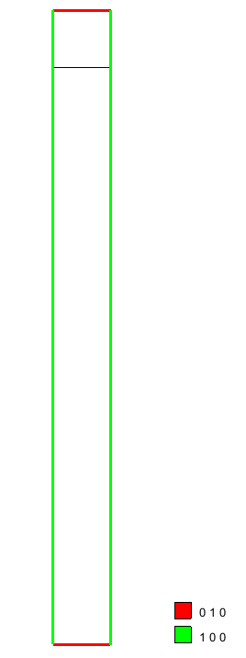
Figure 2 Boundary conditions
Loading conditions
A uniform pressure load of -100kPa is applied at the top nodes of the column. The load is in y-direction as shown in Figure 3.
Gravity is not applied.
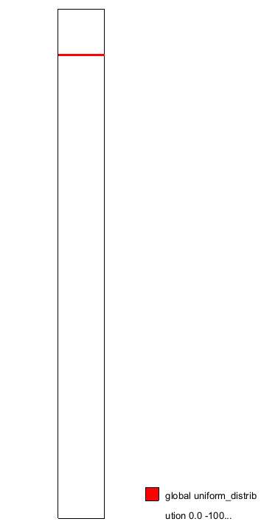
Figure 3 Solid traction loading conditions

Calculation parameters:
## Anura3D_2020 ###
$$NUMBER_OF_LOADSTEPS
10
$$TIME_PER_LOADSTEP
0.02
$$COURANT_NUMBER
0.98
$$COMPUTATION_METHOD
MPM-MIXED
$$GRAVITY_LOAD
off 0.0 1.0
$$SOLID_TRACTION
linear 0.0 1.0
$$LIQUID_PRESSURE
off 0.0 1.0
$$PRESCRIBED_VELOCITY
off 0.0 1.0
$$OUTPUT_NUMBER_OF_MATERIAL_POINTS
5
$$OUTPUT_MATERIAL_POINTS
3
15
24
29
57
$$END

Solution
Figure 4 shows the mean effective stress and the displacements of the particles at the last time step.
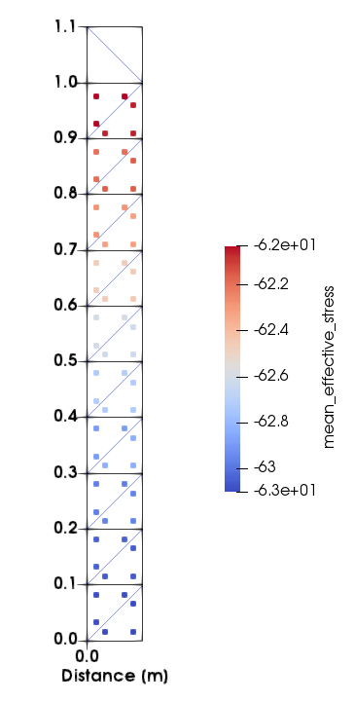 | 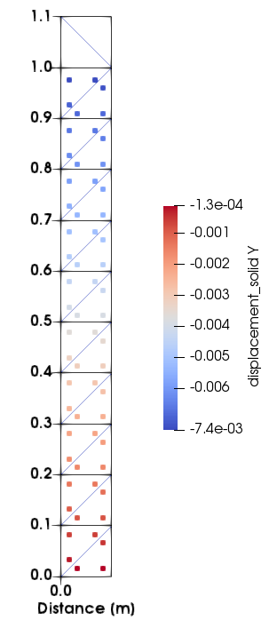
Figure 4 MP mean effective stress and y-displacements

