Benchmark Test: 2D applied pressure on MP
written by Francesca Ceccato, 29/05/2020 (updated: 09/09/2021)
General description
The benchmark considers an applied pressure at the MP on a circular surface. This is necessary to test loading boundary conditions for 2phase.
Mesh
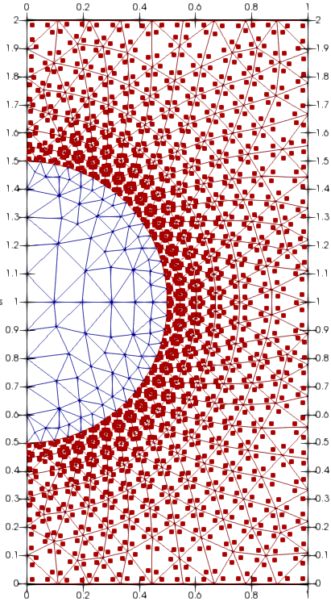
Figure 1 geometry and discretization
$$DIMENSION
2D-plane_strain
$$ELEMENTTYPE
triangular_3-noded
number of MP per element = 3

Material properties
soil
$$MATERIAL_NAME
Soil
$$MATERIAL_TYPE
saturated_material_coupled
$$POROSITY_SOLID
0.4
$$DENSITY_SOLID
2650
$$DENSITY_LIQUID
1000
$$INTRINSIC_PERMEABILITY_LIQUID
1e-10
$$BULK_MODULUS_LIQUID
20000
$$DYNAMIC_VISCOSITY_LIQUID
1e-6
$$K0_VALUE_SOLID
0.0
$$MATERIAL_MODEL_SOLID
linear_elasticity
$$YOUNG_MODULUS
1000
$$POISSON_RATIO
0.0

Boundary conditions
Liquid fixity in x direction at symmetry axis

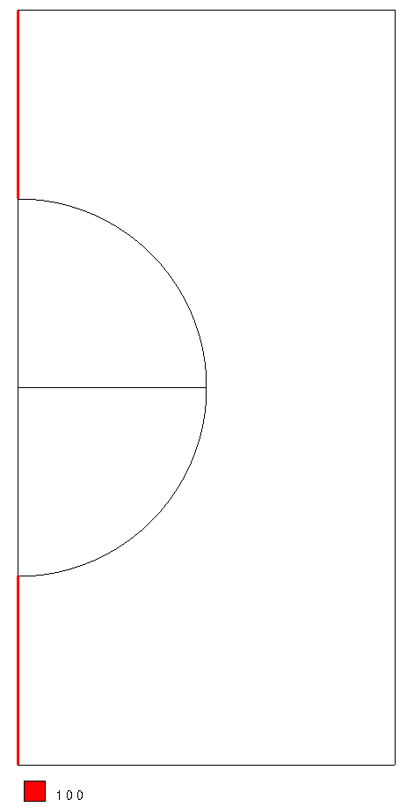
Loading conditions
A pressure load of -10kPa is applied at the MP on the hole.
Gravity is not applied.
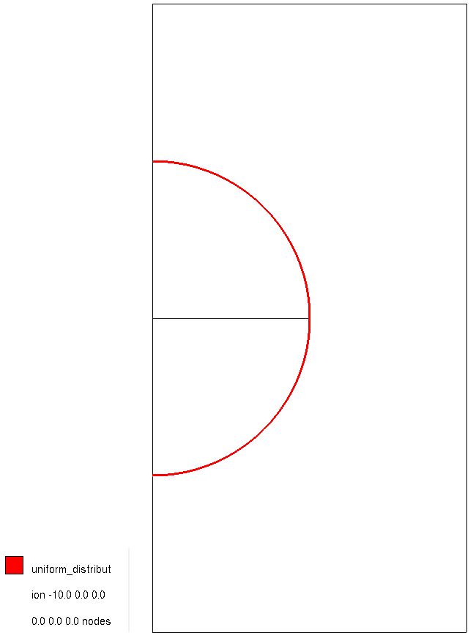
Calculation parameters:
## Anura3D_2021 ###
$$NUMBER_OF_LOADSTEPS
10
$$TIME_PER_LOADSTEP
0.02
$$COURANT_NUMBER
0.98
$$COMPUTATION_METHOD
MPM-MIXED
$$GRAVITY_LOAD
off 0.0 1.0
$$SOLID_TRACTION
off 0.0 1.0
$$LIQUID_PRESSURE
step 1.0 1.0
$$PRESCRIBED_VELOCITY
off 0.0 1.0
$$FIX_SOLID_SKELETON
1
$$STRAIN_SMOOTHING
1
$$OUTPUT_NUMBER_OF_MATERIAL_POINTS
7
$$OUTPUT_MATERIAL_POINTS
88
114
424
427
616
747
874
$$FIX_SOLID_SKELETON
1
$$END

Solution
Figure 2 shows the pore pressure at the last time step. Figure 3 shows the external force liquid. The vector is correctly pointing normal to the surface.
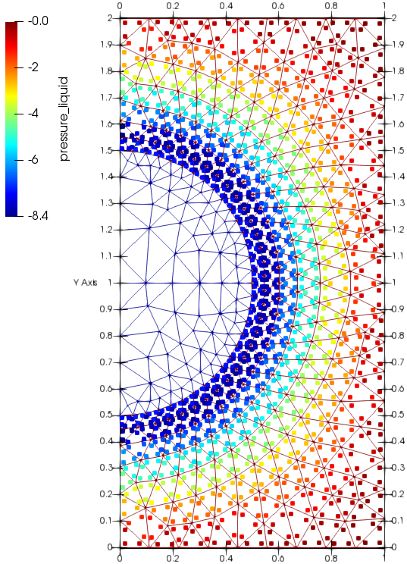  Figure 2 MP pressure at last time step | 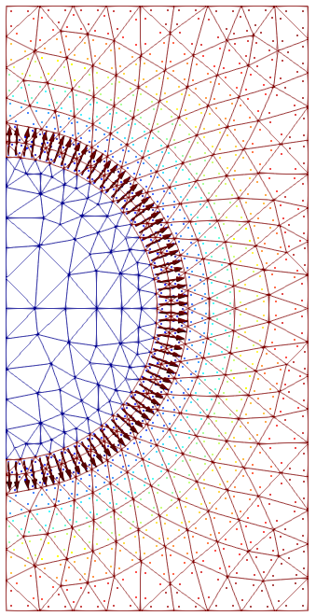  Figure 3 Arrows shows the direction of external force liquid

