**Web Development SIG:**

Get accustomed with HTML5 and CSS basics, and then move to JavaScript. In order to get a first-hand experience of making web pages along with learning, complete the projects mentioned below.

Some Instructions to follow:

* You should complete the projects in the order given.
* Instructions about how to submit these projects and resources are shared at the end of the document.
* In most projects a layout of the design is specified. In those cases you have to come up with your own design to make it look attractive.
* All design SHOULD be responsive.

PS: Don’t be hesitant to ask doubts. Be active on Slack.

**Project 1: Create a webpage similar to the example given below**

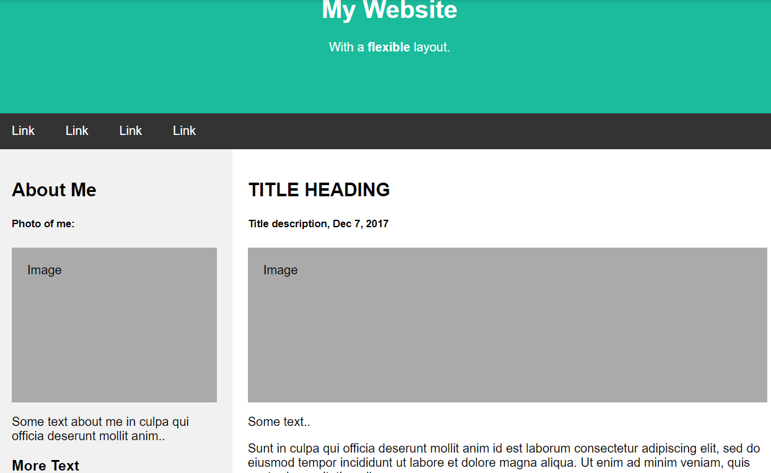

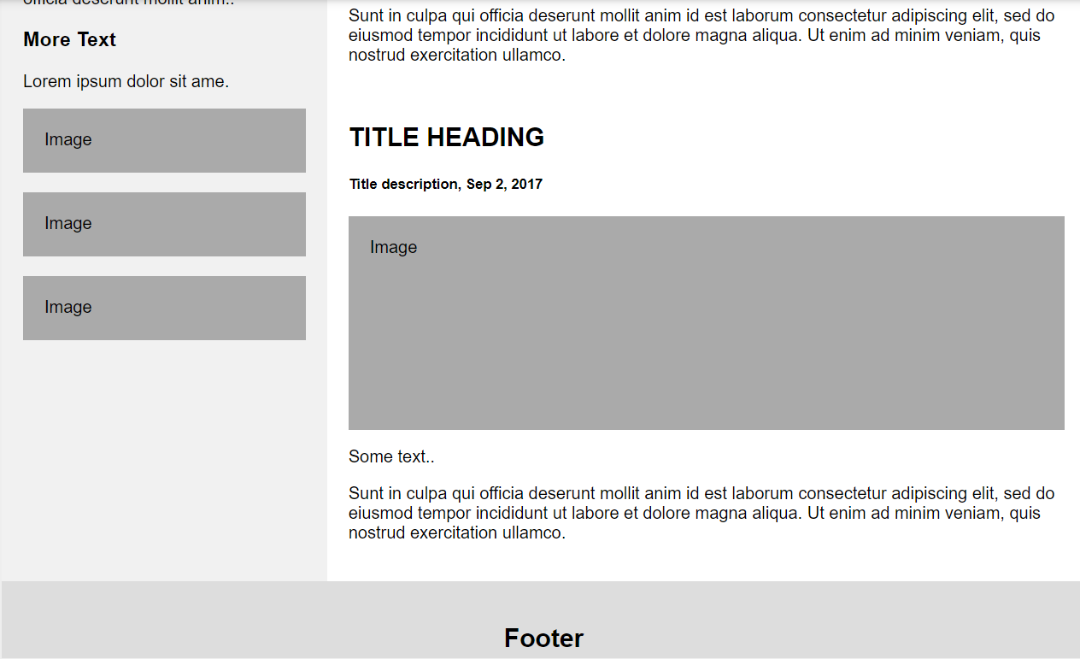

Deadline for submission: 4th June, 2019.

**Project 2: The project will the website for MSP Recruitment exam.**

**2.1)** To make the first page of the portal where the student will enter the personal details: Name, ID Number, Contact Number, Email ID,etc. We need to make sure that if a form field is empty, an alert message should be generated to prevent the form from being submitted. After submission of details and pressing the ‘Start Test’ button, a message should pop up to confirm whether to start the test or not. So, basically the first task is making an entry form and maintaining the database. We will be using Django for backend.

**2.2)** The webpage to display the questions of all types (mcq, descriptive, integer-type and others), provide space for the answers and to store the answers in a separate file. We will having different categories of questions and the questions of each category will be in a separate section. Time might be allotted for each section.

**2.3)** As soon as the test begins, the On Screen timer starts, and time remaining will be displayed at the top. If the user do not submit before completion of time, the browser will automatically submit the answers and close the page when the timer stops.

**2.4)** Proper Styling of the page.

**Details of the Recruitment Exam:**

Recruitment exam will be conducted in two rounds-

**Round 1-**

Objective type questions( MCQs and integers):

* The answers should be stored in backend and on completion, it should automatically store the candidate’s round 1 score in database.
* The timer should be in backend so that it doesn’t get change upon refreshing the web page.
* Auto submission of answers when time gets over if not submitted already.
* MCQs and integer-type questions will be auto checked.

**Round 2-**

* It should start after the submission of round1.
* Open ended type questions.
* The answers should be stored in backend and on completion, it should automatically store the candidate’s answers in the database.
* The timer should be in backend so that it doesn’t get change upon refreshing the web page.
* Auto submission of answers when time gets over if not submitted already.
* The admin can exports the answers of all users of a particular questions through admin panel.

**Later Stage-**

After completion of basic plan, we can further make a admin panel for round 2 in which admin can view answers of user and can assign marks in admin panel itself. After all, admin can generate an excel sheet with details on candidate and score in each section of it.

**Instructions to upload:**

* Upload the 1st project in your own github repository and share the link in our slack group.
* We created a GitHub repository by the name MSP-recruitment-web-portal. Upload your code for the 2nd project there.
* Deploy all the HTML pages using GitHub pages and Jekyll.
* Provide a one-line description and the link to the webpage in the readme of your GitHub repository.

Some resources:

HTML5-

* <https://www.w3schools.com/html/>
* <https://www.tutorialspoint.com/html/>
* <https://www.geeksforgeeks.org/html-tutorials/>

CSS -

* + For the basics -
    - <https://learn.shayhowe.com/>
    - [https://css-tricks.com](https://css-tricks.com/)/
    - <https://www.w3schools.com/css/>
    - <http://100dayscss.com/>

JavaScript -

* + Start with <https://javascript.info/> as it is a comprehensive guide covering things from the basics.
  + You can also look at <https://eloquentjavascript.net/>. A great book which covers almost everything in JavaScript in detail, but a bit difficult to begin with.
  + [https://developer.mozilla.org/en-US/docs/Web/JavaScript/Guide](https://developer.mozilla.org/en-US/docs/Web/JavaScript/Guideis) is also a decent source.
  + <https://www.w3schools.com/js/default.asp>

Python( Django):

* <https://www.w3schools.com/python/default.asp>
* <https://www.tutorialspoint.com/django/>
* <https://docs.djangoproject.com>
* <https://tutorial.djangogirls.org/en/>

You can look for more resources and go through the ones you are comfortable with.

You can go through the courses in **Udemy** as well. Some of them are paid courses.

Look for the courses available in **geeksforgeeks** as well.