Lab 2: Analyse HTTP Request/Response and REST vs SOAP
CEGEP Vanier College
Web Services (420-941-VA)
Teacher: Samir Chebbine
Name: Moied Ahmed
Student #: 1090065
Date: September 22, 2025

1. Using cURL Tool

a) WebHelloWorldProject

Command used:
curl -v http://localhost:8080/WebHelloWorldProject/WebHello

Screenshot:
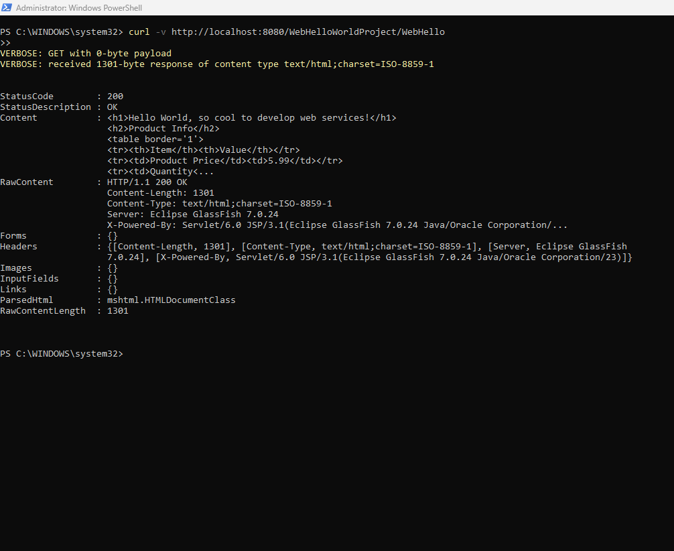

b) WebProcessBillingProject

Command used:
curl -v http://localhost:8080/WebProcessBillingProject/BillingServlet

Screenshot:

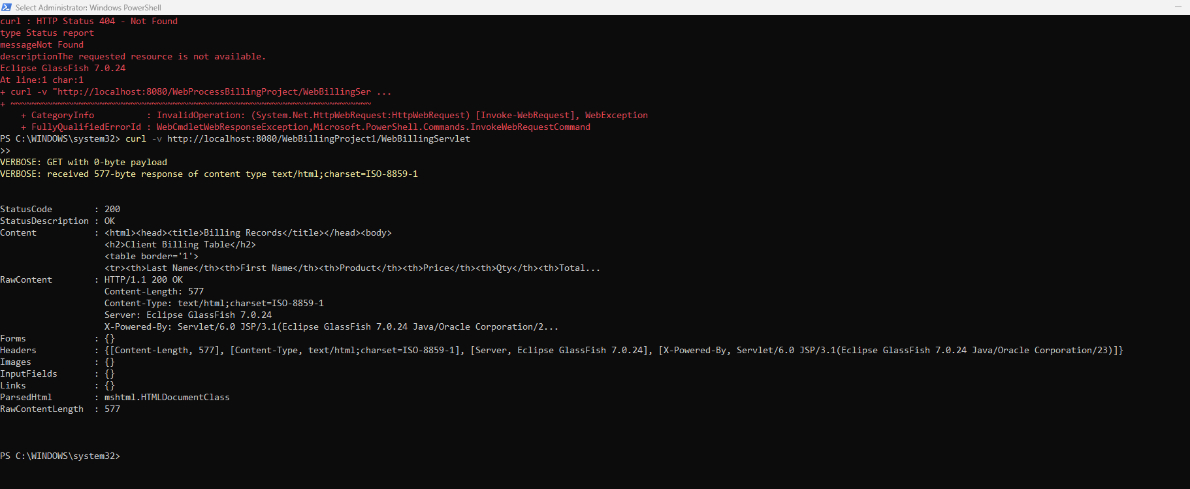

c) WebCourseProject

Command used:
curl -v http://localhost:8080/WebCourseProject/CourseServlet

Screenshot:

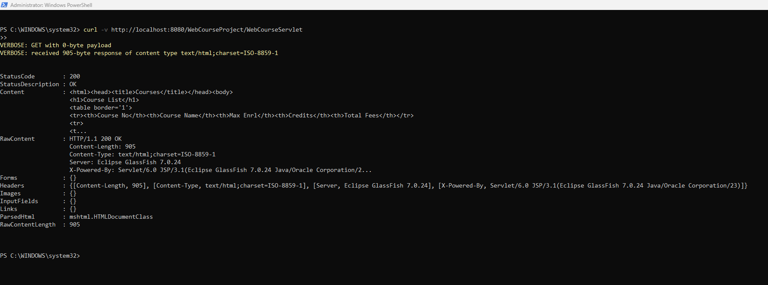

------------------------------------------------------------

2. Using Postman Tool

Collection Name: Lab 2 Testing

a) WebHelloWorldProject

Method: GET
URL: http://localhost:8080/WebHelloWorldProject/WebHello
Screenshot:

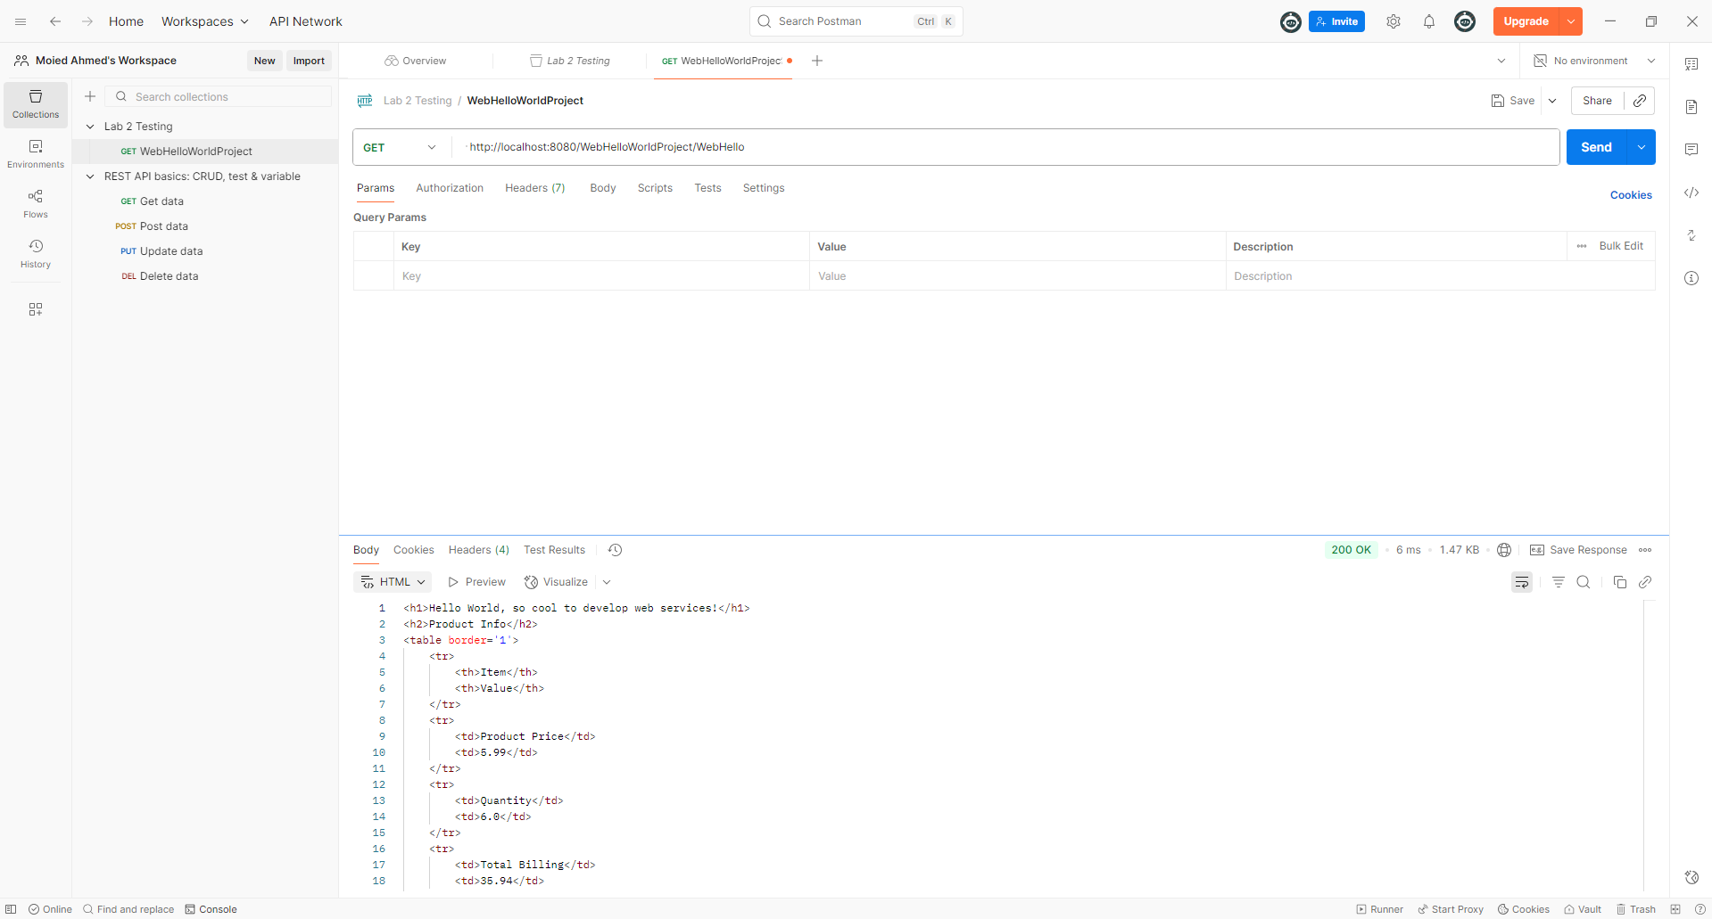

b) WebBillingProject1

Method: GET
URL: http://localhost:8080/WebBillingProject1/WebBillingServlet
Screenshot:

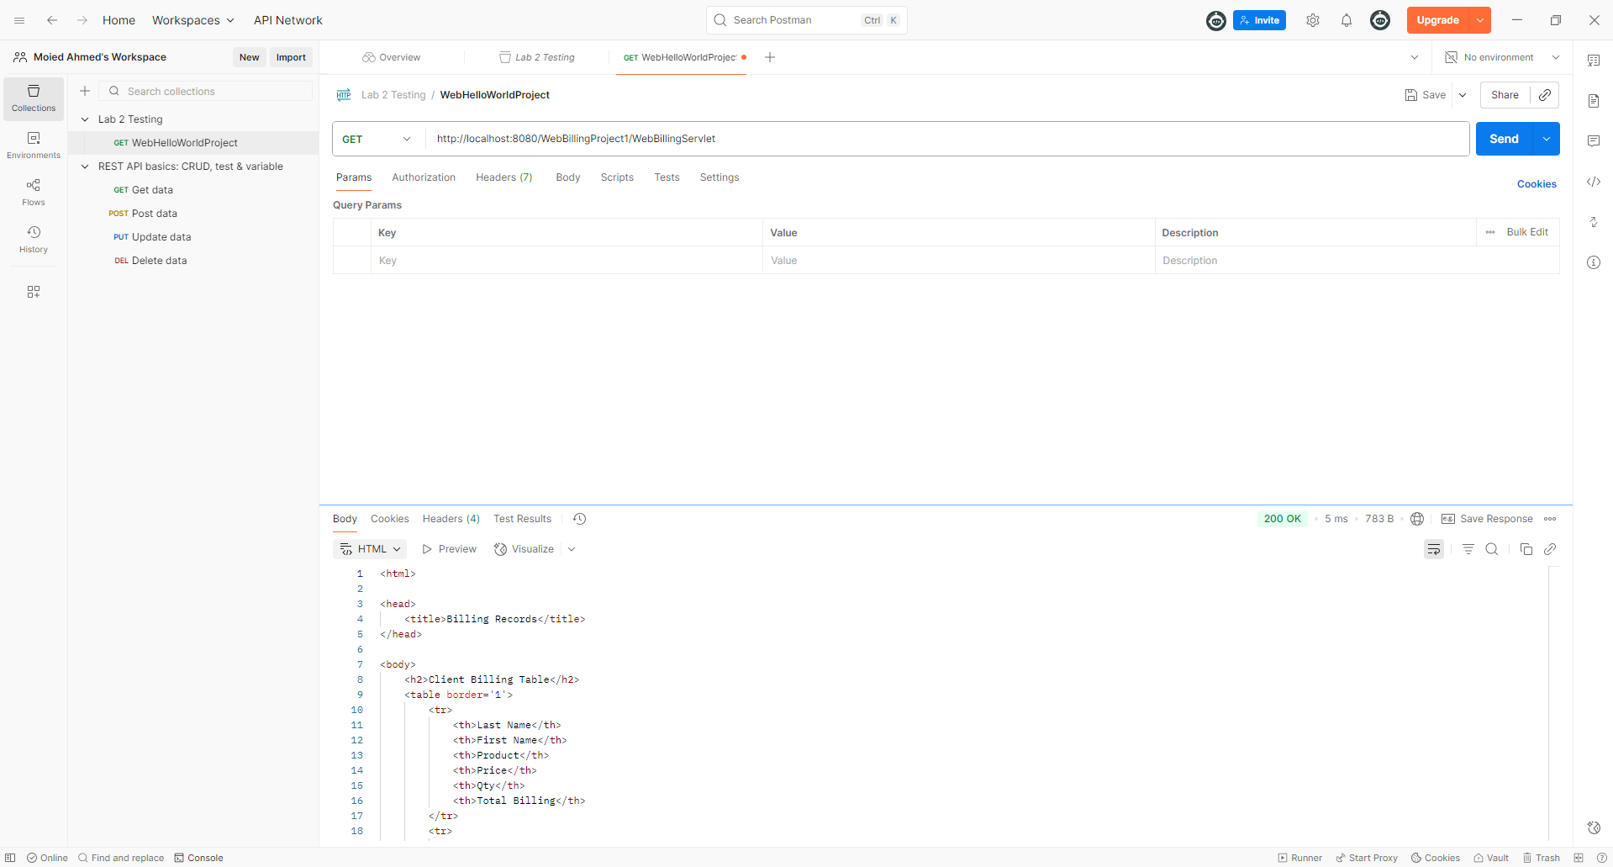

c) WebCourseProject

Method: GET
URL: http://localhost:8080/WebCourseProject/CourseServlet
Screenshot:

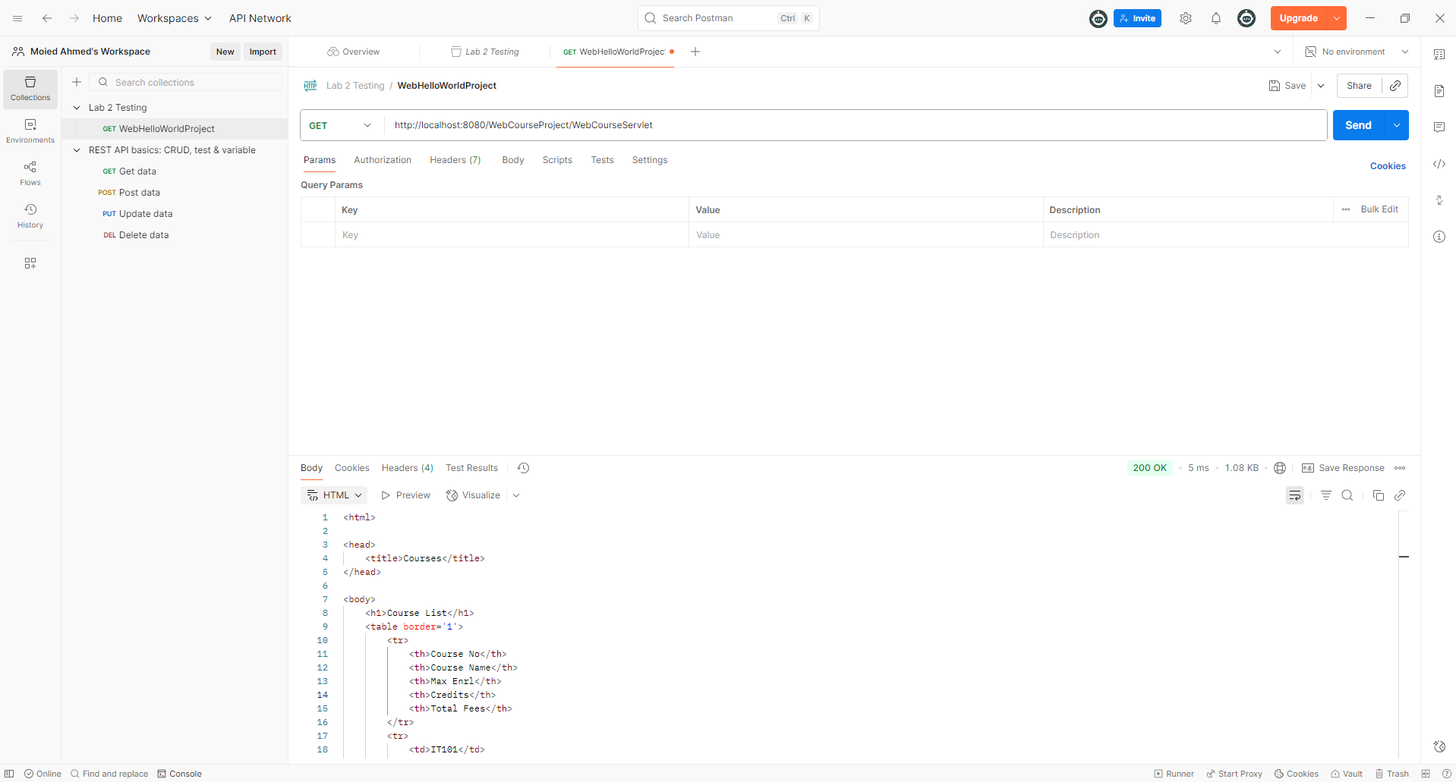

------------------------------------------------------------

3. Consuming Public REST Resources (from Presentation 2)

Example in Presentation 2: Zippopotam.us

Request:
GET http://api.zippopotam.us/us/98121

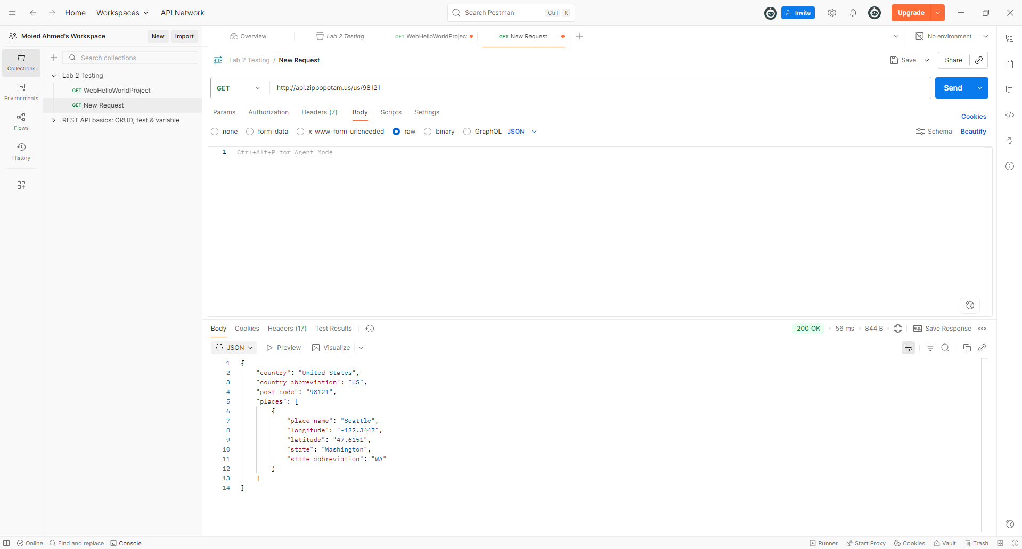

------------------------------------------------------------

4. Public Soap Test

Request: http://webservices.daehosting.com/services/isbnservice.wso

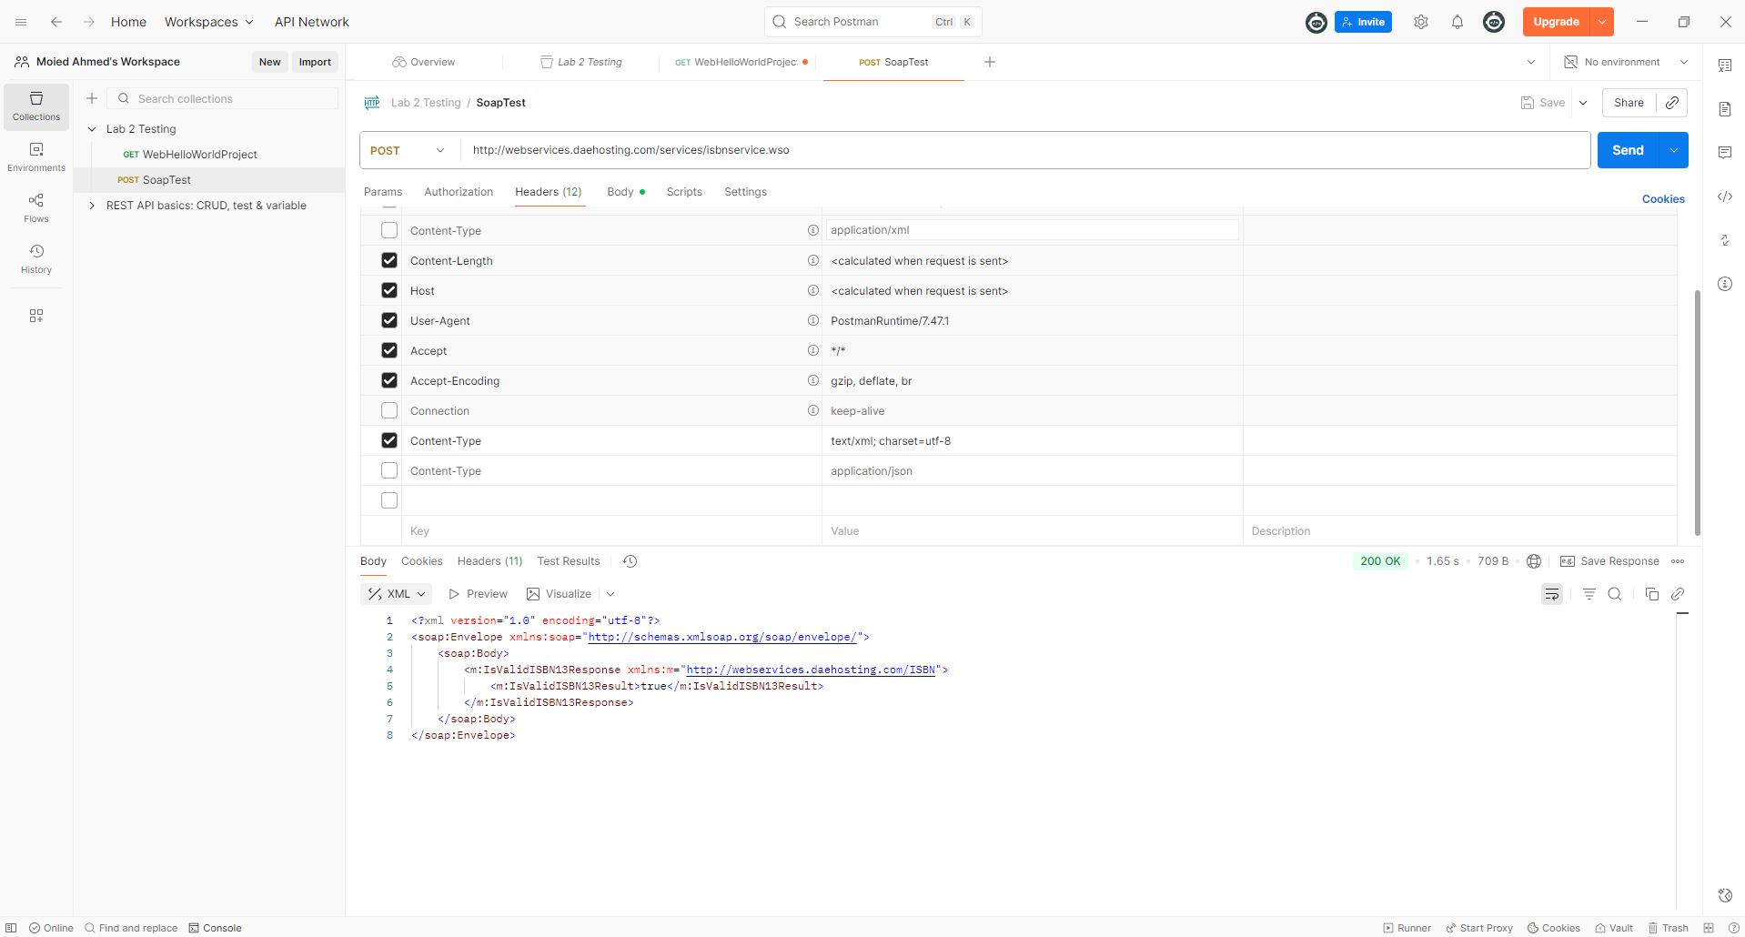

------------------------------------------------------------

5.REST

HTTP link request: https://dog.ceo/api/breeds/image/random Request

Method used For example: GET

HTTP Response: {
"message": "https://images.dog.ceo/breeds/sheepdog-shetland/n02105855_6980.jpg",
"status": "success"
}

Data Format of Response: JSON

Overall Image

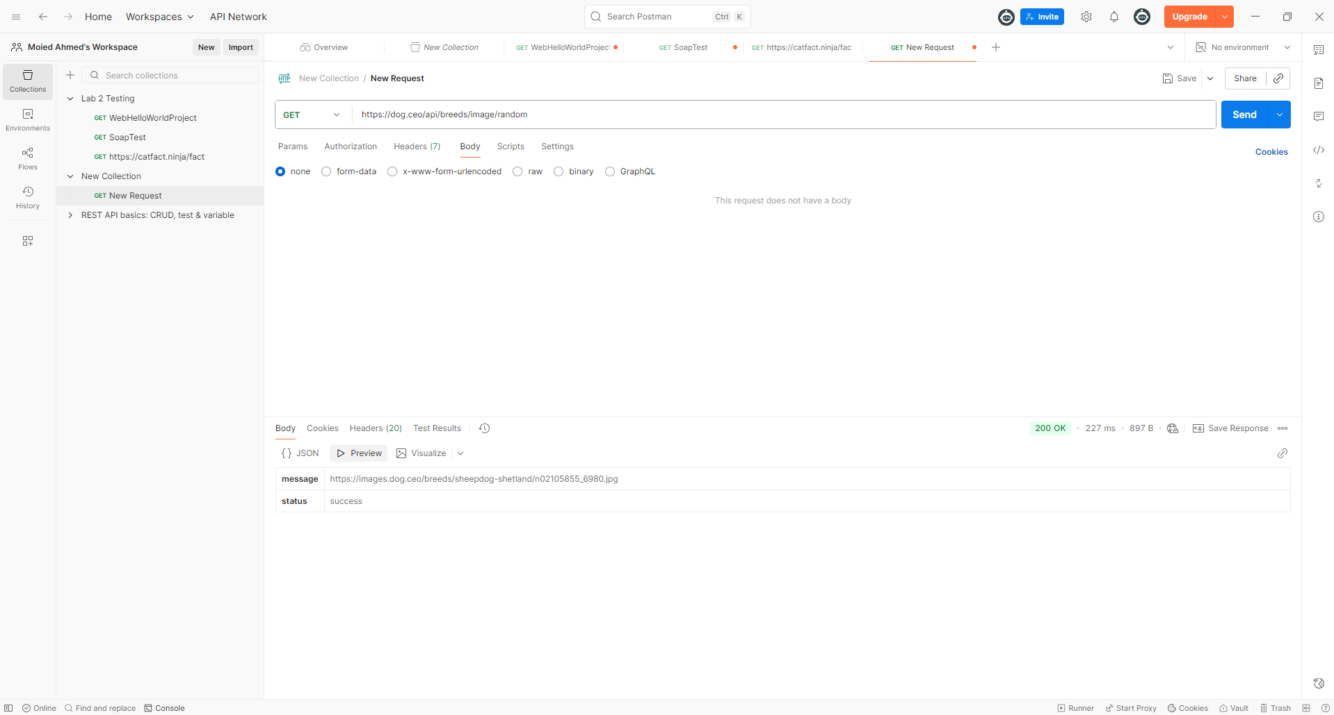

HTTP link request: https://v2.jokeapi.dev/joke/Programming Request

Method used For example: GET

HTTP Response: {
"error": false,
"category": "Programming",
"type": "single",
"joke": "Eight bytes walk into a bar.\nThe bartender asks, \"Can I get you anything?\"\n\"Yeah,\" reply the bytes.\n\"Make us a double.\"",
"flags": {
"nsfw": false,
"religious": false,
"political": false,
"racist": false,
"sexist": false,
"explicit": false
},
"id": 34,
"safe": true,
"lang": "en"
}

Data Format of Response: JSON

Overall Image

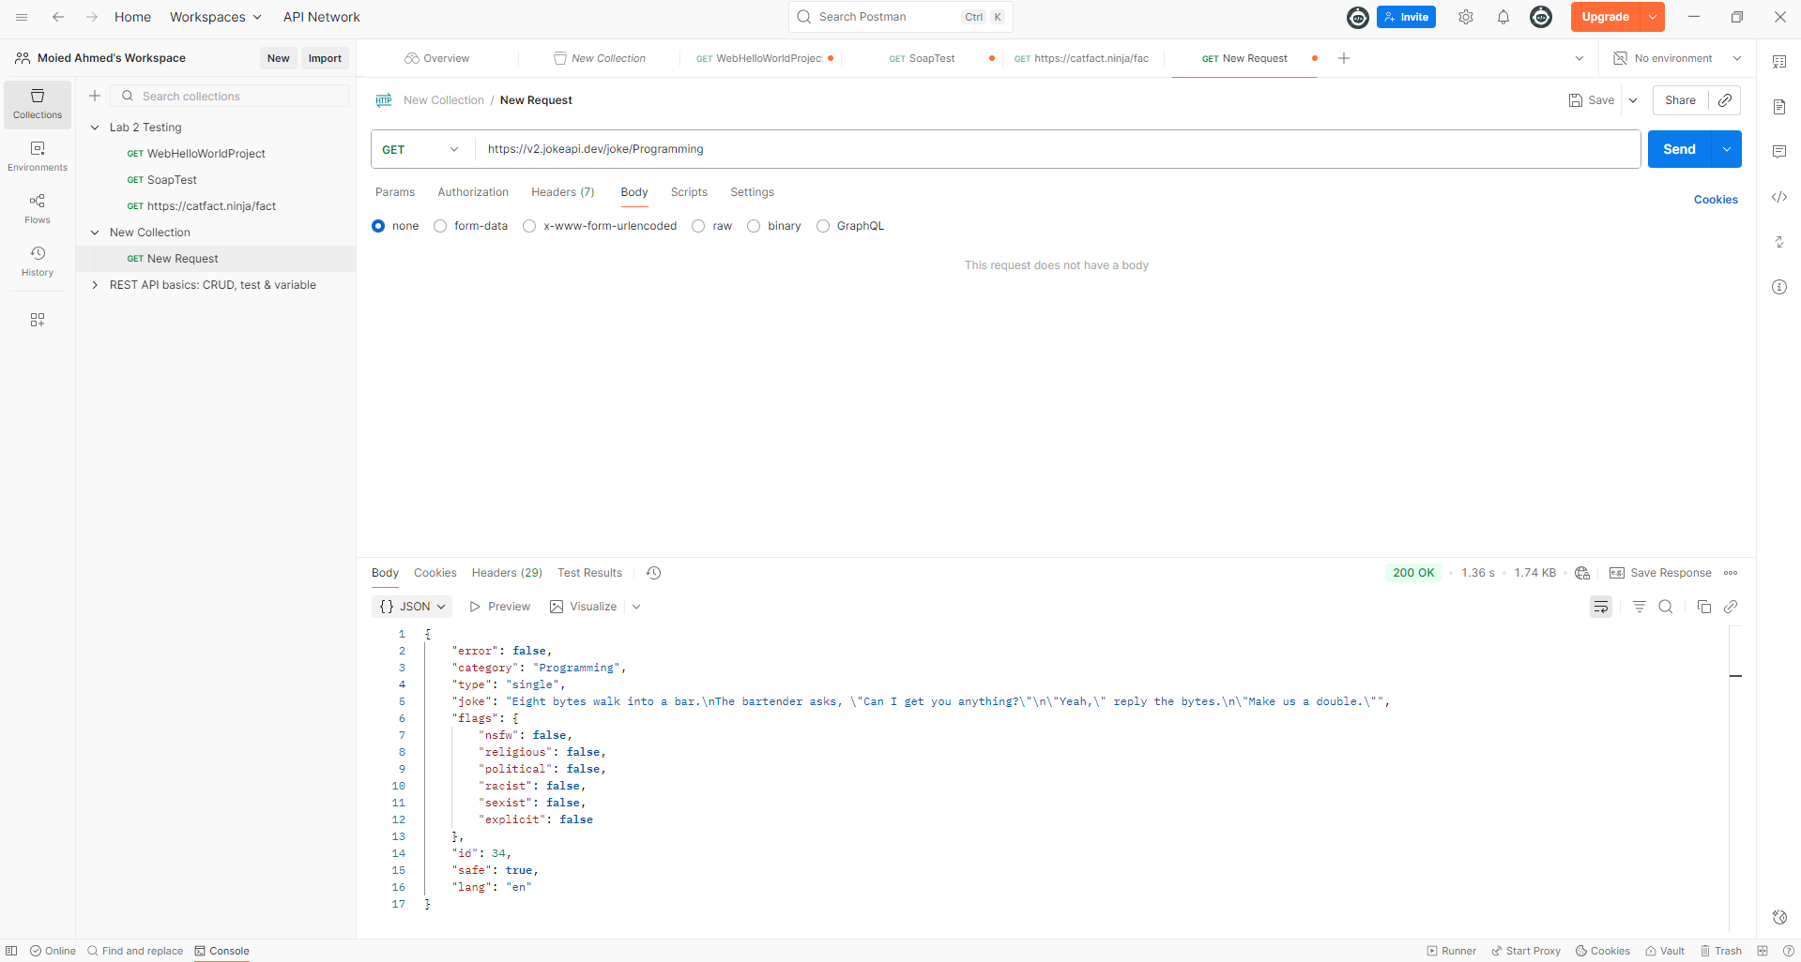
HTTP link request: https://spoonacular.com/food-api Request

Method used For example: GET

HTTP Response: TOO LONG to paste all see image see in POSTMAN

{
<!DOCTYPE html>
<html lang="en">
<head>
<!-- Meta -->
<meta charset="utf-8">
<meta http-equiv="X-UA-Compatible" content="IE=edge">
<meta http-equiv="content-type" content="text/html; charset=utf-8" />
<meta name="viewport" content="width=device-width, initial-scale=1.0">
<meta name="description" content="The only food API you'll ever need. Our knowledge engineers spent years crafting our complex food ontology, which allows us to understand the relationships between ingredients, recipes, nutrition, allergens, and more. We understand 'nut free' muffins can't contain pecans (even if the recipe doesn't mention 'nuts' anywhere!) and we automatically determine that a recipe with Worcestershire sauce isn't vegetarian (we're looking at you, anchovies.)">
<meta name="keywords" content="Food API, Recipe API, Nutrition API, Barcode Scanning API, Meal Planning API">
<meta name="author" content="David Urbansky">
<!-- Page Title -->
…………. Continued }

Data Format of Response: JSON

Overall Image

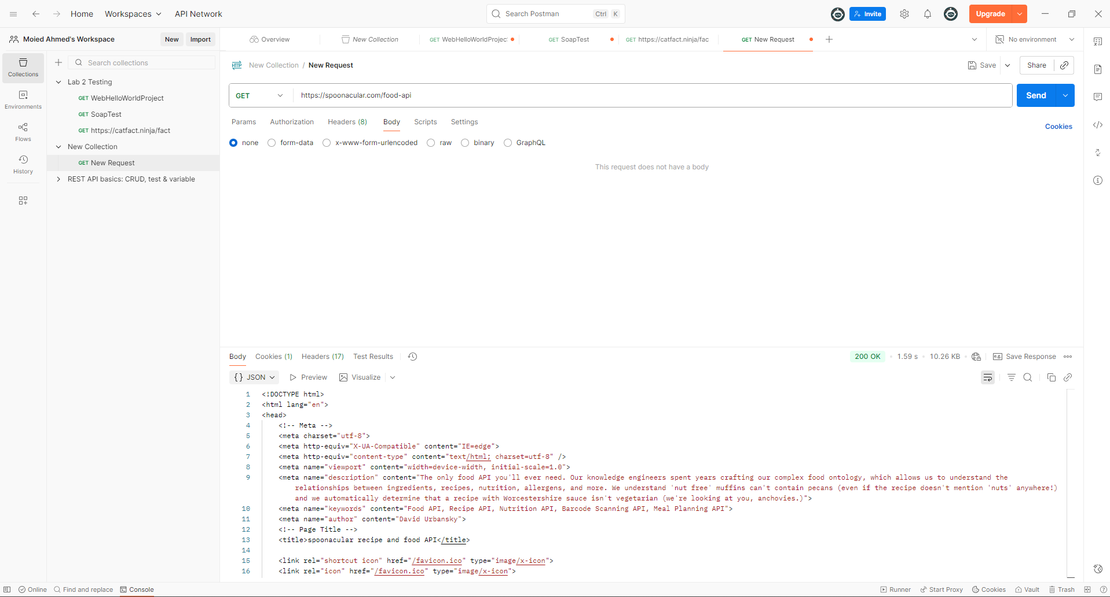

------------------------------------------------------------

6. SOAP

a)

HTTP link request: https://jsonplaceholder.typicode.com/postsRequest

Method used For example: POST

HTTP Response:
{
"id": 101
}

Data Format of Response: JSON

Request Headers: Content-Type: text/xml

Request Body: json { "title": "foo", "body": "bar", "userId": 1 }

Http response: json { "id": 101, "title": "foo", "body": "bar", "userId": 1 }

Overall Image

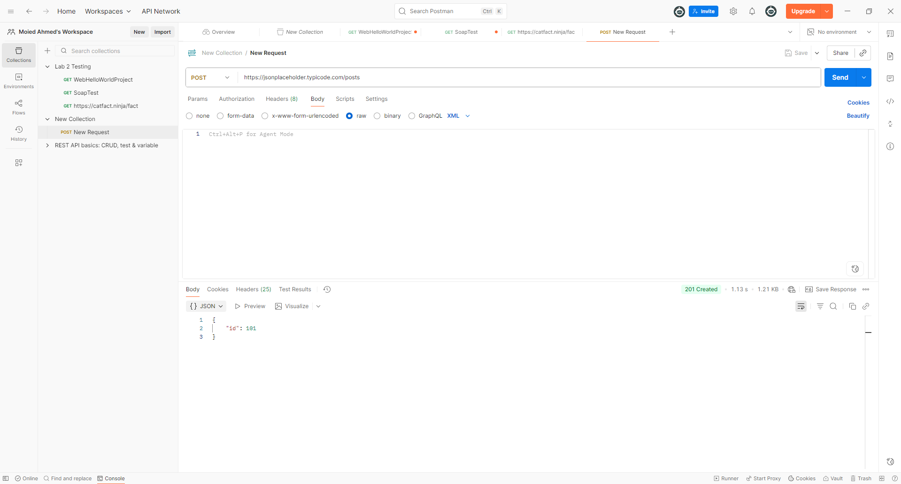

b)
HTTP link request: http://www.dneonline.com/calculator.asmxRequest

Method used For example: POST

HTTP Response:
<?xml version="1.0" encoding="utf-8"?>
<soap:Envelope xmlns:soap="http://schemas.xmlsoap.org/soap/envelope/" xmlns:xsi="http://www.w3.org/2001/XMLSchema-instance" xmlns:xsd="http://www.w3.org/2001/XMLSchema">
<soap:Body>
<AddResponse xmlns="http://tempuri.org/">
<AddResult>15</AddResult>
</AddResponse>
</soap:Body>
</soap:Envelope>

Data Format of Response: XML

Request Headers: Content-Type: text/xml

Request Body: <?xml version="1.0" encoding="utf-8"?>
<soap:Envelope xmlns:xsi="http://www.w3.org/2001/XMLSchema-instance"
xmlns:xsd="http://www.w3.org/2001/XMLSchema"
xmlns:soap="http://schemas.xmlsoap.org/soap/envelope/">
<soap:Body>
<Add xmlns="http://tempuri.org/">
<intA>5</intA>
<intB>10</intB>
</Add>
</soap:Body>
</soap:Envelope>

json <?xml version="1.0" encoding="utf-8"?><soap:Envelope xmlns:soap="http://schemas.xmlsoap.org/soap/envelope/" xmlns:xsi="http://www.w3.org/2001/XMLSchema-instance" xmlns:xsd="http://www.w3.org/2001/XMLSchema"><soap:Body><AddResponse xmlns="http://tempuri.org/"><AddResult>15</AddResult></AddResponse></soap:Body></soap:Envelope>

Overall Image
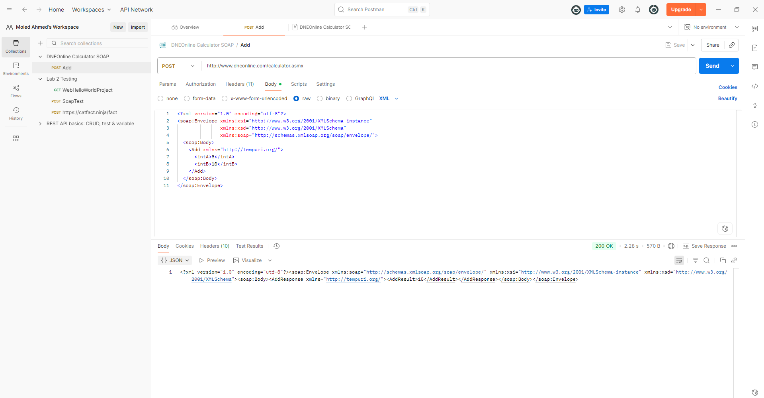

c)

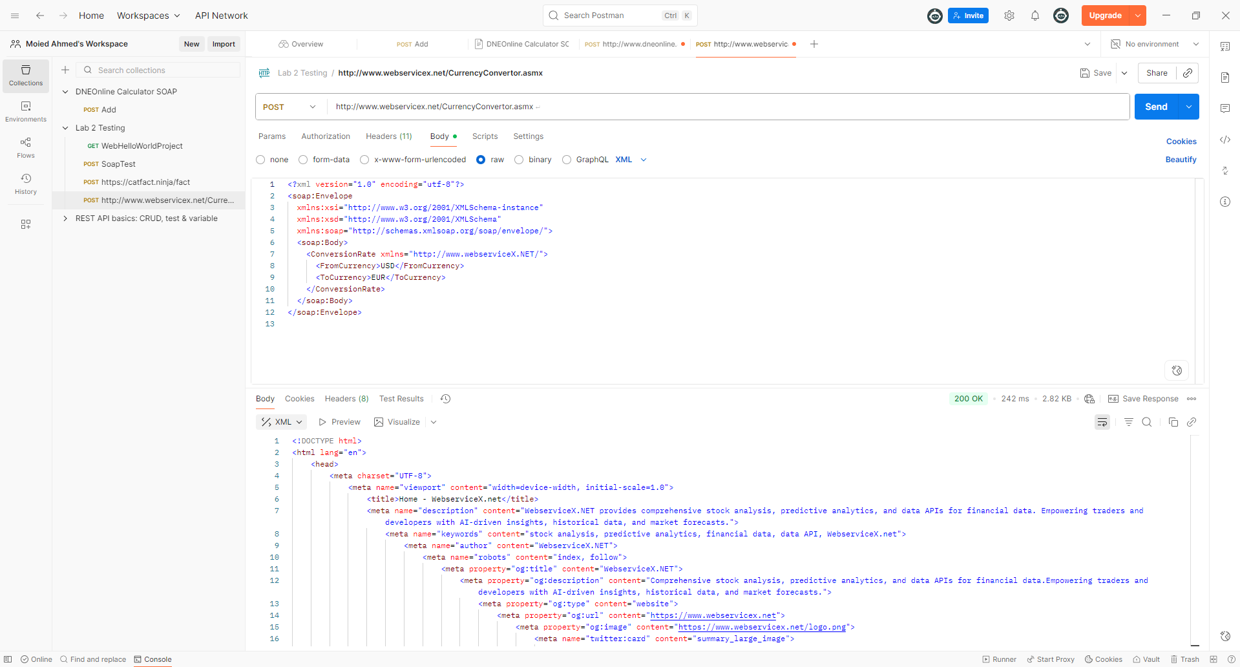

HTTP link request: http://www.webservicex.net/CurrencyConvertor.asmx Request

Method used For example: POST

HTTP Response: TOO LONG TO POST ALL
{
!DOCTYPE html>
<html lang="en">
<head>
<meta charset="UTF-8">
<meta name="viewport" content="width=device-width, initial-scale=1.0">
<title>Home - WebserviceX.net</title>
<meta name="description" content="WebserviceX.NET provides comprehensive stock analysis, predictive analytics, and data APIs for financial data. Empowering traders and developers with AI-driven insights, historical data, and market forecasts.">
<meta name="keywords" content="stock analysis, predictive analytics, financial data, data API, WebserviceX.net">
<meta name="author" content="WebserviceX.NET">
<meta name="robots" content="index, follow">
<meta property="og:title" content="WebserviceX.NET"> ……………………………………………

}

Data Format of Response: XML

Request Headers: Content-Type: text/xml

Request Body: <?xml version="1.0" encoding="utf-8"?>
<soap:Envelope
xmlns:xsi="http://www.w3.org/2001/XMLSchema-instance"
xmlns:xsd="http://www.w3.org/2001/XMLSchema"
xmlns:soap="http://schemas.xmlsoap.org/soap/envelope/">
<soap:Body>
<ConversionRate xmlns="http://www.webserviceX.NET/">
<FromCurrency>USD</FromCurrency>
<ToCurrency>EUR</ToCurrency>
</ConversionRate>
</soap:Body>
</soap:Envelope>

7.

a)WebCarProject

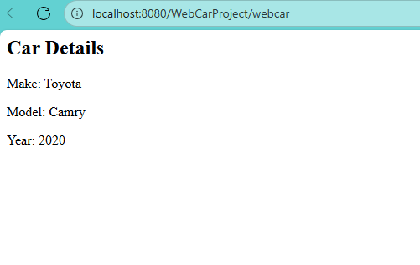

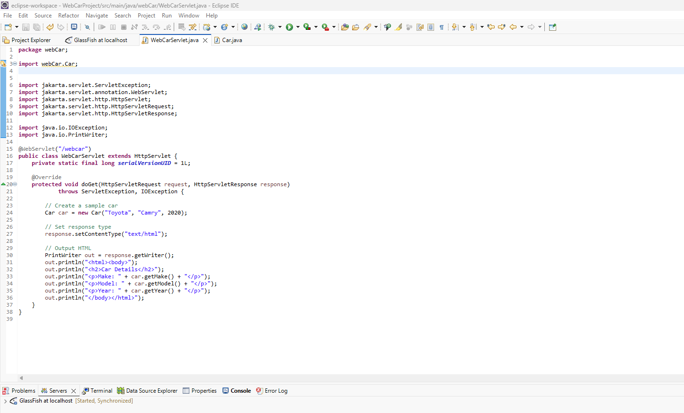

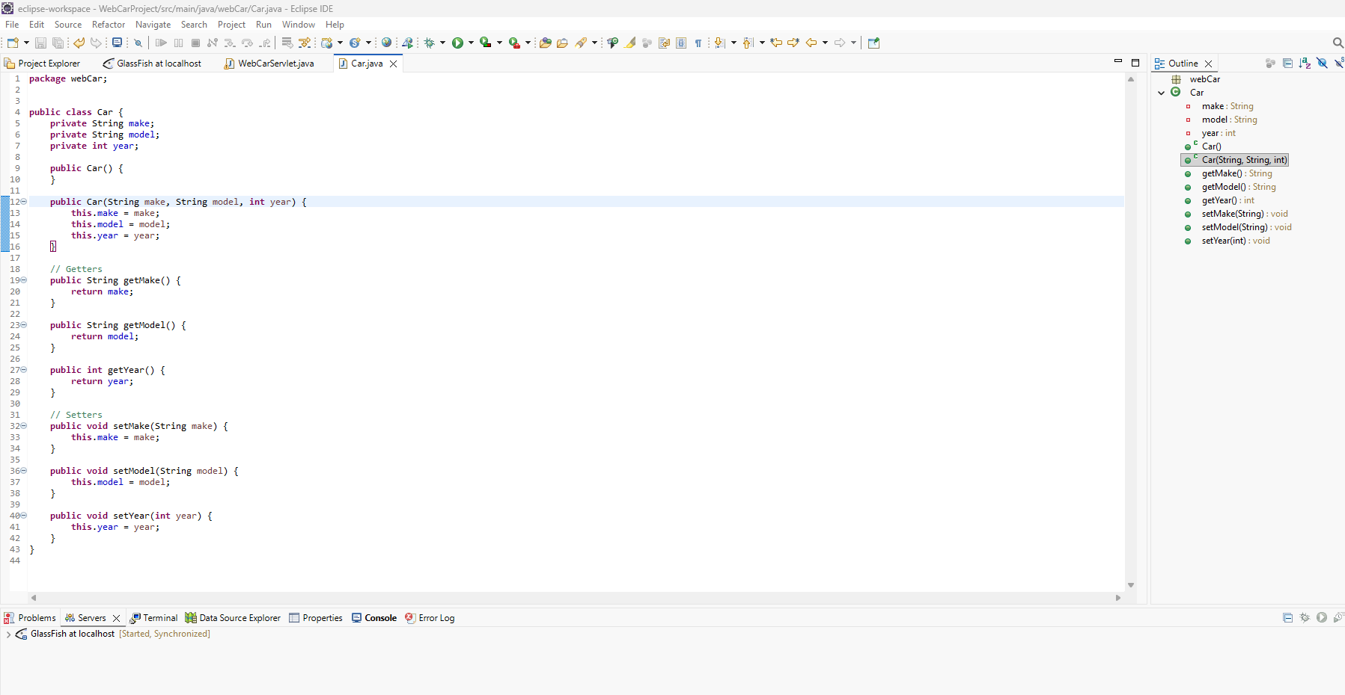

b)WebFacultyProject

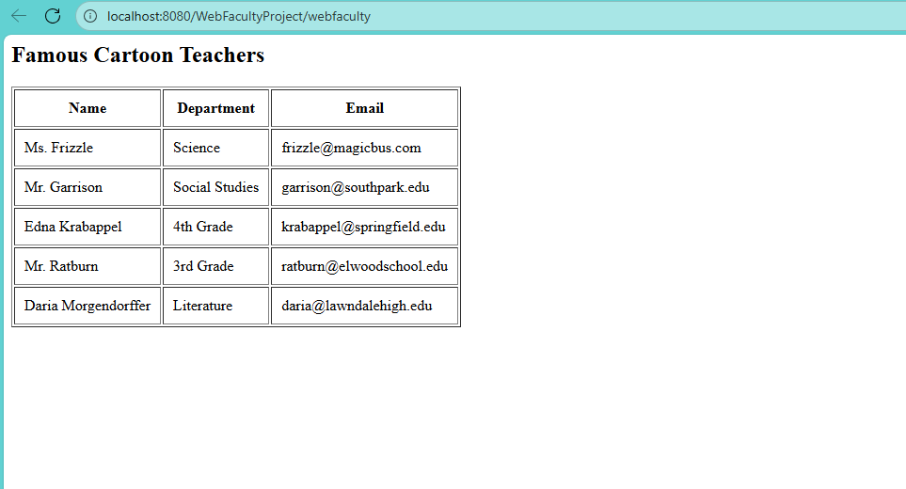

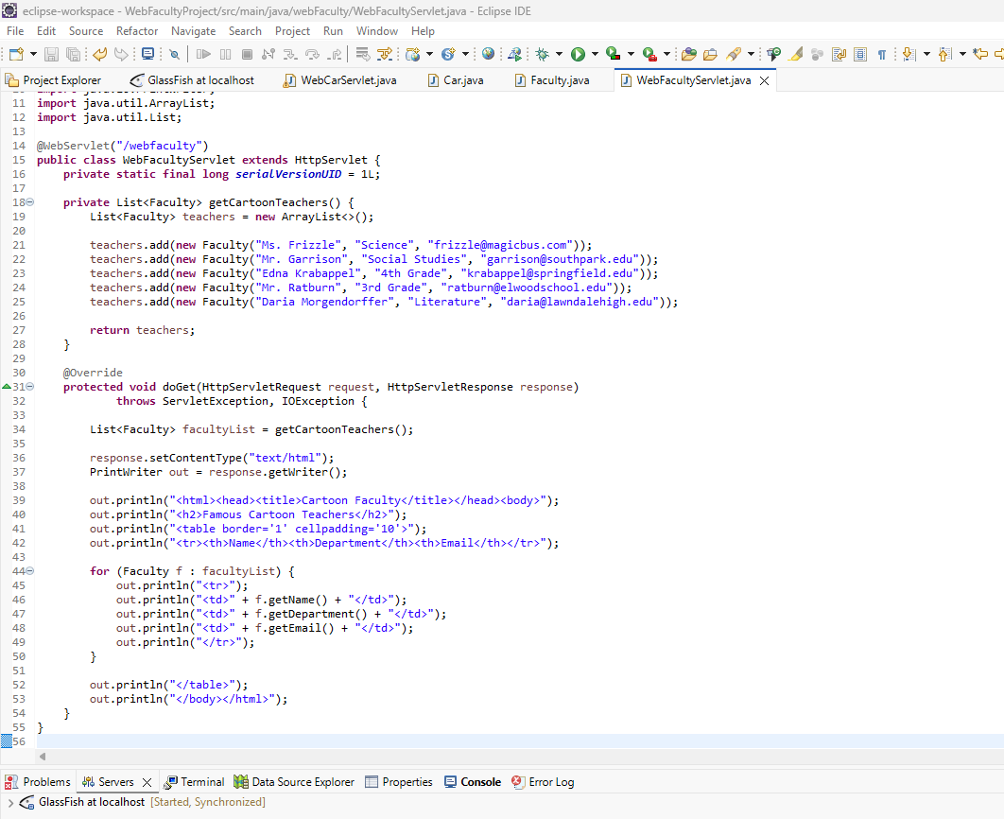

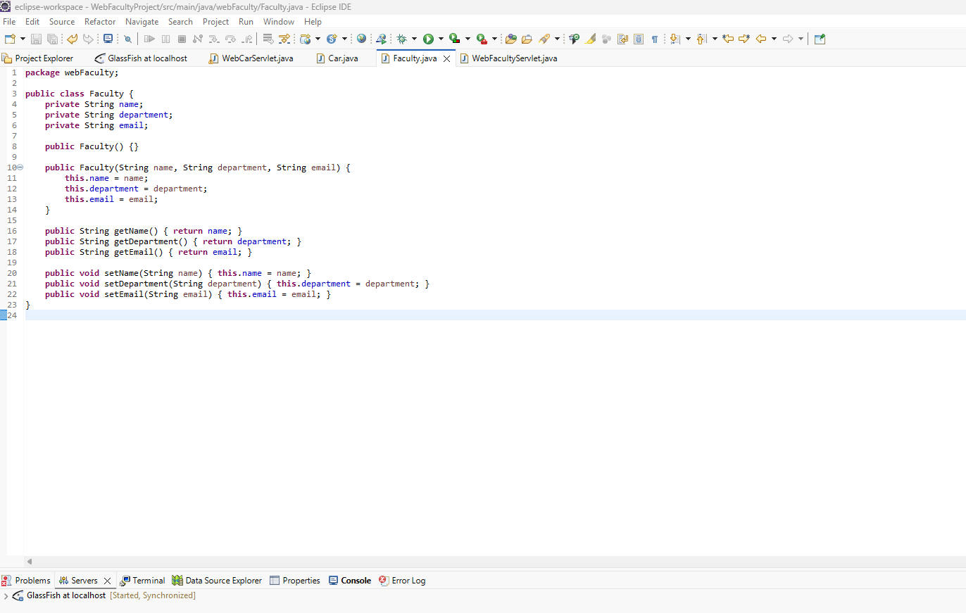

END

