2025-09-30
[Moied Ahmed] [1090065]
System Development Project Phase 1

Vanier College

Project Title:
Student Attendance Management System

1. Information System Components

The Student Attendance Management System includes the following five components:

a) Hardware
- Windows-based PCs or laptops used by teachers or admins
- Optional printer for future report generation
- Local network (optional for future features)

b) Software
- Visual Studio 2022
- .NET Framework
- Windows Forms (C#)
- Windows 10/11 OS

c) Data
- Student details: Name, ID, Class, Section, Contact Info
- Attendance details: Date, Student ID, Status (Present/Absent/Late)

d) Processes (Phase 1 Scope)
Implemented:
- Student Registration
- Marking Attendance

Planned for future:
- Attendance Reporting
- Teacher Login
- Notification System

e) People
- Teachers: Main users for marking attendance
- Admins: Enter student data
- Developers: Build and maintain system

2. System Development Method

Agile methodology was followed for this system.
Phase 1 focuses on implementing two essential processes:
1. Student Registration
2. Attendance Entry

SDLC in Agile – Phase 1 Iteration:
- Planning: Identify initial forms and logic needed
- Analysis: Define inputs, outputs, and in-memory structure
- Design: Build GUI with Windows Forms
- Implementation: Code forms and validation logic
- Testing: Verify with sample data and edge cases

Why Agile?
- Iterative design allowed continuous improvement
- Immediate testing of form usability
- Scope kept flexible for future additions

3. Deliverable Documents

3.1 System Planning

a) Business Case
This system helps replace manual attendance-taking by allowing teachers to register students and mark attendance through a simple GUI. This reduces paper usage, improves accuracy, and allows for easy reporting in later phases.

c) Preliminary Investigation Overview
Manual attendance is inefficient. A lightweight desktop app solves this problem without the need for heavy infrastructure. Teachers can use it offline with no external dependencies.

d) Feasibility

i. Operational Feasibility
- Teachers can easily operate the system using basic forms
- No training is required for Phase 1 functionality

ii. Technical Feasibility
- Developed using free and available tools
- Runs on any standard Windows PC

iii. Economic Feasibility
- Zero cost using Visual Studio Community
- No licensing or additional hardware needed

iv. Schedule Feasibility
- Phase 1 planned and completed in one week with two forms and related logic

e) Project Management

Gantt Chart – Phase 1 Tasks:

| Task ID | Task Description | Start Date | Duration | Dependencies |
|---------|-------------------------------|------------|----------|--------------|
| 1 | Requirements Gathering | Sep 25 | 1 day | - |
| 2 | UI Design for Forms | Sep 26 | 1 day | Task 1 |
| 3 | Create Student & Attendance Classes | Sep 27 | 1 day | Task 2 |
| 4 | Implement Registration Form | Sep 28 | 1 day | Task 3 |
| 5 | Implement Attendance Form | Sep 29 | 1 day | Task 3 |
| 6 | Testing and Debugging | Sep 30 | 1 day | Task 4, 5 |
| 7 | Documentation and Submission | Oct 1 | 1 day | Task 6 |

PERT Chart

(Start)
↓
[1] Requirements
↓
[2] UI Design ──► [4] Registration Form
| ↓
[3] Class Creation ──► [5] Attendance Form
\___________/
↓
[6] Testing
↓
[7] Documentation

3.2 System Analysis

c) i. Process Modeling

Implemented Features in Phase 1:

• Register Student
→ Enter: Name, ID, Class, Section, Contact
→ Validate inputs
→ Add to in-memory list

• Mark Attendance
→ Select student
→ Choose date and status (Present/Absent/Late)
→ Store in temporary list

Sample Flow:

Student Attendance System
│
├── Student Registration
│ ├── Input fields
│ └── Add to memory list
│
└── Attendance Entry
├── Select student
├── Select date
└── Save status

3.3 System Design

a) Development Strategy
- Standalone C# Windows Forms App
- No backend database in Phase 1
- GUI created using drag-and-drop in Visual Studio

b) i. User Interface Considerations

Form 1: Registration Form
- Textboxes: Name, ID, Class, Section, Contact
- Register Button
- Success/Error message via MessageBox

Form 2: Attendance Form
- ComboBox/ListBox: Select Student
- DateTimePicker: Select Date //need to implement
- ComboBox: Select Status
- Submit Button

Design Notes:
- User-friendly layout
- Field validations with message boxes
- Form-switching enabled from Main Menu

d) Design

Classes:

```csharp
public class Student
{
public string Name;
public string ID;
public string Class;
public string Section;

}

public class AttendanceRecord
{
public string StudentID;
public DateTime Date;
public string Status;
}

.Net Framework to create form with form designer was used in User Interface Design

f) Entity Relationship Model (Phase 1 - Conceptual Overview)
- Student (StudentID, Name, Class, Section, Contact)
- AttendanceRecord (StudentID, Date, Status)
Relationships:
- One-to-many (1:M): One Student can have many AttendanceRecords.
3.4 System Implementation
- Client/Server Architecture:
Phase 1 is a standalone desktop application, no client/server interaction yet. Future phases will explore multi-user client/server models.
- Server Processing: Not applicable in Phase 1.
- Client Processing: All processing occurs on the client machine (desktop PC).
- Web 2.0, Cloud Computing, Wireless Technology: Not implemented in Phase 1. Future phases may integrate cloud storage and wireless access.
3.5 System Testing
- Unit testing on Registration Form and Attendance Form:
  - Valid input accepted and stored in-memory
  - Invalid input triggers appropriate error messages
  - Attendance status saved correctly and displays confirmation
- Integration Testing:
  - Switching between forms without data loss
  - Consistency of student list across forms

2 business processes implemented — Student Registration and Marking Attendance — were implemented within the same project in a structured manner. After registering a student, their information is immediately available in the attendance form, allowing the user to mark them as Present, Absent, or Late. This integration demonstrates the working flow between the two processes in a single, unified application.

Steps: 1. Register student
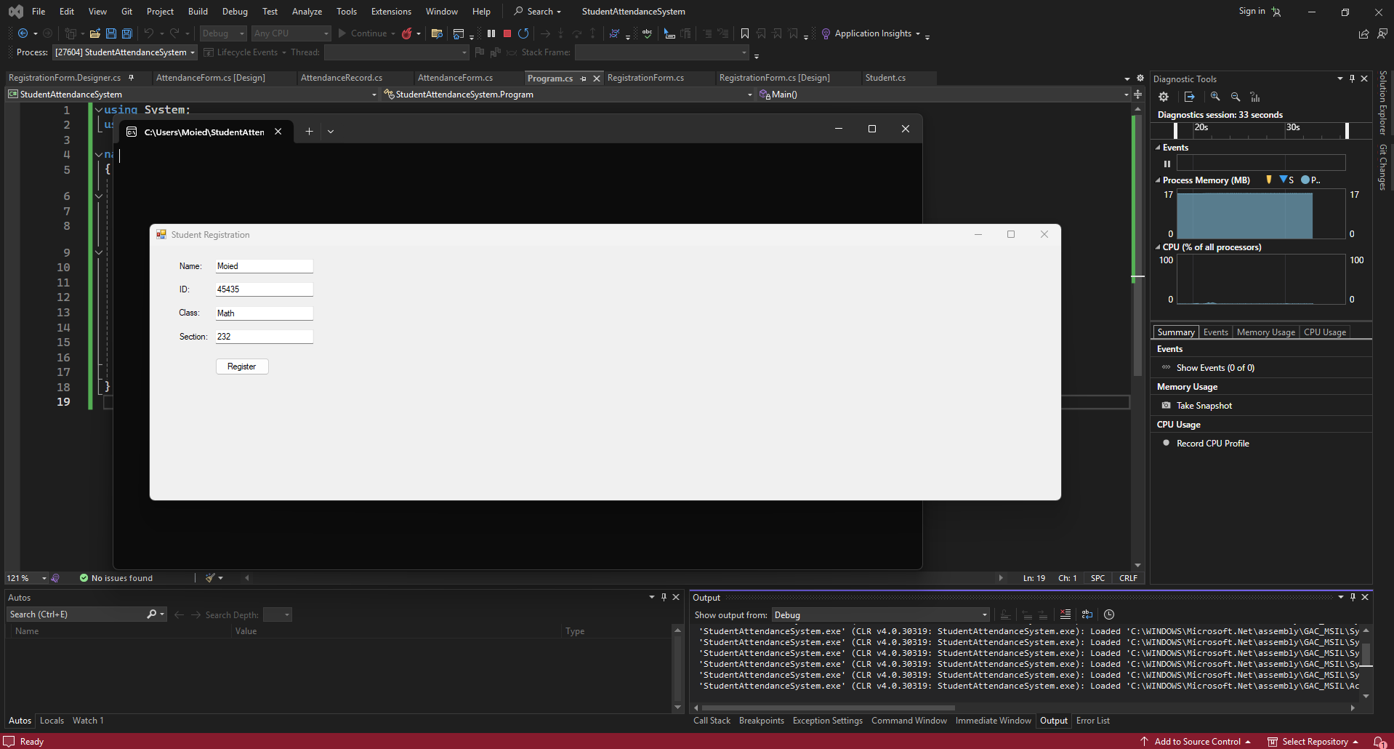2. Record attendance of registered student as either present, late, or absent
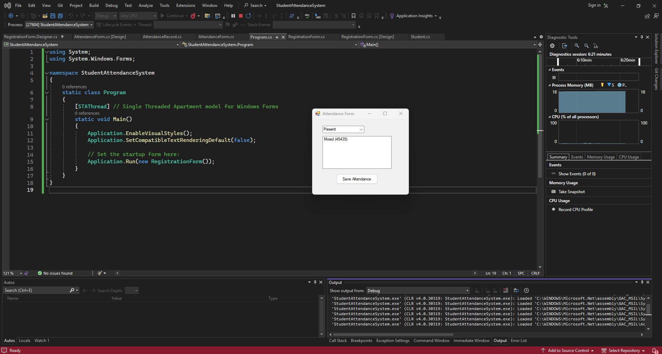
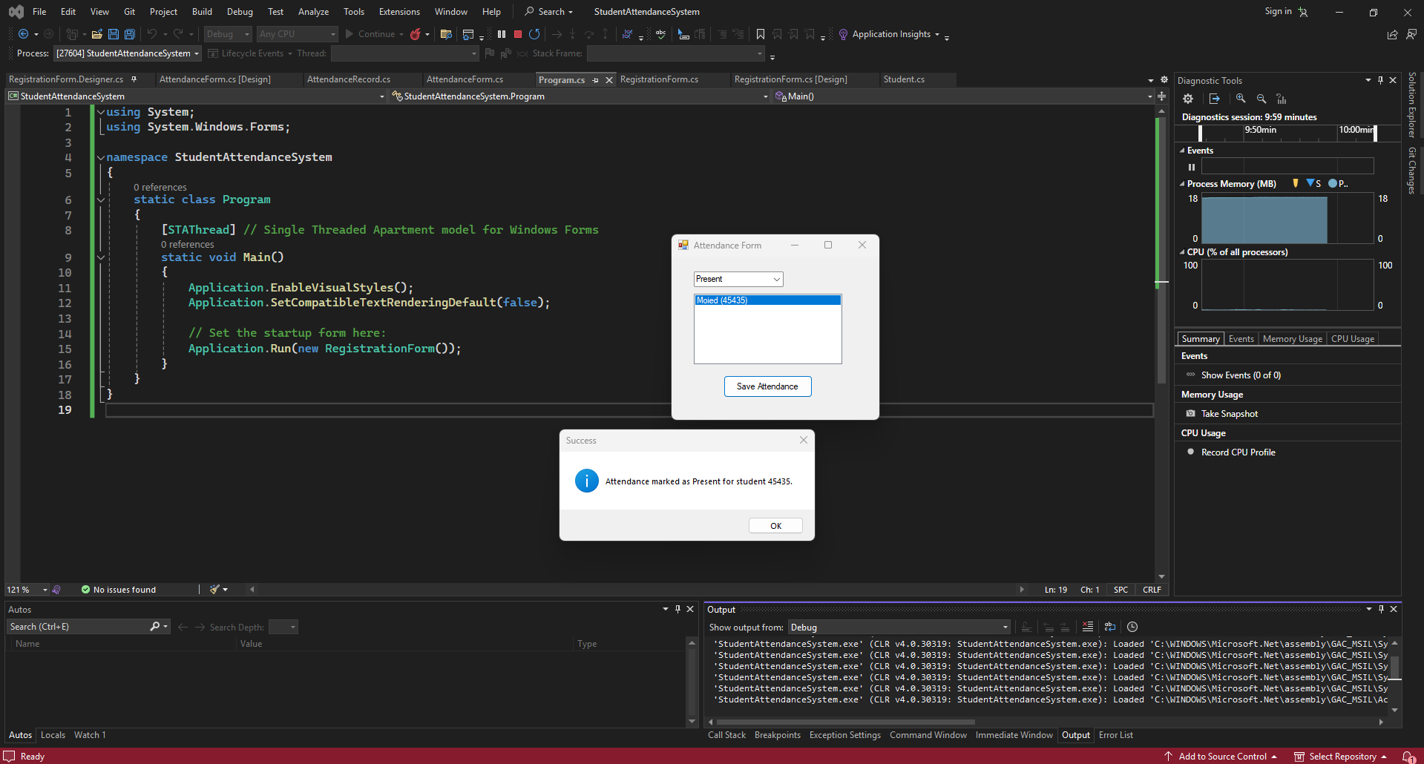

- Case Study
a) Individual Activity: Apply and generate deliverable documents of every SDLC phase described previously.
Student Attendance Management System Case Study:
- Phase 1 focuses on Student Registration and Attendance Entry.
- Iterative Agile approach used to build and test functionalities.
Using Object-Oriented Analysis (OOA), two main classes identified:
- Student class (properties: Name, ID, Class, Section, Contact)
- AttendanceRecord class (properties: StudentID, Date, Status)
Sample Functionality for Attendance Calculation (Future phase):
- Track number of days Present, Absent, and Late
- Generate simple attendance percentage (to be implemented later)
Summary:
The Phase 1 deliverables demonstrated a working system allowing teachers to register students and mark attendance efficiently using a simple Windows Forms app written in C#. Future phases will expand on reporting, notifications, and database integration.
What I Learned
- How to apply Agile methodology in a real-world project, focusing on iterative development and continuous testing.
- Designing user-friendly GUI forms using Windows Forms and Visual Studio for desktop applications.
- Implementing basic object-oriented programming concepts in C# by creating classes such as Student and AttendanceRecord.

