CEGEP VANIER COLLEGE
CENTRE FOR CONTINUING EDUCATION
System Development
Teacher: Samir Chebbine
Project Phase 3
Date: November 13, 2025
Student: Moied Ahmed
Student #: 1090065
Deliverable Documents of SDLC Phases - Phase 3
(Student Attendance Management System with MS SQL Server Integration)

Information System Components

The Student Attendance Management System (Phase 3) expands on Phase 2 by adding Microsoft SQL Server integration, reporting features, and a secure login system using a local database.

a) Hardware:
- Windows-based PCs/laptops for teachers/admins
- Optional printer for generated reports

b) Software:
- Microsoft Visual Studio 2022
- C# Windows Forms Application (.NET Framework)
- Microsoft SQL Server 2019 / 2022
- SQL Server Management Studio (SSMS)
- Windows 10/11 OS
- iTEXT and ReportViewer for reporting

c) Data:
Stored persistently in local SQL Server
Tables:
- Users: UserID, Username, PasswordHash, Role
- Students: StudentID, Name, Class, Section, ContactInfo
- Attendance: AttendanceID, StudentID (FK), Date, Status
- Grades: GradeID, StudentID (FK), Subject, Score

d) Processes (Phase 3 Scope):
Implemented:
- Database connectivity using SQL Server
- Full CRUD operations for Students, Attendance, and Grades
- User authentication with role-based access
- Attendance and Grade summary reports (printable)
- Input validation, password security, and error handling
- UI form-to-database synchronization

Planned for Future:
- Web-based version of the system
- Email notifications for absences
- Advanced analytics and dashboards

e) People:
- Teachers: Mark attendance, manage grades, view reports
- Admins: Manage users, students, and all records
- Developers: Maintain desktop app and database

System Development Method

Agile Methodology:
- Iterative, continuous improvement, and adaptive design

Agile Iteration for Phase 3:
- Iteration 1 (Week 1): SQL Database setup, connection testing, create Users table for login
- Iteration 2 (Week 2): Implement CRUD and Authentication logic
- Iteration 3 (Week 3): Implement Reports

Development Stages:
Planning → Analysis → Design → Implementation → Testing → Deployment

Deliverable Documents

3.1 System Planning
Business Case:
The upgraded system now supports secure user login, persistent local data storage, and the ability to generate attendance and grade reports for students and classes.

SWOT Analysis:
Strengths:
- Secure login system with role-based access
- Reliable local database access
- Printable reports for attendance and grades
- Easy configuration and maintenance

Weaknesses:
- Multi-user access requires proper local network setup
- No cloud access or remote connectivity

Opportunities:
- Future integration with a web portal or mobile app
- Potential use of analytics for student performance tracking

Threats:
- Local system failures could affect availability
- Data privacy risks if credentials are mishandled

Feasibility:
- Operational: Minimal retraining for teachers
- Technical: ADO.NET and ReportViewer fully compatible with local SQL Server
- Economic: Low cost using Microsoft tools and local infrastructure
- Schedule: 3-week implementation

3.2 System Analysis
Requirement Modeling:
- Inputs: Login credentials, student data, attendance, grades
- Processes: Authentication, SQL CRUD, Report generation
- Outputs: User access control, data summaries, printable reports
- Security: Password security, parameterized queries, restricted roles

Data and Process Modeling:

Student Attendance Management System
├── Users
│ ├── UserID
│ ├── Username
│ ├── PasswordHash
│ └── Role
├── Students
│ ├── StudentID
│ ├── Name
│ ├── Class
│ ├── Section
│ └── ContactInfo
│ ├── AttendanceRecords
│ │ ├── AttendanceID
│ │ ├── Date
│ │ └── Status
│ └── Grades
│ ├── GradeID
│ ├── Subject
│ └── Score
├── ReportManager
│ ├── Generates Attendance Reports
│ └── Generates Grade Reports
└── Actors / Use Cases
├── Admin
│ ├── Manage Users
│ ├── Manage Students
│ └── Generate Reports
└── Teacher
├── Manage Attendance
├── Manage Grades
└── Generate Reports

Data Flow:
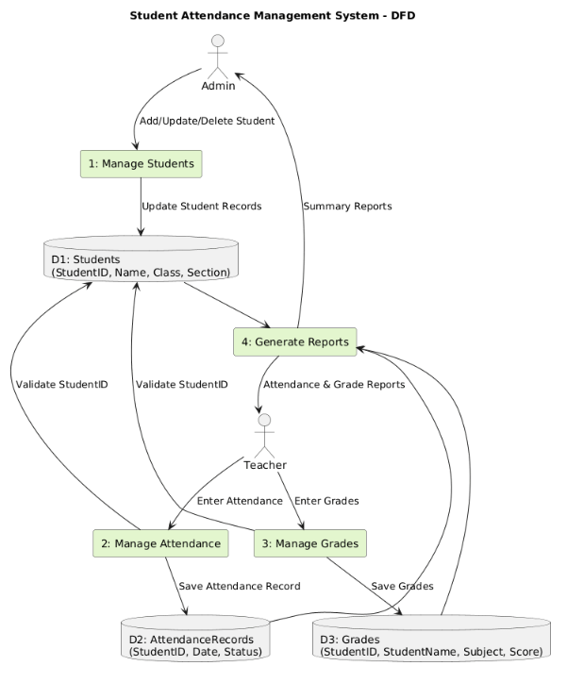

Functional Decomposition:
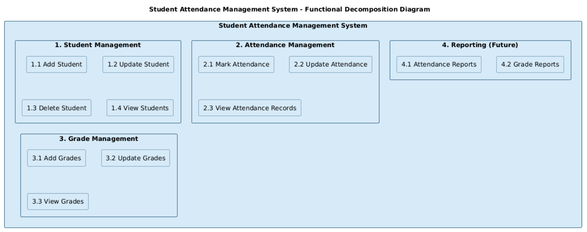
- Login and Authentication
- Manage Students
- Manage Attendance
- Manage Grades
- Generate Reports

Object Modeling:
Use Case Diagram:
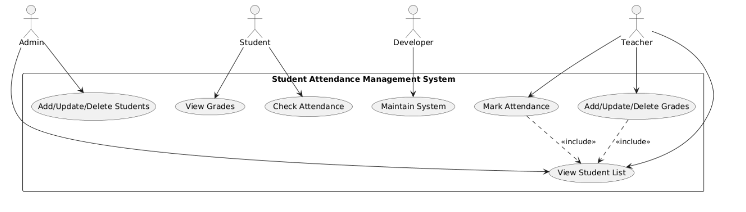
- Admin logs in and manages users
- Teacher logs in and manages attendance/grades
- System authenticates user and displays appropriate menus
- User generates attendance and grade reports

Sequence Diagram:
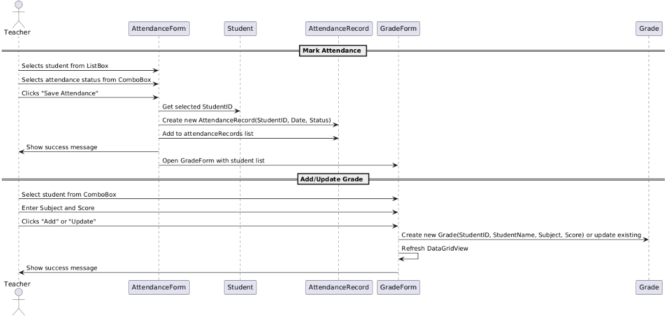ERD
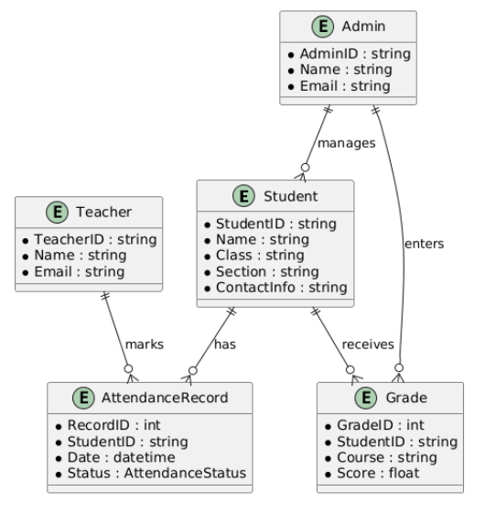

Class Diagram:
- User class for authentication
- ReportManager class for generating reports
- Student, AttendanceRecord, and Grade classes interact through DatabaseManager
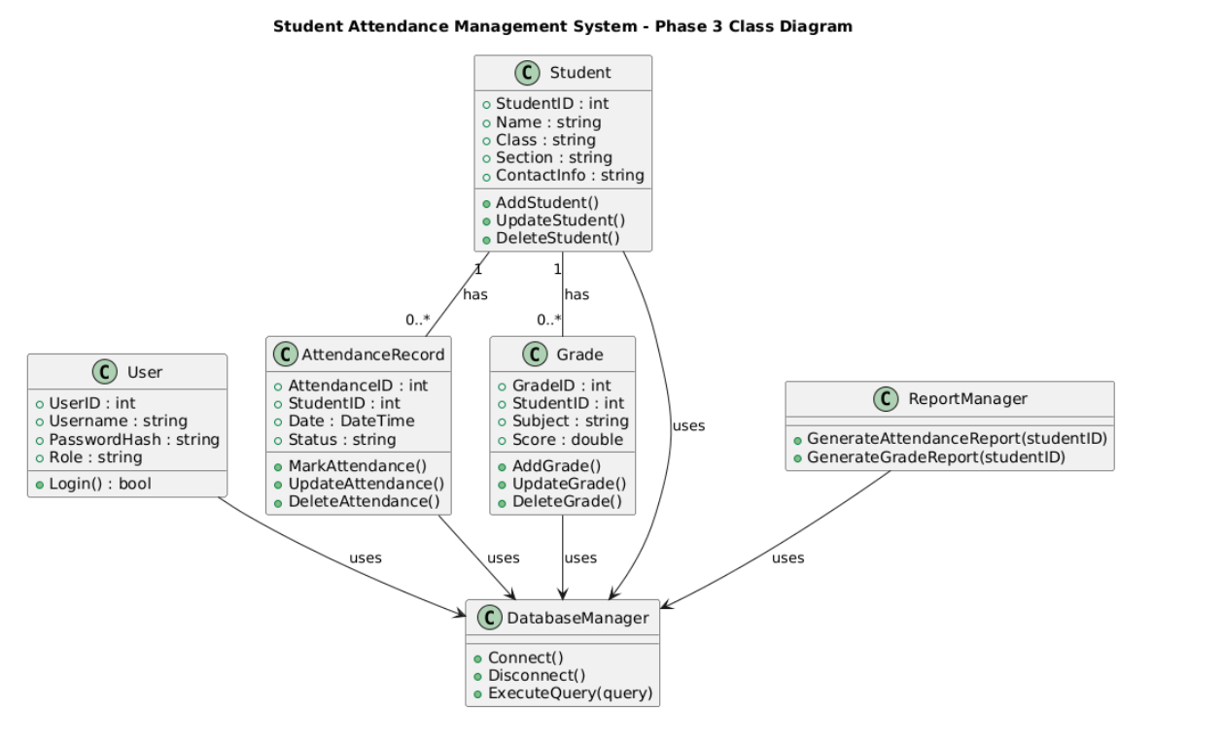

3.3 System Design
Development Strategies:
- Layered design (UI → Business Logic → Database)
- Secure login mechanism with role-based access
- Local SQL Server connectivity

System Design for Prototyping:
- Login Form verifies credentials
- Main Menu enabled based on user role (Admin or Teacher)
- Report Form generates attendance and grade summaries
- DatabaseManager supports local SQL Server connection

Output Design:
- Login success/failure messages
- Attendance and Grade summary reports viewable and printable
- Confirmation boxes for CRUD actions

Data Design:
Database Name: StudentAttendanceDB (local)
Tables: Users, Students, Attendance, Grades

3.4 System Implementation
Implemented Features:

Login System:
- User credentials validated against Users table
- Role-based menu access (Admin or Teacher)
- Passwords stored securely

CRUD Operations:
- Students, Attendance, Grades managed through ADO.NET
- SQL queries secured against injection

Attendance and Grade Reports:
- ReportViewer displays class-wise or student-wise summaries
- Export options: PDF and Print

Database Integration:
- Local SQL Server database is primary
- Multi-user access managed via local network

3.5 System Testing
Test Type | Description | Result
Unit Testing | Tested all CRUD and Login functions | Passed
Integration Testing | Tested UI ↔ SQL Server connections | Passed
Validation Testing | Handled invalid logins and empty fields | Passed
Security Testing | Verified password security and SQL safety | Passed
Report Testing | Checked accuracy and printability of reports | Passed

Screenshots:
- Created a User: admin password: Admin for testing with credentials also used PasswordHash for safe data storage
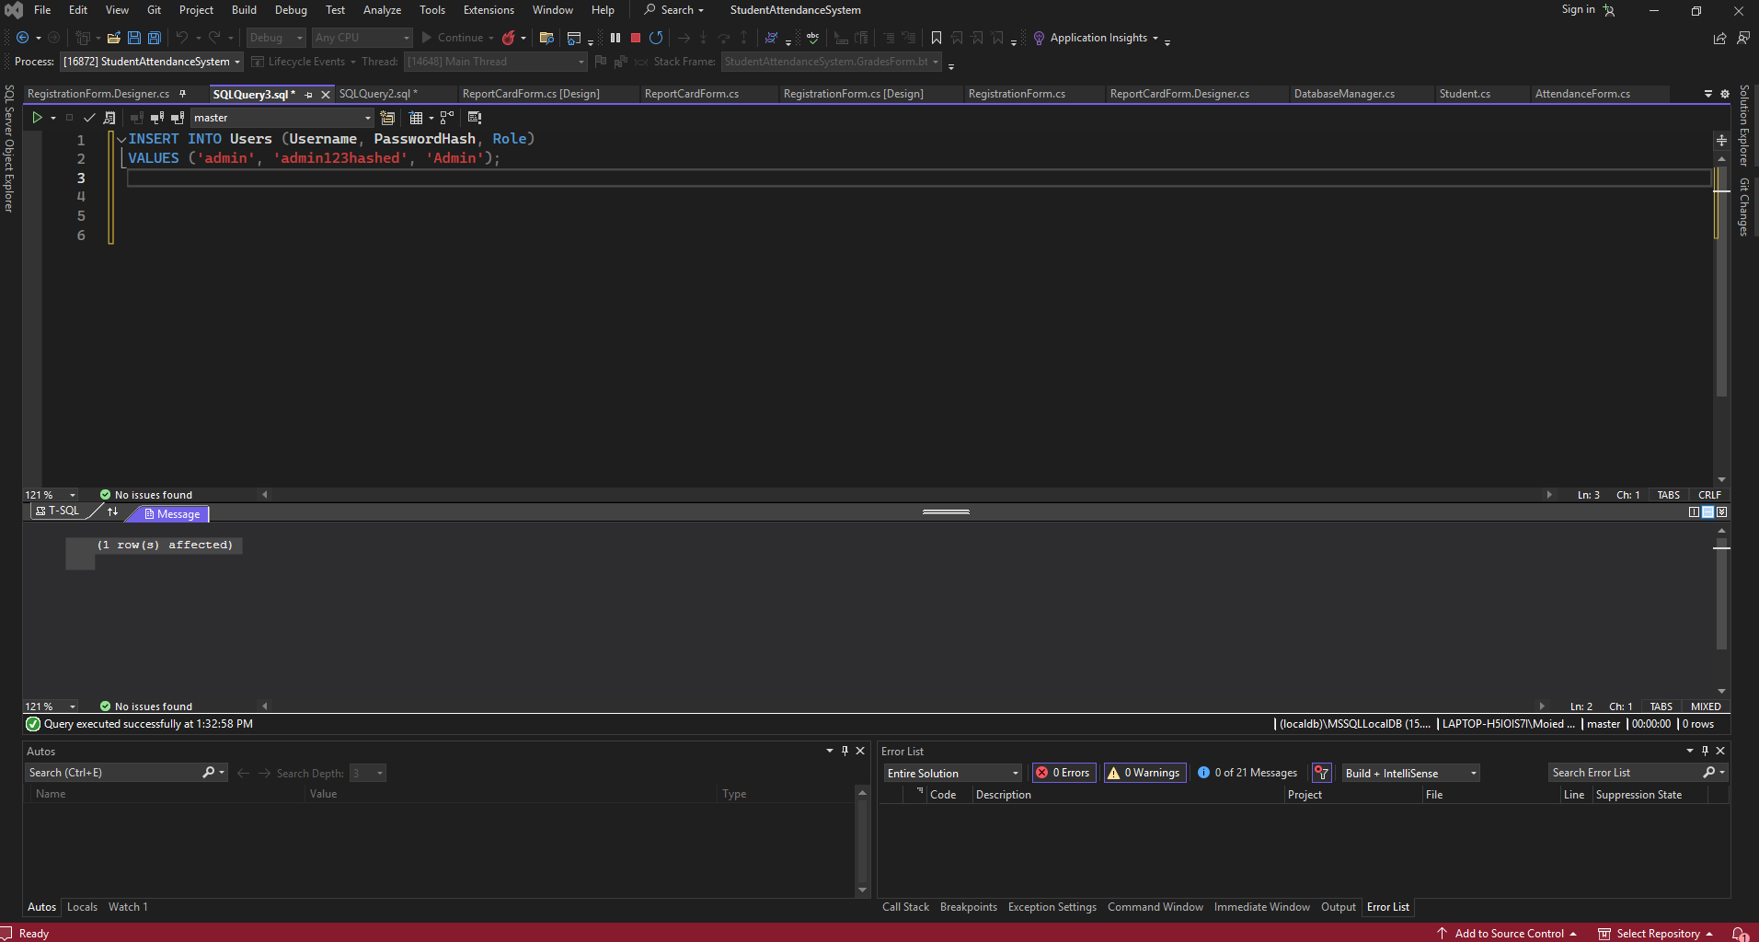
- Registration Form with authentication
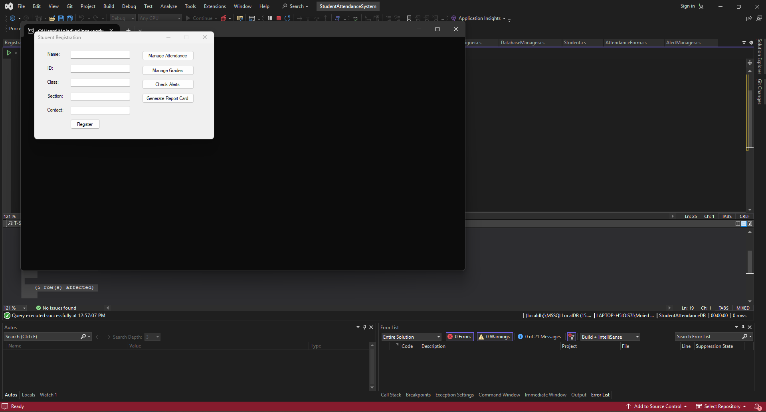

- StudentForm with data grid
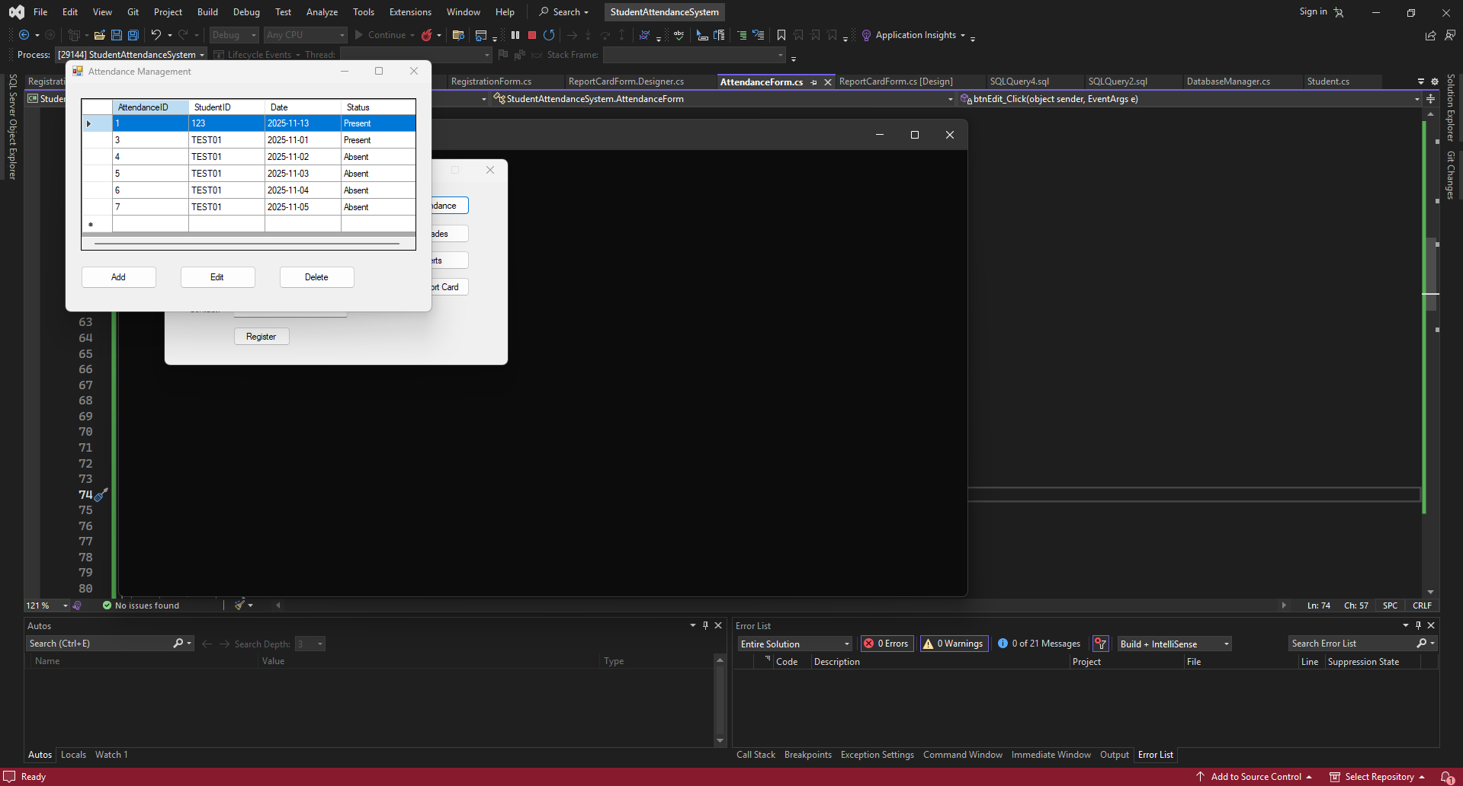
- AttendanceForm and GradeForm CRUD operations

- Reports displaying summaries
- Local SQL Server tables in SSMS
- Alerts for low performing students

CREATED LOW PERFORMING STUDENT FOR EXAMPLE
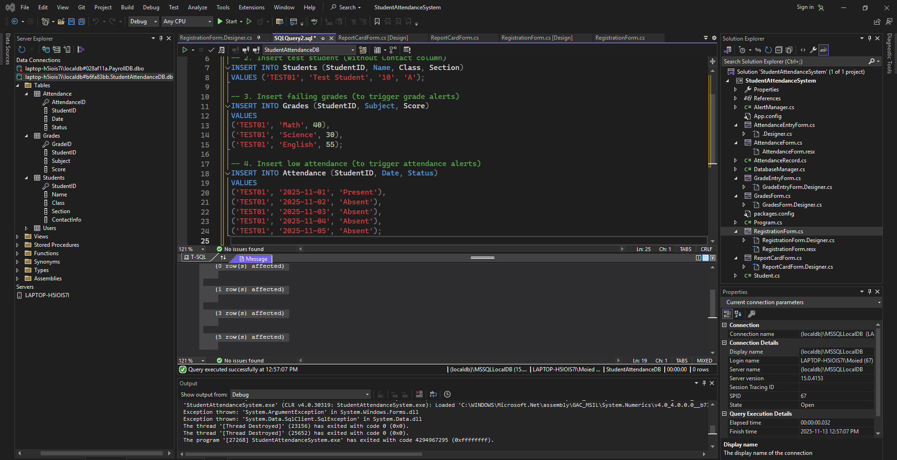

ALERT GENERATED WHEN CLICKED ON
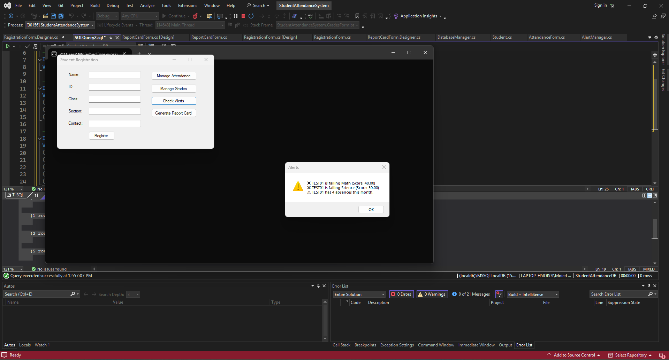
Case Study
Iteration Summary:
- Iteration 1: Setup local SQL databases, implement Users table
- Iteration 2: Implement Login and CRUD functionalities
- Iteration 3: Generate attendance and grade reports
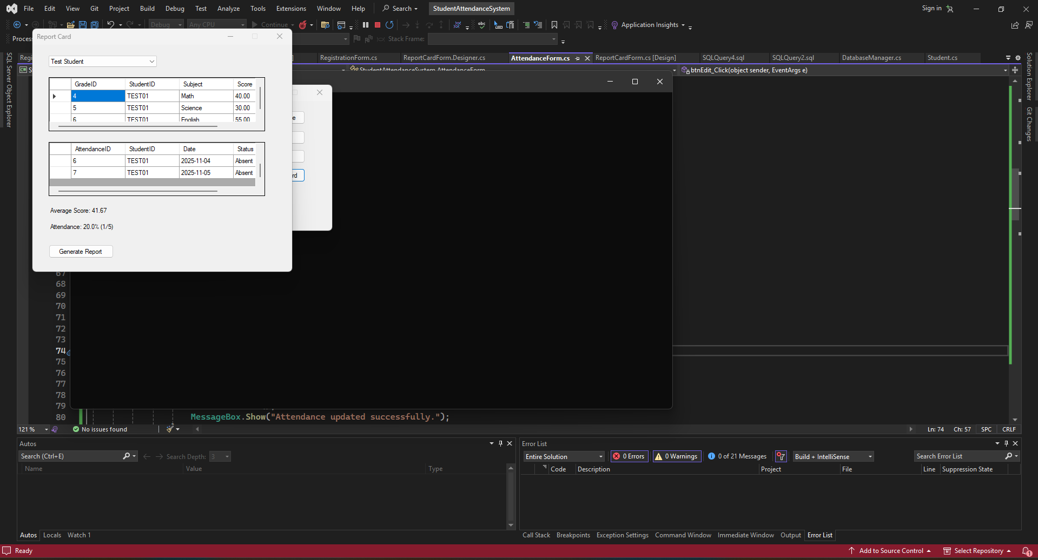

Outcome:
Phase 3 now includes secure login, local database storage, and reporting capabilities. The system is scalable, reliable, and ready for future web or mobile extensions.

