Lab 3 – Web Services using REST Implementation
Name: Moied Ahmed
Student Number: 1090065
Course: 420-941-VA
Teacher: Samir Chebbine

Part 1 – Create Dynamic Web Project and Convert to Maven
- Create Dynamic Web Project
  - Name: WebHelloRESTProject
  - Runtime: GlassFish
  - Module version: 4.0
  - Finish
- Convert to Maven Project
  - Right-click project → Configure → Convert to Maven
  - Group ID: webHelloREST
  - Artifact ID: WebHelloRESTProject
  - Packaging: war
- Add Dependencies in pom.xml
  - Add provided Jersey and Jakarta dependencies
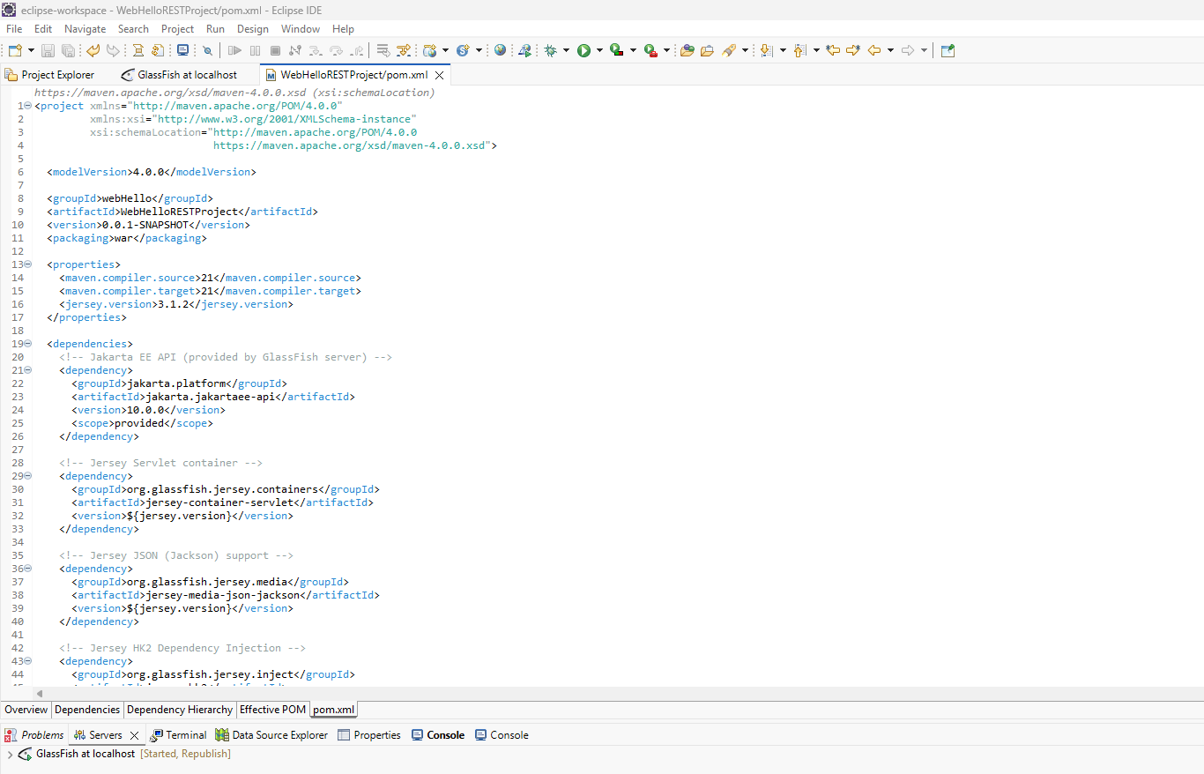
- Create Package and REST Class
  - Package: webHello
  - Class: HelloResource.java
  - Use @Path("HiHi") and @GET
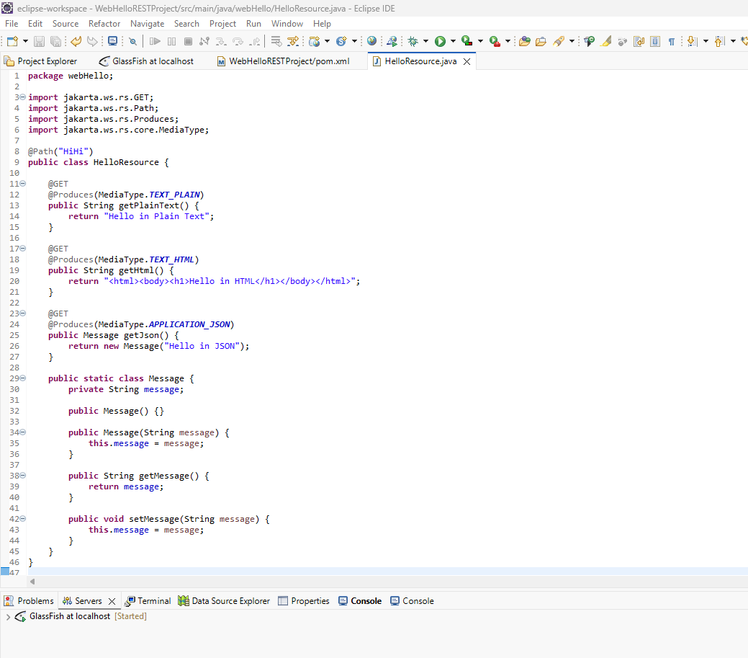

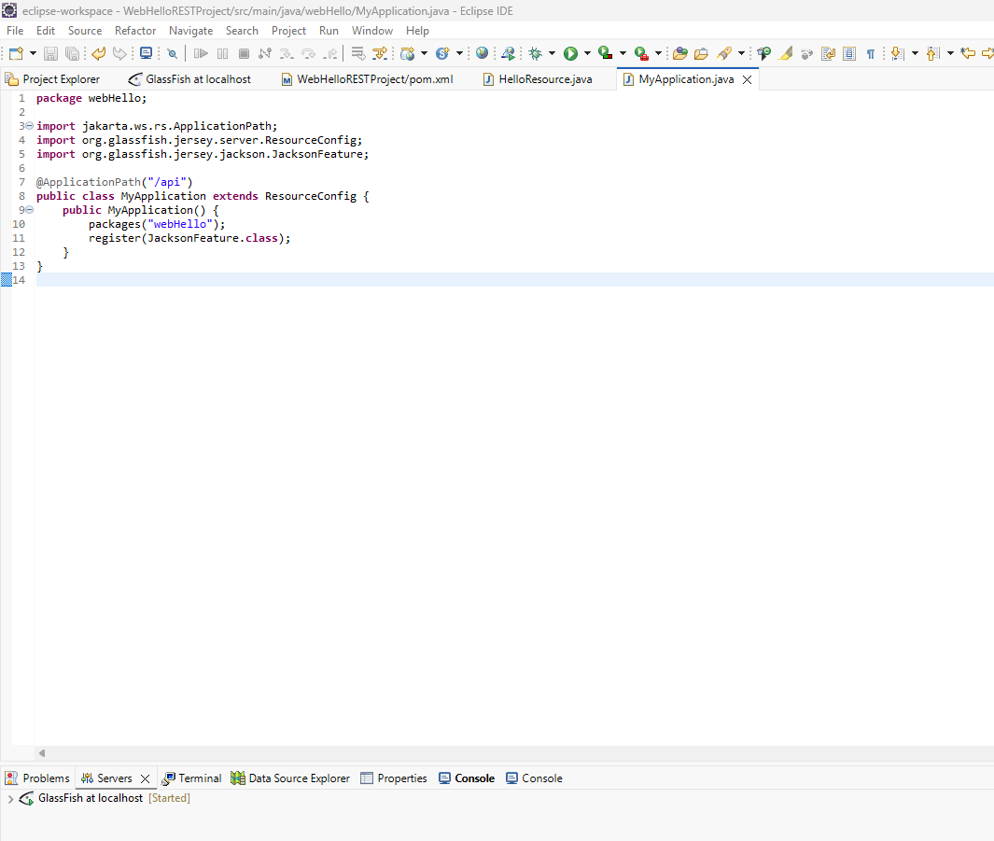
- Configure web.xml
  - Add Jersey ServletContainer config
  - Map to /rest/*

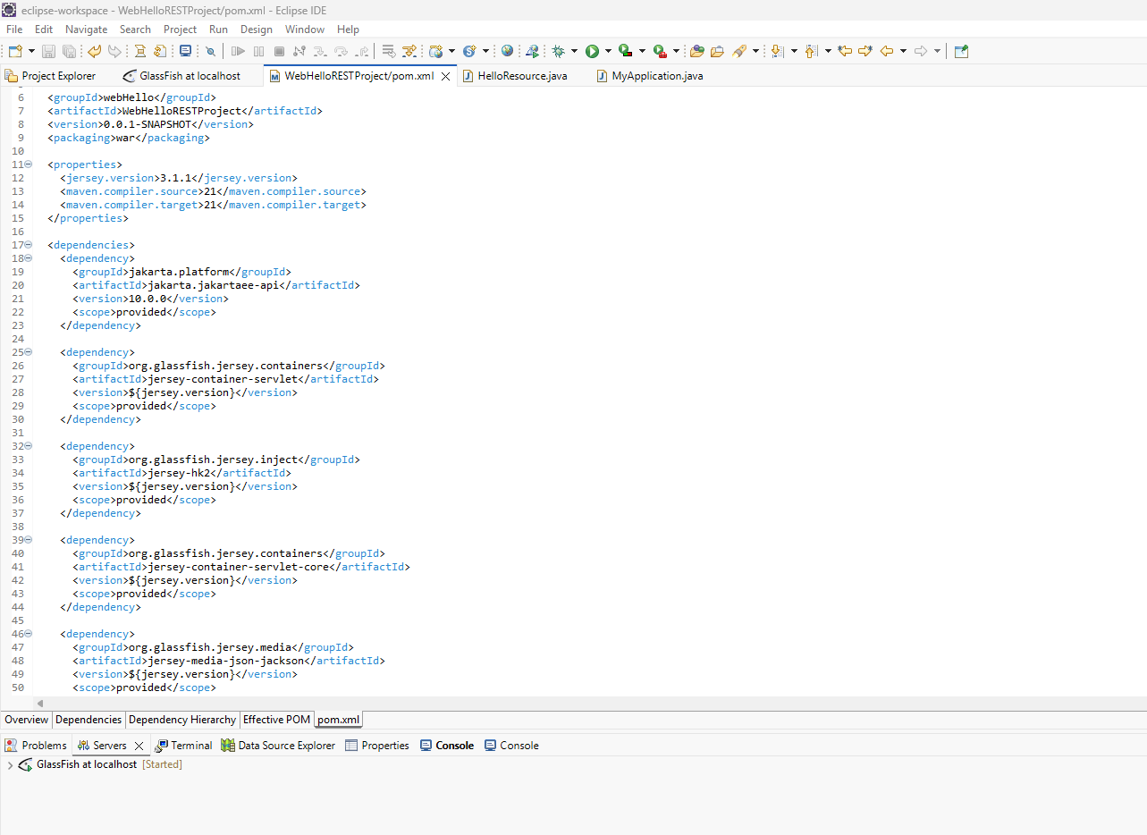
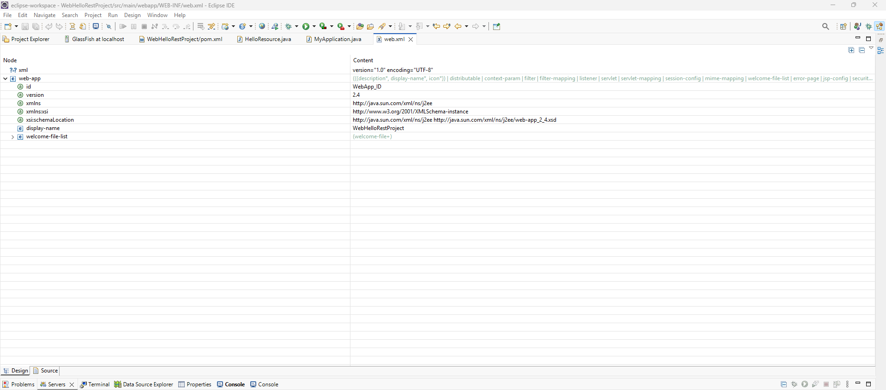
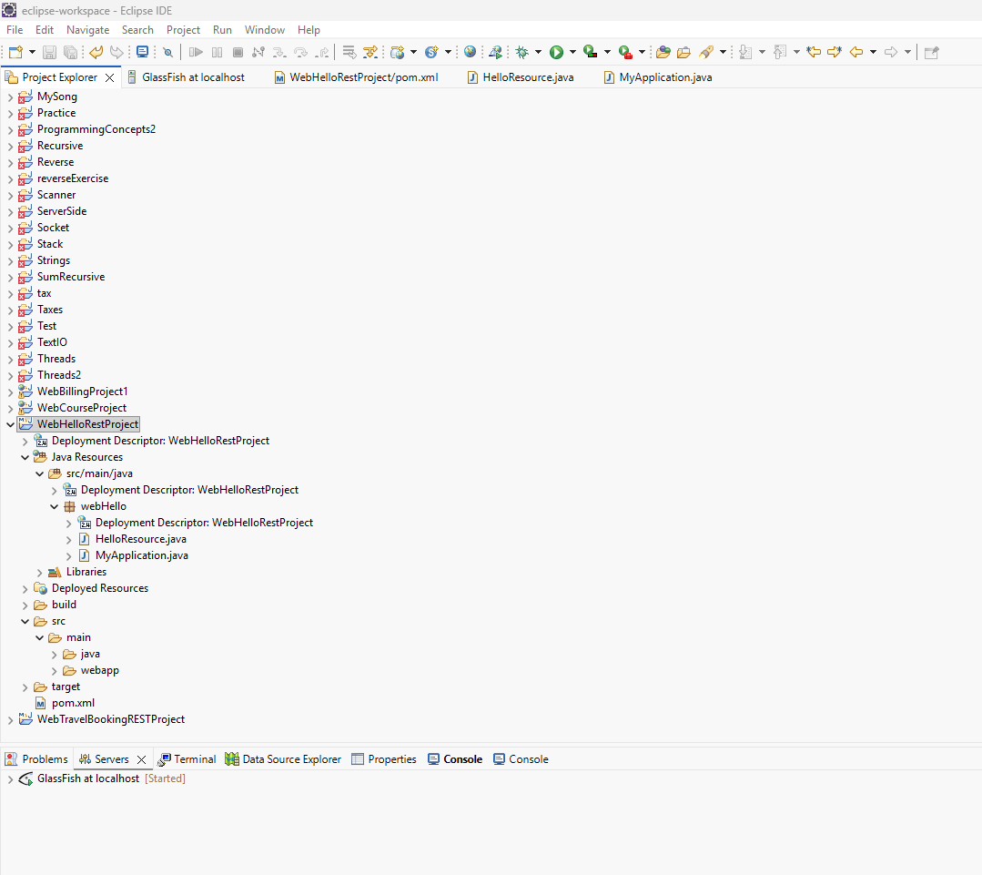
- Run on GlassFish Server
  - Right-click project → Run on Server
  - Select GlassFish
RUNNING ON : http://localhost:8080/WebHelloRESTProject/api/HiHi/text

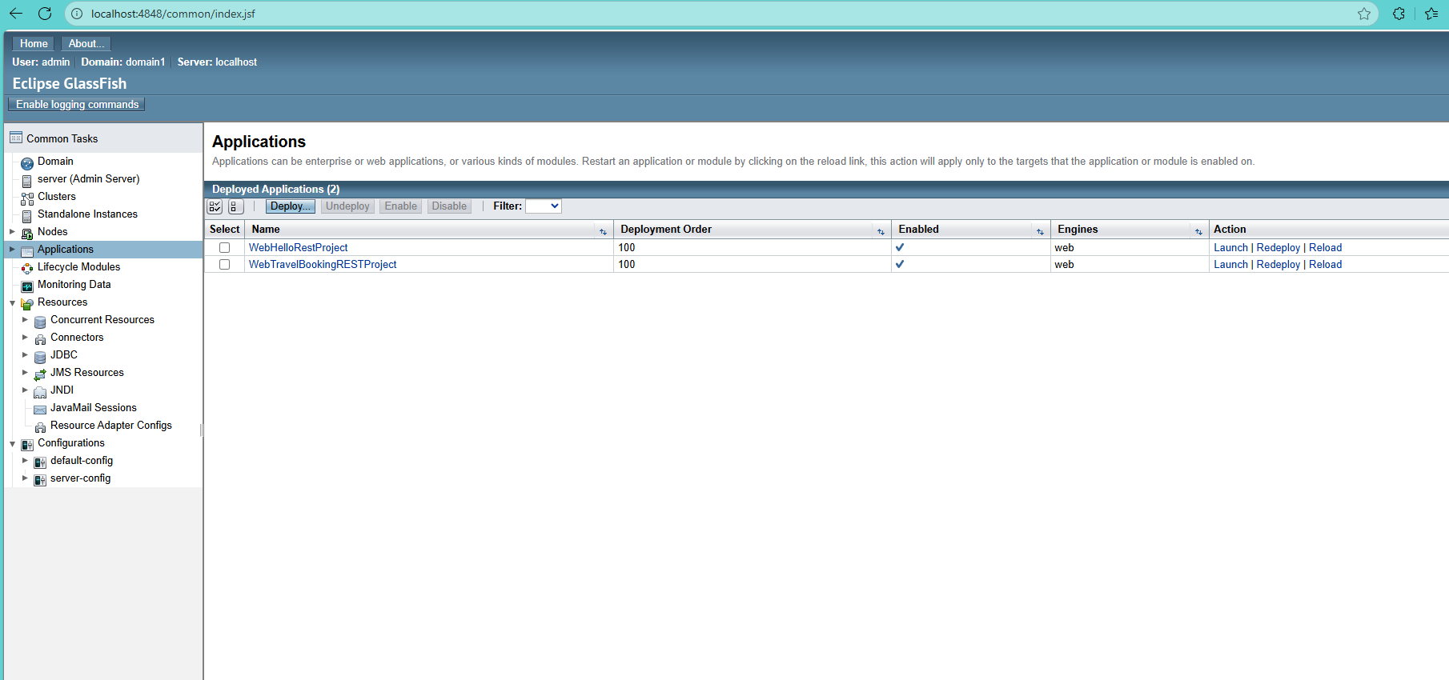

- Test in Browser
  - URL: http://localhost:8080/WebHelloRESTProject/api/HiHi/text
  - Expected output: Hello Everyone
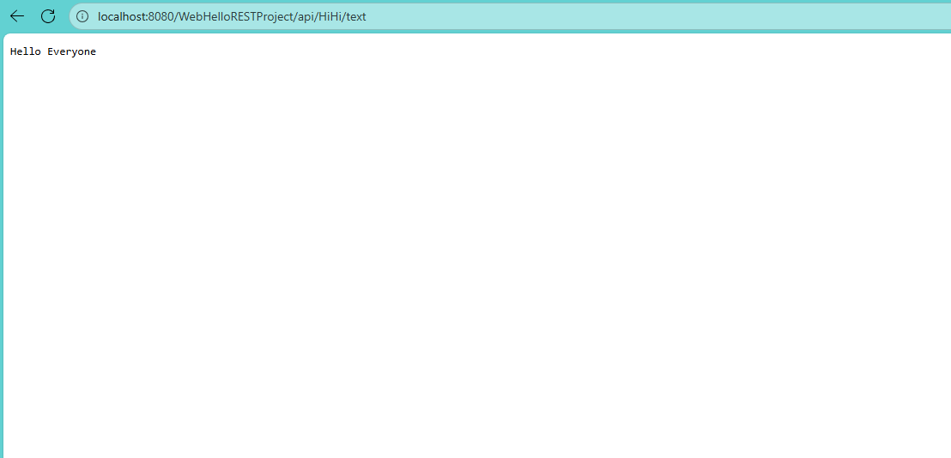

Testing University class :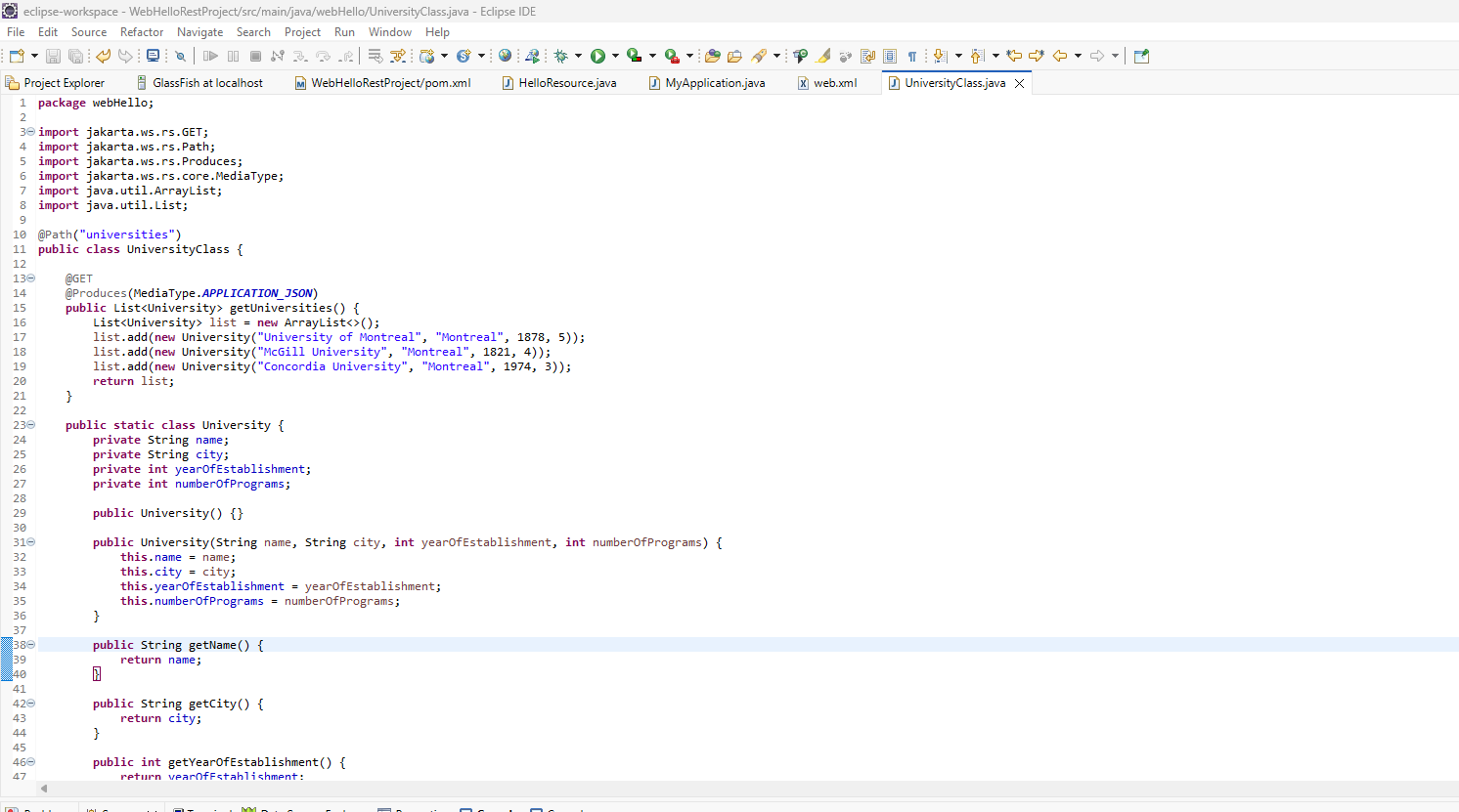

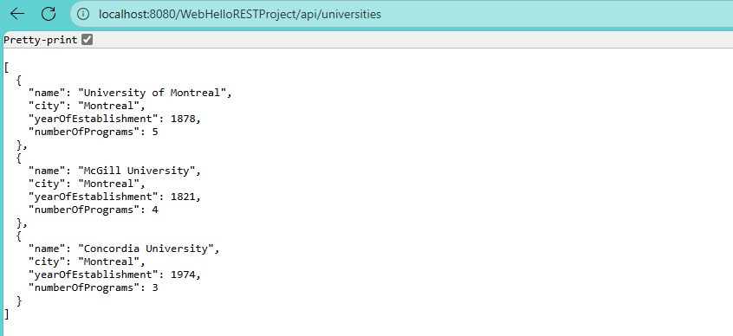

POSTMAN TESTING:

GET: http://localhost:8080/WebHelloRESTProject/api/universities

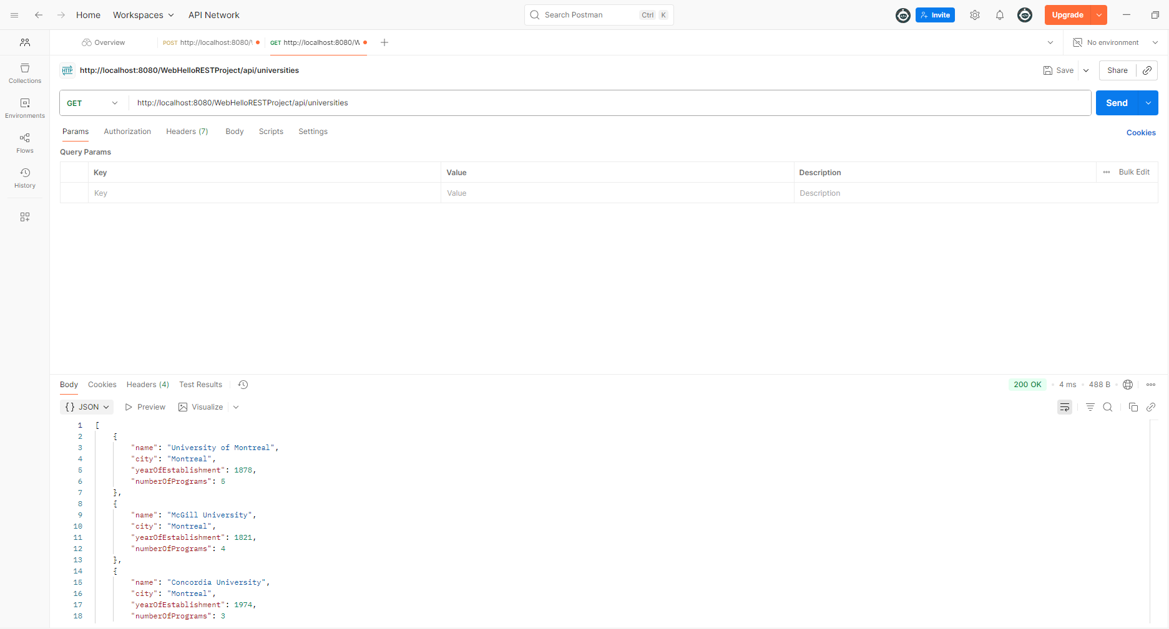

POSTMAN TESTING:

GET : http://localhost:8080/WebHelloRESTProject/api/HiHi/text
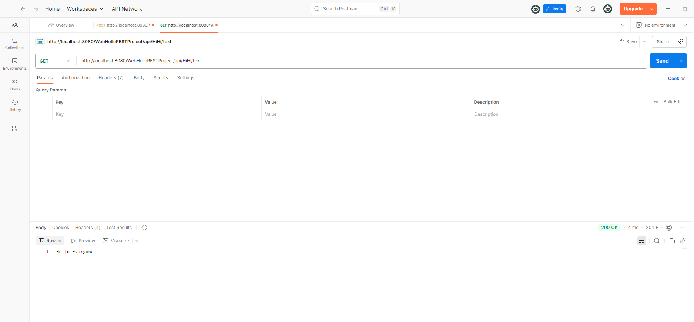

UPDATED CONTEXT ROOT to /WebHelloRESTProject1
localhost:8080/WebHelloRESTProject1/api/HiHi/html
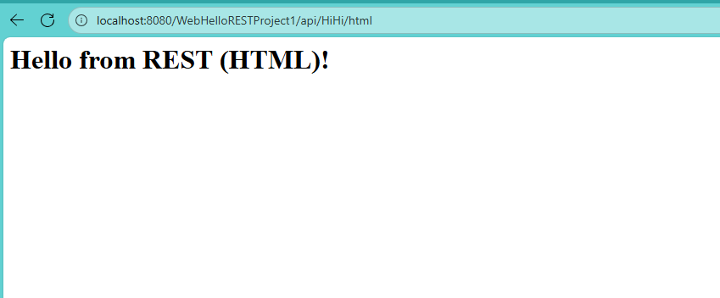
localhost:8080/WebHelloRESTProject1/api/HiHi/json
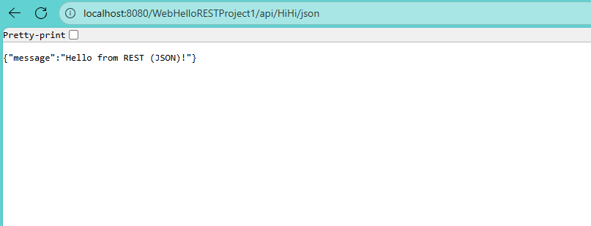

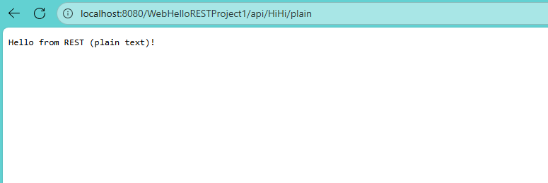

localhost:8080/WebHelloRESTProject1/api/HiHi/plain

Part 2 – WebMathOperationsRESTProject

a) Create Dynamic Web Project and Convert to Maven

Project Name: WebMathOperationsRESTProject
Runtime: GlassFish Server
Dynamic Web Module Version: 4.0

Convert to Maven Project:
- Right-click project → Configure → Convert to Maven
- Group ID: mathOperationsREST
- Artifact ID: WebMathOperationsRESTProject
- Packaging: war

b) Add Maven Dependencies in pom.xml

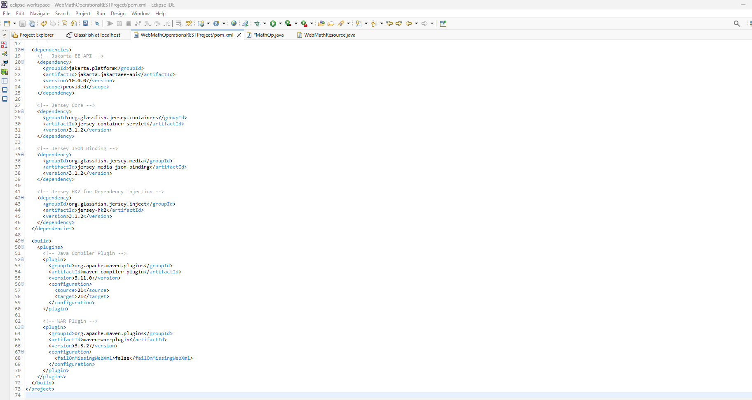

c) Create Package and Deploy

Package Name: mathOperationsREST

Create 2 classes:
- MathOp.java
- WebMathResource.java

Deploy using:
- Right-click project → Run on Server → Select GlassFish

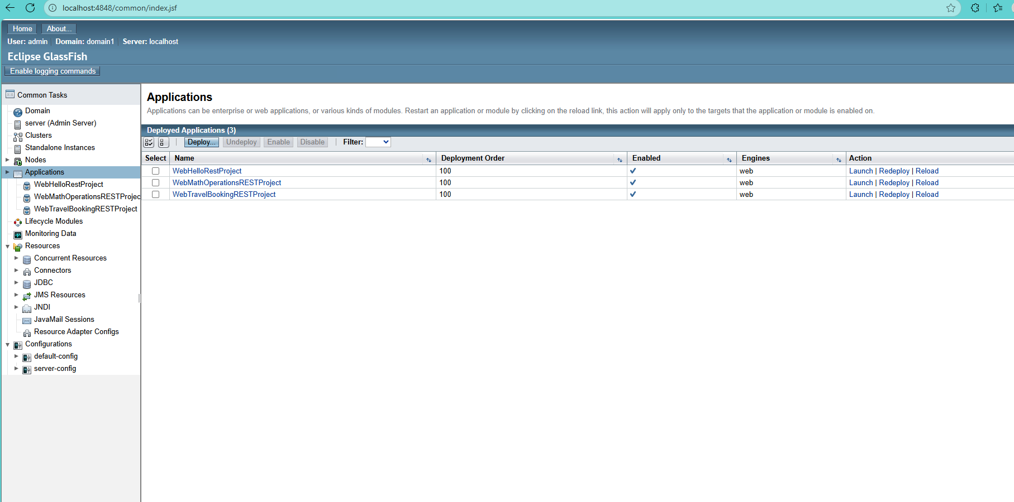

d) Java Class: MathOp.java

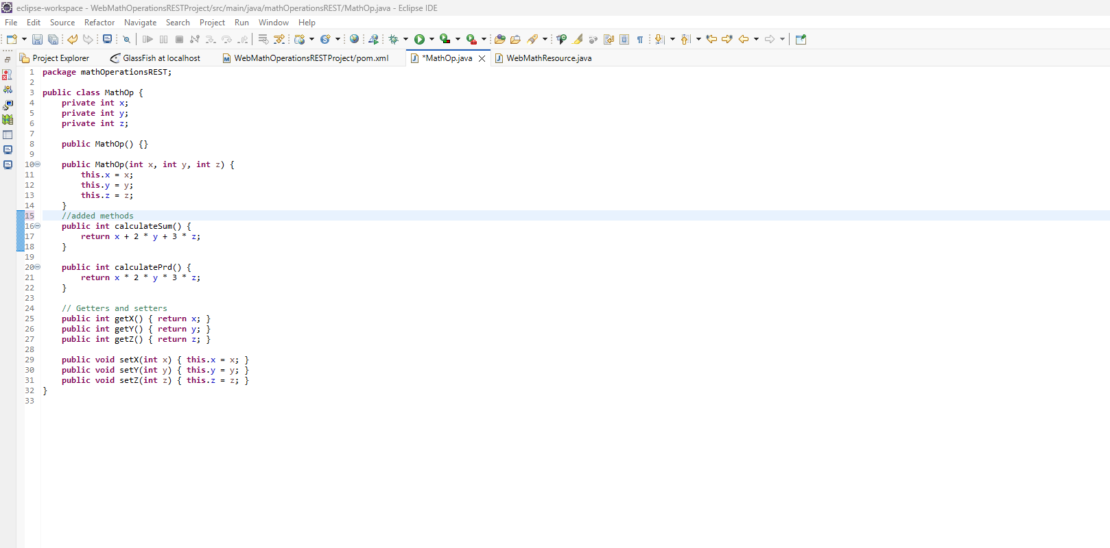

e) REST Class: WebMathResource.java

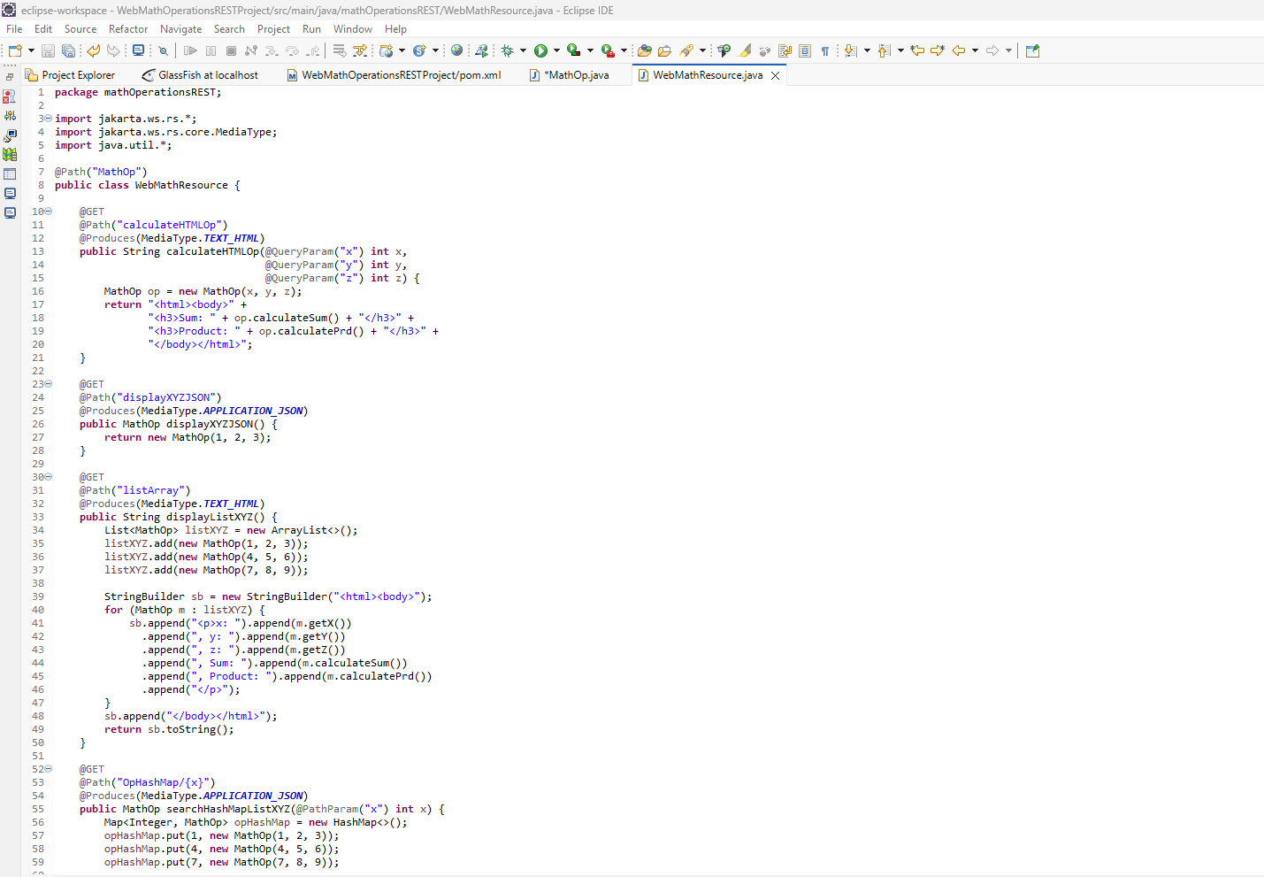

Test REST Endpoints (Use Postman or Browser)

GET → http://localhost:8080/WebMathOperationsRESTProject/api/MathOp/calculateHTMLOp?x=1&y=2&z=3
Returns HTML with Sum and Product

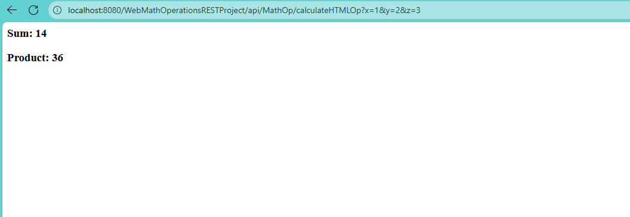
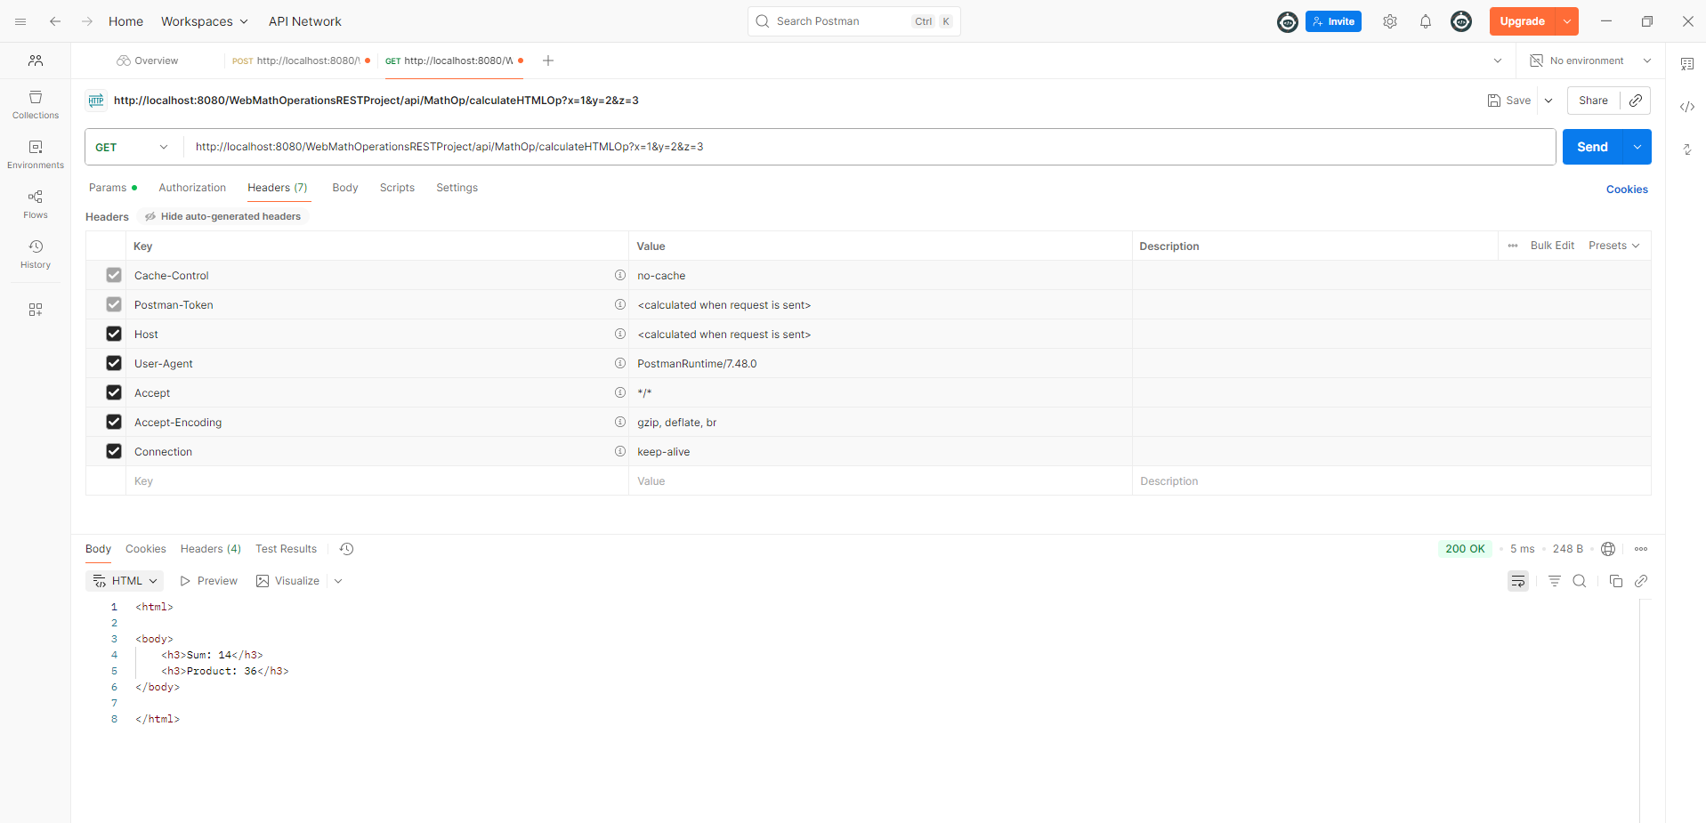

GET → http://localhost:8080/WebMathOperationsRESTProject/api/MathOp/displayXYZJSON
Returns JSON object {x:1, y:2, z:3}

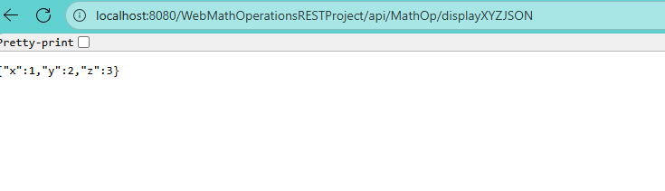

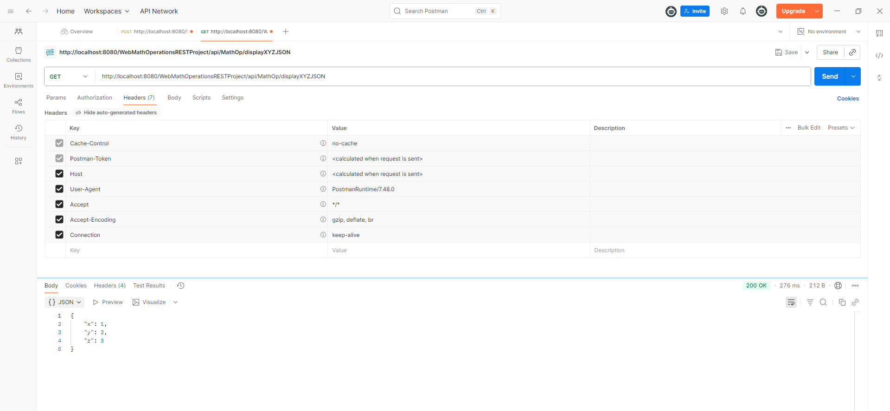

GET → http://localhost:8080/WebMathOperationsRESTProject/api/MathOp/listArray
Returns HTML table with 3 objects

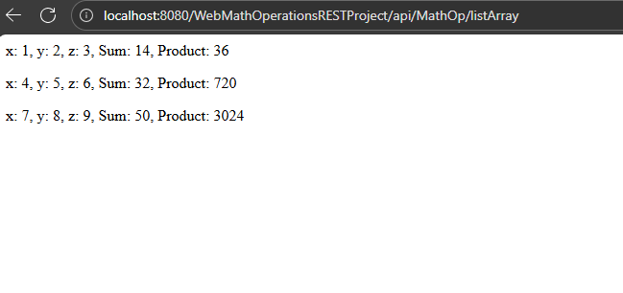

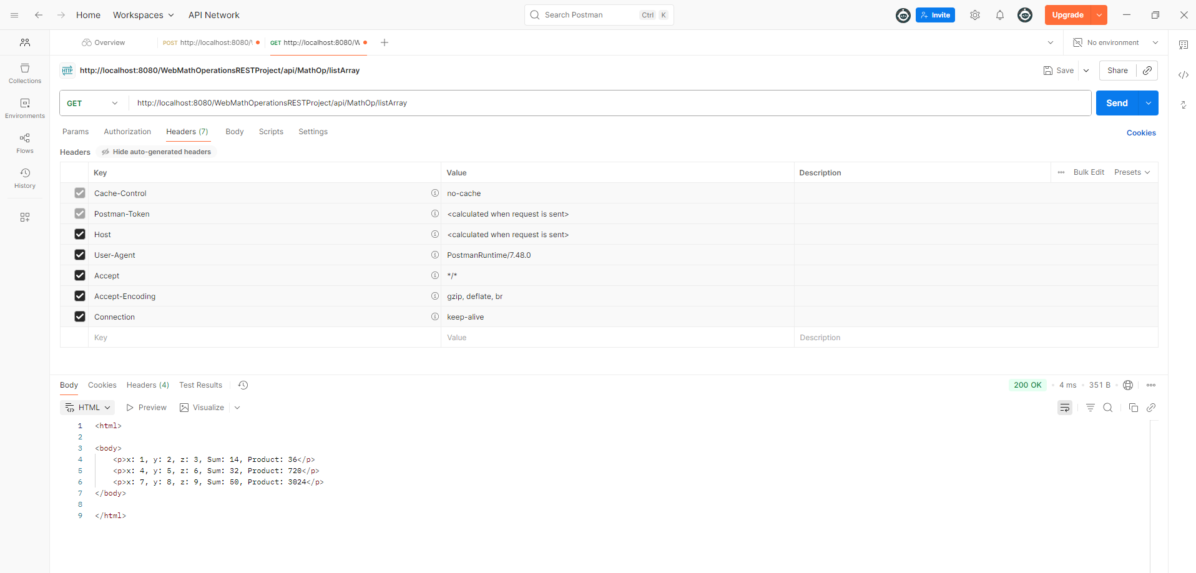

GET → http://localhost:8080/WebMathOperationsRESTProject/api/MathOp/OpHashMap/4
Returns JSON object {x:4, y:5, z:6}

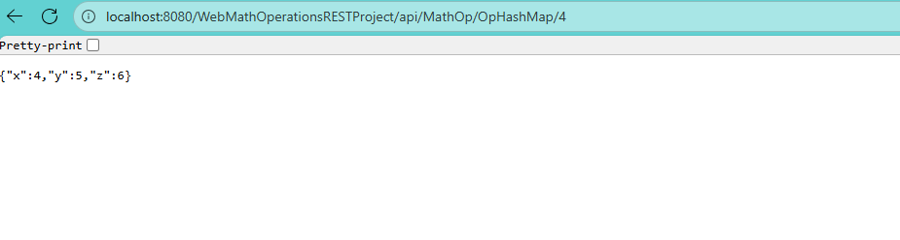

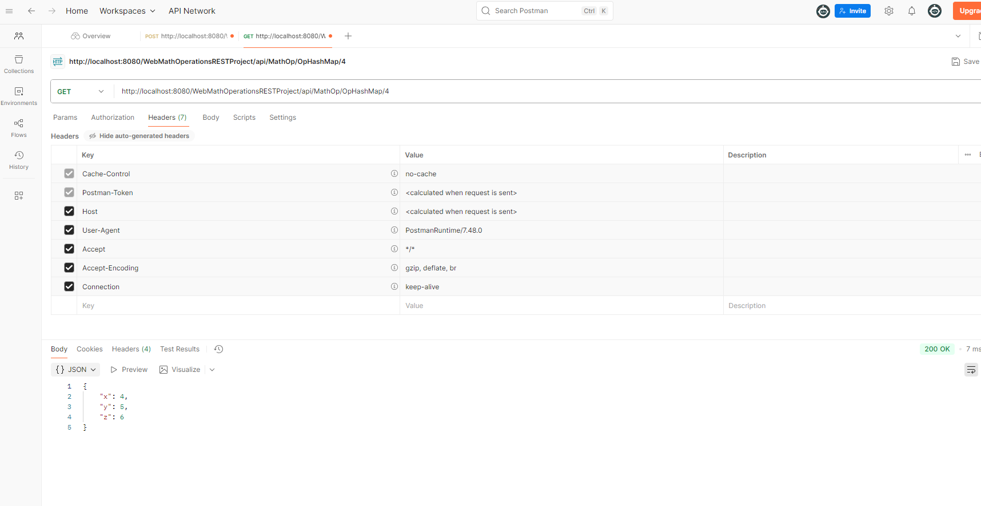

End of Part 2.

Part 3 – Maven Dynamic Web Project: WebCarRESTProject

a) Create a new Dynamic Web project called WebCarRESTProject and convert it into Maven Project.

b) Add Maven Project dependencies in pom.xml. Create new package called webCarREST.

c) Deploy WebCarRESTProject within GlassFish Server to be executed by Servlet class ServletContainer specified in web.xml.

d) Develop a Java class called Car with the following:

- Private non-static members: vin (String), desc (String), price (double).
- Method discountPrice() that calculates the discounted price after applying 10% discount on price.

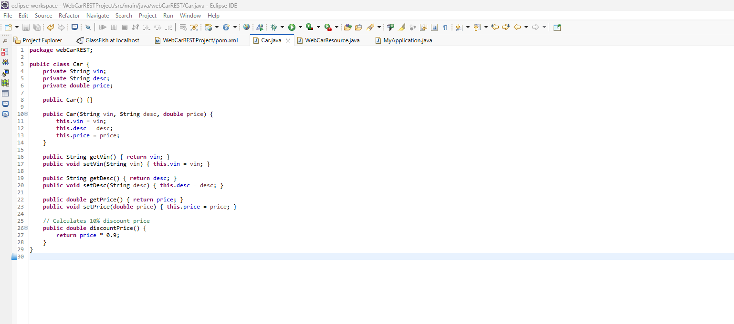

e) Create a new REST Resource class WebCarResource.java with the following:

1. Add path URL mapping ("WebCar") to access REST resource using appropriate Java REST annotation.

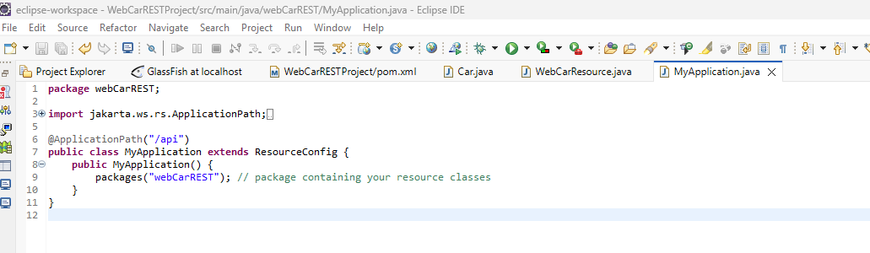

2. Add method displayHTMLCarInfo() that returns HTML media type.

3. In displayHTMLCarInfo(), instantiate a HashMap<String, Car> (carHashMap) where key = vin and value = Car object.
Read components from text file Car.in (tab-separated), with values:
- vin = K1245, desc = Ford, price = 35000
- vin = M198754, desc = Honda, price = 40000
- vin = M98524M4, desc = Hyundai, price = 25000
- vin = S741582, desc = Nissan, price = 30000

Display the unsorted and sorted car list (by discounted price) in a web table.
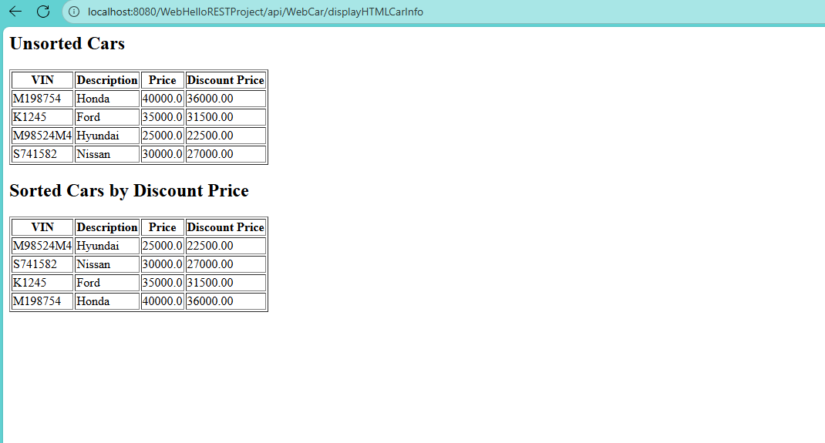

4. Add method displayTextCarInfo() that returns the same output as plain TEXT media type.

5. Add method displayJSONCarInfo() that returns the HashMap elements as JSON media type.

6. Add a path URL mapping ("/searchCar/{vin}") with path parameter vin to search car in the HashMap.

7. Add method searchJSONCarInfo(String car_vin) that returns the search result as JSON media type.
8. Test all endpoints using Postman OR Browser with screenshots. GLASSFISH SERVER
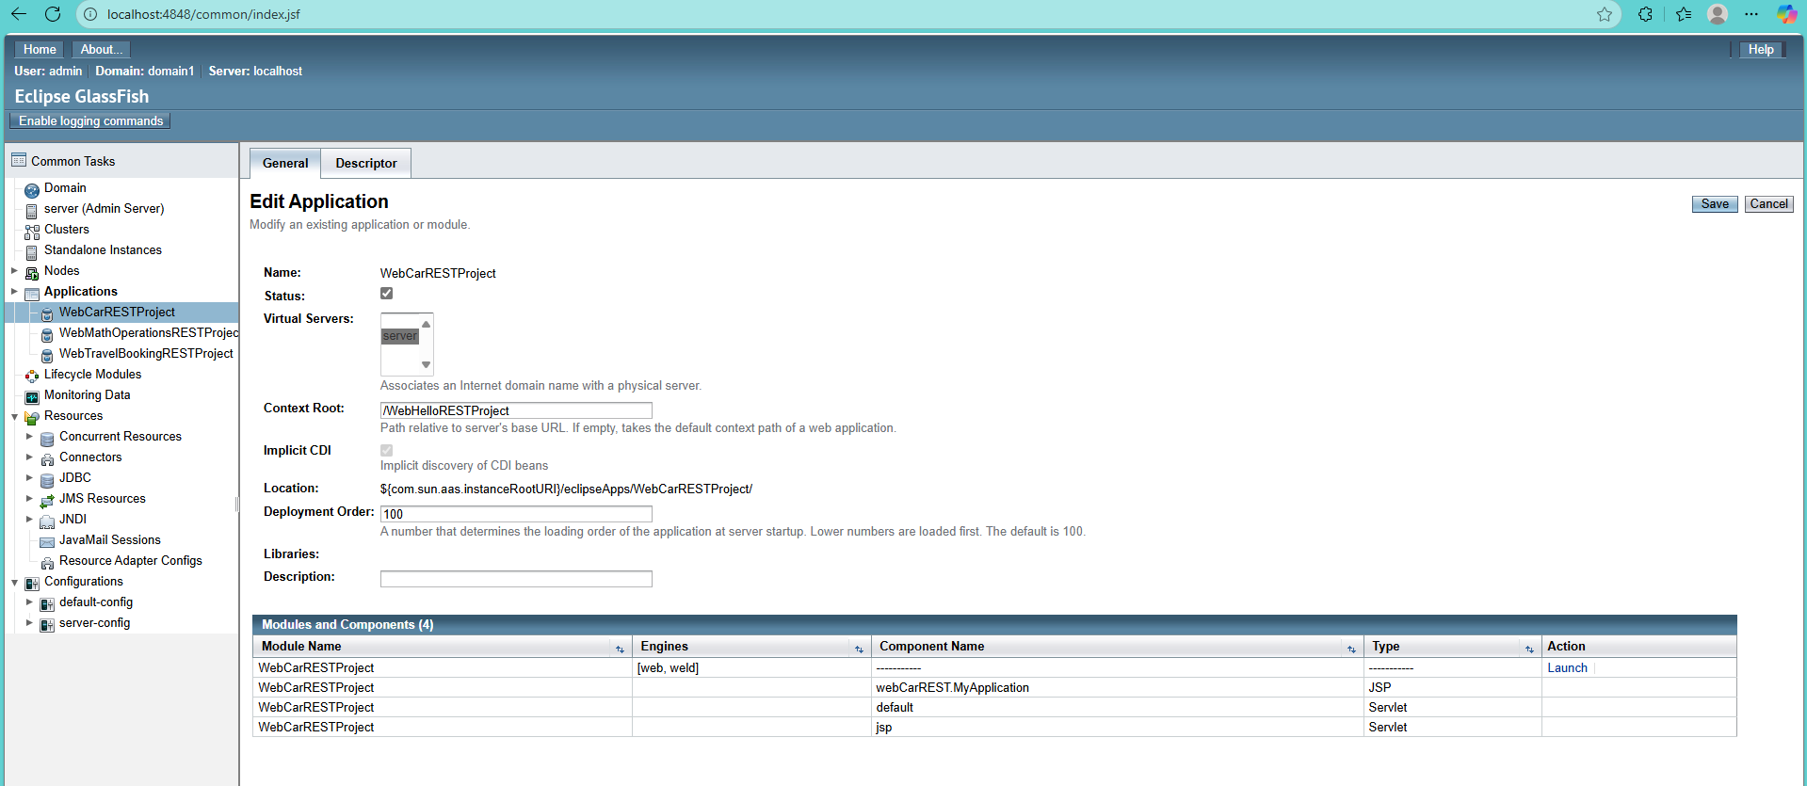
ENDPOINT : localhost:8080/WebHelloRESTProject/api/WebCar/displayHTMLCarInfo

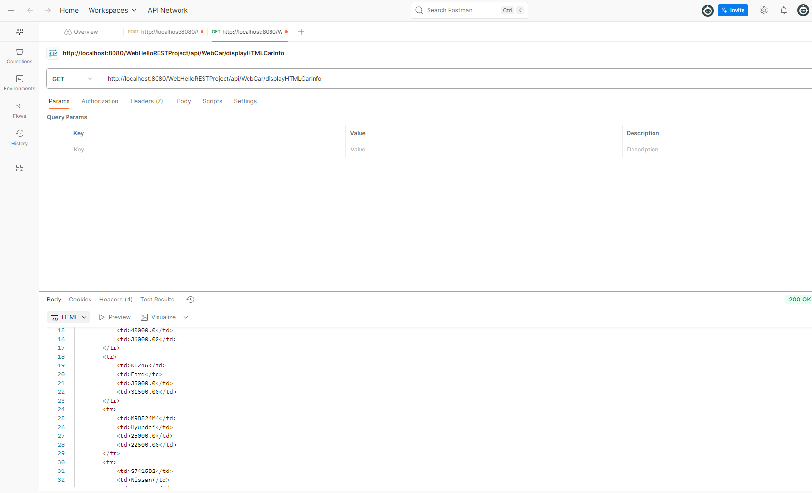

ENDPOINT: http://localhost:8080/WebHelloRESTProject/api/WebCar/displayTextCarInfo

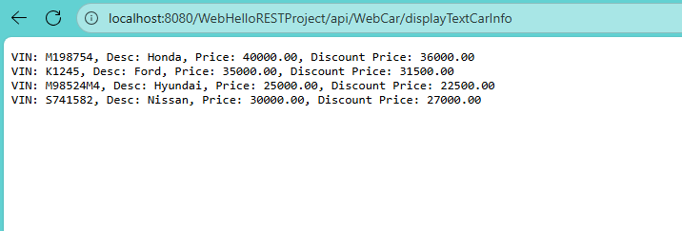

ENDPOINT: http://localhost:8080/WebHelloRESTProject/api/WebCar/displayJSONCarInfo

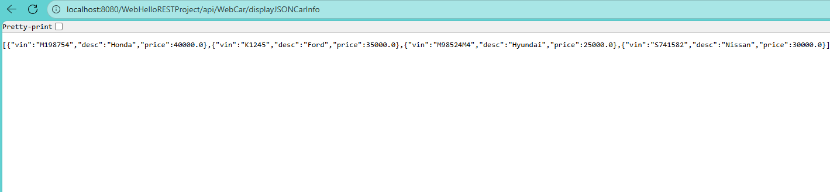

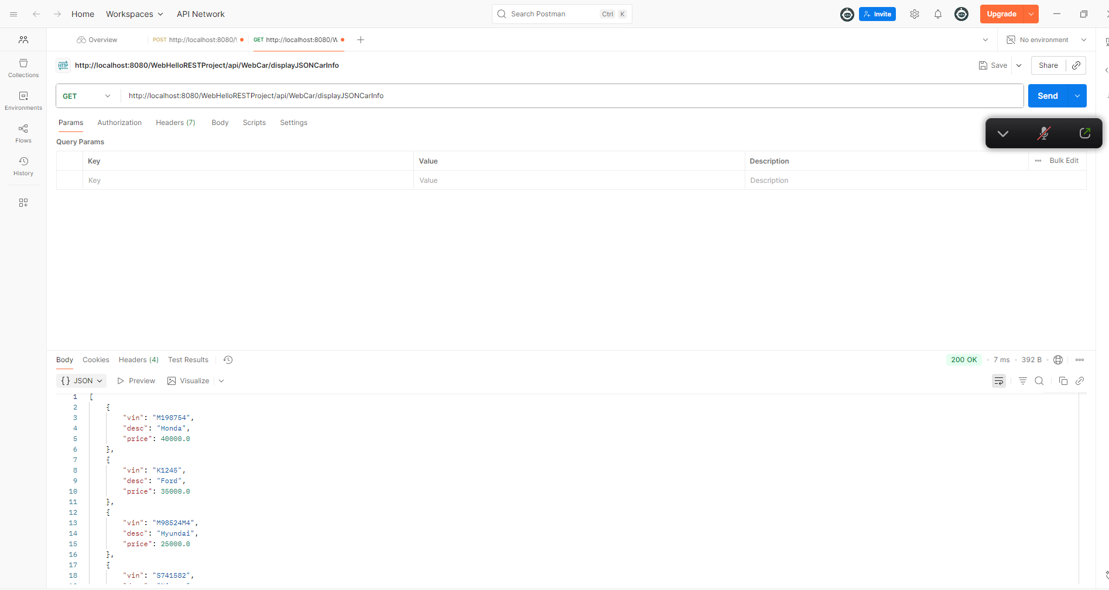

GET: http://localhost:8080/WebHelloRESTProject/api/WebCar/searchCar/K1245

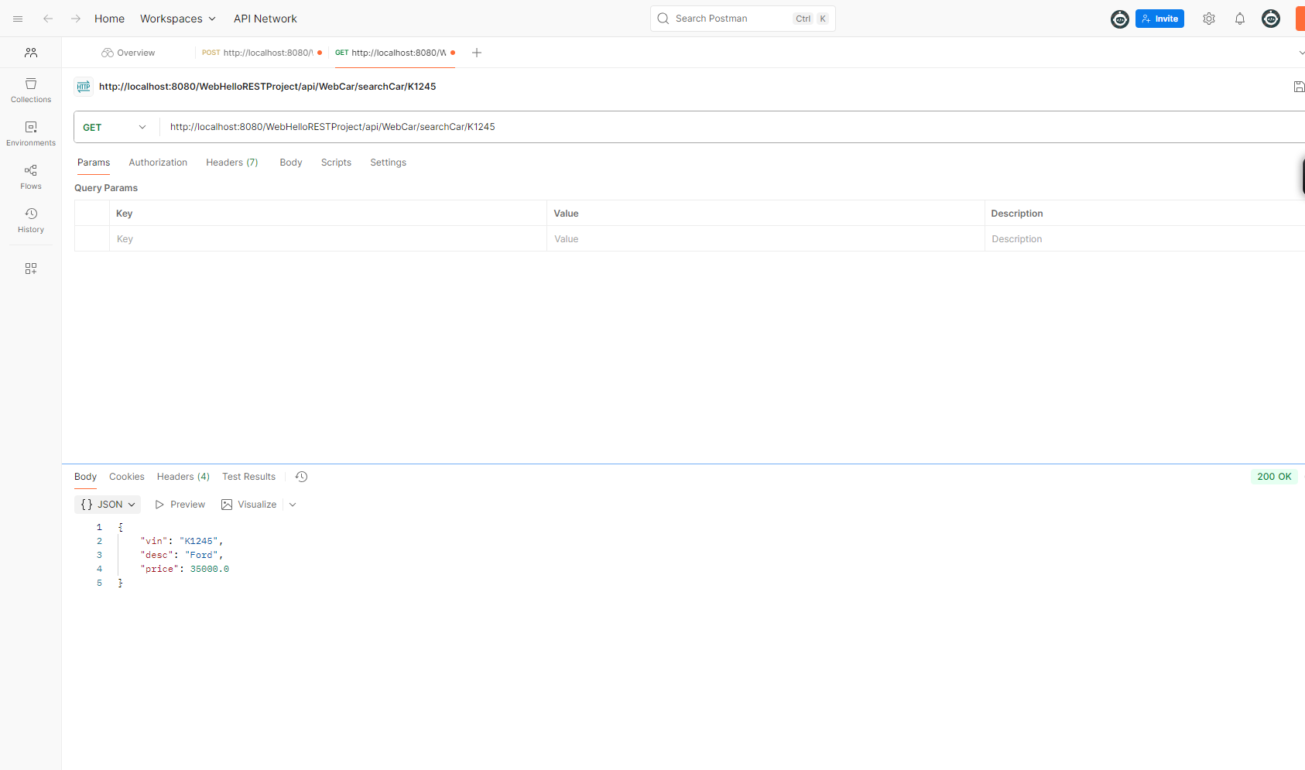

- Received responses expected:

displayHTMLCarInfo: HTML table in response body
displayTextCarInfo: plain text info
displayJSONCarInfo: JSON array of cars
searchCar/{vin}: JSON object with that car or null

- Used appropriate Jakarta REST annotations: @Path, @GET, @Produces, @PathParam.

- For sorting, used Java Comparator comparing discountPrice().

- Used Jersey ServletContainer configured in web.xml for deployment.

—

I CHANGED THE CONTEXT ROOT IN GLASSFISH FOR ORGANIZATION

UPDATED SCREENSHOTS:

localhost:8080/WebCarRESTProject/api/webCar/displayHTMLCarInfo
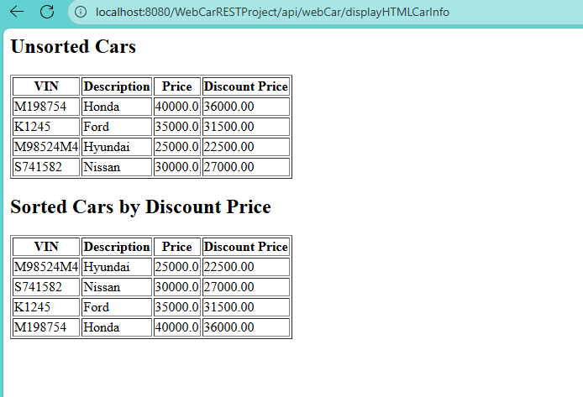

localhost:8080/WebCarRESTProject/api/webCar/displayTextCarInfo

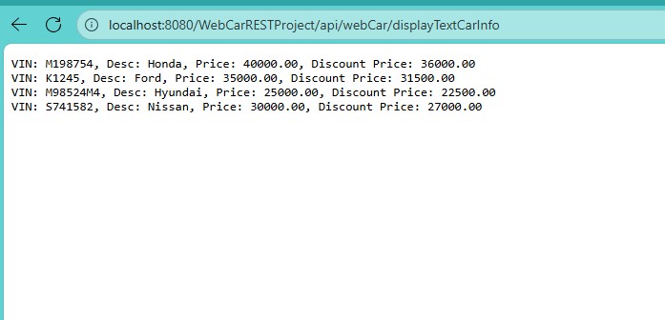

localhost:8080/WebCarRESTProject/api/webCar/displayJSONCarInfo

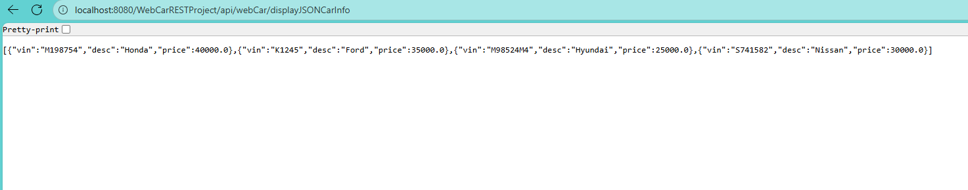

localhost:8080/WebCarRESTProject/api/webCar/searchCar/K1245

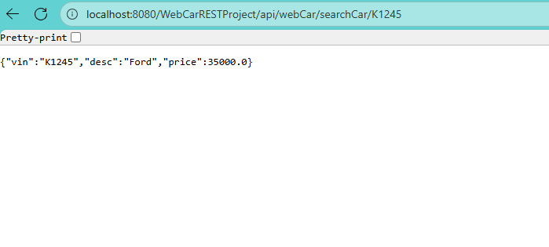

End of Part 3

Part 4 – Maven Dynamic Web Project: WebBillingRESTProject

For this part of the lab, I created a new Maven Dynamic Web Project named WebBillingProject and configured it for deployment on the GlassFish server.
First, I converted the project into a Maven project and updated the pom.xml to include all the necessary dependencies for Jakarta EE and Jersey (JAX-RS) to support RESTful web services and JSON output. I also made sure to include the Maven Compiler and WAR plugins to allow successful builds and deployment.
I created a new package called webBilling, where I added the Java classes for this project. I implemented the Billing class with the required private fields such as client_ID, client_LName, client_FName, product_Name, prd_Price, and prd_Qty. I also defined the public static fields Fed_Tax and Prv_Tax, as specified in the assignment. The class includes the necessary constructors, getter and setter methods, and the CalculateBilling() method to compute the total billing amount.
I also created a REST resource class named WebBillingResource and mapped it to the path /WebBilling using the appropriate JAX-RS annotations. The application’s base path was configured as /api.
Inside WebBillingResource, I implemented the following endpoints:
- displayHTMLBillingInfo – Returns an HTML table displaying billing information in an unsorted format.
- displayTextBillingInfo – Returns the same billing information as plain text.
- searchBilling/{client_id} – Allows searching for a specific client by client_ID and returns the matching billing entry in JSON format.
For all these methods, I read billing data from an input file named Billing.in. I manually created this file and placed it in the src/main/resources folder of the project. The data in the file is tab-separated, as required. I used a Java ArrayList to store instances of the Billing class populated from this input file.
After building the project and deploying it to GlassFish, I tested each of the endpoints using Postman and verified that the responses were returned in the correct format.

Postman Screenshots
- HTML Billing Output
GET: http://localhost:8080/WebBillingRESTProject/api/WebBilling/displayHTMLBillingInfo
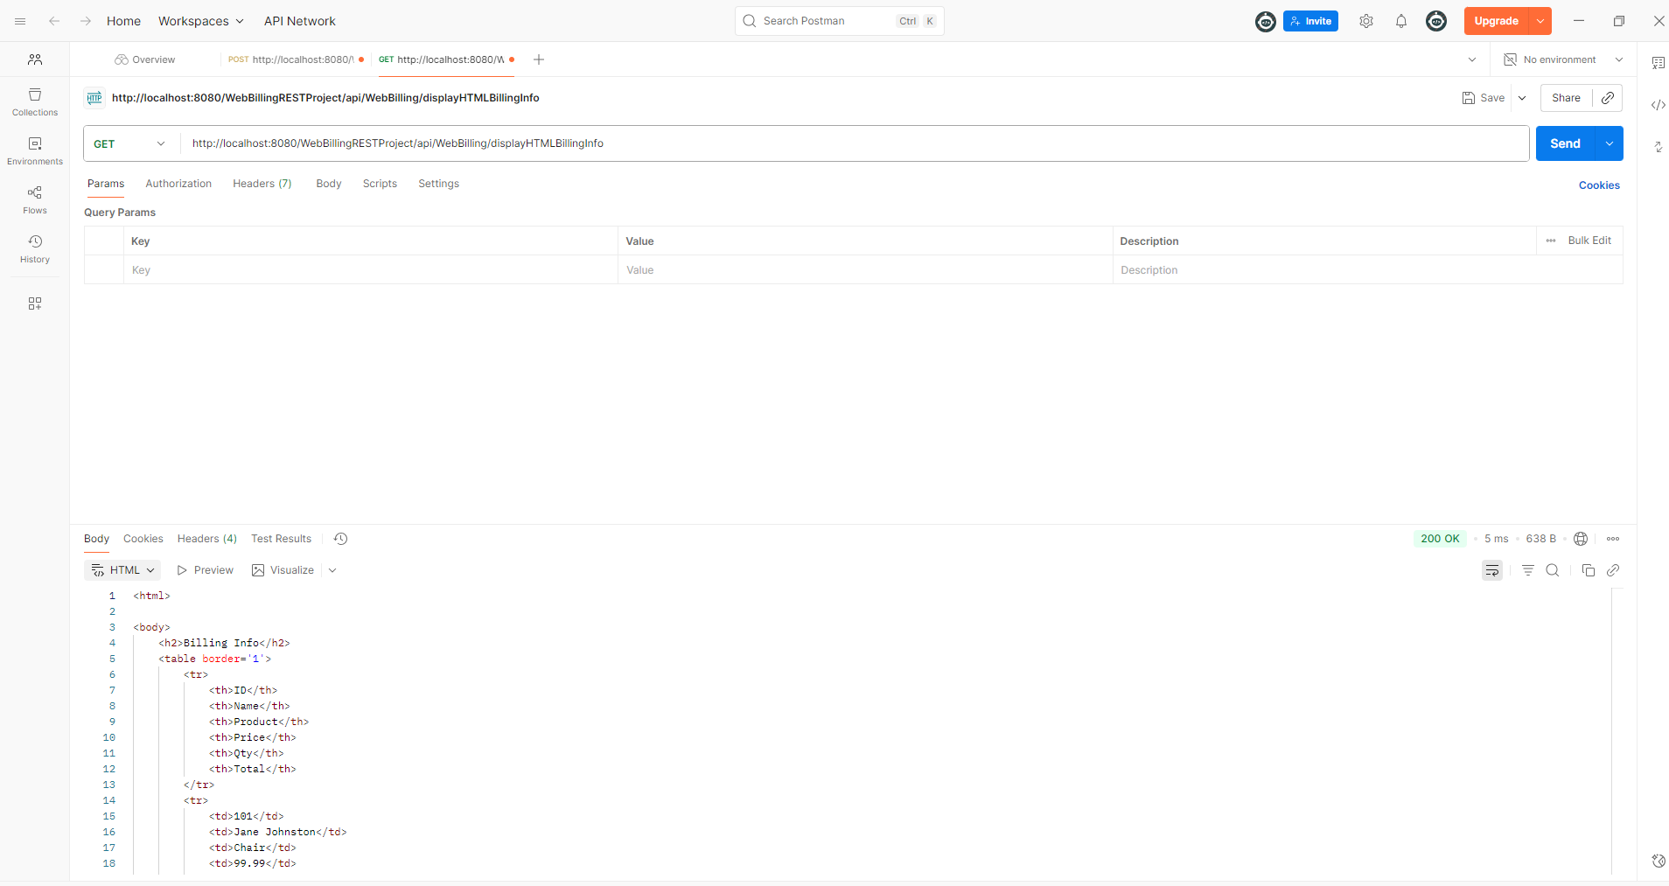
- Plain Text Billing Output
GET: http://localhost:8080/WebBillingRESTProject/api/WebBilling/displayTextBillingInfo
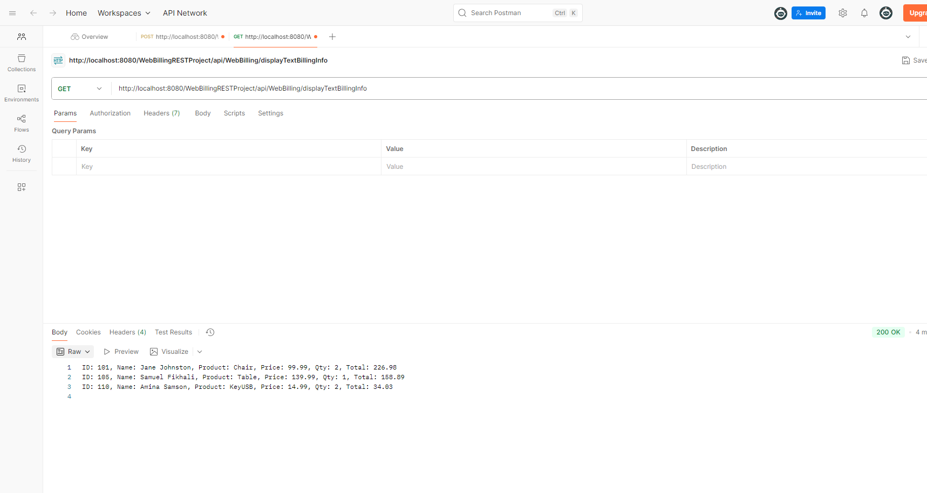
- JSON Search Billing Output (e.g., /searchBilling/101)
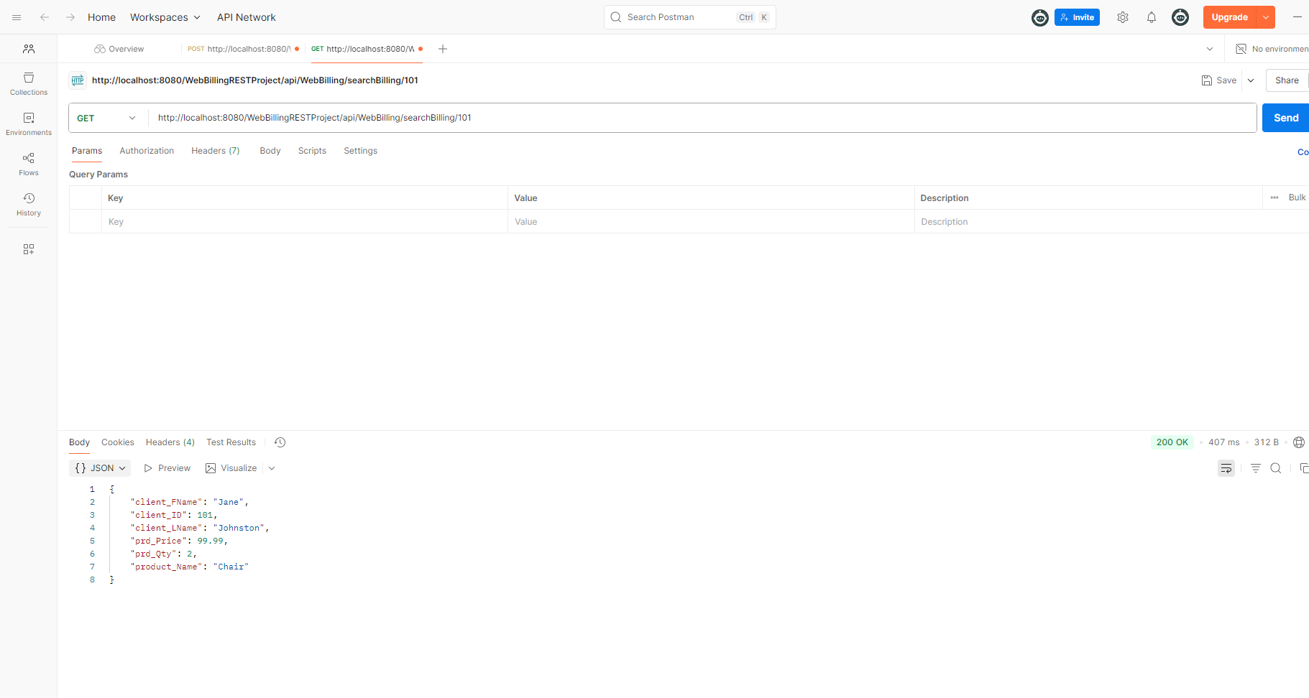
Part 5 – Maven Dynamic Web Project: WebCourseRESTProject

I created a Maven Dynamic Web project named WebCourseRESTProject and configured the necessary dependencies in the pom.xml to support Jakarta EE and Jersey REST.
Inside the project, I created the package webCourseREST and implemented the following classes:
- Course.java
This class models a course with private fields for course number, course name, and maximum enrollment, plus a public static field for credits. It includes a constructor to initialize these fields, getter and setter methods for accessing and modifying data, and a method CalculateTotalFees() which returns the total fees by multiplying maximum enrollment by a fixed rate (250).
- WebCourseResource.java
This REST resource class defines endpoints to handle HTTP GET requests for course data. It reads the course data from a tab-separated text file named Course.in, which I placed in the project’s resources folder. Reading the file is done by loading it as a resource stream using the class loader, then parsing each line to create Course objects, which are collected into a list.
The endpoints provide:
  - HTML-formatted course data as a web table (displayHTMLCourseInfo)
  - Plain text course information (displayTextCourseInfo)
  - JSON array of all courses (displayJSONCourseInfo)
  - JSON response for a searched course by course number (searchJSONCourseInfo)
- MyApplication.java
This class extends Jersey’s ResourceConfig and sets the base URI path /api for REST resources. It also registers JSON support through Jackson. This application configuration enables GlassFish to recognize and serve the REST endpoints.

Reading from the Input File
The input file Course.in contains course data with each line formatted as:
course_no \t course_name \t max_enrl \t credits
Using the class loader, the application reads this file as a resource stream at runtime. It parses each line by splitting on the tab character, extracts values, and creates Course objects accordingly. This approach ensures the data can be easily updated without changing the code, and the file is packaged within the application’s resources.

I deployed the project on GlassFish and tested all REST endpoints successfully with Postman. Screenshots of the test results are saved separately.

TESTING IN POSTMAN:

Display courses as HTML

GET: http://localhost:8080/WebCourseRESTProject/api/WebCourse/displayHTMLCourseInfo

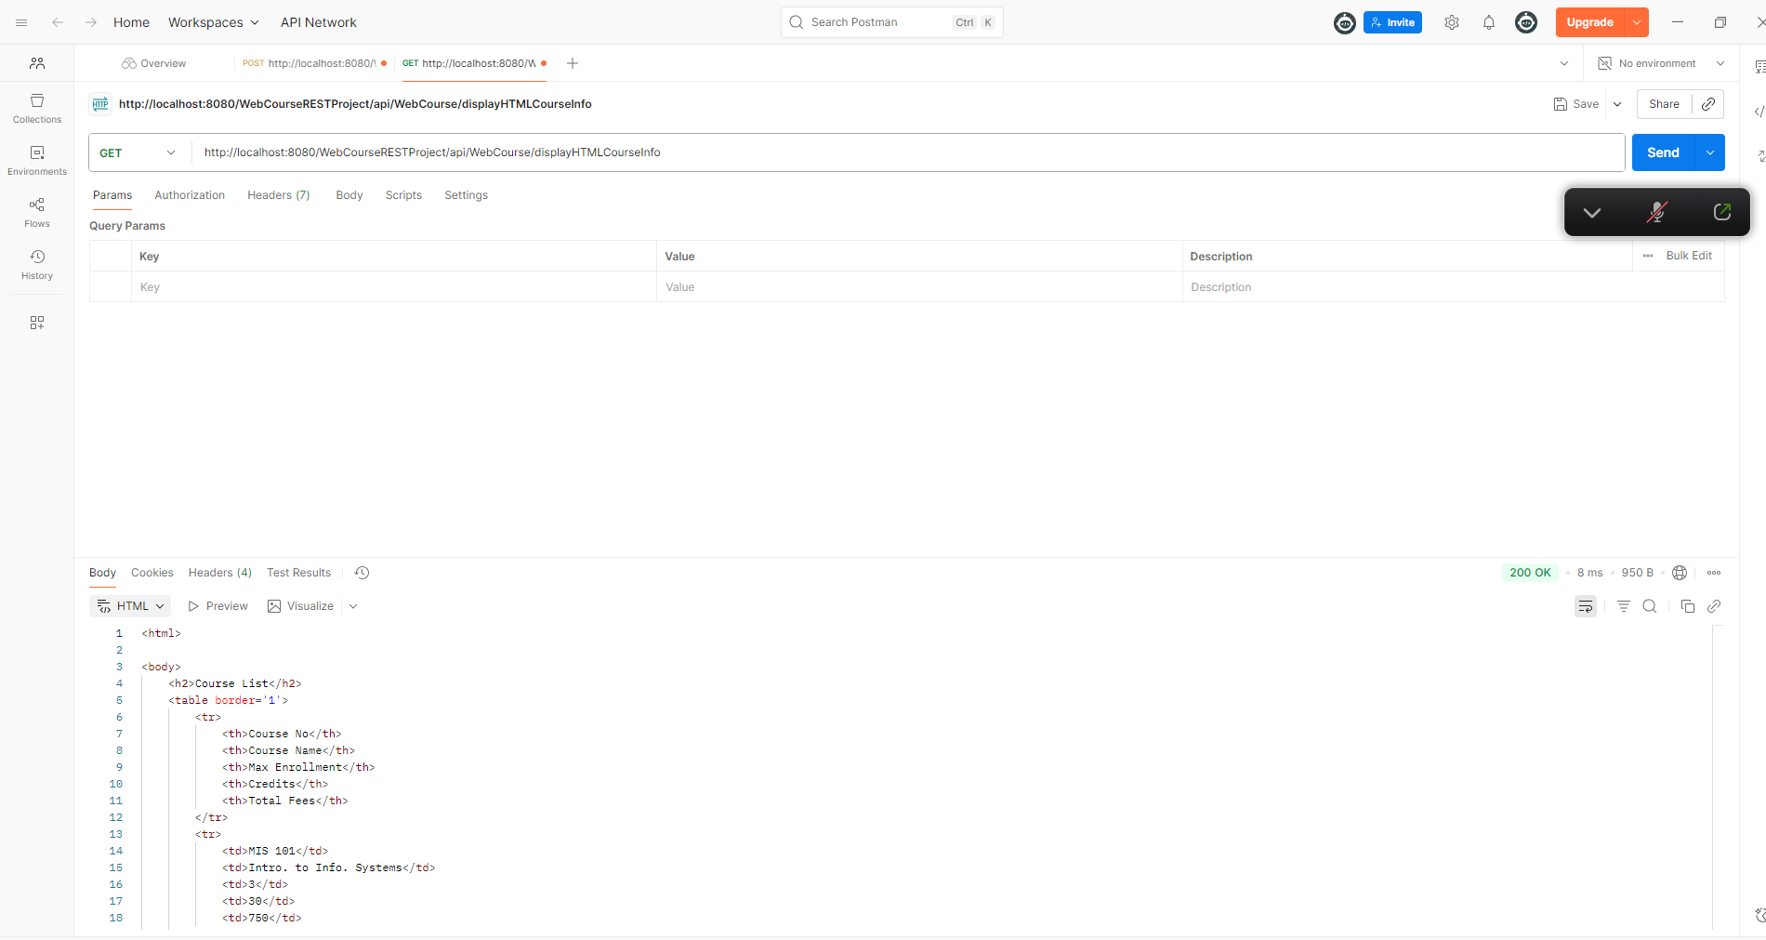
Display courses as Plain Text
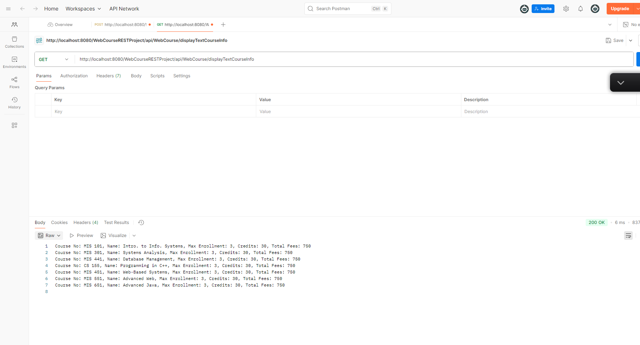

JSON example in POSTMAN

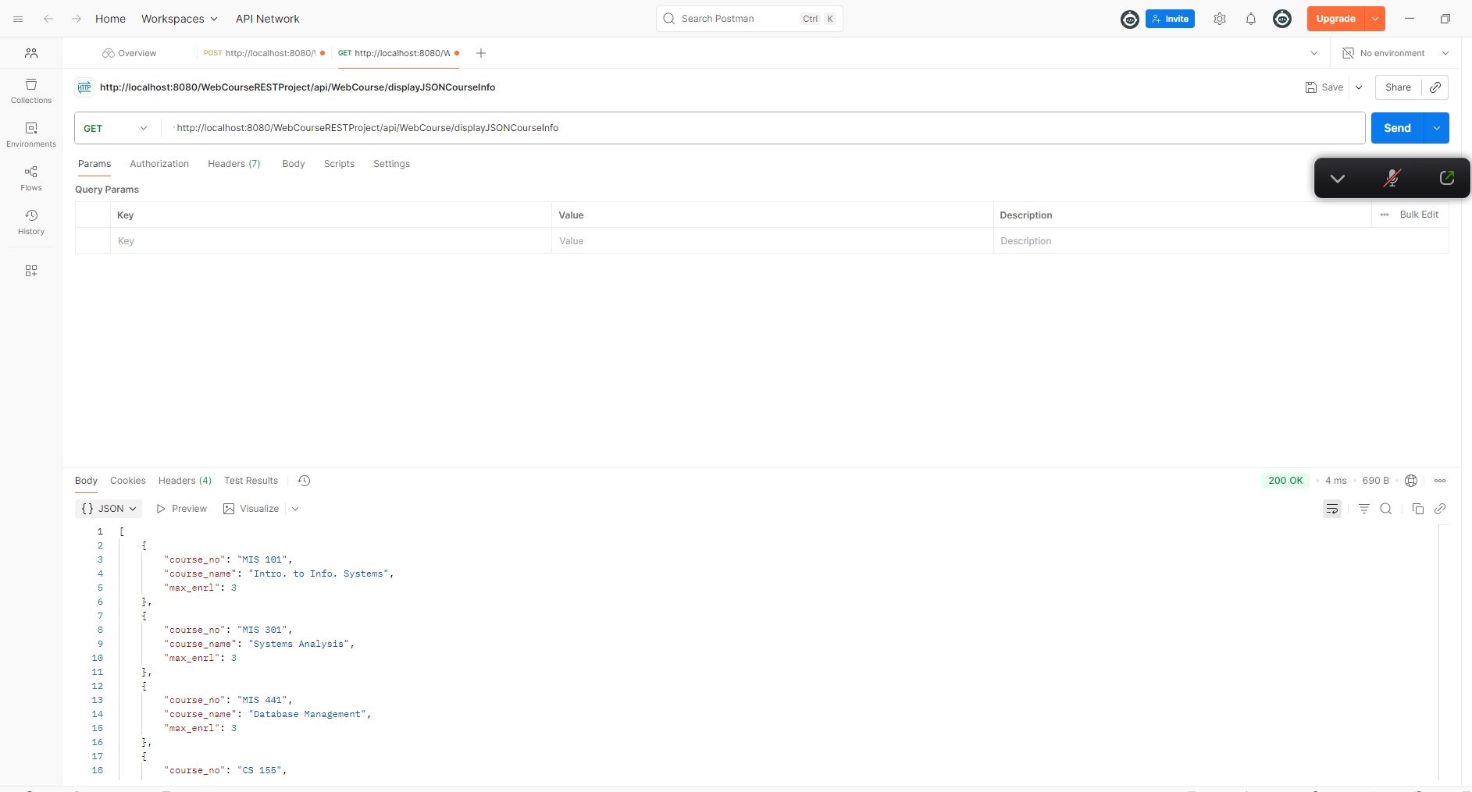

Searching for a course based on course number

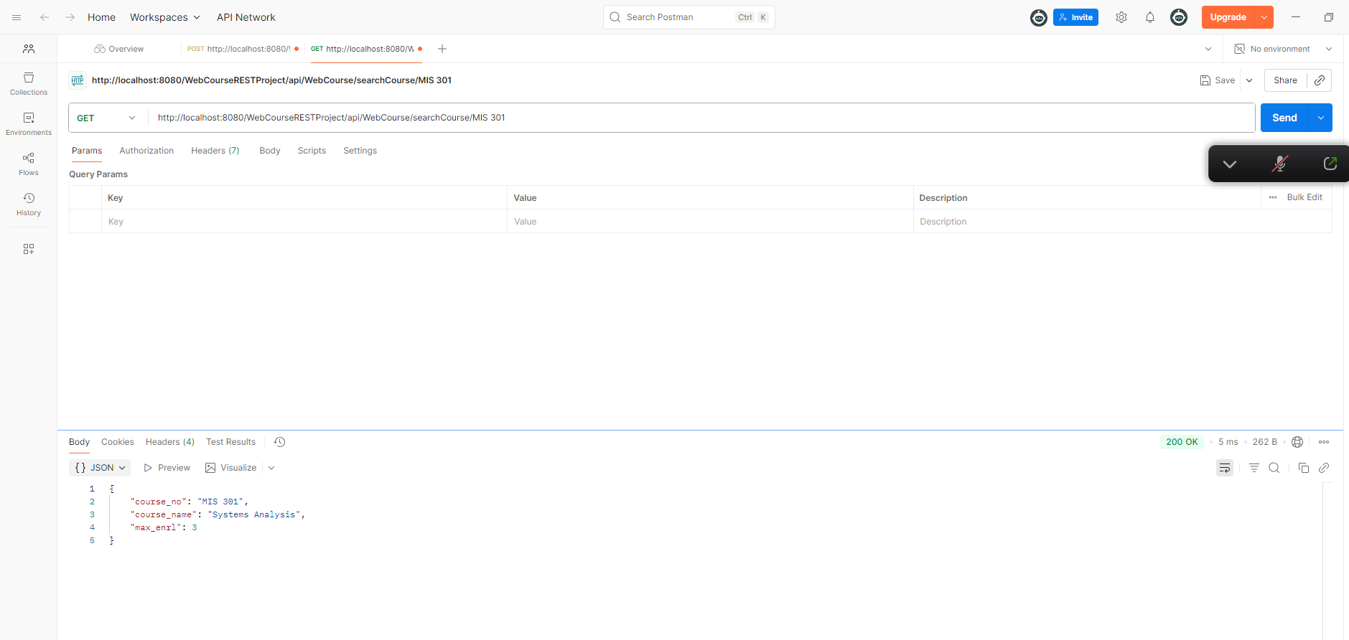

END OF LAB

