**Summary**

Asynchronous programming is a means of parallel programming. Multithreading and async programming are totally different concepts. Async programming in rust must be done in single thread. Future is a term in rust which means values that are awaitable. Async in rust is totally different from other programming languages. async/.await is Rust's built-in tool for writing asynchronous functions that look like synchronous code.

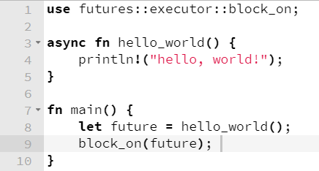For Example:

**Code:**

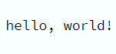

**Output:**