**MICROSERVICES**

By S.M. Moiez Ali Zaidi

What is mean by microservices? According to oxford dictionary micro means small and services means providing something. But the discussion is about microservices, basically microservices is a most useful technique use to develop software. Developers create structure of software on different architecture like monolithic, layered, component-based etc. Microservices is an architecture use for software development. Microservices is consist of small modules and these small modules combine together to form an application. Look at figure 1 given below; in this figure four small boxes combine to form a large box.

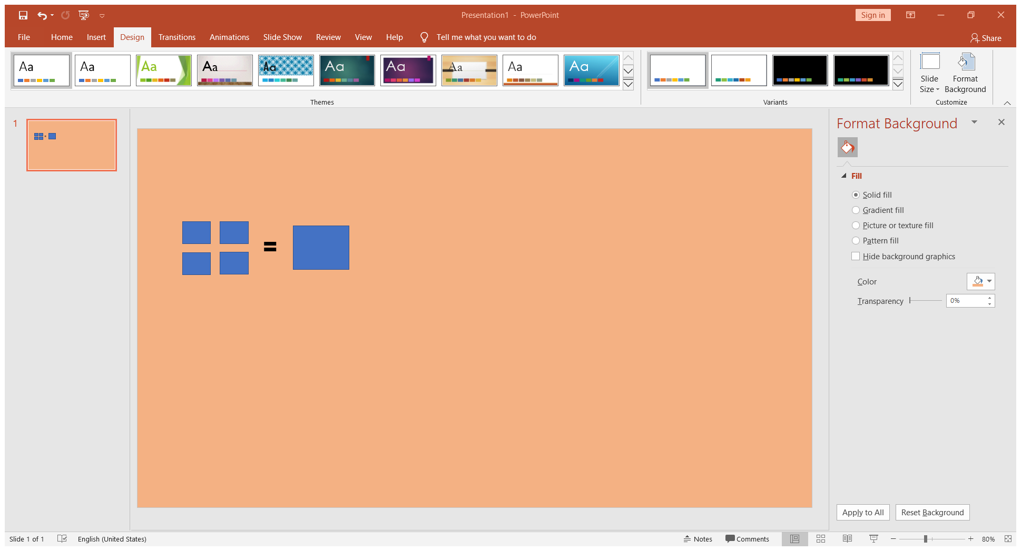

Figure 1

Why microservices is useful architecture? By using microservices maximum number of developers work together. Microservices provides fastest route to upgrade application. Every developer works on microservices architecture-based software work on his module very easily. Before microservices is introduced monolithic architecture were used for software development. Monolithic architecture is like big container where all program is tightly coupled and dependent on each other. Due to monolithic architecture the risk associated with redeployment increases which discourages frequent updates. All the modules are running in same process a bug in any module can bring down the entire application, this makes monolithic architecture highly unstable. In microservices an existing application can update without rebuilding and deploying the entire application.

What are the benefits of microservices architecture? Microservices is small focused its means that it can be rewritten and maintained without any extra efforts by the development team. Microservices is loosely coupled means each module independent of each other so update any module doesn’t need to update other modules of microservices. Fault isolation is another benefit of microservices, if a service goes down it will not entire application goes down with it.

Lastly, microservices is a modernized architecture use to develop applications. This architecture is easy to handle and manage by development team. Microservices provides a huge platform where every team member works easily on specific modules and fix bugs in specific module without interrupting other modules.