BrightStart Education Support
Website and Mobile Application
Task 1: Updated Project Plan, Sitemap and Wireframes
Module: XISD6329
Submitted by:
Dennis Moima – St10451932
Kgothatso Magatsela – St10448288
Keabetswe Modiba – St10438507
Chantal Mafa – St10444319
GitHub Repository: github.com/MoimaDennis/BrightStart--website
Submission Date: 04/05/2026

Table of Contents
Table of Contents 2
List of Figures 3
Updated Project Plan 4
Description of the Client's Needs 6
Site Map 7
Wireframes 8

Updated Project Plan

1. Project Overview
BrightStart connects students, volunteers, and program administrators through a role-based education support system created for a non-profit organization in South Africa. In order to boost awareness, expedite enrollment and attendance tracking, and enhance communication with volunteers, students, and their guardians, this project creates a public website and a mobile application.

2. Scope Update
Since XISD5319, the scope has grown to include a public website in addition to the native Android role-based app (authentication, dashboards, student/volunteer/program/session management). Both platforms share the same branding, navigation logic, and essential user journeys (Home/Dashboard, Programs, Get Involved/Enrollments, Contact/Profile). The sitemap and wireframes for this release include the remaining native app components (Enrollments, Attendance, Performance, Donations).

3. Team Roles
See the deliverable allocation table below.
Deliverable | Member | Due Date | Evidence | Status
Project Plan Update | Dennis | 15 Aug | Word doc section | Done
Website Sitemap | Keabetswe | 17 Aug | Figure 1 | Done
Mobile App Sitemap | Kgothatso | 22 Aug | Figure 2 | Done
Website Wireframes | Chantal | 25 Aug | Figures 3-8 | Done
Mobile Wireframes | Kgothatso | 29 Aug | Figures 9-13 | Done
GitHub + Folder Structure | Dennis | 03 Sept | Repo link | Done

4. Timeline
Week 1: Finalise sitemap and wireframes (web + mobile)
Week 2: Set up GitHub repo, folder structure, HTML skeleton
Week 3: Build and style all pages, add content and images
Week 4: Testing, screenshots, document compilation, final submission

Risks and Assumptions: GitHub pushes rely on reliable internet access. Weekly check-ins reduce the risk of inconsistent member availability.
Communication Method: WhatsApp group, GitHub commit notifications, weekly Zoom check-in.

DevOps Lifecycle
Phase | What Our Team Does | Evidence
Plan | Update project plan, allocate deliverables | This document
Code | Write HTML/CSS for all pages | GitHub repo
Build | Combine HTML+CSS+JS+images into working pages | Local browser test
Test | Check every link, form, layout | Screenshot appendix
Release | Final version tagged, doc finalised | Final commit
Deploy | Push final files to GitHub | GitHub repo link
Operate | Present/demo the site working | Class demo / screenshots
Monitor | Note feedback and fixes for Part 2 | Comments/issues log

Description of the Client's Needs
In addition to providing staff and volunteers with a dependable method of managing enrollments, attendance, and student performance, BrightStart's non-profit client requires a digital presence that makes its education support programs apparent to potential students, guardians, volunteers, and contributors. Coordinating an increasing number of students and volunteers across many programs and sessions without a single, role-based framework is the organization's main difficulty.
Therefore, the website and mobile app must facilitate easy program discovery for the general public; a straightforward registration or involvement process for children, guardians, and volunteers; and, for staff and volunteers who are signed in, tools for managing sessions, tracking performance, and recording attendance. The mobile app is essential, not optional, since volunteers and facilitators are usually on-site rather than at a desk.

Site Map
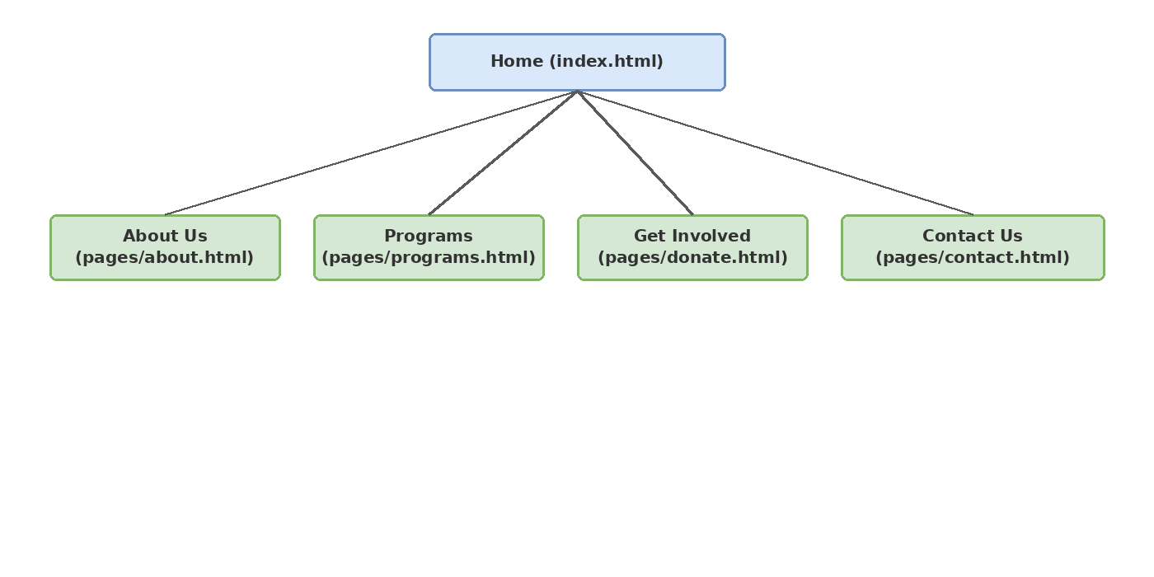
Website Sitemap
The website sitemap shows the main navigation structure, with Home linking to About Us, Programs, Get Involved, and Contact.
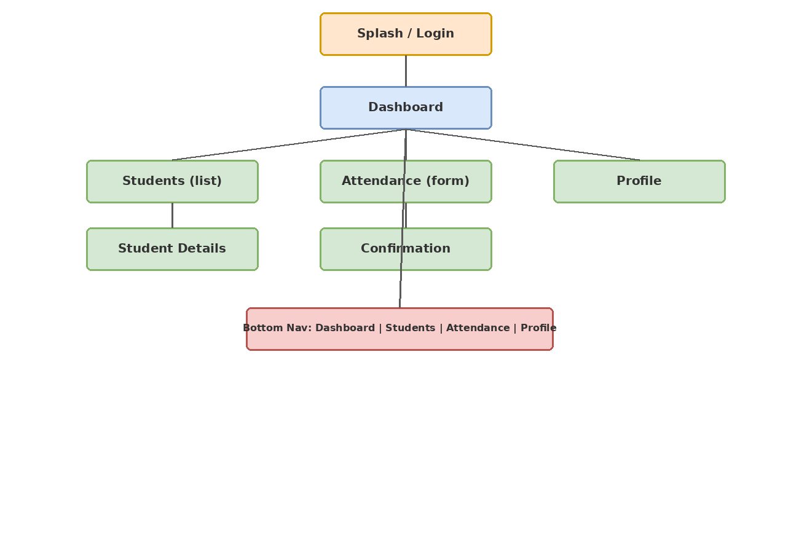
Mobile App Sitemap
The mobile app mirrors the website's structure (Dashboard as Home, Students/Programs, Attendance/Enrolments, Profile) for a consistent user journey across platforms, reflecting BrightStart's actual role-based modules.

Wireframes
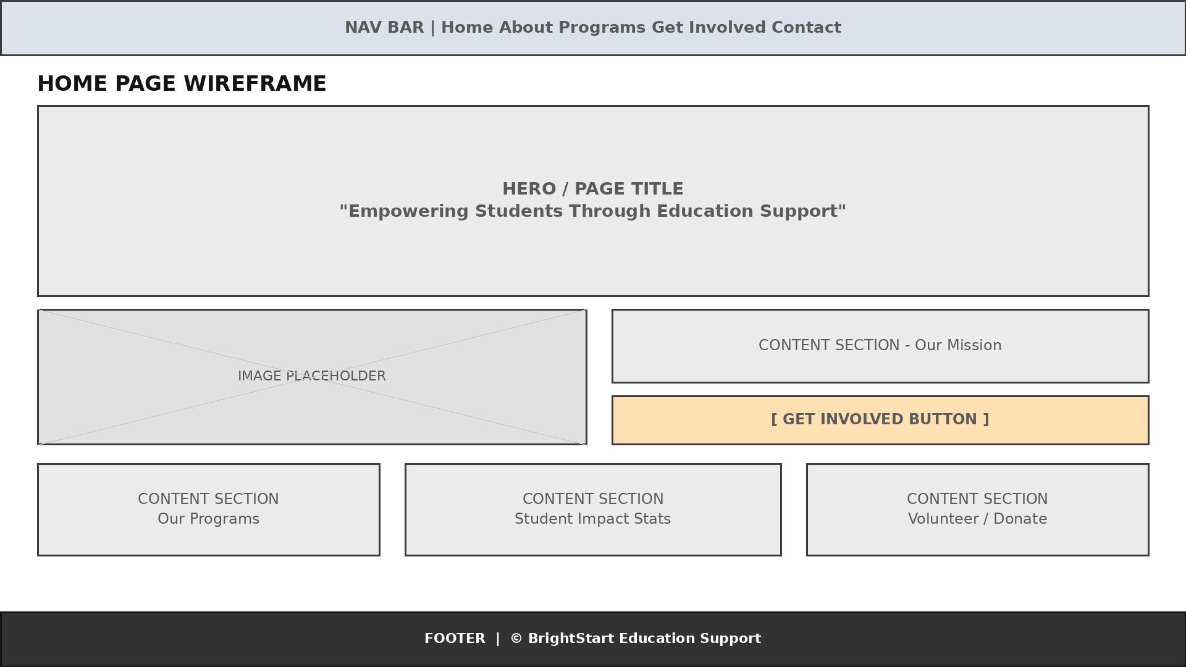
Home Page Wireframe
Shows the hero banner, navigation, and get-involved call-to-action layout.
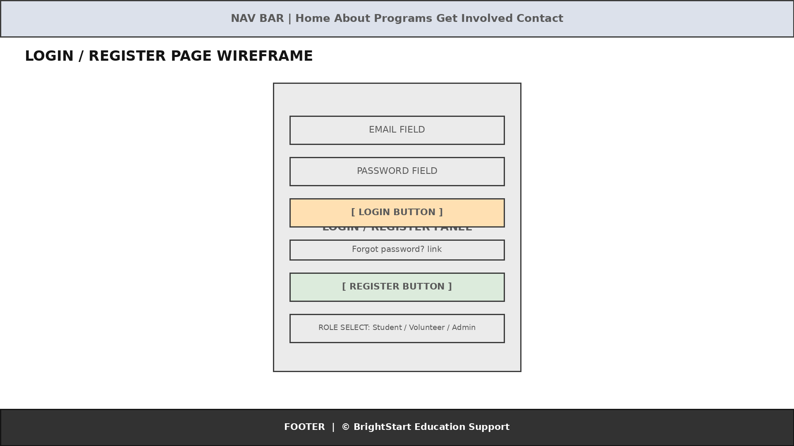
Login/Register Page Wireframe
Shows the login fields and role selection (Student/Volunteer/Admin).
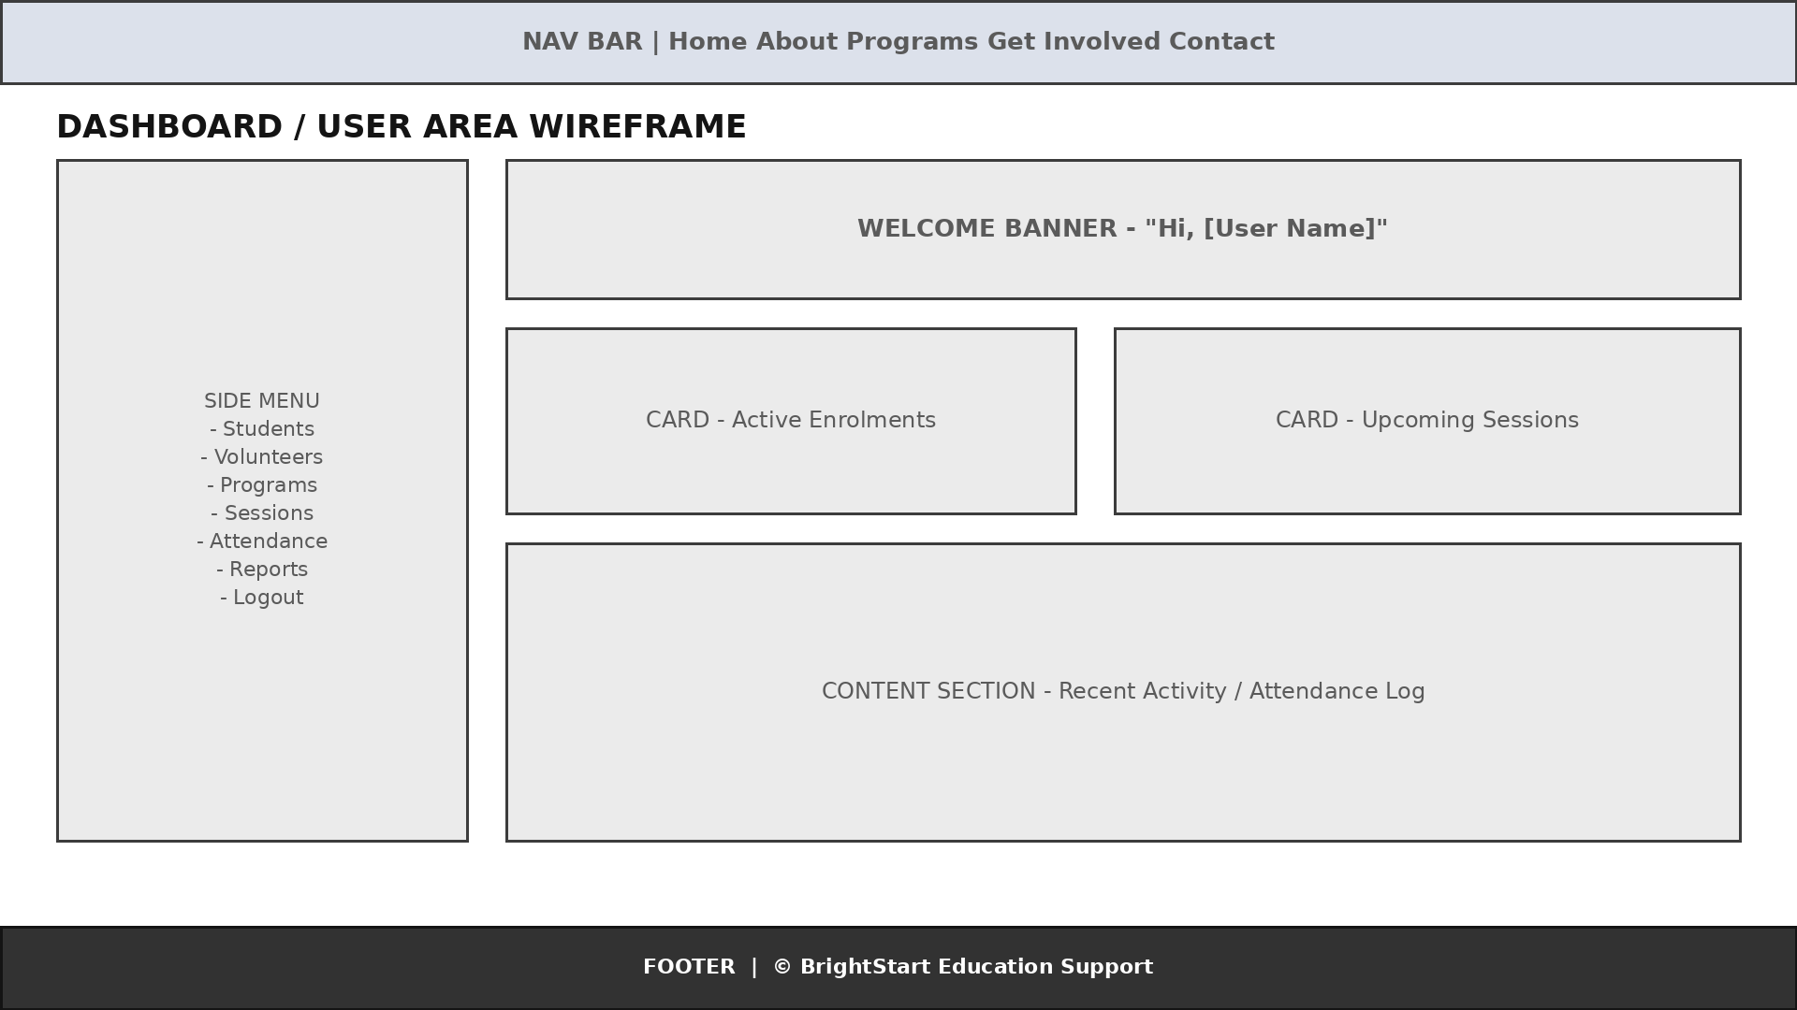
Dashboard Page Wireframe
Shows the staff/volunteer dashboard with enrolments and session tracking.
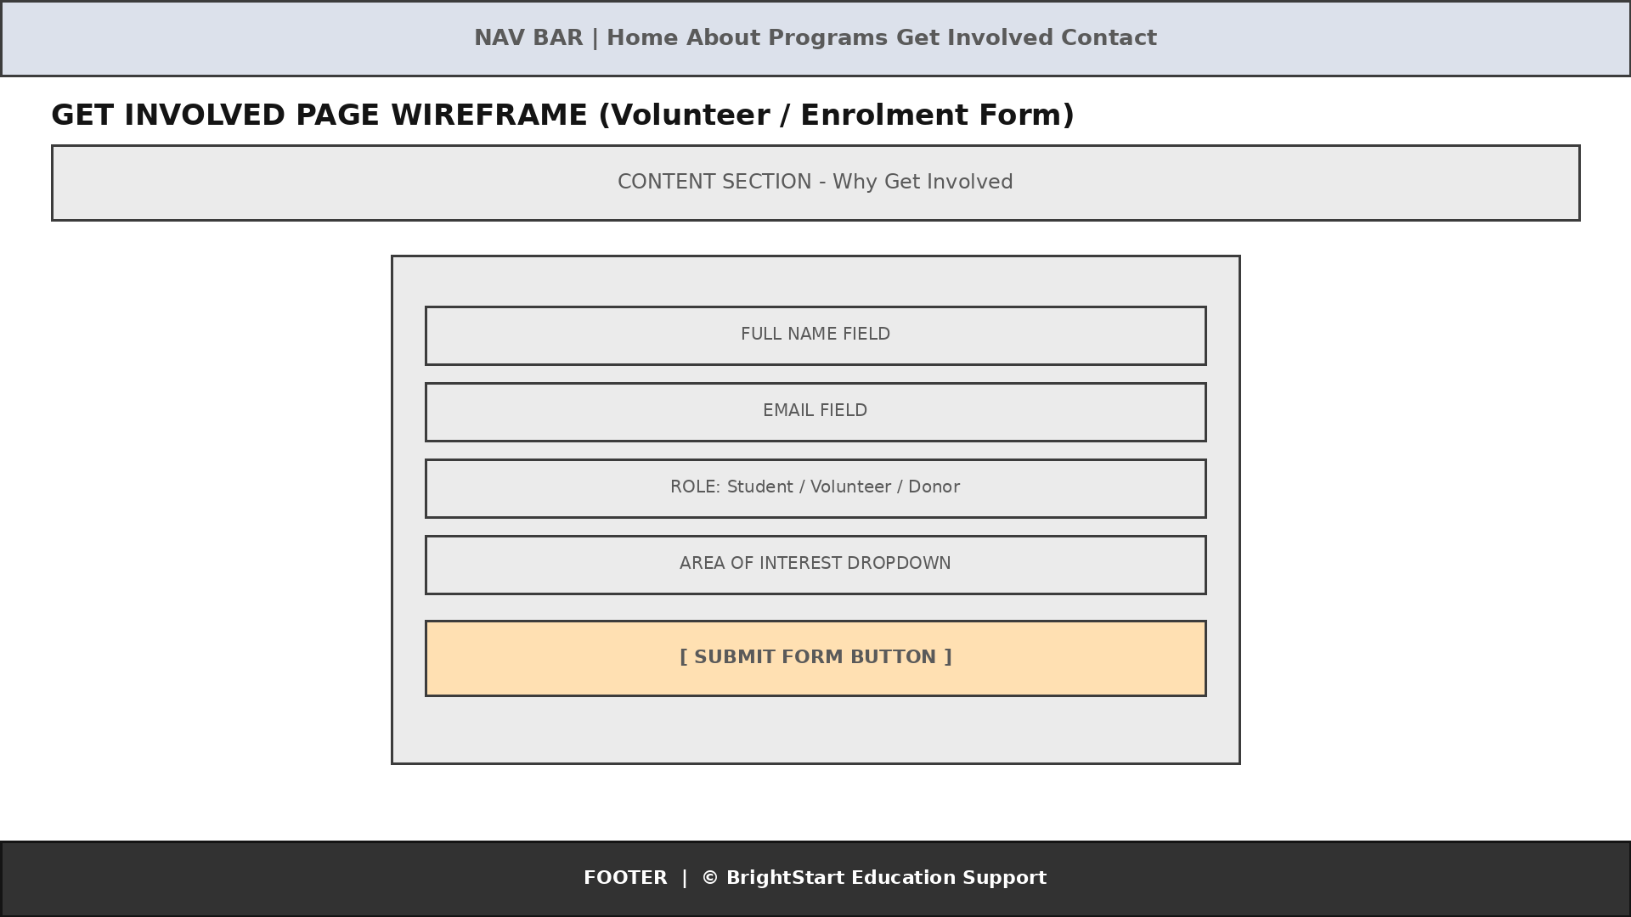
Get Involved Page Wireframe
Shows the volunteer/enrolment sign-up form layout and submit button placement.
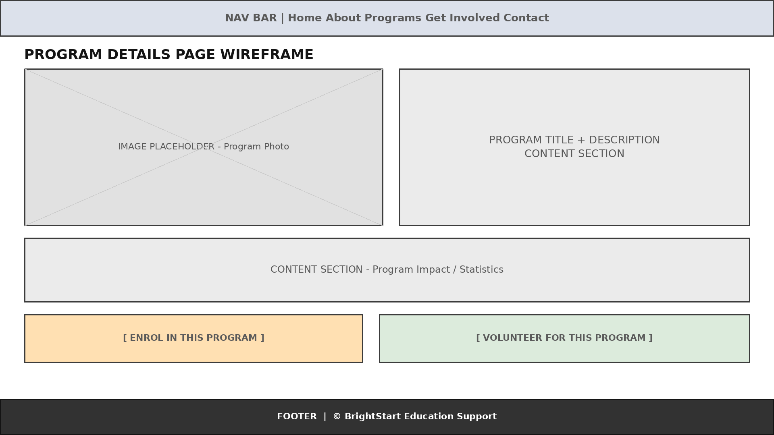
Program Details Page Wireframe
Shows programme information and enrol/volunteer calls to action.
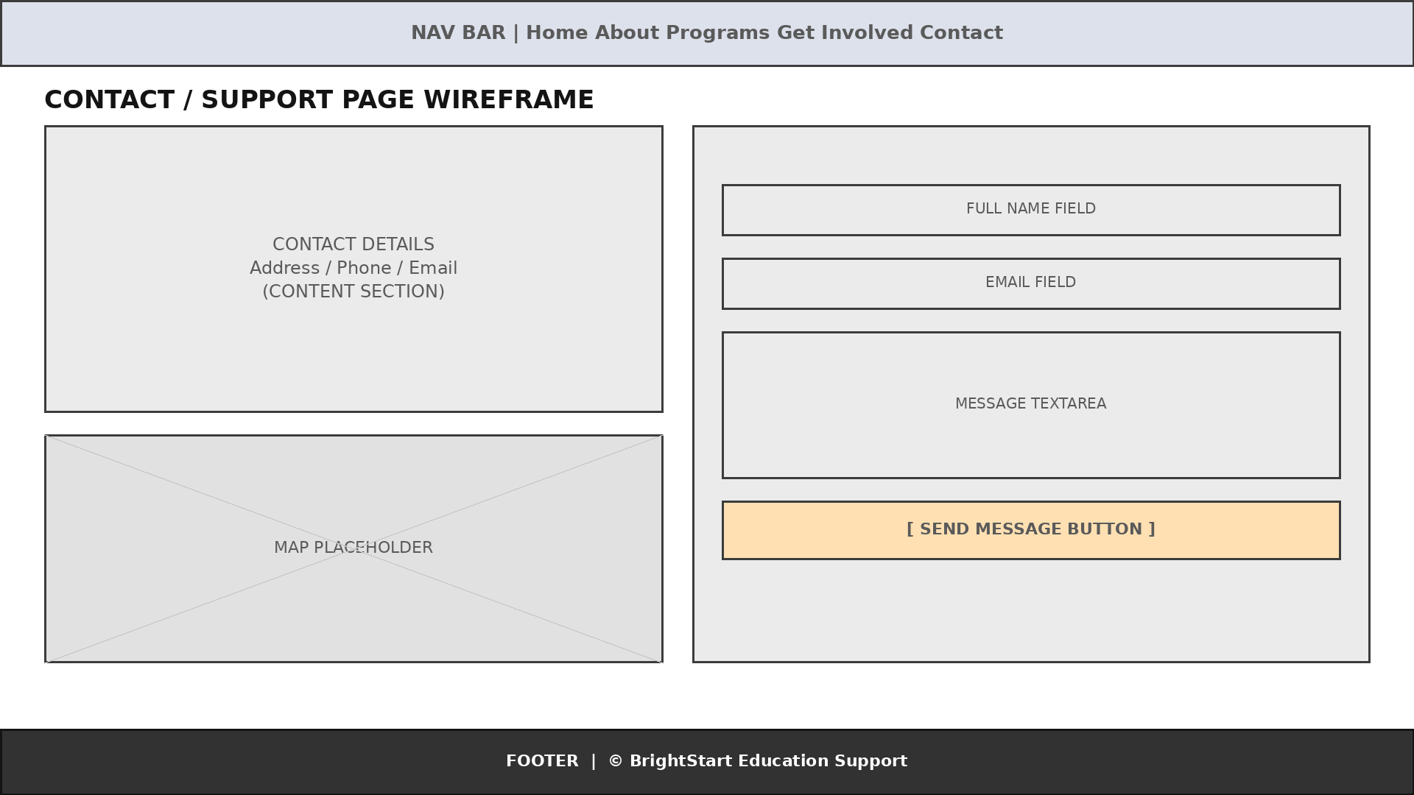
Contact Page Wireframe
Shows the contact form and location details.
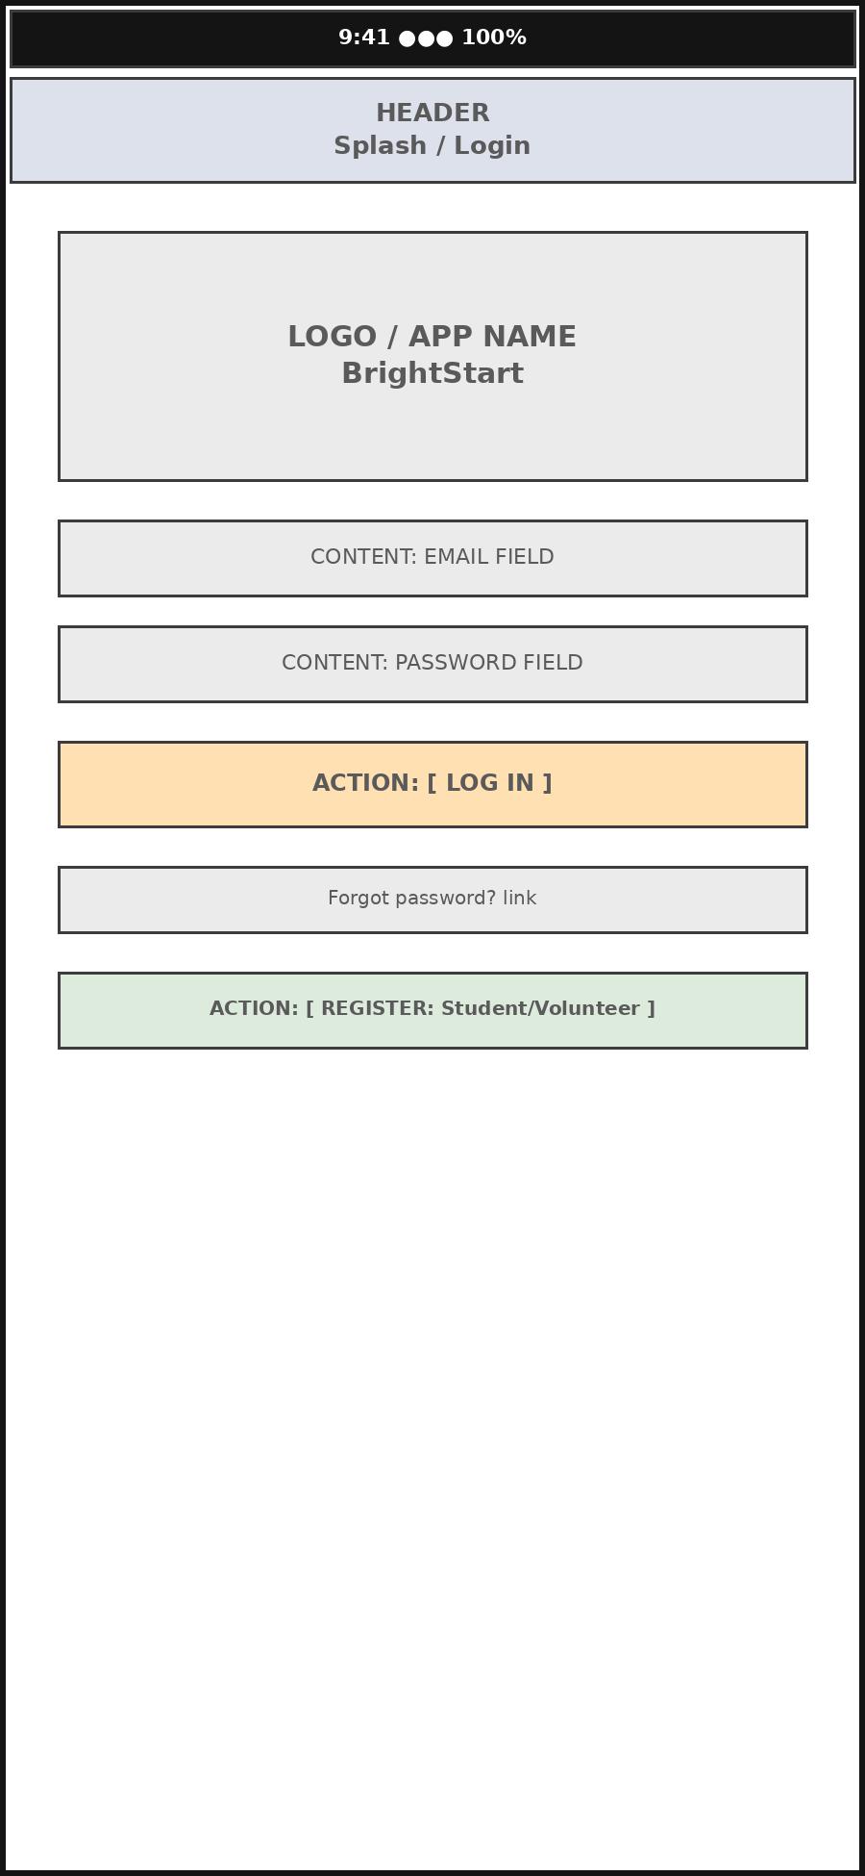
Mobile App - Splash/Login Wireframe
Shows the mobile login and role-based registration flow.
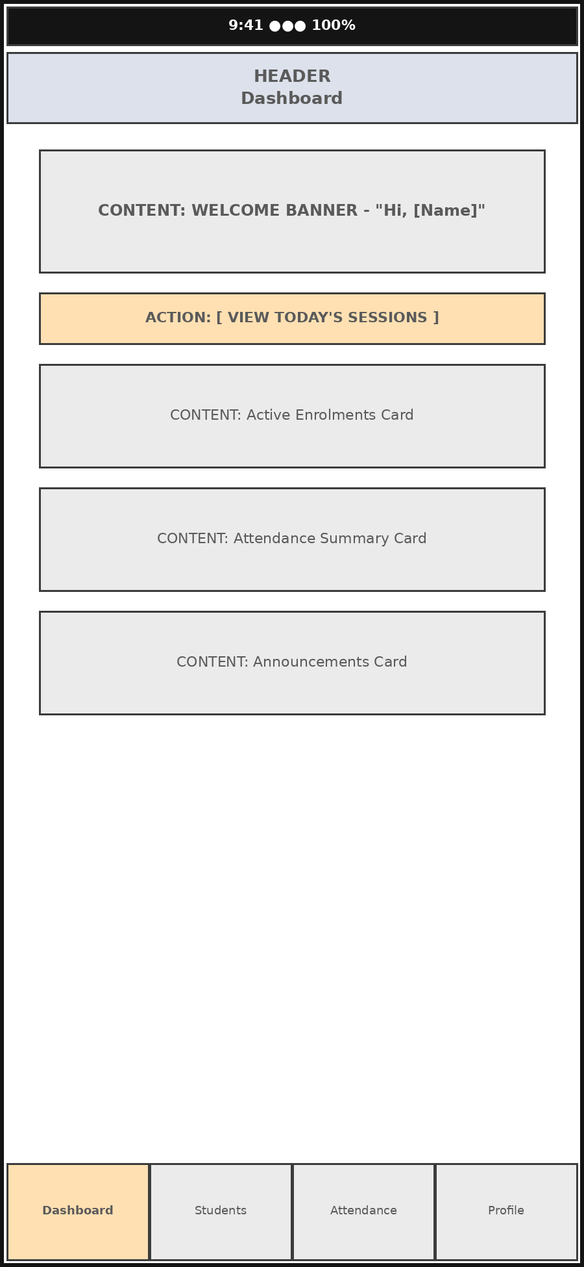
Mobile App - Dashboard Wireframe
Shows the mobile dashboard, enrolments summary, and bottom navigation.
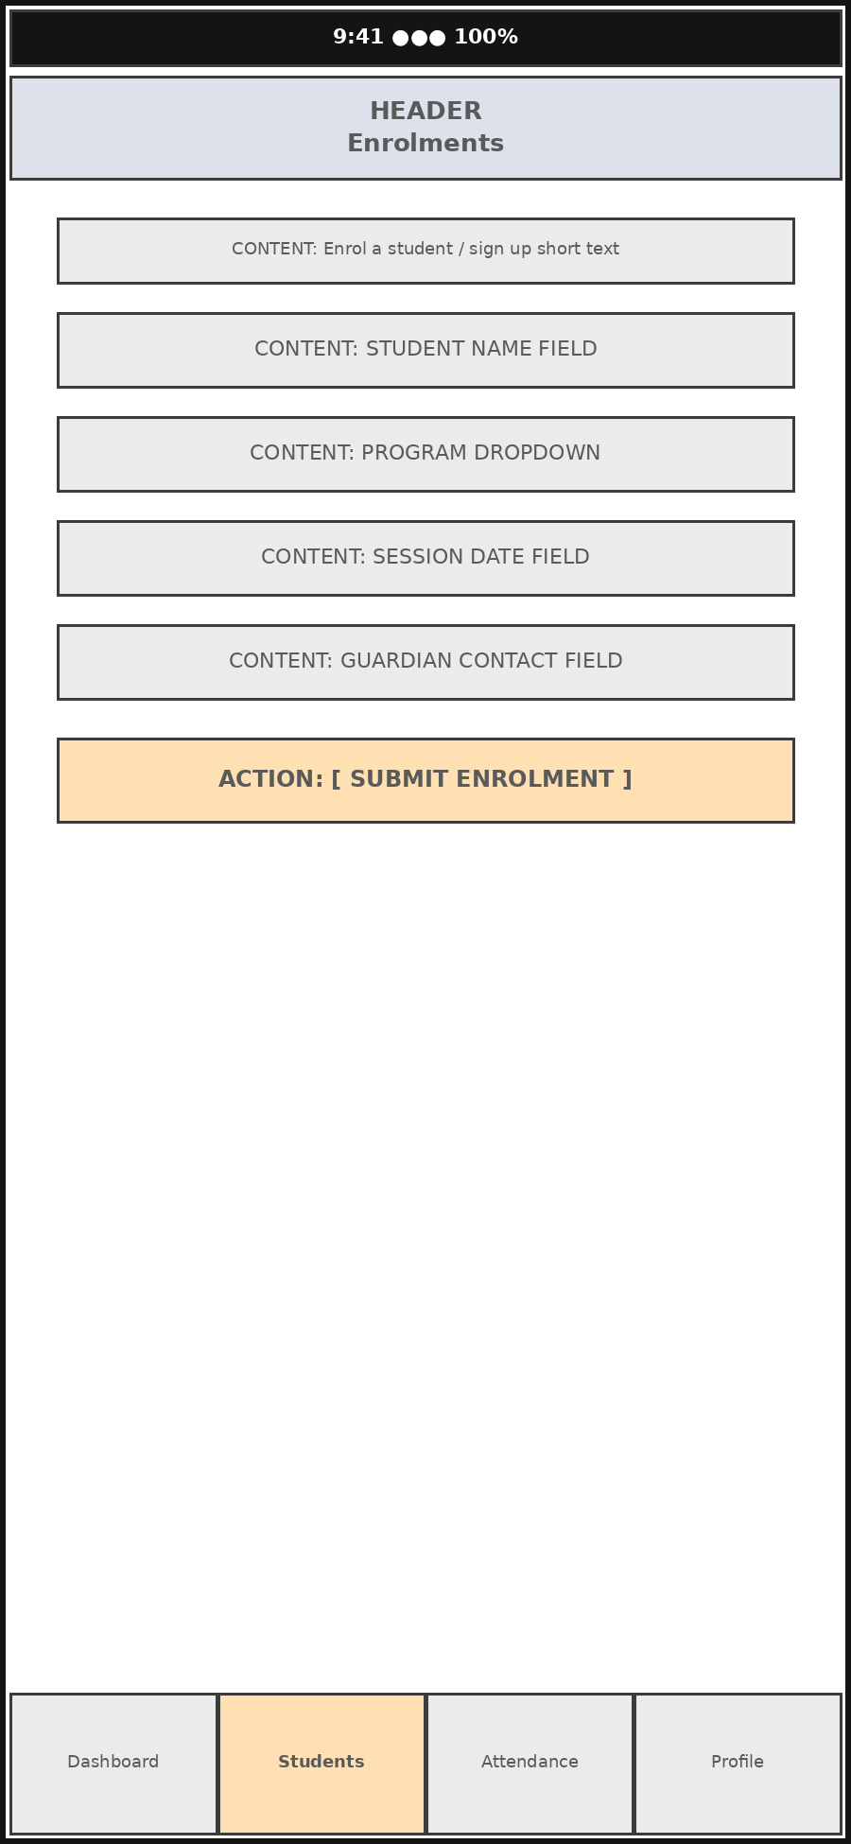
Mobile App - Enrolments Form Wireframe
Shows the mobile student enrolment form.
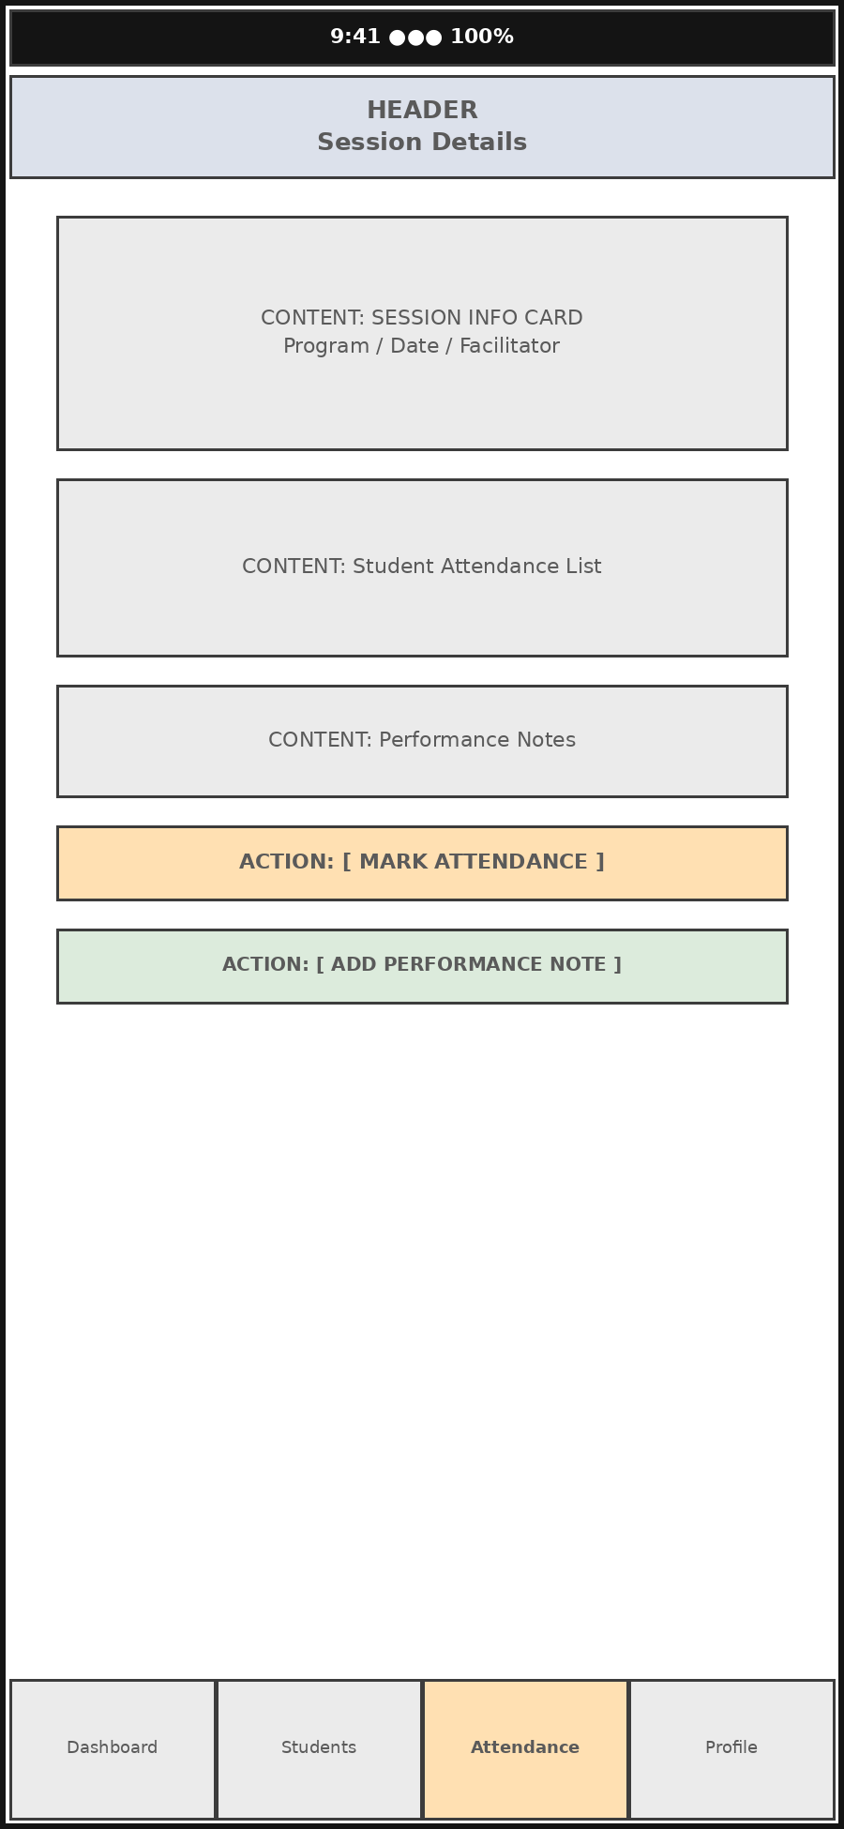
Mobile App - Session Details Wireframe
Shows the mobile session details, attendance marking, and performance notes.
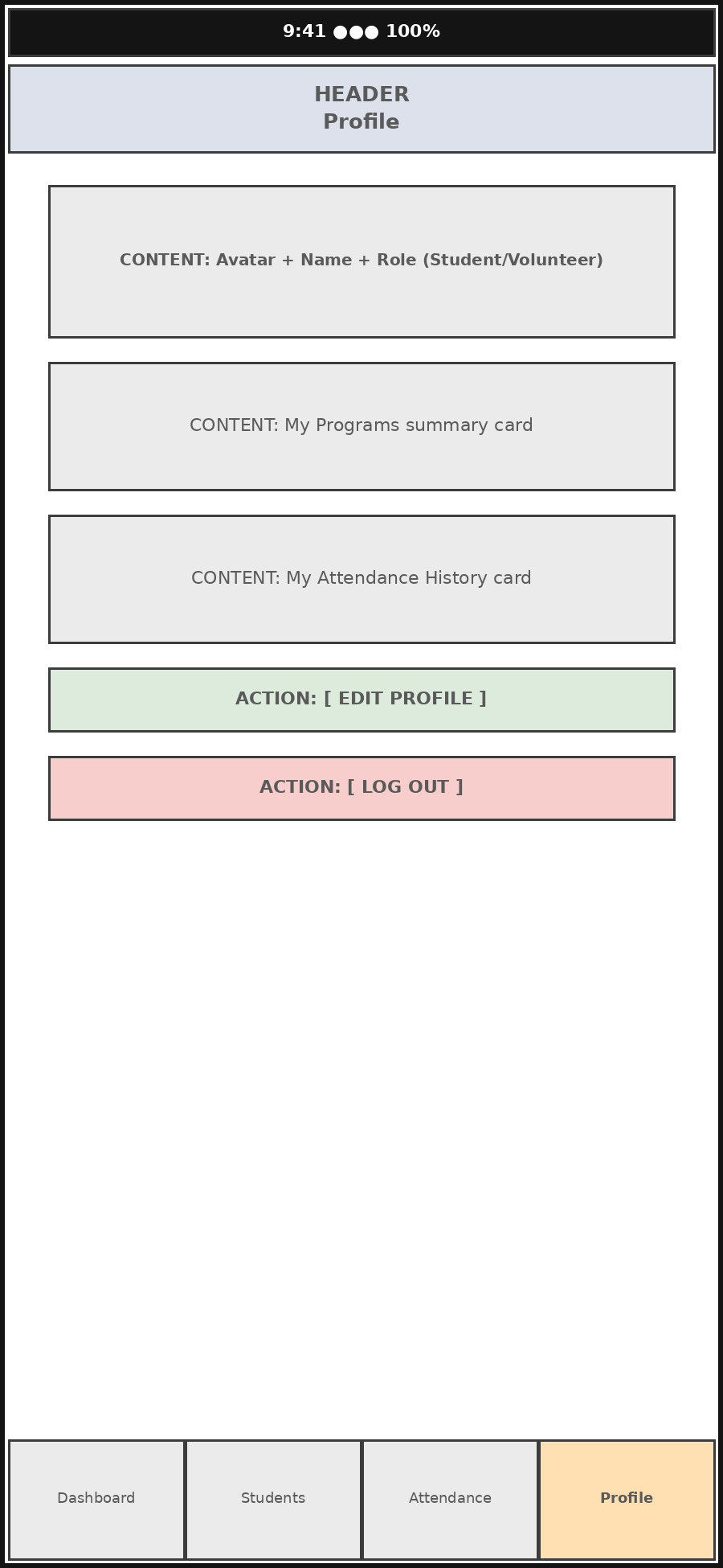
Mobile App - Profile Wireframe
Shows the mobile user profile screen.

