22L-7883

SE-C

SCD LAB 5

TASK 1:

1. Create a temporary user

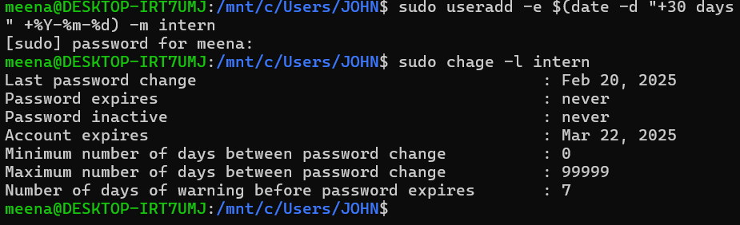

1. Restrict simultaneous logins



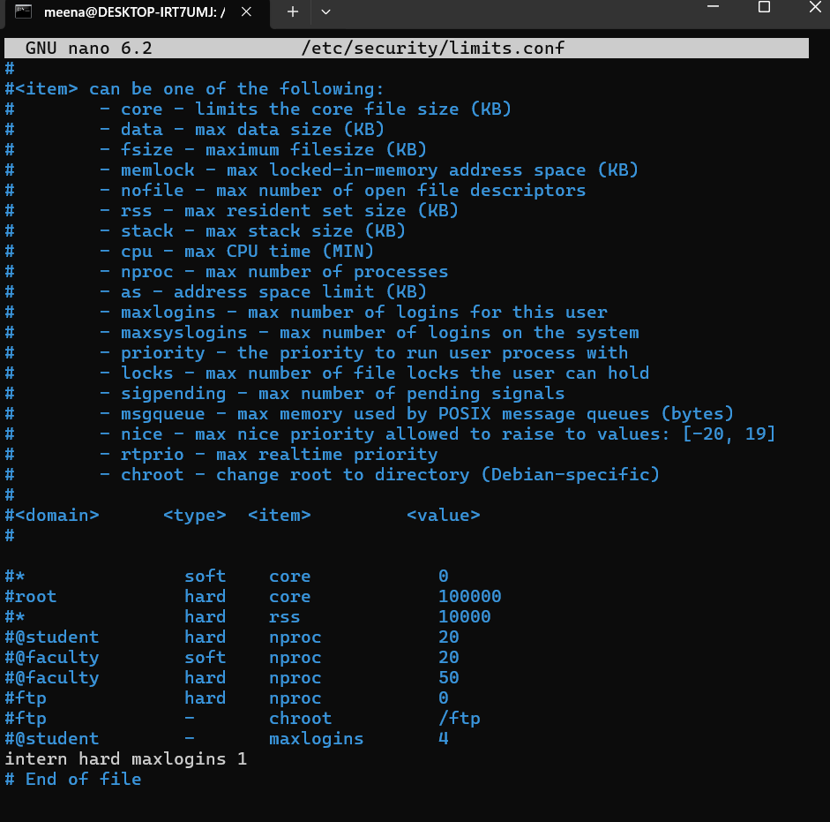

1. Deny login during off-hours



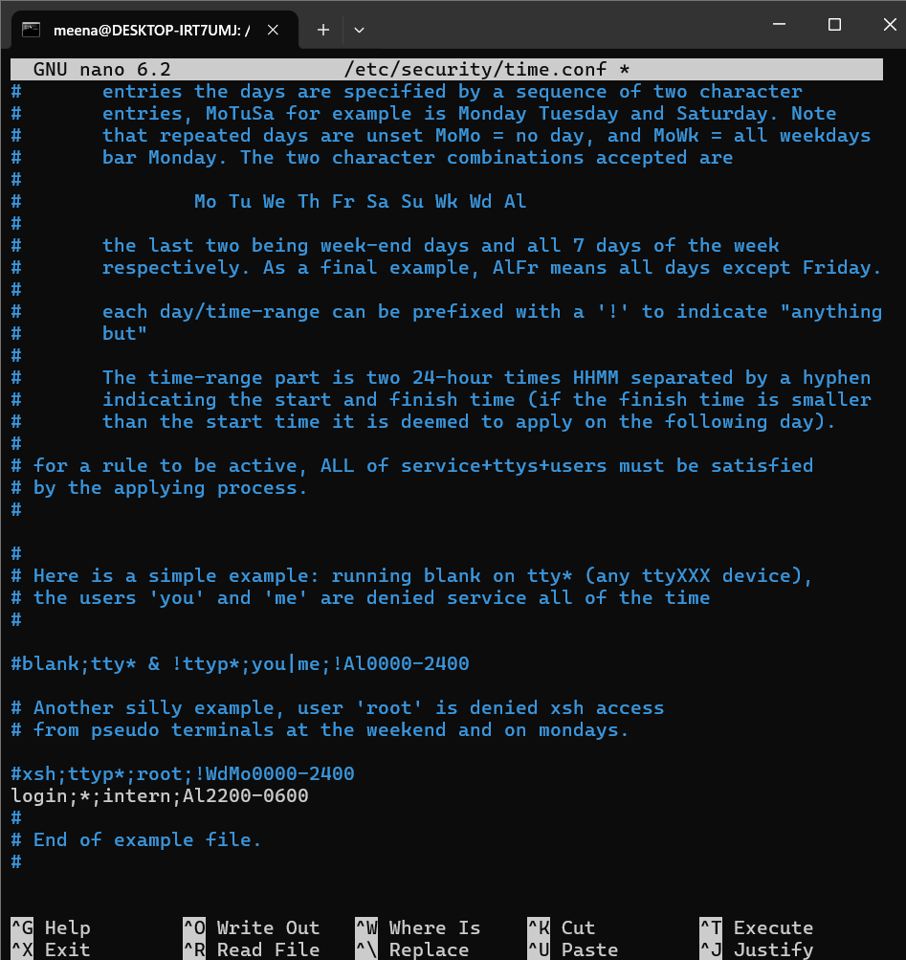

TASK 2:

1. Create a group project



1. Add users dev1 and dev2 to project

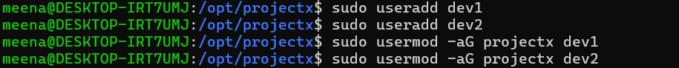

1. Create a shared directory /opt/project



1. Enable the setgid permission

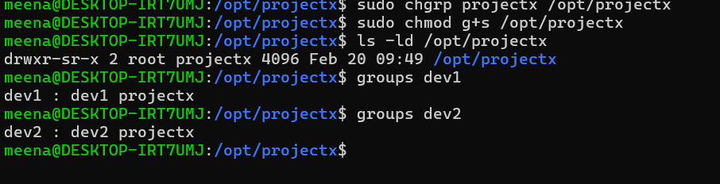

TASK 3:

1. Log Currently Logged-in Users Every 30 Minutes

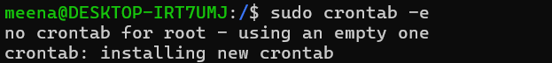

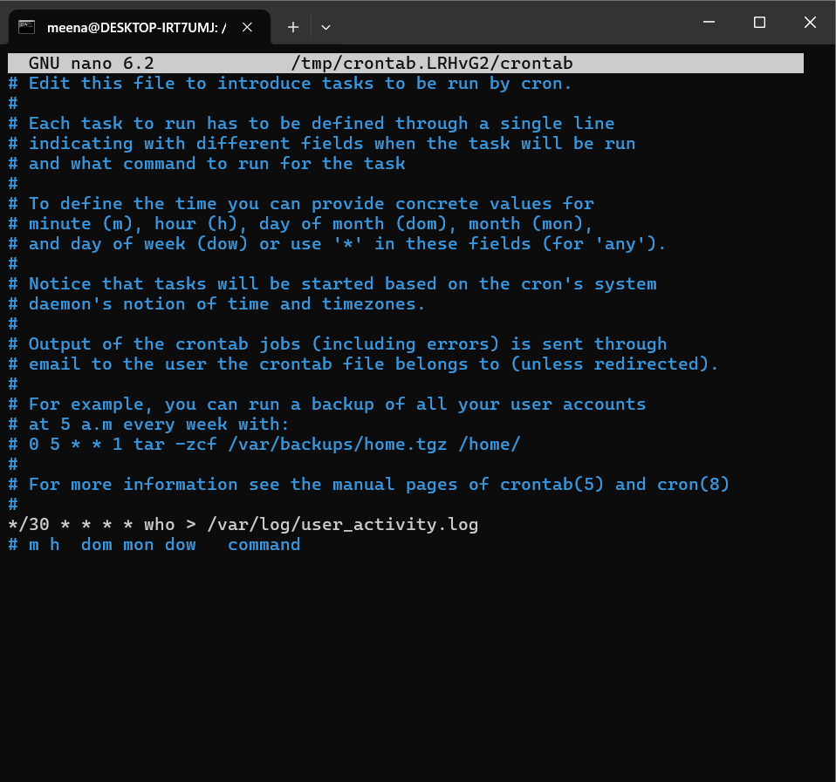

1. Check Disk Usage Every Day at 12 AM

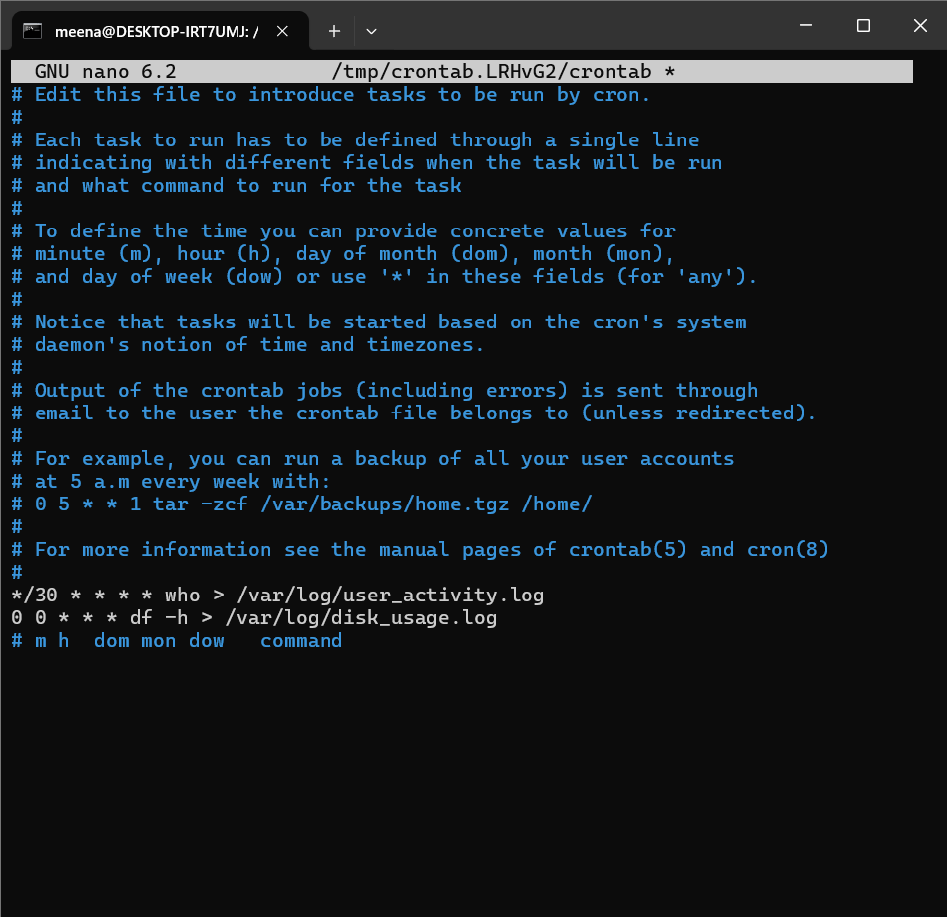

1. Clear Temporary Files Every Sunday at 3 AM

