22L-7883

SE-C

SCD LAB 4

APACHE2:

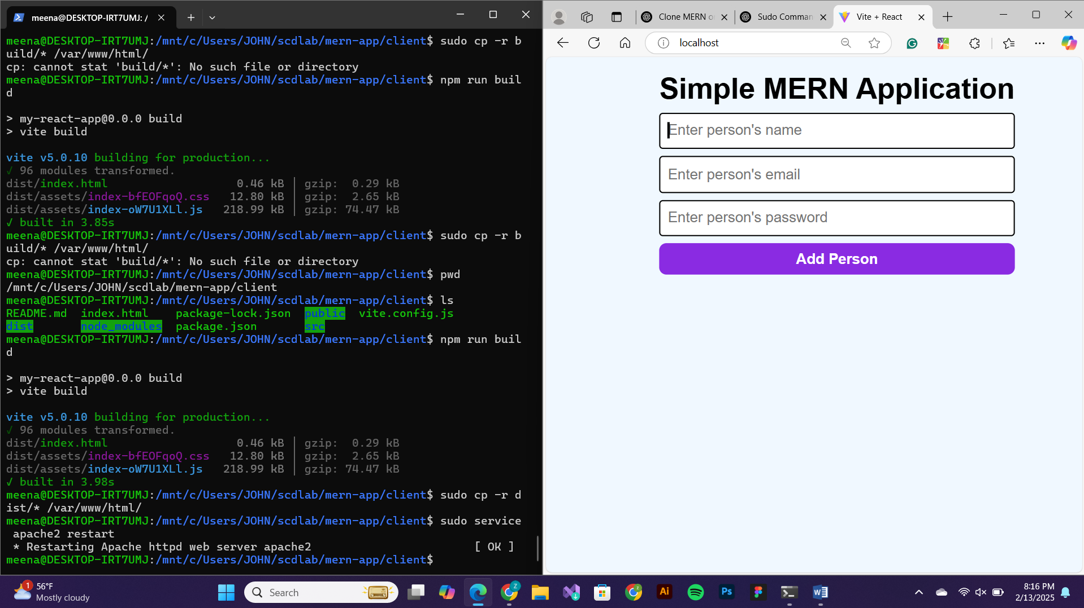

NGINX:

