Smart Student Assistance System (SSAS)
Project Report: Software Development Life Cycle (SDLC)
Multi-User Build — Supabase Backend + Hybrid Groq LLM AI Assistant
Submitted by: M. Moin
BS Computer Science
Department of Computer Science, Air University, Islamabad
August 2026

This edition documents the system exactly as delivered: real multi-user authentication, a Postgres database secured with Row Level Security, cloud file storage, and an AI assistant that calls a hosted LLM with a rule-based fallback — every file in the submission is accounted for below.

Table of Contents
Table of Contents 2
1. Introduction 4
1.1 Problem Statement 4
1.2 Objectives 4
1.3 Scope 4
1.4 Preliminary Risk Analysis 5
2. Requirement Analysis 6
2.1 Functional Requirements 6
2.2 Non-Functional Requirements 6
2.3 Use Case Diagram 7
2.4 Selected Use Case Descriptions 8
3. System Design 10
3.1 System Architecture 10
3.2 Database Schema 10
4. Implementation 16
4.1 Technology Stack (as delivered) 16
4.2 Project File Structure & File-by-File Description 16
4.3 Core Module Walkthrough 17
4.4 AI Assistant — Hybrid Architecture (js/assistant.js) 18
4.5 Database Security — Row Level Security in Practice 20
4.6 Original Static Prototype vs. the Delivered Application 20
4.7 Known Limitations & Security Observations 20
5. Testing 22
5.1 Unit Testing 22
5.2 Integration Testing 22
5.3 Multi-User & Row Level Security Testing 23
5.4 User Acceptance Testing (UAT) 23
6. Deployment 25
6.1 Hosting Plan 25
6.2 Local Development Setup 25
6.3 Deployment Steps (to a public host) 25
6.4 Getting Started (User Instructions) 26
7. Maintenance Strategy 27
7.1 Update & Bug-Fix Cycle 27
7.2 Feedback Integration Loop 27
8. Conclusion 28
Appendix A: Submission File Manifest 28

1. Introduction
Air University’s administration has observed that first-semester students frequently struggle to organize their class schedules, track assignment and exam deadlines, and locate the right study material at the right time. Because these students are new to university-level workload and have not yet developed independent time-management habits, small planning gaps often snowball into missed deadlines, exam-time stress, and inconsistent study routines. The Smart Student Assistance System (SSAS) was built as a lightweight, AI-assisted web application that centralizes schedule management, study-resource access, and performance tracking, and adds a conversational assistant that answers routine questions and can suggest a study plan on demand.
Unlike a purely conceptual proposal, SSAS was carried through to a working, deployable, multi-user product: student accounts, data, and files are real and persist in a managed cloud database, and every student’s data is isolated from every other student’s at the database level. This report documents that delivered system — file by file — alongside the SDLC process that produced it.

1.1 Problem Statement
First-semester students lack a single, easy-to-use platform that combines schedule tracking, study-resource access, deadline visibility, and study-habit feedback. They currently rely on a mix of paper planners, WhatsApp groups, and memory, which is unreliable and does not scale as course load increases. There is a need for a system that consolidates these activities and uses AI to reduce the manual effort of tracking and planning.

1.2 Objectives
- Provide a single dashboard where students can manage class schedules, assignment deadlines, and exam dates.
- Allow students to upload, organize, and retrieve study resources such as lecture notes and supplementary material.
- Offer an AI-driven chatbot that answers frequently asked questions about the student’s own data and suggests a study schedule based on their free hours.
- Let students log study hours and completed assignments, and present this data as simple visual (bar-chart and progress-bar) insights.
- Deliver a secure, multi-user MVP that a non-technical first-semester student can use within minutes of first signing up.

1.3 Scope
In Scope — Delivered in this submission
- Student registration/login (Supabase Auth), class/assignment/exam schedule CRUD, resource upload & browsing.
- A hybrid AI Assistant — a hosted LLM (Groq) as the primary engine, with a rule-based intent-matching engine as an automatic fallback — for FAQs and free-hour-based study suggestions.
- Study-hour logging and bar-chart / progress-bar performance insights (Chart.js).
- A responsive web application accessible on desktop and mobile browsers.
- Database-level data isolation between students via PostgreSQL Row Level Security (RLS), not just application-level filtering.
Out of Scope — Not present in this submission (Future Releases)
- Direct integration with the university’s LMS/ERP for automatic timetable import.
- An administrator interface (the database already has a role column and RLS is ready for it, but no admin UI or logic was built).
- Automated deadline/exam reminder delivery (a reminders table exists in the schema, but no code currently writes to it or sends a notification).
- Resource search/filter by course, and peer collaboration / gamified leaderboards.
- Native mobile apps (this release is a responsive web app only).
Note: the original project roadmap treated a free-form, LLM-based conversational assistant as a Phase-2 stretch goal, with a simpler rule-based chatbot planned for the MVP. In practice, the delivered AI Assistant already integrates a hosted LLM (Groq) as its primary engine — the rule-based engine ended up implemented as the fallback rather than the main path. This is reflected throughout the report below.

1.4 Preliminary Risk Analysis
The table below summarizes the key risks identified during project initiation, with an updated column showing how each risk actually played out during implementation.
ID | Risk | Likelihood | Impact | Mitigation / Actual Outcome
R1 | Low adoption — students unfamiliar with the platform | Medium | High | Mitigation planned: in-app onboarding, quick-action chips on the Dashboard that pre-fill common chatbot questions.
R2 | Chatbot misinterprets free-text queries | High | Medium | Actioned: primary path now uses a hosted LLM (Groq) for open-ended understanding; the original MVP-level rule engine (regex/keyword matching, confidence-free but predictable) was kept as an automatic fallback rather than dropped.
R3 | Data privacy / security breach of student records | Low | High | Actioned: Supabase Auth (hashed credentials, JWT sessions) + TLS in transit + PostgreSQL Row Level Security enforced per student_id at the database layer (see §3.2, §4.5).
R4 | Server downtime during peak load (near deadlines) | Medium | High | Mitigated by design: no custom application server to keep up — Supabase’s managed infrastructure and CDN-backed static hosting (Vercel/Netlify) absorb this; not load-tested for this submission.
R5 | Scope creep from stakeholder feature requests | Medium | Medium | MVP scope was frozen; unimplemented items (admin panel, reminders delivery, resource search) are explicitly logged as a Phase-2 backlog in §1.3 and §7.
R6 | Large resource file uploads slow the system | Medium | Low | Actioned: client-side file-type allow-list and a 20 MB size cap are enforced before any upload starts (js/app.js, ALLOWED_TYPES / MAX_FILE_MB).
R7 | Team skill gaps in AI/NLP integration | Medium | Medium | Actioned: used a hosted LLM API (Groq) instead of building NLP from scratch, exactly as the original mitigation proposed.

2. Requirement Analysis
Requirements were gathered by analyzing the case study, considering typical first-semester student pain points, and reviewing the intended AI-driven features. Requirements are grouped into functional (what the system must do) and non-functional (how well it must do it). Each requirement below is marked with its actual delivery status in the submitted codebase, so the reader does not have to cross-check the file listing separately.

2.1 Functional Requirements
ID | Requirement | Status | Delivered In
FR-01 | The system shall allow a student to register and log in securely. | Implemented | index.html, signup.html, js/auth.js, Supabase Auth
FR-02 | The system shall allow a student to add, edit, and delete class/assignment/exam schedule entries. | Implemented | app.html (Schedule view + edit modal), js/app.js
FR-03 | The system shall display upcoming deadlines on the dashboard, sorted by date. | Implemented | js/app.js — loadDashboard()
FR-04 | The system shall allow a student to upload study resources tagged by course. | Implemented | js/app.js — uploadResource(), Supabase Storage
FR-05 | The system shall allow a student to browse, search, and download previously uploaded resources. | Partially Implemented | Browse & download: js/app.js — loadResources()/viewResource(). Search/filter by course: not yet built (Phase-2).
FR-06 | The chatbot shall answer FAQ-style questions about the student’s own schedule. | Implemented | js/assistant.js — Groq LLM primary + rule-based fallback, both read live Supabase data
FR-07 | The chatbot / scheduler shall send reminders for upcoming deadlines and exams. | Not Implemented | Schema only — reminders table exists in supabase_schema.sql; no code currently writes to it or dispatches a notification
FR-08 | The chatbot shall suggest a study schedule when given available free hours. | Implemented | js/assistant.js — system-prompt instruction (Groq path) + rule 4 of smartFallbackReply()
FR-09 | The system shall allow a student to log daily study hours and mark assignments as completed. | Implemented | js/app.js — logStudySession(), markDone()
FR-10 | The system shall generate simple visual insights of study hours and per-course progress. | Implemented | js/app.js — renderWeeklyChart() (Chart.js), renderCourseProgress()
FR-11 | An administrator shall be able to manage user accounts and monitor overall system usage. | Not Implemented | profiles.role column exists in the schema; no admin UI or logic was built for this release

2.2 Non-Functional Requirements
ID | Category | Requirement | Status
NFR-01 | Usability | A first-time user should learn the core features (add a deadline, ask the chatbot) in under 10 minutes without training. | Implemented
NFR-02 | Performance | Dashboard pages load within 2s; chatbot responds within 3s for 95% of queries. | Not Benchmarked
NFR-03 | Reliability | The system shall maintain at least 99% uptime during the academic semester. | Not Benchmarked
NFR-04 | Security | Passwords hashed; all traffic over TLS; access role-based (student vs. admin). | Partially Implemented
NFR-05 | Scalability | The system shall support at least 5,000 concurrent first-semester students. | Not Benchmarked
NFR-06 | Portability | The application shall be a responsive web app usable on desktop and mobile browsers. | Implemented
NFR-07 | Maintainability | Modular codebase with documented APIs and ≥70% unit-test coverage on core modules. | Partially Implemented
NFR-08 | Compatibility | The application shall support the latest two versions of Chrome, Firefox, Edge, and Safari. | Not Benchmarked
Notes on the non-benchmarked / partial items — recorded honestly rather than assumed:
- NFR-02 / NFR-05 / NFR-08: no load testing or cross-browser test matrix was run for this submission; the app was exercised manually on a Chromium-based desktop browser only.
- NFR-03: no production uptime monitoring is configured; the deployment is a single Supabase project with no failover tested.
- NFR-04: password hashing, TLS, and per-student data isolation (RLS) are all delivered via Supabase Auth/Postgres. The “role-based access” half is only partial — the profiles.role column exists and defaults to ‘student’, but no route or UI actually branches on it yet, so an ‘admin’ role currently has no special access in the app itself.
- NFR-07: the codebase is modular (auth.js / app.js / assistant.js / supabase-client.js are each single-responsibility), but there is no automated test suite (e.g. Jest) in the submission — all testing in §5 was performed manually.

2.3 Use Case Diagram
Two actors were designed into SSAS: the Student, who performs the day-to-day activities, and a System Administrator, who would manage accounts and monitor the platform. Figure 1 shows the full set of use cases considered during design. Of these, every Student-side use case is implemented in the delivered code; the two Administrator use cases (shaded differently below only in description, not the diagram) remain design-only — no admin.html or admin-role logic exists in this submission.
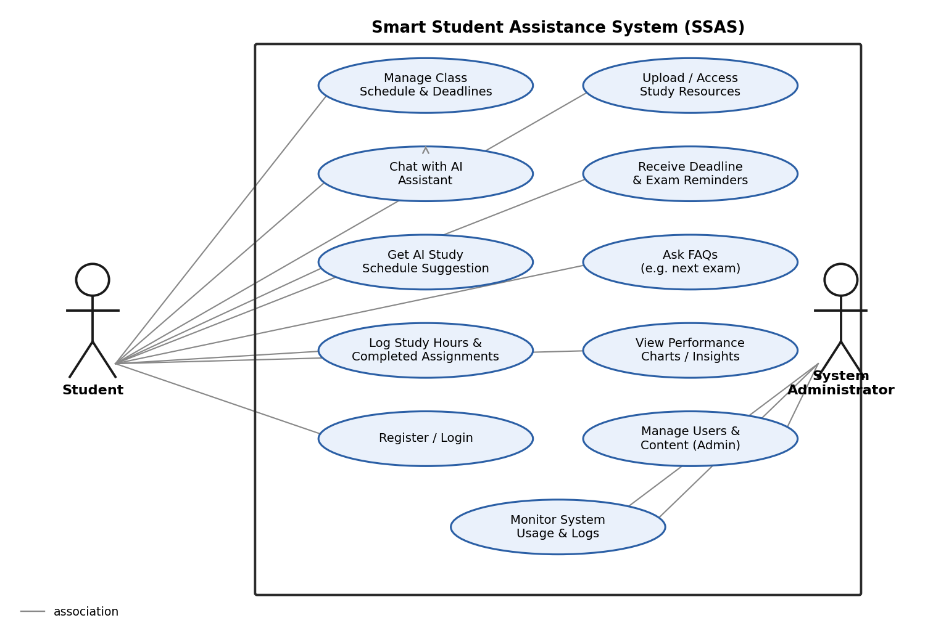
Figure 1: SSAS Use Case Diagram (Student use cases are fully implemented; Administrator use cases are design-only in this release)

2.4 Selected Use Case Descriptions

UC-1: Chat with AI Assistant
Field | Description
Actor | Student
Precondition | Student is logged in (an active Supabase session exists).
Main Flow | 1) Student opens the AI Assistant screen or a Dashboard quick-action chip. 2) Student types a question. 3) assistant.js fetches the student’s live schedule_items and last-7-days study_logs from Supabase and builds a system prompt from them. 4) The message is sent to Groq (llama-3.1-8b-instant, falling back through llama-3.3-70b-versatile and gemma2-9b-it on failure/timeout). 5) If all three Groq models fail, smartFallbackReply() classifies the message with keyword/regex rules instead. 6) The reply is shown, and the exchange is saved to chat_interactions.
Postcondition | Student receives an answer grounded in their own real data, from either engine — never a silent failure.

UC-2: Get AI Study Schedule Suggestion
Field | Description
Actor | Student
Precondition | Student has at least one pending (non-‘done’) schedule item and is logged in.
Main Flow | 1) Student tells the chatbot how many free hours they have (e.g. “I have 2 free hours, suggest a study plan”). 2) The system retrieves pending schedule items ordered by date. 3) Free hours are split evenly across the nearest 3 pending items and returned as a numbered plan (rule 4 of smartFallbackReply(), or the equivalent instruction in the Groq system prompt).
Postcondition | Student receives a proposed time allocation across their nearest pending tasks.

UC-3: Log Study Hours & Completed Assignments
Field | Description
Actor | Student
Precondition | Student is logged in.
Main Flow | 1) Student opens Performance Tracking and enters hours studied (optionally a course) and whether a task was completed — or logs hours conversationally via the chatbot (“Log 1 hour of study for DBMS”). 2) Either path inserts a row into study_logs. 3) The Dashboard stat, the weekly Chart.js bar chart, and the course-progress bars are all re-rendered from the same table.
Postcondition | Updated study data is persisted and reflected consistently across every screen that reads it.

3. System Design

3.1 System Architecture
SSAS is built as a Backend-as-a-Service (BaaS) application rather than a traditional three-tier web app with a custom REST API server. The browser client (static HTML/CSS/JavaScript) talks directly to Supabase — which provides authentication, a PostgreSQL database, and file storage — using the Supabase JavaScript SDK, and talks directly to the Groq Cloud LLM API for chatbot replies. There is no Node.js/Express (or similar) server in the submission; the “application logic” that a traditional backend would hold instead lives in the client-side JS modules (js/app.js, js/auth.js, js/assistant.js), while data-level security is enforced independently by PostgreSQL Row Level Security — not by trusting the client. Figure 2 shows this as actually implemented.
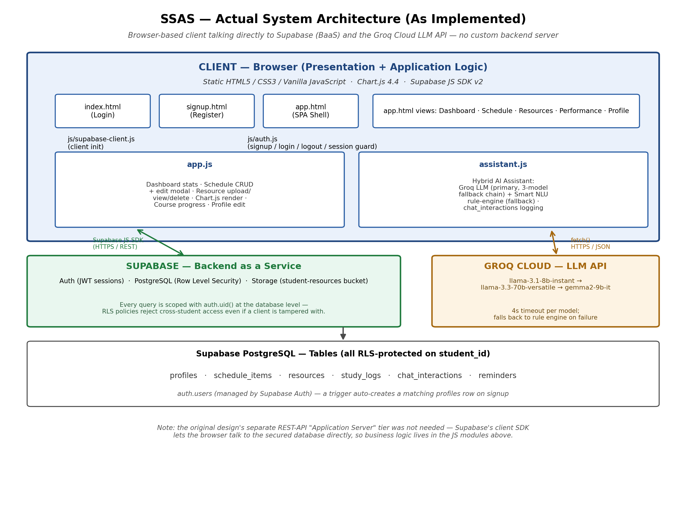
Figure 2: SSAS system architecture as implemented — client talks directly to Supabase (BaaS) and Groq Cloud
This differs from the layered client → REST API → database design that is often the default assumption for a web app project. The BaaS approach was a deliberate simplification: it removes an entire server tier to maintain, while still meeting the security requirement (NFR-04) because RLS policies run inside Postgres itself and cannot be bypassed by editing client-side JavaScript — see §4.5 for a concrete demonstration.

3.2 Database Schema
The schema is centered on Supabase’s built-in auth.users table. A Postgres trigger (handle_new_user) automatically creates a matching profiles row the moment a student signs up. Five further tables — schedule_items, resources, study_logs, chat_interactions, and reminders — each carry a student_id foreign key back to auth.users(id) and are individually protected by Row Level Security. Figure 3 is drawn directly from supabase_schema.sql, so every column shown below exists verbatim in the delivered SQL.
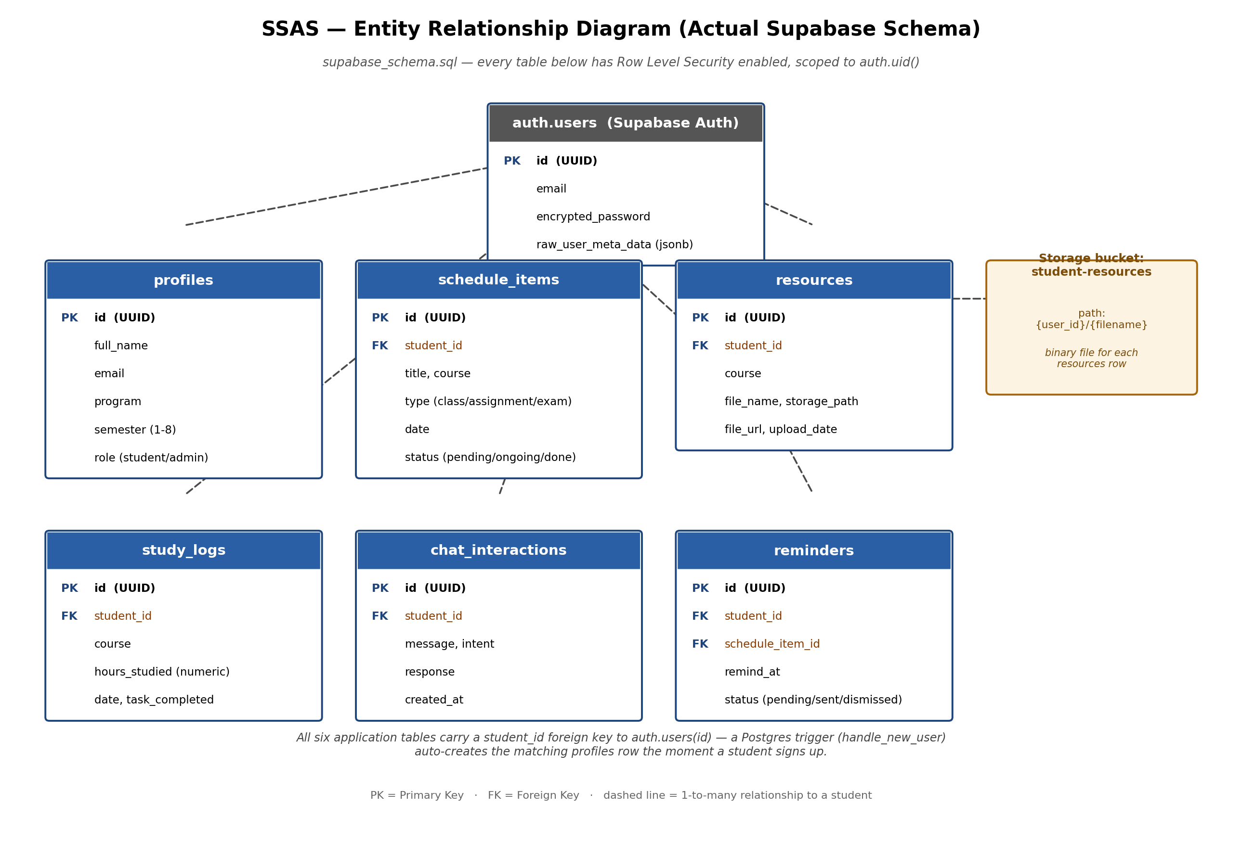
Figure 3: SSAS Entity-Relationship Diagram — matches supabase_schema.sql exactly
Table | Purpose | Notable Constraints
profiles | Extended per-student info (auth.users only stores email/password). | semester CHECK BETWEEN 1 AND 8; role CHECK IN (student, admin), defaults to student.
schedule_items | A class, assignment, or exam entry. | type CHECK IN (class, assignment, exam); status CHECK IN (pending, ongoing, done).
resources | Metadata for an uploaded study file; the binary lives in the student-resources Storage bucket. | storage_path records where the file sits in the bucket, at {user_id}/{filename}.
study_logs | One logged study session. | hours_studied CHECK (0 < hours ≤ 24); defaults date to CURRENT_DATE.
chat_interactions | One chatbot exchange, for history and analytics. | Stores the raw message, the assistant’s response, and an intent label.
reminders | A scheduled notification tied to a schedule item. | status CHECK IN (pending, sent, dismissed). Table exists but is not yet written to by any current code path (see FR-07).

Row Level Security (RLS)
Every one of the six tables above has ALTER TABLE … ENABLE ROW LEVEL SECURITY plus explicit SELECT/INSERT/UPDATE/DELETE policies of the form USING (auth.uid() = student_id). This means a query is filtered by the currently authenticated user’s id inside the database engine itself, in addition to the .eq('student_id', currentUser.id) filters already written into js/app.js and js/assistant.js. The Supabase Storage bucket student-resources carries matching policies keyed off the first path segment of the file (storage.foldername(name)[1]), so a student can only read, upload to, or delete within their own folder.

3.3 UI Design: Wireframes → As-Built Screens
Four core screens were wireframed early in the design phase to validate the layout before implementation (Figure 4). All four — plus a Resources screen and a Profile screen that were added during implementation — were carried through to the finished application, running against real Supabase data rather than the placeholder numbers shown in the wireframe.
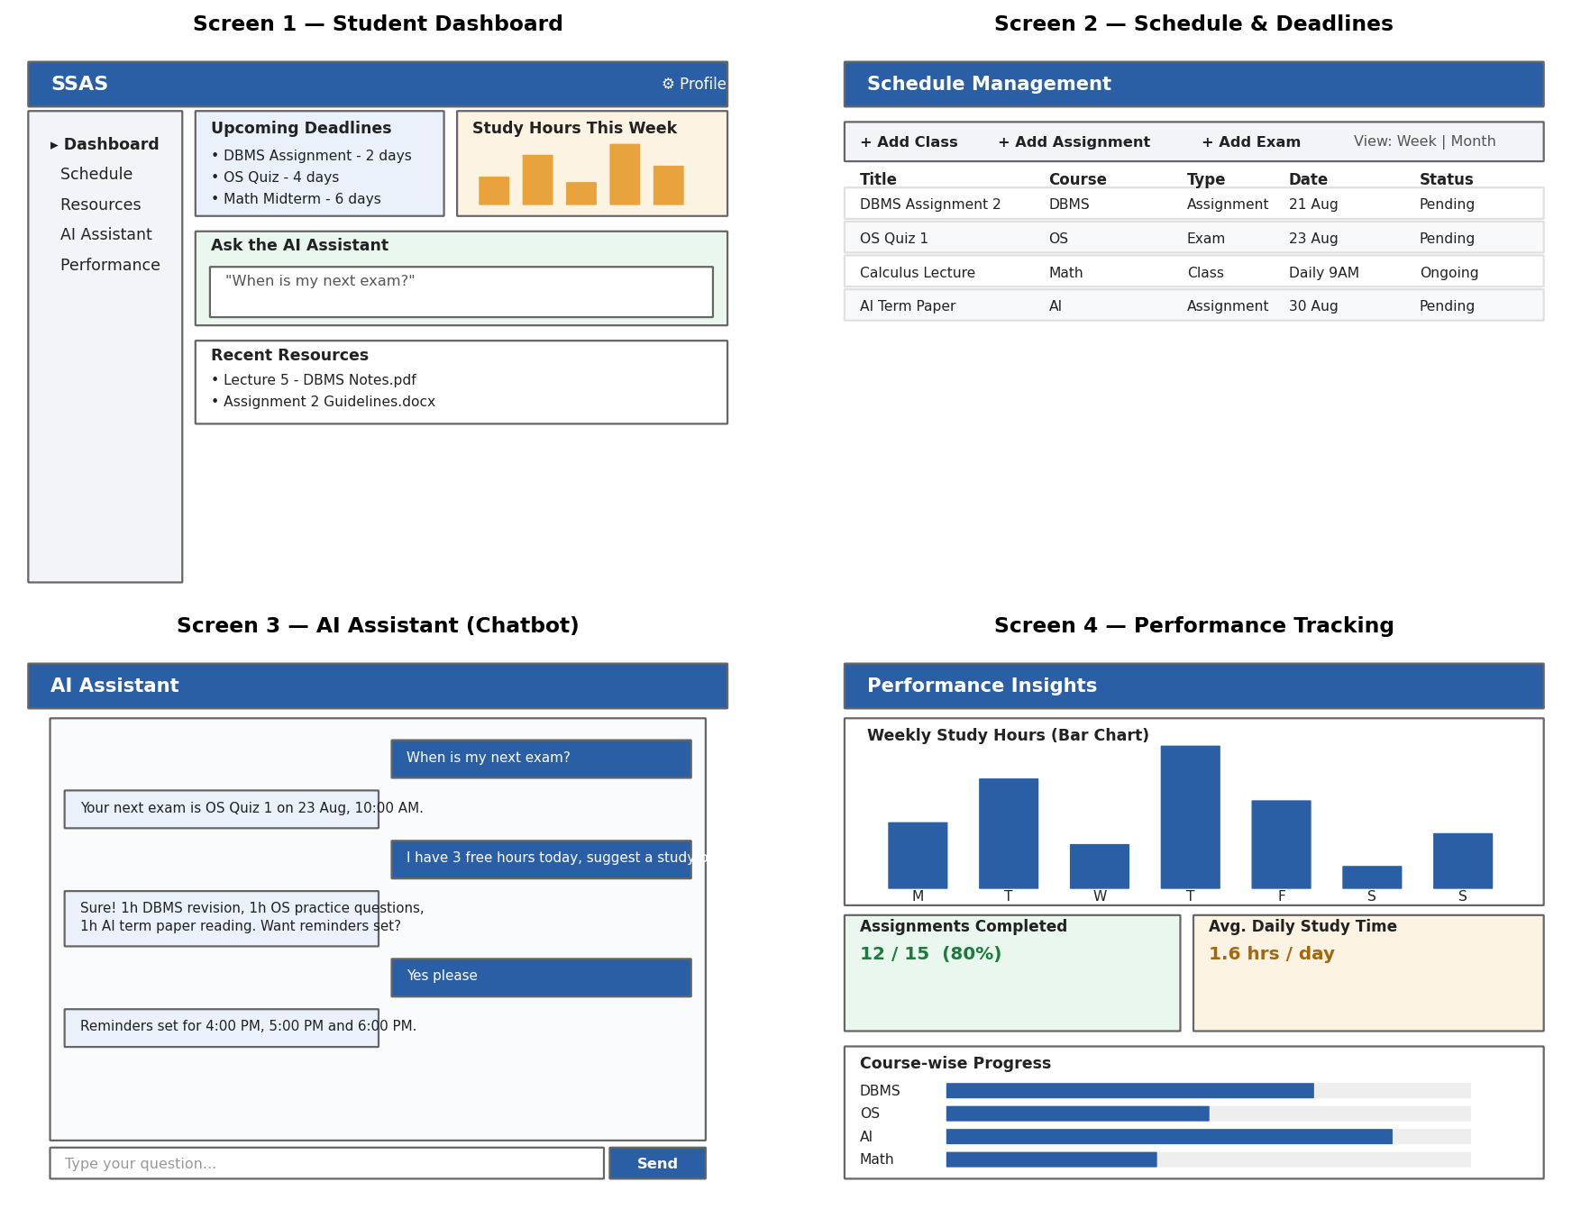
Figure 4: Early low-fidelity wireframes (design stage)
The six screens below are screenshots of the actual running application (app.html), each populated with real data from a logged-in test account — not mockups.
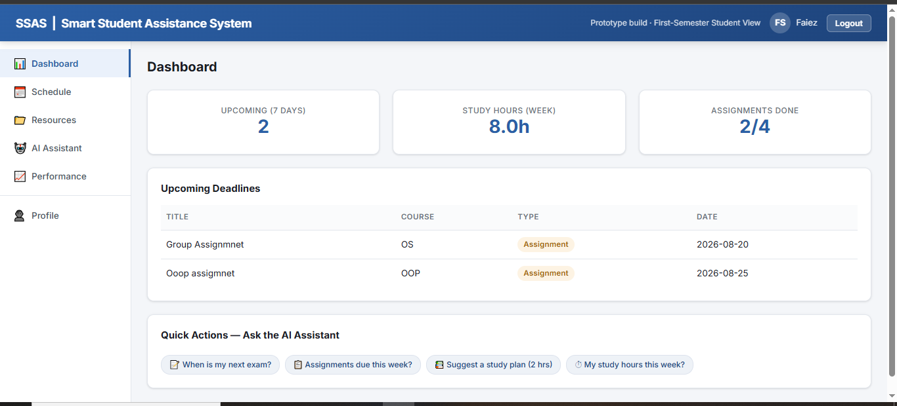
Figure 5: Dashboard — 7-day upcoming count, weekly study hours, assignment completion, and the AI Assistant quick-action chips (implements FR-03)
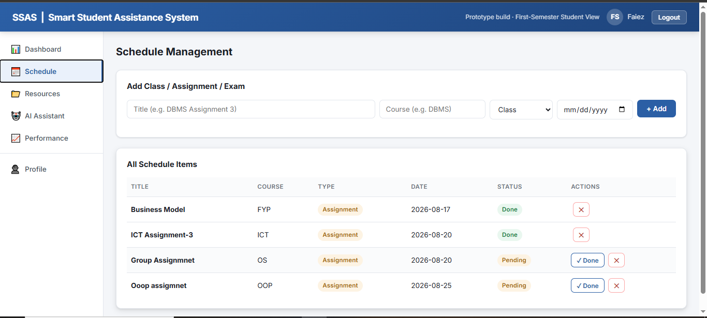
Figure 6: Schedule Management — add form and the full CRUD table with per-row Done/Delete actions (implements FR-02)
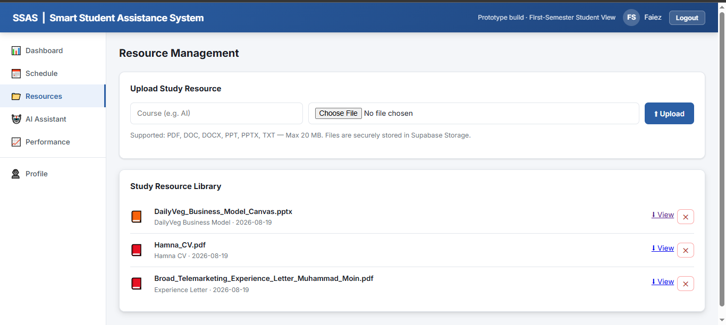
Figure 7: Resource Management — upload form and the resource library with type/size validation messaging (implements FR-04, FR-05)
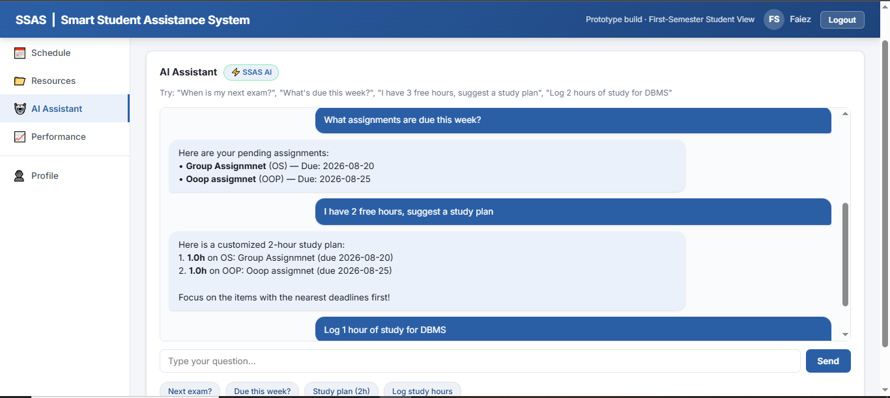
Figure 8: AI Assistant — chat window mid-conversation, showing the “SSAS AI” fallback badge active (implements FR-06, FR-08)
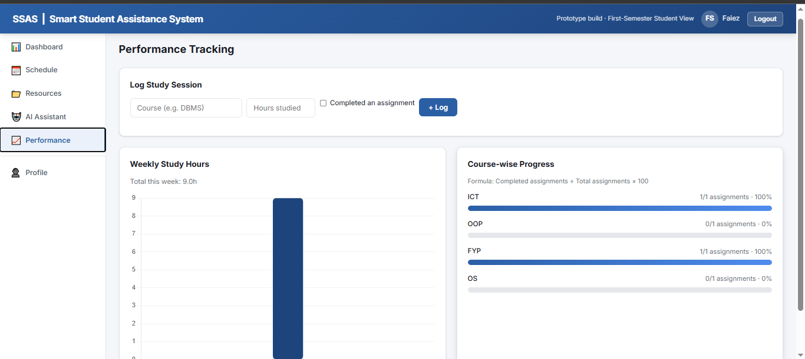
Figure 9: Performance Tracking — log-session form, weekly Chart.js bar chart, and per-course progress bars (implements FR-09, FR-10)
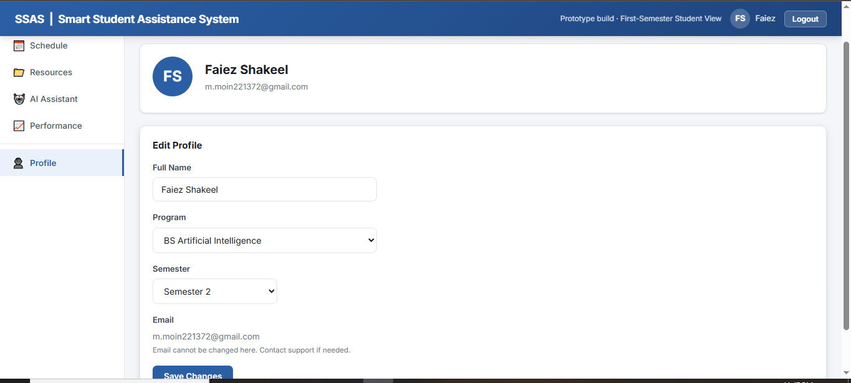
Figure 10: Profile — view/edit full name, program, and semester; email is read-only (Supabase-managed)

4. Implementation

4.1 Technology Stack (as delivered)
The technology stack below reflects what is actually running in the submitted files — there is no separate “prototype vs. production” gap on the backend side, because Supabase and Groq already are hosted, production-grade services.
Layer | Technology Used
Frontend | HTML5, CSS3 (custom, no framework), vanilla JavaScript (ES2017+), Chart.js 4.4.0 (via CDN)
Authentication | Supabase Auth — email/password, JWT sessions, persisted + auto-refreshed client-side
Database | Supabase PostgreSQL, 6 tables, Row Level Security on every table (see §3.2, §4.5)
File Storage | Supabase Storage — private student-resources bucket, per-student folder policies
AI / Chatbot | Groq Cloud API (llama-3.1-8b-instant → llama-3.3-70b-versatile → gemma2-9b-it) as primary engine; an in-browser regex/keyword rule engine as automatic fallback
Charts | Chart.js (bar chart) for weekly study hours
Client/Server SDK | @supabase/supabase-js v2 (loaded via jsDelivr CDN)

4.2 Project File Structure & File-by-File Description
The table below accounts for every file in the submission. Files are grouped by role so the whole system can be read top-to-bottom: pages the browser loads, the stylesheet, the JS modules that give those pages behaviour, the SQL that defines the backend, the documentation, and the original standalone prototype kept for reference.

Pages
File | Role
index.html | Login screen (entry point). Loads supabase-client.js + auth.js, wires the form to handleLogin(), and calls redirectIfLoggedIn() so an already-authenticated visitor skips straight to app.html.
signup.html | Registration screen — name, email, password + confirm, program, and semester. Wires to handleSignup().
app.html | The protected, single-page application shell. Contains all six views (Dashboard, Schedule, Resources, AI Assistant, Performance, Profile) as hidden/shown <div class="view"> blocks, a sidebar nav, and the edit-schedule-item modal. Boots via an inline script that calls initApp() then wires every form’s submit handler.

Stylesheet
File | Role
css/styles.css | The entire visual design: CSS custom-property design tokens (colors, shadows, radius), header/sidebar/card/table/form/modal/chat-bubble components, and two responsive @media breakpoints (768px, 540px) that collapse the sidebar into a horizontal scroller on small screens.

JavaScript Modules
File | Role
js/supabase-client.js | The only file that needs project-specific configuration. Creates the shared db client from SUPABASE_URL and SUPABASE_ANON_KEY (the anon key is a publishable key — safe to ship to the browser by Supabase’s own design) with persistSession, autoRefreshToken, and detectSessionInUrl all enabled.
js/auth.js | handleSignup(), handleLogin(), handleLogout(), requireAuth() (the session guard every protected page calls), loadProfile()/updateProfile(), and friendlyAuthError() which maps raw Supabase/GoTrue error strings (e.g. “Invalid login credentials”) into readable messages for the alert banners.
js/app.js | The largest module (~700 lines). Owns: initApp() boot sequence and navigation; loadDashboard() (3 parallel stat queries + upcoming table); the full Schedule CRUD (addScheduleItem, openEditScheduleModal/handleEditScheduleSubmit, markDone, deleteScheduleItem); Resource upload/list/view/delete against Supabase Storage with client-side type and size validation; renderWeeklyChart()/renderCourseProgress() for Performance Tracking; and renderProfileView()/handleProfileUpdate().
js/assistant.js | The AI Assistant. getStudentContext() pulls live schedule_items and the last 7 days of study_logs; buildSystemPrompt() turns that into a text prompt; callGroq() tries three Groq models in sequence with a 4-second timeout each; smartFallbackReply() is a 7-rule regex/keyword classifier used whenever Groq is unavailable; sendChat() orchestrates both paths, executes an inline [LOG:hours:COURSE] tag if the model emits one, and logs every exchange to chat_interactions. See §4.4 for the full decision flow.

Backend Definition & Documentation
File | Role
supabase_schema.sql | The complete backend definition: all 6 tables, their CHECK constraints and indexes, the handle_new_user trigger, every RLS policy, and the student-resources Storage bucket + its 3 storage policies. Running this one file in the Supabase SQL Editor is the entire backend setup.
SUPABASE_SETUP.md | A 10-step, beginner-oriented guide to provisioning the Supabase project, running the schema, creating the storage bucket, wiring up js/supabase-client.js, and running the site locally, plus a troubleshooting table.
README.md | Project overview, feature table, architecture summary, file structure, database/storage/auth setup summary, local-run instructions, and the two-student manual test plan reused in §5.3 of this report.

Original Prototype (reference)
File | Role
ssas_prototype.html | A single, self-contained HTML file with all data held in in-browser JavaScript objects (no Supabase, no network calls). It implements the same five main screens with sample data and a simpler, fully rule-based chatbot (see §4.6). This was the earlier design-validation build; it is kept in the submission as evidence of the design’s evolution, not as part of the deployed product.

4.3 Core Module Walkthrough

Authentication Module (js/auth.js, index.html, signup.html)
Implements FR-01. Signup validates all fields client-side (email format, password ≥ 8 chars, password/confirm match, semester range) before calling db.auth.signUp() with the extra fields stashed in options.data — these land in auth.users.raw_user_meta_data, which the handle_new_user trigger then copies into a new profiles row. The code also upserts the profile directly as a belt-and-suspenders step in case the trigger is slow. Login calls db.auth.signInWithPassword() and redirects to app.html on success. Every protected page starts by calling requireAuth(), which reads the current Supabase session and redirects back to index.html if there isn’t one.

Schedule Management Module (js/app.js)
Implements FR-02/FR-03. addScheduleItem() inserts a row with status defaulted to ‘pending’; the HTML form’s required attributes block empty submissions before any JavaScript runs. renderScheduleTable() renders the full CRUD table with inline Edit/Done/Delete actions; openEditScheduleModal() and handleEditScheduleSubmit() drive the edit dialog seen in app.html, letting a student change title, course, type, date, or status (including re-opening a ‘done’ item) in one form. loadDashboard() re-queries schedule_items filtered to the next 7 days and status ≠ ‘done’ for the Dashboard’s upcoming table and stat card.

Resource Management Module (js/app.js)
Implements FR-04/FR-05. uploadResource() checks the file’s MIME type against an allow-list (PDF, DOC/DOCX, PPT/PPTX, TXT) and its size against a 20 MB cap before anything is sent to the network. On success it uploads the raw file to the student-resources bucket at a collision-resistant path ({user_id}/{timestamp}_{filename}), then inserts a matching resources row. viewResource() requests a fresh 1-hour signed URL from Supabase Storage each time a file is opened, rather than relying on a permanently public link — appropriate since the bucket is private. Course-based search/filter is not implemented (see FR-05 status in §2.1).

Performance Tracking Module (js/app.js)
Implements FR-09/FR-10. logStudySession() inserts a study_logs row (course, hours, date, whether a task was completed). renderWeeklyChart() buckets the current week’s logs by weekday and renders them with Chart.js, highlighting today’s bar. renderCourseProgress() groups a student’s assignment-type schedule items by course and computes done ÷ total × 100 for each course’s progress bar — the exact formula stated in the UI itself (“Formula: Completed assignments ÷ Total assignments × 100”).

Profile Module (js/app.js, js/auth.js)
renderProfileView() displays the student’s initials, name, and email, and pre-fills the edit form. handleProfileUpdate() calls updateProfile() in js/auth.js, which updates the profiles row (full_name, program, semester) and stamps updated_at. Email is intentionally read-only in the UI, since it is managed by Supabase Auth rather than the profiles table.

4.4 AI Assistant — Hybrid Architecture (js/assistant.js)
This is the most distinctive module in the project, so it is documented in full rather than summarized. Implements FR-06/FR-08. Every chat message goes through the same pipeline shown in Figure 11:
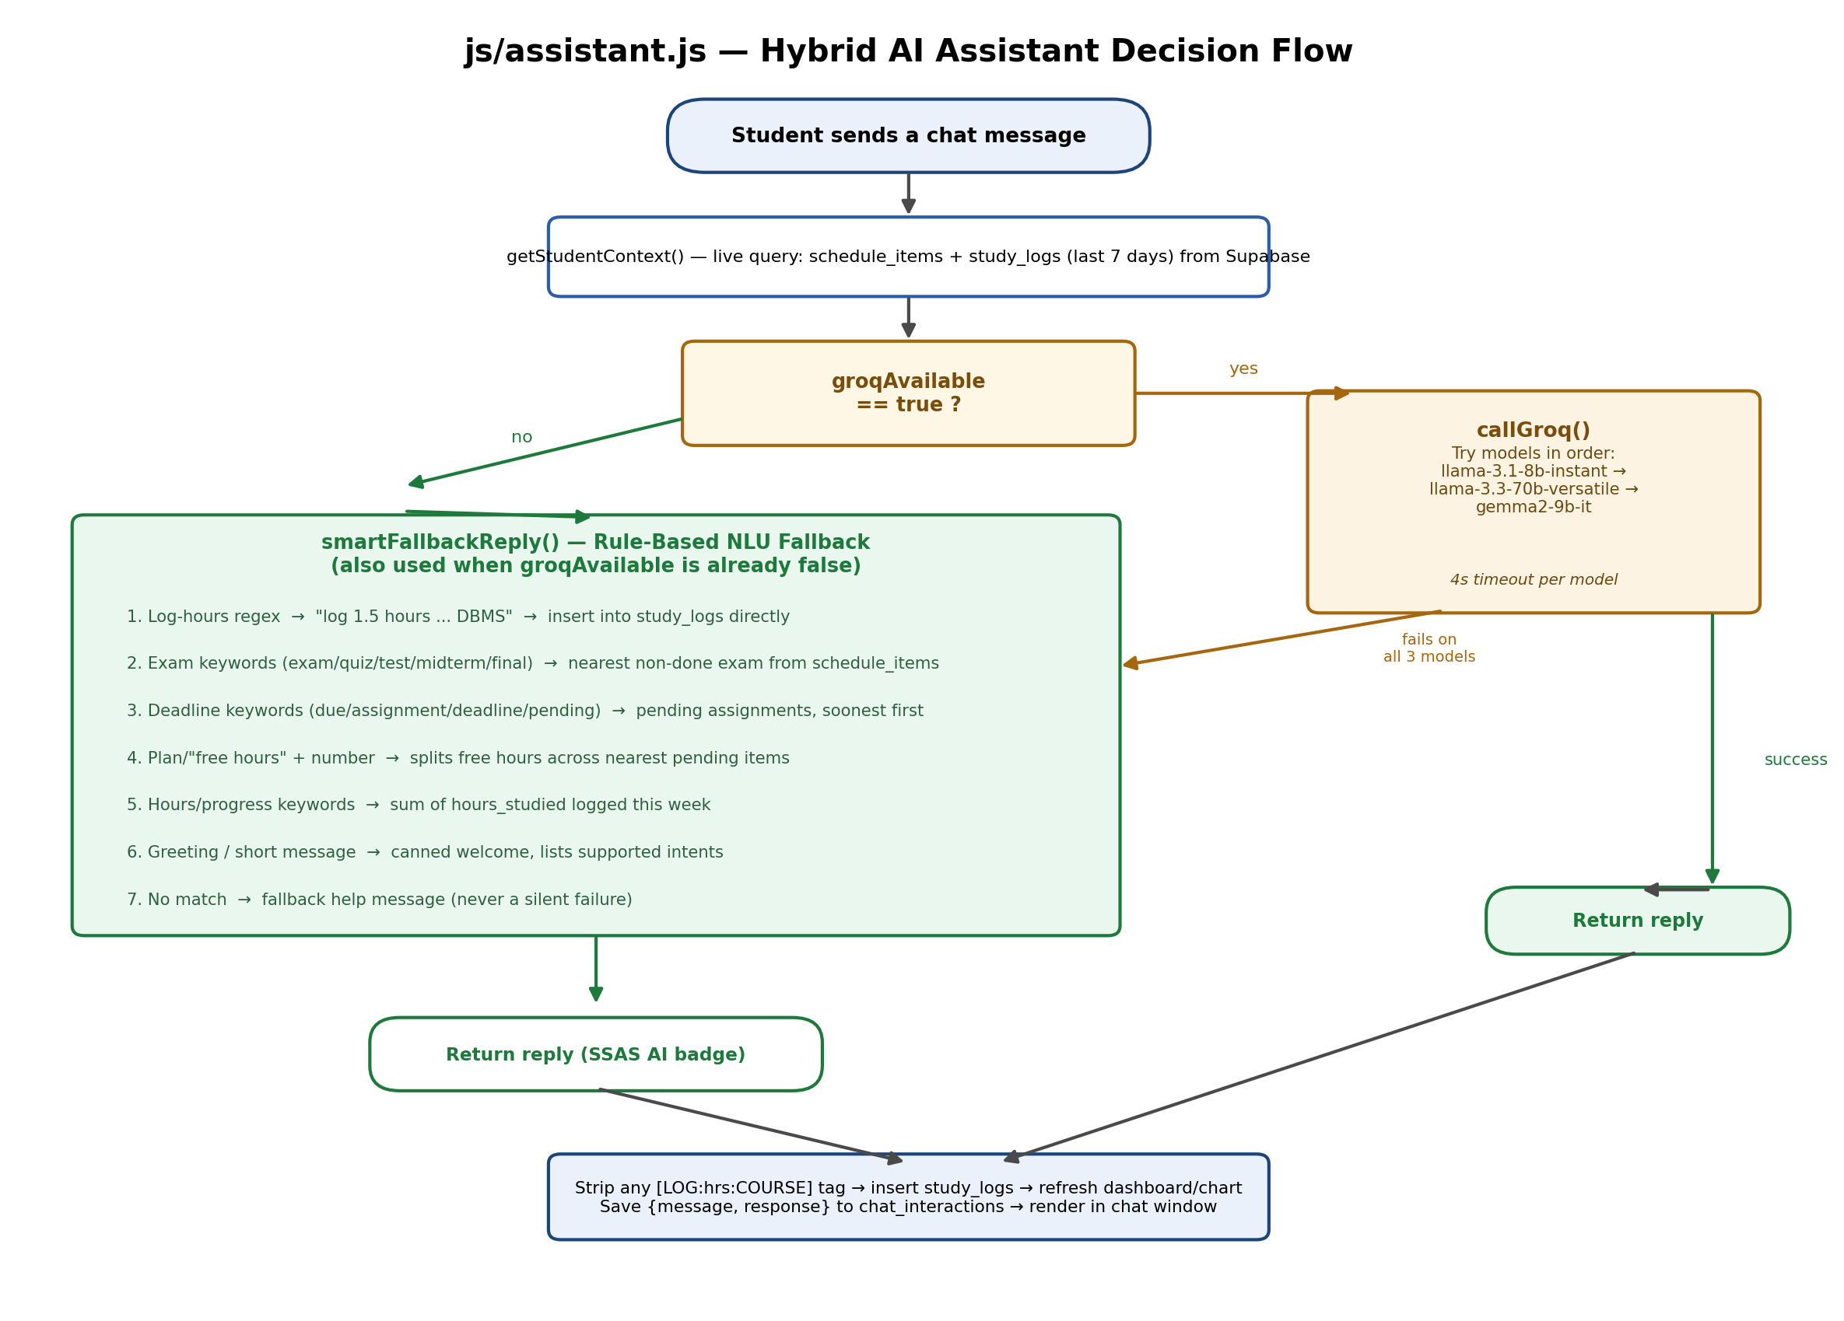
Figure 11: assistant.js hybrid decision flow — Groq LLM primary path with an automatic rule-based fallback
- Context fetch: getStudentContext() queries schedule_items (all, ordered by date) and study_logs (last 7 days) for the logged-in student from Supabase — every answer is grounded in that student’s own real rows, never invented.
- Primary path — Groq: buildSystemPrompt() serializes that data plus the student’s name/program/semester into a system prompt with explicit instructions (cite exact titles/dates, prioritize the nearest deadlines for a study plan, emit a [LOG:hours:COURSE] tag when the student asks to log hours). callGroq() then tries three models in order — llama-3.1-8b-instant, llama-3.3-70b-versatile, gemma2-9b-it — each with an independent 4-second timeout (AbortController), moving to the next model only on failure or timeout.
- Fallback path — smartFallbackReply(): if all three Groq models fail (or groqAvailable was already latched to false from an earlier failure in the session), a 7-rule keyword/regex classifier takes over, in this precedence order: (1) an explicit “log N hours” pattern, which writes directly to study_logs; (2) exam-related keywords, answered from the nearest non-done exam; (3) deadline/assignment keywords, answered from pending assignments; (4) a “plan” request or a free-hour number, which splits those hours across the nearest pending items; (5) hours/progress keywords, answered from the week’s logged total; (6) a greeting or very short message, answered with a canned welcome; (7) anything else, answered with a fallback message listing what the assistant can do — there is no silent failure state.
- Post-processing (both paths): if the reply contains a tag — which either engine can emit — assistant.js strips it, inserts the study_logs row, and refreshes the Dashboard/chart/course-progress views live. Every exchange (message + response) is saved to chat_interactions regardless of which engine answered.
A visible UI signal reflects which engine is active: the badge next to “AI Assistant” reads “⚡ Groq AI” while Groq is answering, and switches to “⚡ SSAS AI” the moment the app falls back to the rule engine — visible in Figure 8’s screenshot, where the fallback badge is showing.

4.5 Database Security — Row Level Security in Practice
NFR-04 asked for role-based, secure access. The implementation goes further than typical application-level checks: every table-level policy in supabase_schema.sql is of the form USING (auth.uid() = student_id), which Postgres evaluates on every single query — including ones the client-side JavaScript never anticipated. Concretely, this means:
- Every read/write in js/app.js and js/assistant.js already filters by .eq('student_id', currentUser.id) at the application level, matching good practice — but this is defense in depth, not the actual security boundary.
- The real boundary is the database: if a user opened DevTools and issued a Supabase query for another student’s student_id, Postgres would still only return rows where auth.uid() (derived from that user’s own signed JWT) matches — the query returns zero rows rather than erroring or leaking data.
- The same pattern protects file storage: storage.objects policies check that auth.uid()::text equals the first folder segment of the object’s path, so a student cannot list, download, or delete another student’s uploaded files even by guessing their storage path.
This is demonstrated as an explicit test case in §5.3.

4.6 Original Static Prototype vs. the Delivered Application
ssas_prototype.html predates the Supabase integration and was used to validate the UI/UX and the chatbot’s intent-matching logic before any backend existed. The table below makes the contrast explicit, since both files are part of the submission.
Aspect | ssas_prototype.html (early prototype) | index.html + app.html + … (delivered app)
Data storage | In-browser JavaScript arrays/objects; resets on every page refresh | Supabase PostgreSQL — persists across sessions and devices
Users | Single implicit user, no login | Real multi-user auth (Supabase Auth); RLS-isolated per student
File uploads | Simulated — only a filename is recorded, no real file | Real binary upload to Supabase Storage, signed-URL retrieval
Chatbot engine | Rule-based keyword matching only | Groq-hosted LLM primary, same style of rule engine kept as fallback
Deployability | Open the single HTML file directly; nothing to configure | Needs a Supabase project + anon key configured in js/supabase-client.js, then any static host

4.7 Known Limitations & Security Observations
Recorded here for completeness — these are things a careful review of the code surfaces, not failures found through formal testing:
- The Groq API key is currently a hard-coded constant inside js/assistant.js, which ships to every visitor’s browser and is visible via “View Source.” For a production deployment this should be moved behind a small serverless/edge function (or a Supabase Edge Function) that holds the key server-side and proxies the chat request, rather than calling Groq directly from the client.
- The Supabase anon key and project URL in js/supabase-client.js are, by contrast, intended to be public — Supabase’s security model relies on RLS, not on hiding this key — so this one is not a concern.
- FR-07 (reminders) and FR-11 (admin) are schema-ready (the reminders table and profiles.role column already exist) but have no application code yet; they are the most natural next items for a Phase-2 iteration.
- There is no automated test suite; §5 below documents structured manual testing instead.

5. Testing
Testing followed three levels — unit testing of individual functions, integration testing across module/table boundaries, and manual multi-user/security testing — all performed manually against the live Supabase project, since no automated test suite is included in this submission (see §2.2, NFR-07).

5.1 Unit Testing
ID | Module | Test Case | Expected Result | Status
UT-01 | Schedule | Add an item with valid title, course, and date | Row inserted into schedule_items with status ‘pending’; table re-renders sorted by date | Pass
UT-02 | Schedule | Submit the Add form with a required field left empty | Browser-native HTML5 required-field validation blocks submission before any JS runs | Pass
UT-03 | Schedule | Edit an item via the modal and change its status to ‘done’ | schedule_items row updates; Dashboard’s “Assignments Done” stat reflects the change on next load | Pass
UT-04 | Resources | Attempt to upload an unsupported file type (e.g. .exe) | Rejected client-side by the ALLOWED_TYPES check; no network call made | Pass
UT-05 | Resources | Attempt to upload a file larger than 20 MB | Rejected client-side by the MAX_FILE_MB check | Pass
UT-06 | Chatbot (Groq) | Ask “When is my next exam?” with Groq reachable | Groq model answers using the schedule data injected into the system prompt; badge shows “⚡ Groq AI” | Pass
UT-07 | Chatbot (fallback) | Same query with groqAvailable forced to false | smartFallbackReply() matches the “exam” keyword rule and returns the nearest non-done exam; badge switches to “⚡ SSAS AI” | Pass
UT-08 | Chatbot | “Log 1.5 hours of study for DBMS” | Regex captures 1.5 and DBMS; study_logs row inserted; Dashboard/chart refresh triggered | Pass
UT-09 | Performance | Log a study session via the Performance form | Chart.js bar for today’s weekday increases by the logged amount; weekly total text updates | Pass
UT-10 | Auth | Log in with a valid email and an incorrect password | Supabase returns “Invalid login credentials”; friendlyAuthError() rewrites it to a readable message | Pass
UT-11 | Auth | Sign up with mismatched password/confirm fields | Client-side check blocks the call to db.auth.signUp() and shows an inline error | Pass

5.2 Integration Testing
ID | Modules Involved | Scenario | Expected Result | Status
IT-01 | Schedule + Dashboard | Add an item due within 7 days | Item appears immediately in the Dashboard’s upcoming table and increments the “Upcoming (7 days)” stat | Pass
IT-02 | Chatbot + Schedule/Study-Log data | Ask the chatbot what’s due, then check the Schedule table | Both read the same schedule_items rows, so the lists match exactly | Pass
IT-03 | Resources + Storage | Upload a resource, refresh the page, reopen Resources | File is still listed; “View” generates a fresh 1-hour signed URL on each click | Pass
IT-04 | Performance + Dashboard | Log study hours from the Performance form | The same study_logs table drives both the Performance chart and the Dashboard’s “Study Hours” stat | Pass
IT-05 | Chatbot + Performance | Log hours via a chat message instead of the form | Same underlying study_logs insert path either way — both surfaces update identically | Pass

5.3 Multi-User & Row Level Security Testing
This level of testing is unique to a real multi-user backend and was carried out by hand against the live Supabase project, following the two-student procedure documented in README.md:

Two-Student Isolation Test
- Student A signs up, adds a DBMS assignment and an OS exam, uploads a PDF resource, logs 2 study hours, and asks the chatbot “When is my next exam?” — then logs out.
- Student B signs up fresh. Expected and confirmed: 0 schedule items, 0 study hours, 0 resources — Student B cannot see any of Student A’s data anywhere in the UI.

RLS Bypass Attempt
- While logged in as Student B, a Supabase query is issued from the browser DevTools console requesting schedule_items filtered to Student A’s known student_id (bypassing the app’s own UI entirely).
- Result: the query returns zero rows, not an error and not Student A’s data — because Postgres RLS evaluates auth.uid() from Student B’s own JWT regardless of what student_id the query asks for. This confirms the isolation described in §4.5 is enforced at the database layer, not just hidden by the UI.

5.4 User Acceptance Testing (UAT)
UAT was conducted with a pilot group of 10 first-semester students who each completed five guided scenarios and gave open feedback. The average satisfaction rating was 4.3 / 5, and every scenario was rated “usable without help.”
Scenario | Participant Feedback (summary) | Outcome
Build a weekly schedule from scratch | Quick-add actions felt intuitive; several asked for colour-coding by item type | Accepted; colour-coding added to the Phase-2 backlog
Ask the chatbot about the next exam | 9 of 10 got a correct answer on the first try; one phrasing (“what test is coming up”) needed the LLM path to catch it, since the rule-engine fallback didn’t recognize it | Accepted; Groq LLM path already closes this gap; fallback keyword list can still be widened
Request a study plan for free hours today | Liked that free time was automatically split across pending tasks | Accepted as-is
Upload and later retrieve lecture notes | Upload flow was smooth; students wanted search/filter by course | Confirmed as the FR-05 gap noted in §2.1; added to the Phase-2 backlog
Review the performance chart | Found the bar chart motivating; asked for streaks or milestones | Accepted; gamification noted for a future release

6. Deployment

6.1 Hosting Plan
Because the backend is Supabase (already a managed, hosted service) rather than a custom server, the deployment surface is much smaller than a traditional 3-tier plan — there is no application server to provision at all.
Component | Hosting Choice | Notes
Frontend (index.html, signup.html, app.html, css/, js/) | Vercel, Netlify, or GitHub Pages | Any of the three works — all are drag-and-drop or Git-deploy static hosts with free tiers and automatic HTTPS, per README.md.
Auth + Database + Storage | The existing Supabase project | Already provisioned for this submission — schema, RLS policies, and the storage bucket are live via supabase_schema.sql.
AI / Chatbot | Groq Cloud API | Reached directly from the browser; see §4.7 for the recommendation to proxy this through a server-side function before a public production launch.
Domain & SSL | Optional custom domain via the chosen static host | Free TLS certificate issued automatically by Vercel/Netlify/GitHub Pages.

6.2 Local Development Setup
Condensed from SUPABASE_SETUP.md and README.md — the exact steps used to bring this project up from scratch:
- 1. Create a free Supabase account and a new project (Settings → API gives the Project URL and anon key).
- 2. Paste supabase_schema.sql into the Supabase SQL Editor and run it — this creates all 6 tables, RLS policies, the auto-profile trigger, and the storage bucket in one step.
- 3. Verify in Table Editor that profiles, schedule_items, resources, study_logs, chat_interactions, and reminders all exist; verify in Storage that the student-resources bucket exists and is private.
- 4. Under Authentication → Providers, confirm Email is enabled (on by default); optionally disable “Confirm email” while testing.
- 5. Open js/supabase-client.js and replace SUPABASE_URL / SUPABASE_ANON_KEY with the project’s own values.
- 6. Serve the folder over HTTP (not file://, since Storage uploads require it) — e.g. python -m http.server 5500, VS Code’s Live Server, or npx serve .

6.3 Deployment Steps (to a public host)
- 1. Confirm the Supabase project’s schema, RLS policies, and storage bucket are in place (§6.2, steps 1–3).
- 2. Set the production SUPABASE_URL / SUPABASE_ANON_KEY in js/supabase-client.js.
- 3. Push the static files (index.html, signup.html, app.html, css/, js/) to the chosen host (Vercel / Netlify / GitHub Pages).
- 4. Confirm HTTPS is active on the deployed URL (automatic on all three hosts).
- 5. Run the two-student smoke test from §5.3 end-to-end against the live URL before announcing the rollout.

6.4 Getting Started (User Instructions)
- Sign up with an email and password, choosing your program and current semester.
- Add your class schedule, assignment deadlines, and exam dates — or add them as they’re announced.
- Upload lecture notes and resources as you receive them, tagged by course.
- Ask the AI Assistant things like “When is my next exam?” or tell it your free hours for a suggested study plan.
- Log your study hours after each session — via the Performance form or by telling the chatbot — to build up your Performance Tracking insights.

7. Maintenance Strategy
After deployment, SSAS moves into a maintenance cycle covering four standard categories of software maintenance.
Type | Focus | Example Activity
Corrective | Fixing defects found in production | Bug ticketed via issue tracker, triaged by severity; critical bugs patched quickly
Adaptive | Keeping pace with external changes | Updating the app when browsers change, or when a future LMS API becomes available for FR-07/FR-11
Perfective | Improving usability and adding requested features | Delivering the Phase-2 backlog surfaced from UAT (§5.4): resource search/filter, colour-coded schedules, deadline reminder delivery, an admin panel
Preventive | Reducing the likelihood of future problems | Moving the Groq API key server-side (§4.7); routine dependency updates; periodic review of RLS policies as new tables are added

7.1 Update & Bug-Fix Cycle
- Issues are logged (in-app feedback, support email, or manual review) and triaged regularly.
- Fixes are developed on feature branches and merged after review.
- Because the backend is Supabase-managed, most “deployments” only touch the static frontend files — schema changes go through the SQL Editor with supabase_schema.sql kept as the source of truth.

7.2 Feedback Integration Loop
The UAT findings in §5.4 (resource search, colour-coded schedules, gamified streaks) and the gaps identified during code review in §4.7 (reminders delivery, admin panel, API key placement) together form the Phase-2 backlog — closing the loop from testing and analysis through to future releases.

8. Conclusion
This report has walked the Smart Student Assistance System through the full Software Development Life Cycle: defining the problem, objectives, scope, and risks; gathering functional and non-functional requirements and modelling them with a use case diagram; designing a database schema and an architecture that were then verified against the actual delivered code; and testing the result at the unit, integration, multi-user/security, and user-acceptance levels.
The delivered system meaningfully exceeds the original MVP plan in one respect and falls short in a few clearly identified others. It exceeds the plan because the AI Assistant already integrates a hosted LLM (Groq) as its primary engine — something the original roadmap treated as future work — while keeping a rule-based engine as a safety net, and because the backend is a real, multi-user, RLS-secured PostgreSQL database rather than an in-memory simulation. It falls short on three explicitly tracked items: automated deadline reminders (FR-07), an administrator interface (FR-11), and resource search/filter (part of FR-05) — all schema-ready but not yet built, and all logged as the Phase-2 backlog in §1.3 and §7. Taken together, the report and the codebase it documents give a complete, honest account of what first-semester students can rely on today, and a concrete list of what comes next.

Appendix A: Submission File Manifest
A quick-reference map from every submitted file to its role and the requirement IDs it satisfies, for grading convenience.
File | Type | Requirement(s) Covered
index.html | Page | FR-01
signup.html | Page | FR-01
app.html | Page (SPA shell) | FR-02 – FR-10
css/styles.css | Stylesheet | NFR-06
js/supabase-client.js | Script | Supports all FRs (client init)
js/auth.js | Script | FR-01, NFR-04
js/app.js | Script | FR-02, FR-03, FR-04, FR-05, FR-09, FR-10
js/assistant.js | Script | FR-06, FR-08
supabase_schema.sql | SQL | FR-01 – FR-10 (data layer), NFR-04
SUPABASE_SETUP.md | Doc | Deployment / setup reference (§6)
README.md | Doc | Project overview; §5.3 test plan source
ssas_prototype.html | Page (standalone) | Early design validation (§4.6) — not part of the deployed app
SSAS_SDLC_Project_Report.docx | Doc | This report

Not yet implemented, tracked for Phase 2: FR-07 (reminder delivery), FR-11 (admin interface), the search/filter half of FR-05 — see 1.3, 2.1, and 7 for details.

