PRODUCTION-GRADE MERN STACK APPLICATION DEPLOYMENT USING KUBERNETES, JENKINS AND ELK STACK

~ Moin Mohammed Naik
Technologies Used
- Technologies Used
- React.js
- Node.js
- Express.js
- MongoDB Replica Set
- Docker
- Kubernetes
- Jenkins
- NGINX Ingress Controller
- Cert Manager
- Elasticsearch
- Kibana
- Filebeat
- Metricbeat
- Elastic APM

Date: 16-06-2026

TABLE OF CONTENTS

Sr. No. | Title | Page No.
1. | Introduction | 3
2. | Chapter 1: Project Overview | 4
3. | Chapter 2: Technology Stack | 6
4. | Chapter 3: System Architecture | 8
5. | Chapter 4: Kubernetes Implementation | 12
7. | Chapter 5: CI/CD Pipeline Implementation | 17
8. | Chapter 6: Monitoring and Observability | 22
9. | Chapter 7: Result and Conclusion | 26

INTRODUCTION
Modern applications require scalable infrastructure, automated deployment mechanisms, centralized monitoring, and high availability to meet production standards. Traditional deployment methods often involve manual configuration, downtime during updates, and limited visibility into application performance.
To address these challenges, organizations adopt DevOps practices and cloud-native technologies such as Docker, Kubernetes, Jenkins, and Elasticsearch. These tools enable automation, scalability, observability, and efficient resource utilization.
This project focuses on designing and deploying a Production-Grade MERN Stack Application using industry-standard DevOps practices. The application consists of a React.js frontend, Node.js and Express.js backend, and MongoDB database deployed as a Replica Set for high availability.
The complete infrastructure is containerized using Docker and orchestrated using Kubernetes. Continuous Integration and Continuous Deployment (CI/CD) pipelines are implemented using Jenkins, allowing automated application builds, testing, image creation, and deployment.
To provide complete observability, the Elastic Stack (ELK) is integrated into the architecture. Filebeat collects application logs, Metricbeat collects infrastructure metrics, and Elastic APM provides application performance monitoring. All collected data is centralized in Elasticsearch and visualized through Kibana dashboards.
Additionally, NGINX Ingress Controller and Let's Encrypt SSL certificates are configured to provide secure HTTPS communication between users and the application.
The final solution demonstrates a fully automated, scalable, secure, and observable production-grade deployment capable of supporting real-world workloads.
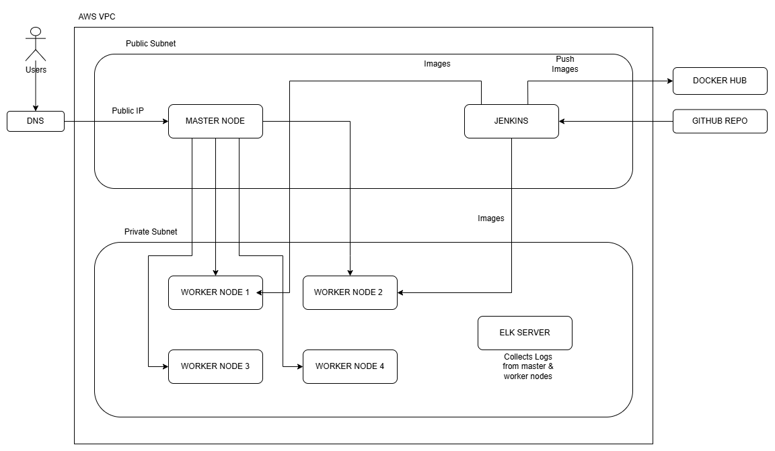
Figure 1: Overall Production Architecture
CHAPTER 1: PROJECT OVERVIEW
This project is a Production-Grade MERN Stack Application deployed on Kubernetes using DevOps best practices. The application consists of a React frontend, Node.js/Express backend, and MongoDB Replica Set database.
The entire application is containerized using Docker and deployed inside a Kubernetes cluster for scalability and high availability. Jenkins is used to automate the CI/CD process, enabling automatic build, image creation, testing, and deployment whenever code changes are pushed to GitHub.
To ensure database reliability, MongoDB is configured as a 3-node Replica Set with one Primary and two Secondary nodes. This provides redundancy and protects against data loss in case of node failure.
An NGINX Ingress Controller is used to expose the application externally, while Let's Encrypt SSL certificates secure communication through HTTPS.
For monitoring and observability, the ELK Stack is integrated into the environment. Filebeat collects logs from application containers, Metricbeat gathers infrastructure metrics, and Elastic APM monitors backend application performance. All monitoring data is stored in Elasticsearch and visualized through Kibana dashboards.
Key Features
- MERN Stack Application
- Docker Containerization
- Kubernetes Deployment
- MongoDB Replica Set
- Jenkins CI/CD Pipeline
- HTTPS using Let's Encrypt SSL
- NGINX Ingress Controller
- Horizontal Pod Autoscaling (HPA)
- Centralized Logging using ELK
- Application Performance Monitoring (APM)
- High Availability Architecture

Project Workflow
- Developer pushes code to GitHub.
- Jenkins automatically triggers the pipeline.
- Docker images are built and pushed to Docker Hub.
- Images are distributed to Kubernetes worker nodes.
- Kubernetes deploys updated application containers.
- MongoDB Replica Set stores application data.
- Users access the application through the Ingress Controller.
- Logs, metrics, and traces are collected by the ELK Stack for monitoring.

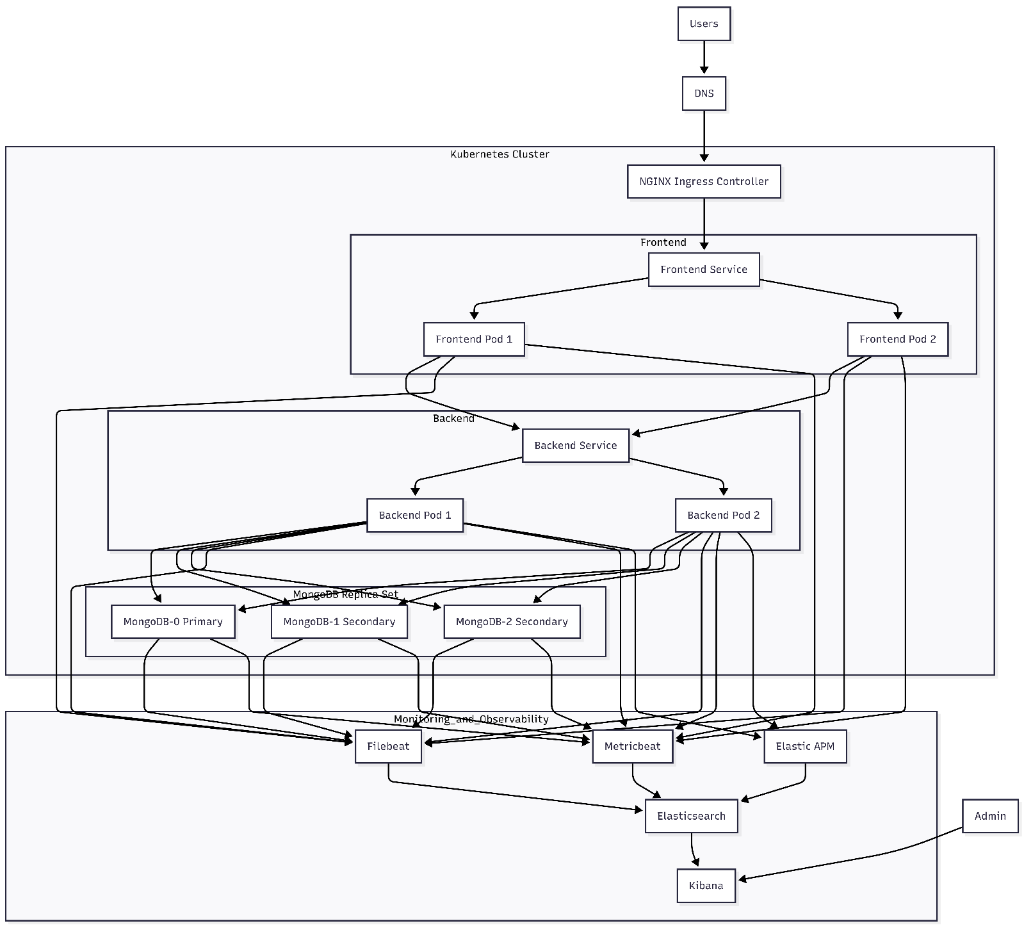
Figure 2: Overall System Architecture

CHAPTER 2: TECHNOLOGY STACK
The project uses modern DevOps and cloud-native technologies to build, deploy, monitor, and manage the application.
Component | Technology Used | Purpose
Frontend | React.js + Vite | User Interface
Backend | Node.js + Express.js | REST API Services
Database | MongoDB Replica Set | Data Storage & High Availability
Containerization | Docker | Application Packaging
Orchestration | Kubernetes | Container Management
CI/CD | Jenkins | Automated Build & Deployment
Image Registry | Docker Hub | Image Storage
Ingress | NGINX Ingress Controller | External Access
SSL | Cert Manager + Let's Encrypt | HTTPS Security
Logging | Filebeat | Log Collection
Monitoring | Metricbeat | Infrastructure Monitoring
APM | Elastic APM | Application Performance Monitoring
Analytics | Elasticsearch | Data Storage & Search
Visualization | Kibana | Monitoring Dashboards
Source Control | GitHub | Code Repository
Infrastructure Details
The Kubernetes environment consists of:
- 1 Master Node
- 2 Worker Nodes
- 1 Jenkins Server
- 1 ELK Server

The application components are deployed as follows:
- Frontend Deployment – 2 Replicas
- Backend Deployment – 2 Replicas
- MongoDB Replica Set – 3 Pods
- Horizontal Pod Autoscaler (HPA) enabled for Backend
- NGINX Ingress Controller for external traffic routing
This architecture provides scalability, fault tolerance, automated deployment, centralized logging, and monitoring capabilities suitable for production workloads.
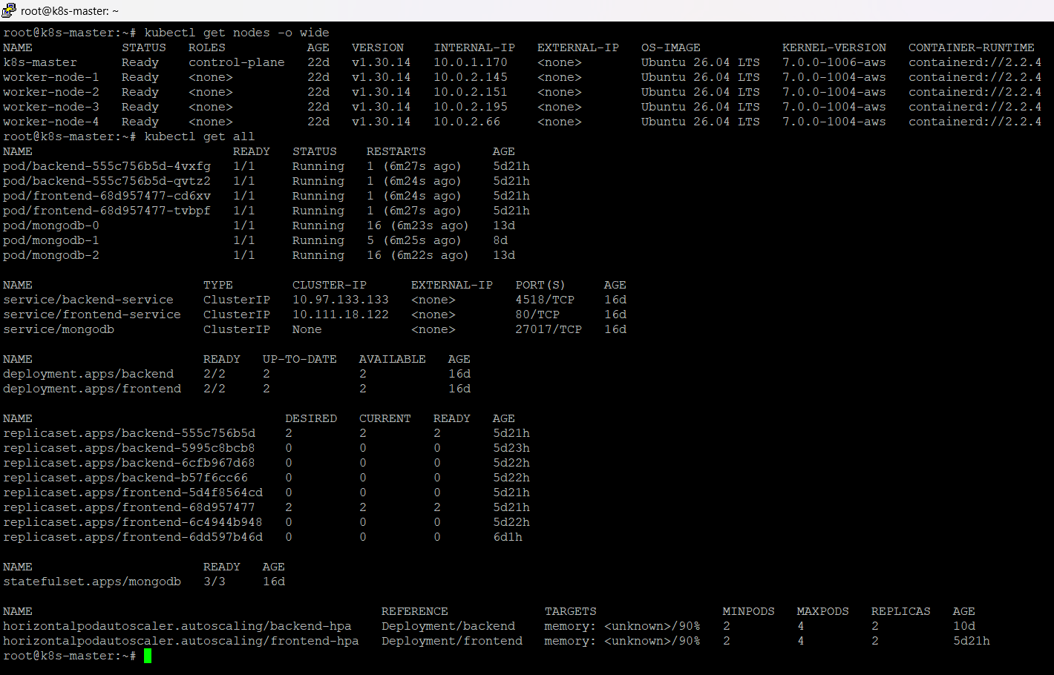
Figure 3: Kubernetes Cluster Nodes & Resources
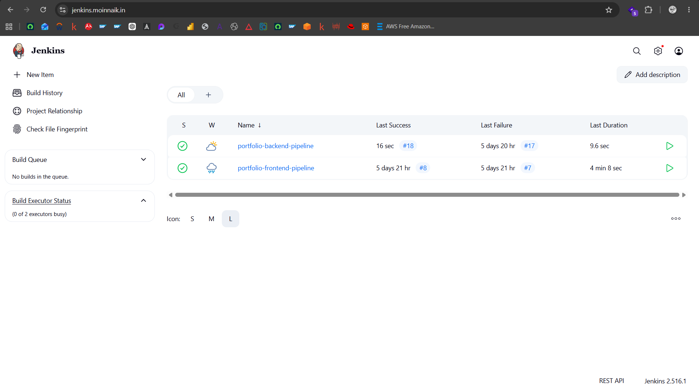
Figure 4: Jenkins Dashboard
CHAPTER 3: SYSTEM ARCHITECTURE
The application follows a microservice-based architecture deployed on Kubernetes. All application components are containerized using Docker and managed through Kubernetes Deployments and StatefulSets.
The architecture consists of the following layers:
4.1 Client Layer
Users access the application through the domain:
https://profile.moinnaik.in
All incoming traffic is routed through the NGINX Ingress Controller, which acts as the entry point to the Kubernetes cluster.
4.2 Frontend Layer
The frontend is developed using React.js and deployed as a Kubernetes Deployment with multiple replicas.
Responsibilities:
- Display portfolio information
- Handle user interactions
- Communicate with backend APIs
- Serve static web content

Frontend traffic is distributed across multiple pods using a Kubernetes Service.
4.3 Backend Layer
The backend is developed using Node.js and Express.js.
Responsibilities:
- Process API requests
- Handle business logic
- Manage database operations
- Provide REST APIs to frontend applications

Backend pods are deployed with multiple replicas to ensure high availability and fault tolerance.
4.4 Database Layer
MongoDB is deployed as a StatefulSet with a Replica Set configuration consisting of:
- MongoDB-0 (Primary)
- MongoDB-1 (Secondary)
- MongoDB-2 (Secondary)

Benefits:
- High Availability
- Data Replication
- Automatic Failover
- Data Consistency

If the Primary node fails, one of the Secondary nodes automatically becomes the new Primary.
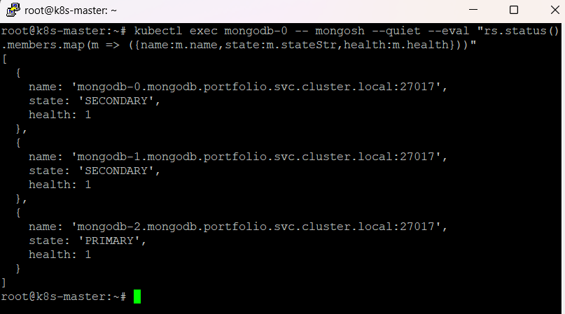
Figure 5: MongoDB Replica Set Status
4.5 CI/CD Layer
Jenkins automates the application deployment process.
Pipeline Workflow:
- Developer pushes code to GitHub.
- Jenkins pipeline starts automatically.
- Docker image is built.
- Application health checks are performed.
- Image is pushed to Docker Hub.
- Image tar file is distributed to worker nodes.
- Kubernetes deployment is updated.
- Rolling update is performed with zero downtime.

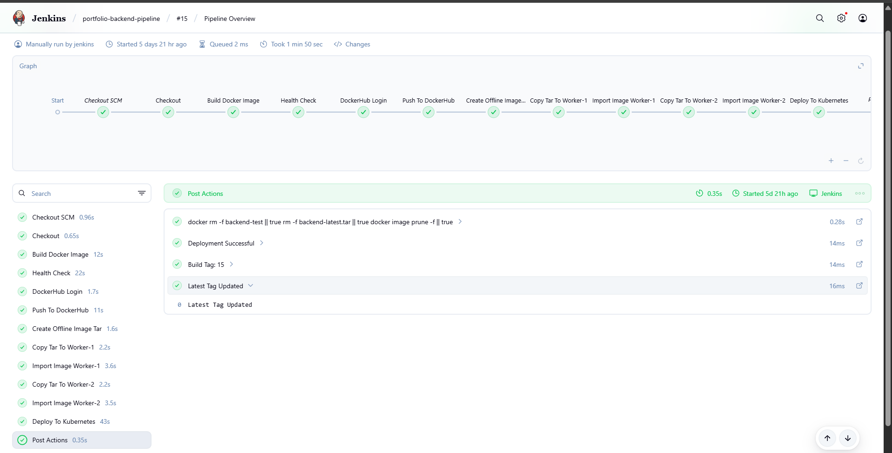
Figure 6: Jenkins CI/CD Pipeline

4.6 Monitoring Layer
The ELK Stack provides centralized monitoring and observability.
Filebeat
Collects logs from:
- Frontend Pods
- Backend Pods
- MongoDB Pods

Metricbeat
Collects:
- CPU Usage
- Memory Usage
- Disk Utilization
- Kubernetes Metrics

Elastic APM
Monitors:
- API Response Time
- Request Traces
- Application Performance
- Error Tracking
Elasticsearch
Stores logs, metrics, and APM traces.
Kibana
Provides dashboards for:
- Log Analysis
- Infrastructure Monitoring
- Application Monitoring
- Troubleshooting

4.7 Security Layer
The application is secured using:
- HTTPS Encryption
- Let's Encrypt SSL Certificates
- Kubernetes Secrets
- Ingress Security Rules

This ensures secure communication between users and application services.

CHAPTER 4: KUBERNETES IMPLEMENTATION
The application is deployed on a Kubernetes cluster to provide scalability, high availability, self-healing, and automated workload management.
The deployment consists of Frontend, Backend, MongoDB Replica Set, Services, Ingress Controller, and Horizontal Pod Autoscaler.
5.1 Namespace Configuration
A dedicated namespace named portfolio is created to isolate application resources from other workloads running in the cluster.
Benefits:
- Resource isolation
- Easier management
- Simplified monitoring
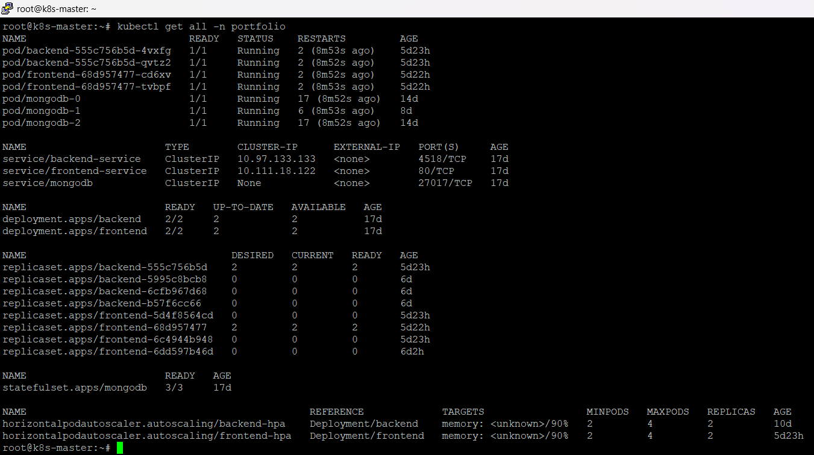
Figure 7: Namespace Resources

5.2 Frontend Deployment
The React frontend application is deployed using a Kubernetes Deployment.
Configuration:
- 2 Replicas
- Docker Image from Docker Hub
- Rolling Update Strategy
- ClusterIP Service

Functions:
- Serve static web content
- Communicate with backend APIs
- Provide user interface

5.3 Backend Deployment
The Node.js backend application is deployed using a Kubernetes Deployment.
Configuration:
- 2 Replicas
- Docker Image from Docker Hub
- Health Checks
- Rolling Updates
- ClusterIP Service

Functions:
- API Processing
- Business Logic Execution
- MongoDB Connectivity
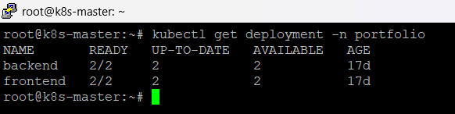
Figure 8: Deployments

5.4 MongoDB StatefulSet
MongoDB is deployed using StatefulSets because database workloads require stable identities and persistent storage.
Configuration:
- 3 Replica Set Members
- Persistent Volumes
- Persistent Volume Claims
- Automatic Recovery

Replica Set Members:
- mongodb-0 (Primary)
- mongodb-1 (Secondary)
- mongodb-2 (Secondary)
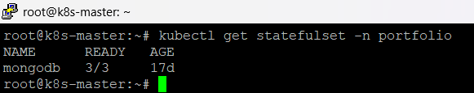
Figure 9: MongoDB StatefulSet

5.5 Services
Kubernetes Services provide internal communication between components.
Frontend Service
Purpose:
- Load balance frontend traffic
- Expose frontend pods internally

Backend Service
Purpose:
- Load balance backend API requests
- Provide stable endpoint for frontend

MongoDB Headless Service
Purpose:
- Enable Replica Set communication
- Provide stable DNS records
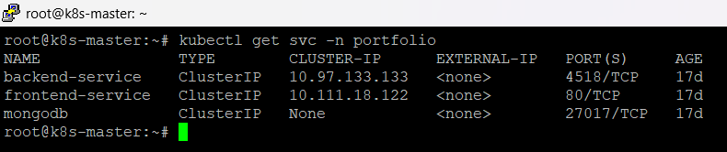
Figure 10: Services

5.6 Ingress Configuration
NGINX Ingress Controller is used to expose the application externally.
Domain: profile.moinnaik.in
Responsibilities:
- Route incoming traffic
- SSL Termination
- HTTPS Redirection
- Load Balancing
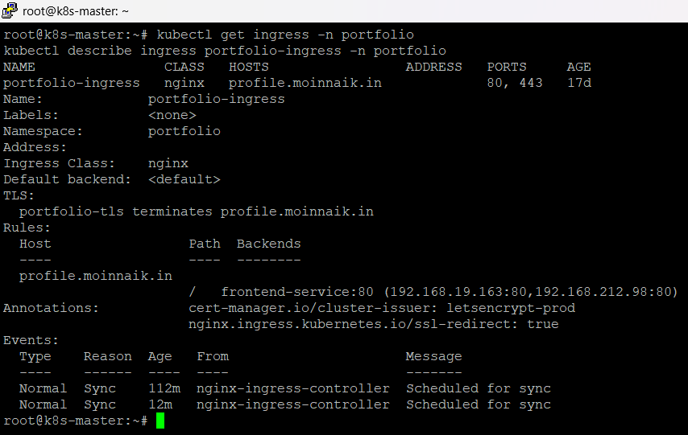
Figure 11: Ingress Configuration

5.7 SSL Certificate Management
Cert Manager is used for automatic certificate issuance and renewal.
Certificate Provider:
Let's Encrypt
Benefits:
- Automatic Certificate Renewal
- Secure HTTPS Communication
- Reduced Manual Administration
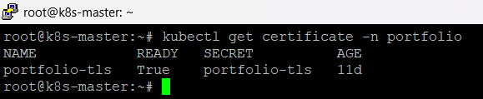
Figure 12: SSL Certificate

5.8 Horizontal Pod Autoscaler
A Horizontal Pod Autoscaler (HPA) is configured for the backend deployment.
Configuration:
- Minimum Pods: 2
- Maximum Pods: 4
- Memory Utilization Threshold: 90%

Benefits:
- Automatic Scaling
- Better Resource Utilization
- Improved Application Availability
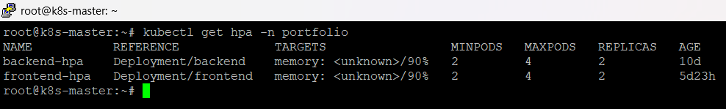
Figure 13: Horizontal Pod Autoscaler

5.9 Rolling Updates
Kubernetes Deployments use rolling updates during application deployment.
Advantages:
- Zero Downtime Deployment
- Automatic Rollback Support
- Continuous Availability
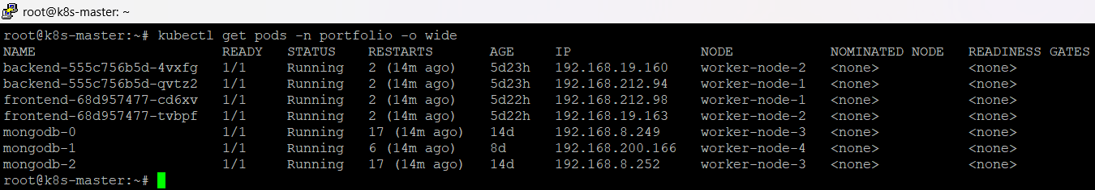
Figure 14: Running Pods

The CI/CD pipeline updates application containers without affecting end users.

CHAPTER 5: CI/CD PIPELINE IMPLEMENTATION
A Continuous Integration and Continuous Deployment (CI/CD) pipeline is implemented using Jenkins to automate the application build, testing, image creation, distribution, and deployment process.
The pipeline eliminates manual deployment steps and ensures consistent releases across the Kubernetes environment.
6.1 CI/CD Workflow
- The deployment workflow follows the sequence below:
- Developer pushes code to GitHub.
- Jenkins automatically detects code changes.
- Source code is pulled from the repository.
- Docker image is built.
- Application health checks are executed.
- Docker image is pushed to Docker Hub.
- Image tar files are generated.
- Images are copied to Kubernetes worker nodes.
- Images are imported into containerd.
- Kubernetes deployment is updated.
- Rolling update deploys the new version.
- Application becomes available without downtime.
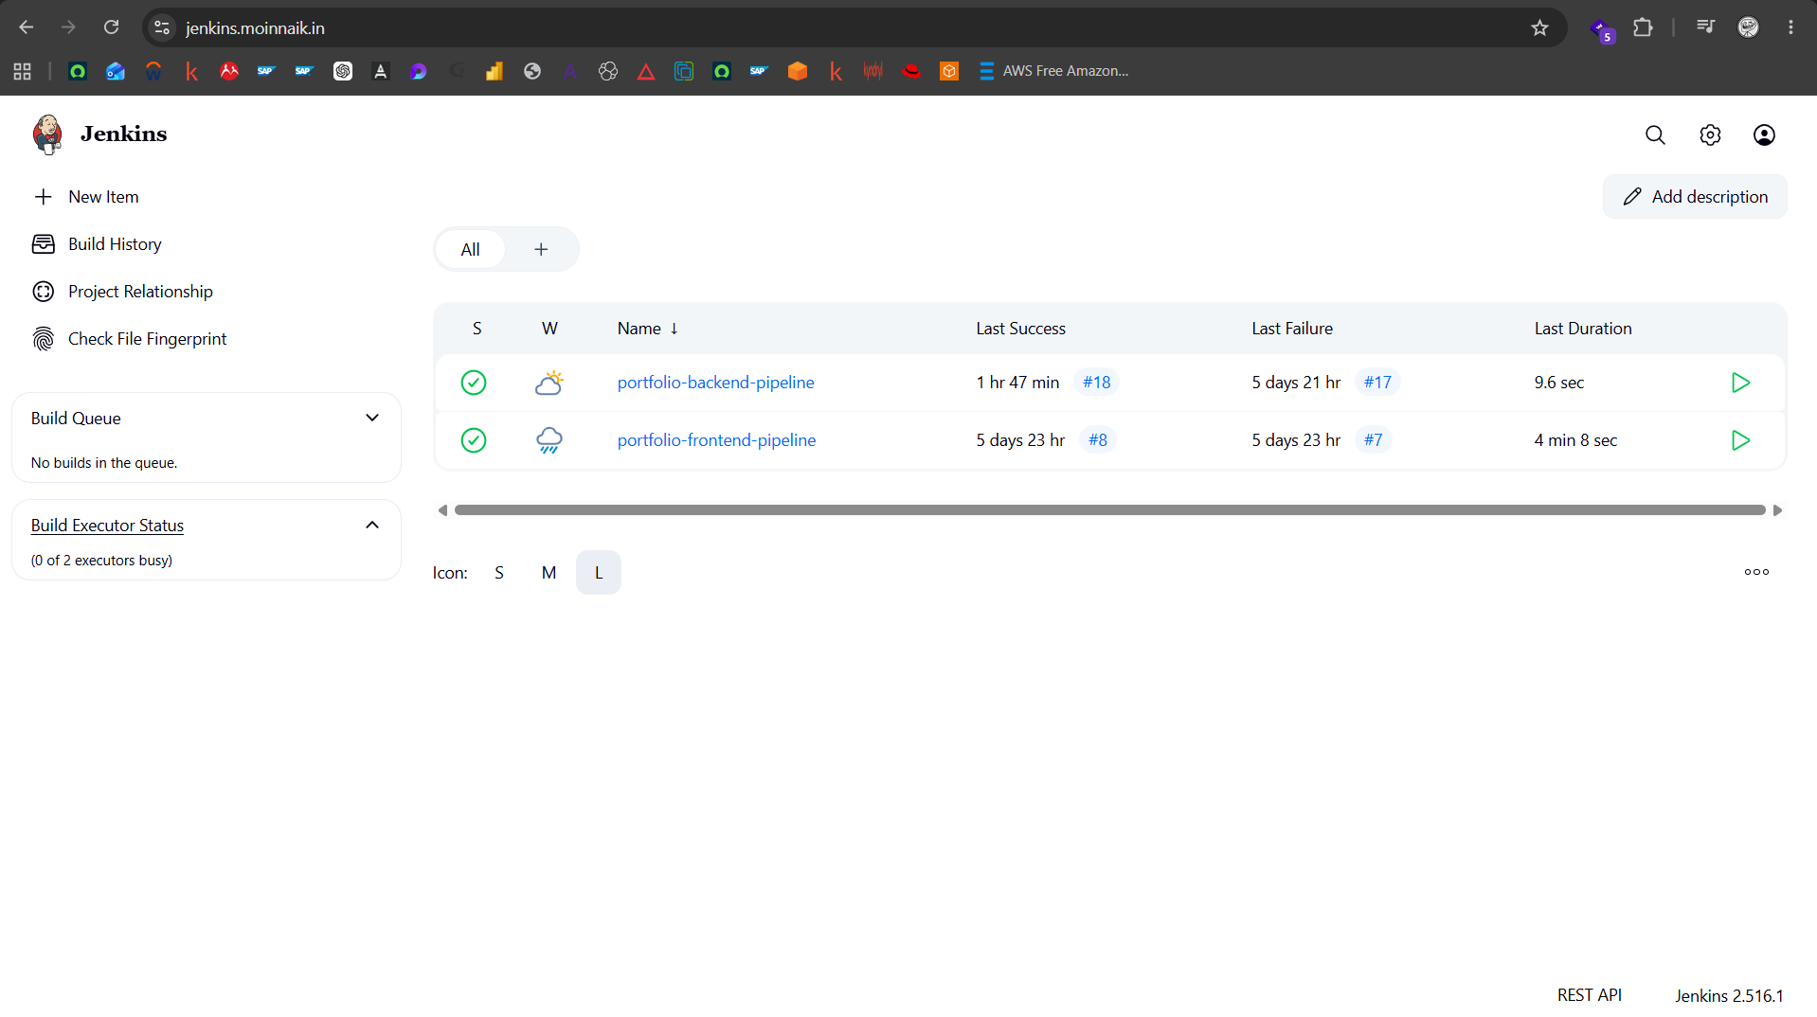
Figure 15: Jenkins Dashboard
6.2 Source Code Management
GitHub is used as the central source code repository.
Repositories include:
- Frontend Application
- Backend Application
- Kubernetes Manifests
- Jenkins Pipeline Definitions

Branch Strategy:
- main branch
- prod branch for production deployments

6.3 Backend Pipeline
The backend Jenkins pipeline performs the following actions:
Source Code Checkout
Jenkins pulls the latest code from GitHub.
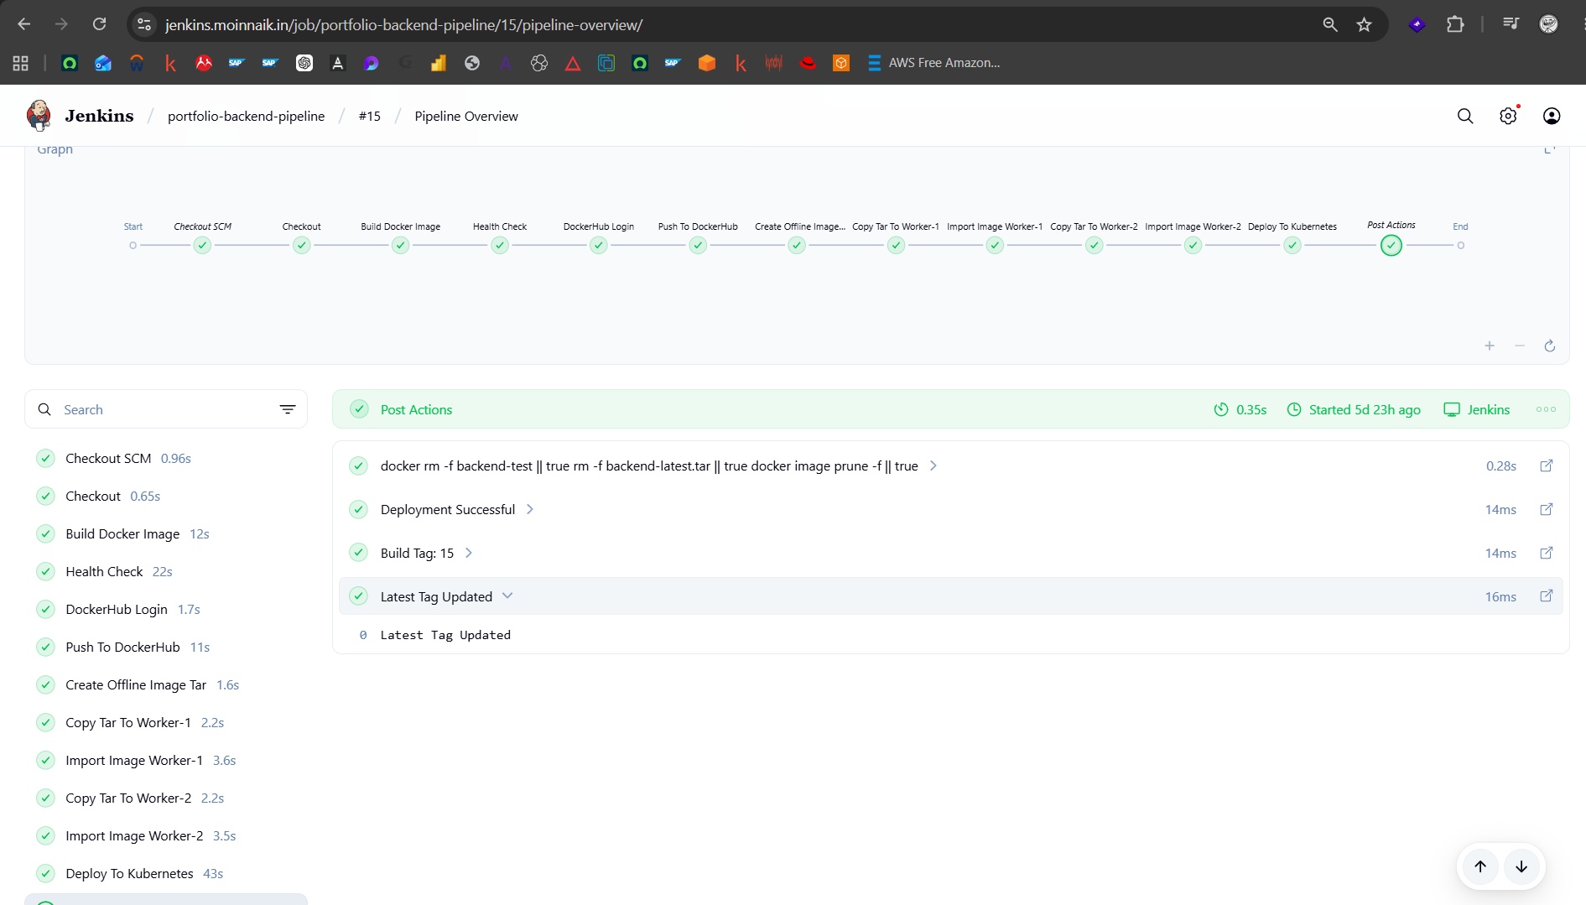
Figure 16: Backend Pipeline Success
Dependency Installation
Node.js dependencies are installed using npm.
Docker Image Build
Backend Docker image is created and tagged with:
- Build Number
- Latest

Example:
moinnaik/portfolio-backend:15
moinnaik/portfolio-backend
Health Verification
A temporary container is launched to verify application startup before deployment.
Docker Hub Push
The image is pushed to Docker Hub.
Offline Image Distribution
Docker image tar files are generated and transferred to Kubernetes worker nodes.
Kubernetes Deployment
The backend deployment is restarted to consume the latest image.

6.4 Frontend Pipeline
The frontend Jenkins pipeline follows a similar process:
Source Code Checkout
Latest frontend code is pulled from GitHub.
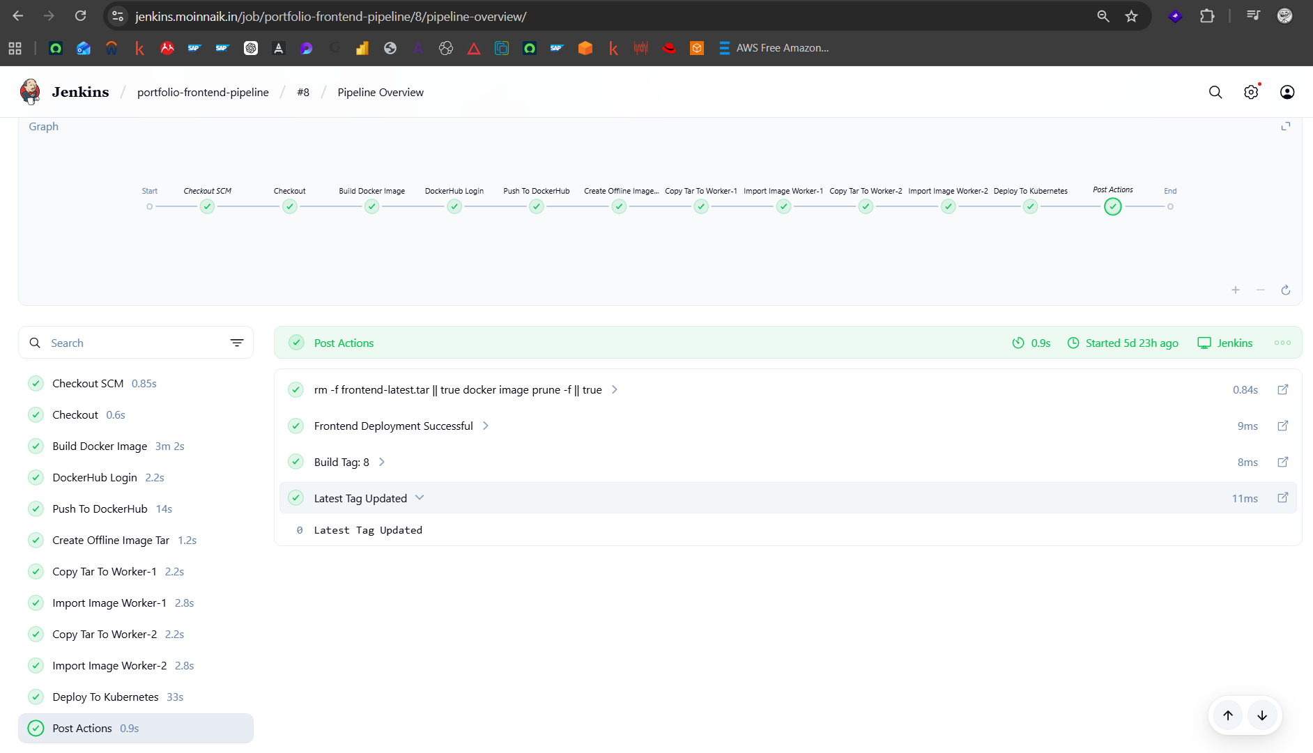
Figure 17: Frontend Pipeline Success
Dependency Installation
Required frontend packages are installed.
Production Build
The React application is compiled using Vite.
Docker Image Creation
Frontend image is tagged using:
- Build Number
- Latest

Example:
moinnaik/portfolio-frontend:15
moinnaik/portfolio-frontend
Docker Hub Push
Images are pushed to Docker Hub.
Worker Node Distribution
Image tar files are copied and imported into worker nodes.
Kubernetes Deployment
Frontend deployment is restarted to use the updated image.
6.5 Image Distribution Strategy
Worker nodes are configured without requiring direct internet access for image pulls.
To achieve this:
- Jenkins creates Docker image tar files.
- Tar files are copied using SCP.
- Images are imported using containerd.
- Kubernetes consumes locally available images.

Benefits:
- Faster deployment
- Reduced external dependency
- Improved security

6.6 Deployment Strategy
Rolling updates are used for application deployment.
Advantages:
- Zero Downtime Deployment
- Service Availability
- Automatic Pod Replacement
- Easy Rollback

6.7 Benefits of CI/CD Automation
- Faster Releases
- Reduced Human Error
- Consistent Deployments
- Automated Validation
- Improved Reliability
- Simplified Operations

CHAPTER 6: MONITORING AND OBSERVABILITY
To ensure application reliability, performance monitoring, and centralized log management, an ELK-based observability platform is implemented.
The monitoring solution consists of:
- Elasticsearch
- Kibana
- Filebeat
- Metricbeat
- Elastic APM

The platform provides centralized visibility into application logs, infrastructure metrics, and application performance.
7.1 Monitoring Architecture
The observability platform collects data from Kubernetes workloads and stores it centrally in Elasticsearch.
Collected data includes:
- Application Logs
- Container Logs
- Kubernetes Metrics
- Node Metrics
- API Performance Metrics
- Application Traces

All collected information is visualized through Kibana dashboards.
7.2 Elasticsearch
Elasticsearch serves as the central data storage engine.
Responsibilities:
- Store logs
- Store metrics
- Store APM traces
- Enable fast searching and filtering

Benefits:
- High-speed indexing
- Real-time search
- Scalability
- Centralized data management

7.3 Kibana
Kibana provides visualization and analysis capabilities.
Features Used:
- Discover
- Dashboards
- Infrastructure Monitoring
- APM Monitoring
- Log Analysis

Kibana enables administrators to monitor the health and performance of the entire application stack.
7.4 Filebeat
Filebeat is deployed to collect logs from Kubernetes workloads.
Log Sources:
- Frontend Pods
- Backend Pods
- MongoDB Pods
- Kubernetes System Components

Workflow:
- Logs are generated by containers.
- Filebeat collects logs.
- Logs are forwarded to Elasticsearch.
- Kibana displays logs in real time.

Benefits:
- Centralized Logging
- Faster Troubleshooting
- Real-Time Monitoring

7.5 Metricbeat
Metricbeat collects infrastructure and Kubernetes metrics.
Collected Metrics:
- CPU Usage
- Memory Usage
- Disk Usage
- Network Usage
- Pod Metrics
- Node Metrics

Benefits:
- Resource Monitoring
- Capacity Planning
- Performance Analysis

7.6 Elastic APM
Elastic APM is integrated with the Node.js backend application.
Monitored Parameters:
- API Response Time
- Request Throughput
- Error Rate
- Transaction Traces
- Service Dependencies

The APM agent automatically sends performance data to Elasticsearch.
Benefits:
- Application Performance Monitoring
- Bottleneck Detection
- Faster Issue Resolution

7.7 Centralized Log Management
All application logs are collected and stored in a centralized location.
Advantages:
- Single Source of Truth
- Easier Log Search
- Faster Incident Investigation
- Historical Analysis

Administrators can search logs using filters such as:
- Application Name
- Log Level
- Timestamp
- Kubernetes Namespace

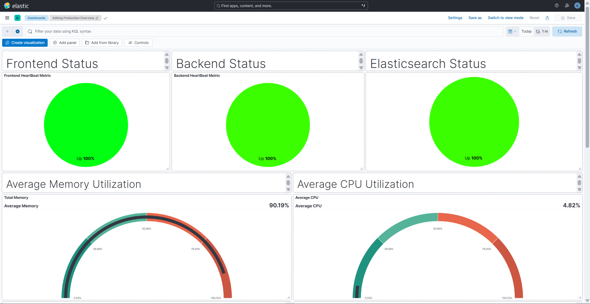
Figure 18: Kibana Dashboard Prod Overview

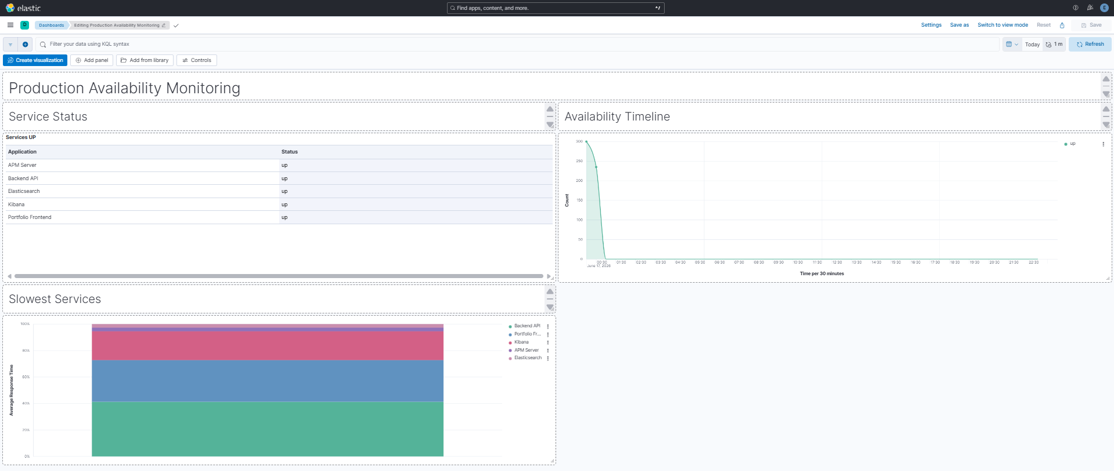
Figure 19: Kibana Dashboard Prod Availability

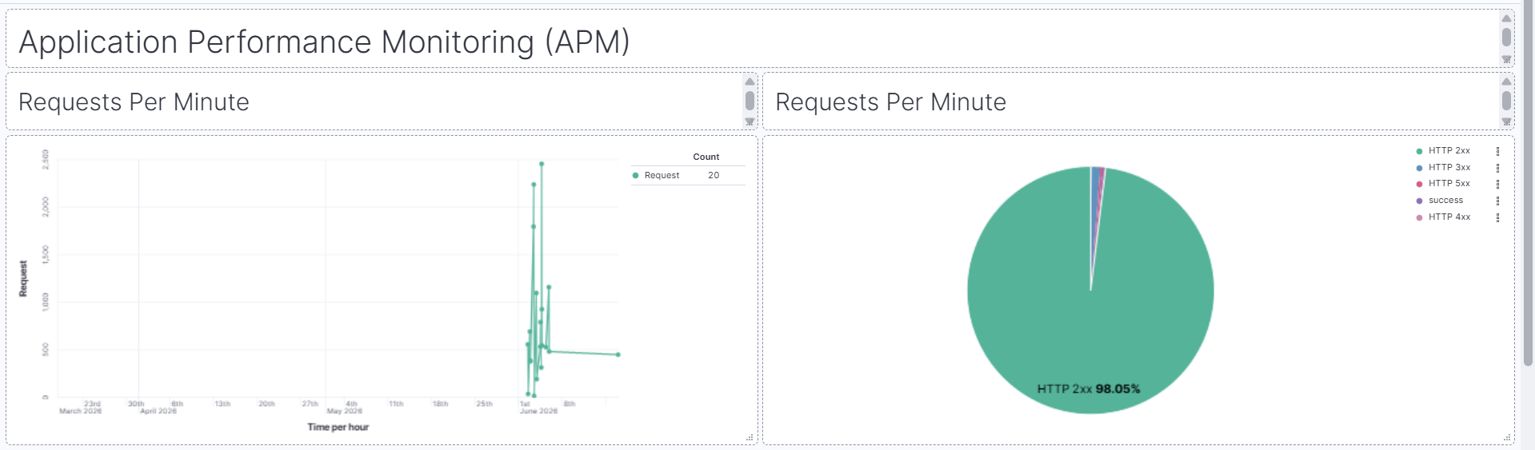
Figure 20: Kibana Dashboard APM - a

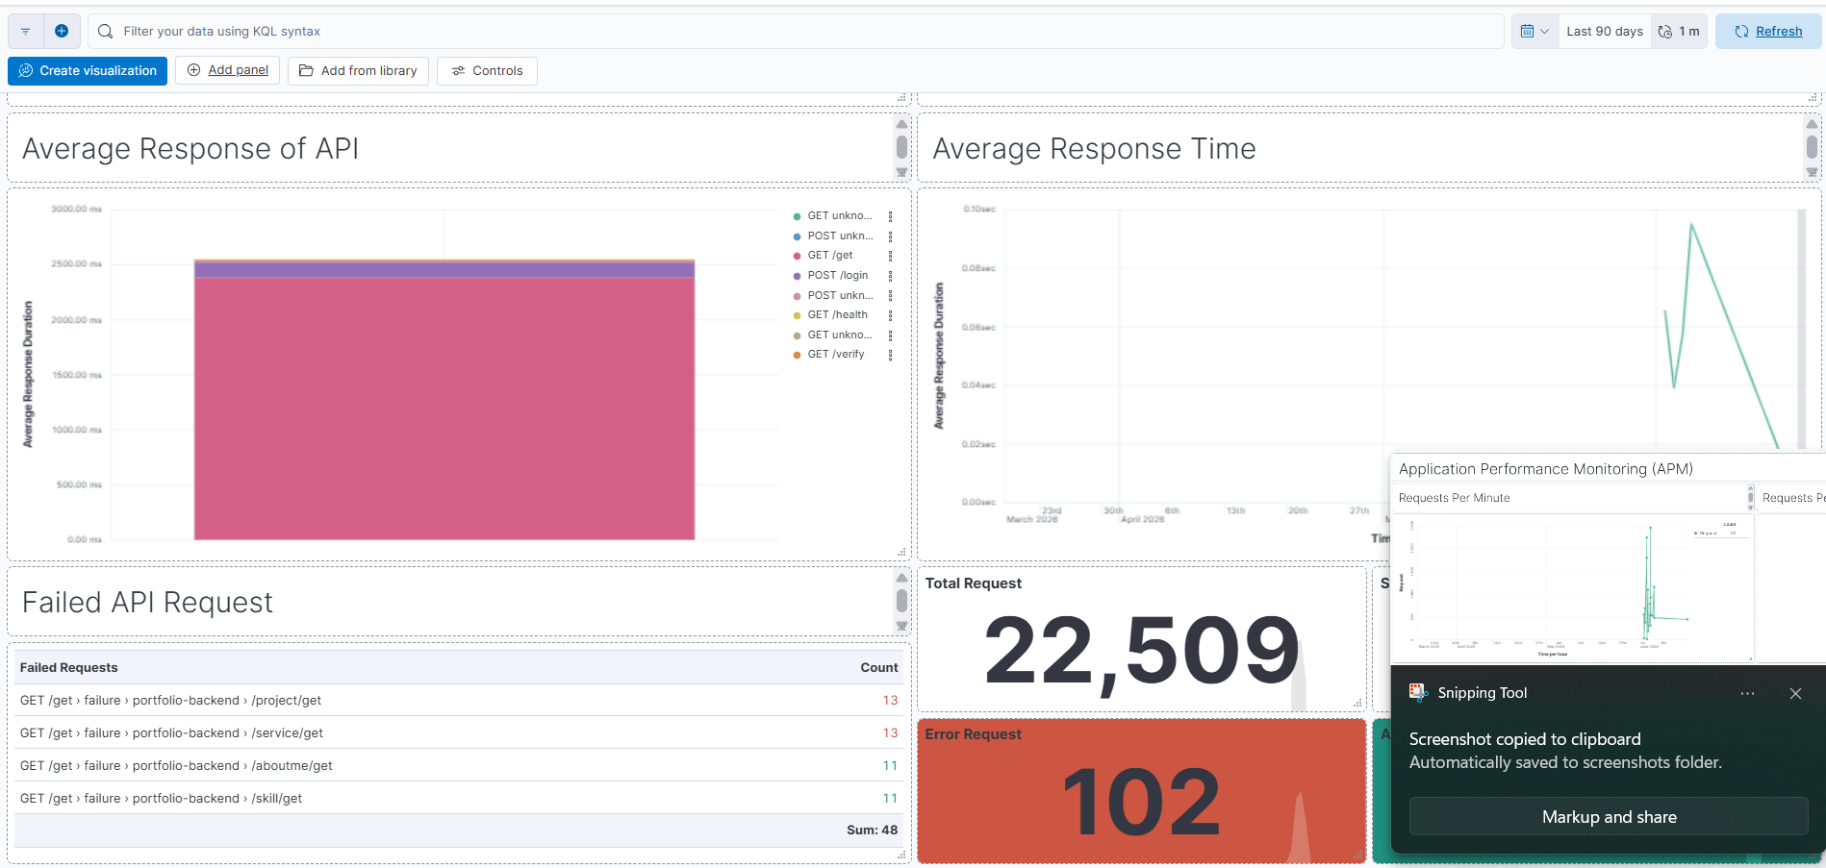
Figure 21: Kibana Dashboard APM - b
7.8 Observability Benefits
The monitoring platform provides:
- Real-Time Visibility
- Faster Troubleshooting
- Centralized Monitoring
- Performance Optimization
- Error Tracking
- Infrastructure Monitoring

This observability solution significantly improves operational efficiency and application reliability.
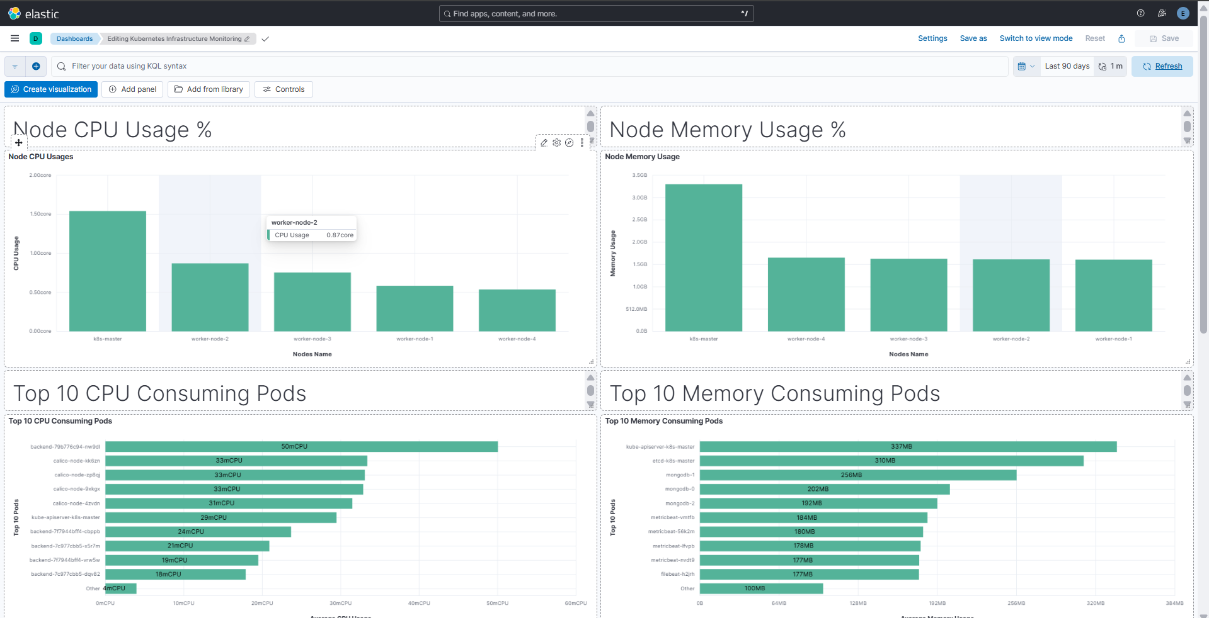
Figure 22: Kibana Dashboard Usages

CHAPTER 7: RESULTS AND CONCLUSION
8.1 Project Results
The project successfully implemented a production-grade MERN stack application deployment using modern DevOps practices and cloud-native technologies.
The solution includes:
- React Frontend Application
- Node.js Backend API
- MongoDB Replica Set Database
- Kubernetes Orchestration Platform
- Jenkins CI/CD Automation
- Docker Containerization
- ELK Monitoring Stack
- HTTPS Security using Let's Encrypt

The deployed infrastructure provides high availability, scalability, automated deployment, and centralized monitoring.
8.2 Key Achievements
Containerization
Frontend and Backend applications were successfully containerized using Docker, ensuring consistency across environments.
Kubernetes Deployment
Applications were deployed on Kubernetes with:
- Deployments
- StatefulSets
- Services
- Ingress
- Horizontal Pod Autoscaler

This provided automated workload management and high availability.
Database High Availability
MongoDB Replica Set was implemented with three members to ensure redundancy and fault tolerance.
CI/CD Automation
Jenkins pipelines automate:
- Source Code Checkout
- Docker Image Build
- Health Verification
- Docker Hub Push
- Image Distribution
- Kubernetes Deployment

This significantly reduced manual deployment effort.
Monitoring and Observability
The ELK Stack provides:
- Centralized Logging
- Infrastructure Monitoring
- Application Performance Monitoring
- Real-Time Visualization

This improves operational visibility and troubleshooting capabilities.
8.3 Benefits Achieved
The implemented solution provides:
- Automated Deployment Process
- High Availability
- Scalability
- Centralized Monitoring
- Secure HTTPS Communication
- Faster Troubleshooting
- Reduced Manual Intervention
- Improved Application Reliability

8.4 Challenges Faced
During implementation, several challenges were encountered and resolved:
- Kubernetes image deployment issues
- MongoDB Replica Set configuration
- Elastic APM integration
- Ingress and SSL configuration
- Jenkins pipeline automation
- Container image distribution to worker nodes

Resolving these issues provided practical experience in real-world DevOps operations.
8.5 Future Enhancements
The project can be extended with:
- AWS EKS Migration
- Terraform Infrastructure Automation
- GitOps using ArgoCD
- Prometheus and Grafana Integration
- Multi-Region Deployment
- Disaster Recovery Automation
- Advanced Security Monitoring

These enhancements can further improve scalability, automation, and resilience.
8.6 Conclusion
This project successfully demonstrates the implementation of a complete production-grade DevOps ecosystem for a MERN stack application.
By combining Docker, Kubernetes, Jenkins, MongoDB Replica Sets, and the ELK Stack, the solution delivers automated deployment, scalability, fault tolerance, monitoring, and operational efficiency.
The project provided practical experience in cloud-native application deployment and modern DevOps practices while creating a reliable and maintainable production environment.

