Software Requirements Specification Document
201501066  201525094  201501246  201525214 | OurFood, Team #30  Moin Hussain Moti  Bakhtiyar Syed  Nitin John Raj  Konigari Rachna

Brief problem statement
OUR FOOD builds an effective end-to-end supply chain starting from scientifically assessing the quality of the crops from farmer, processing the crops and then delivering it to bulk buyers.
Project Details:
1. Administrator interface to input/upload crop details, quality parameters, farmer details, buyer details, logistics etc.
2. Assess the cost of the crop based on the inputs from scientific equipment, crop parameters logistics & history data.
3. Interface for buyers to request bulk orders.
4. Interface for farmers to provide crop details.
5. Analytics: Suggest the best location and logistics based on buyers request. Analyze and build reports based on parameters viz. crop, season, order size, logistics.

System requirements
Languages : Java, XML, JQuery(JavaScript), HTML, CSS
Tools : Spring MVC Framework for developing the web application.
Hibernate to integrate the database.
Thymeleaf for UI Design.
Collaboration Tools : Apache Maven, Tomcat, Spring Tool Suite (STS), Eclipse IDE/IntelliJ IDEA, Visual Paradigm, WPS Office
It should run on all platform that supports java runtime environment.

Users profile
Farmers:
Any form of access to the ourfood.
OurFood Admin:
Admin of the OurFood Systems.
Buyers:
Wholesaler of processes crops
Interested in bulk buys.

Feature requirements (described using use cases)

No. | User Case Name | Description | Release
UC-1 | Admin Login | As an admin, I can log into the system to perform certain actions. | R1
UC-2 | Admin Registration | As a super-admin, I can register other admins. | R2
UC-3 | Direct CRUD Farmer | As an admin, after logging in, I can CRUD a Farmer to the database. | R1
UC-4 | Farmer Registration | As a farmer, I can enter details in a predefined UI to contact the system and thereby register. | R2
UC-5 | Farmer Login | As a farmer, I can enter details in a predefined UI to contact the system and thereby login to perform certain actions. | R2
UC-6 | Direct CRUD CropType | As an admin, after logging in, I can CRUD the names and types of crops so that the farmer can sell us those. | R1
UC-7 | Direct CRUD Farmer’s (Unprocessed) Order | As an admin, after logging in, I can CRUD an order for any farmer who has contacted me offline. | R1
UC-8 | Place Order by Farmer | As a farmer, I can place an order to OurFood via a predefined UI to request OurFood to buy the crop. | R2
UC-9 | Calculate Crop Quality | As an admin, I should be able to view the quality of a farmer’s crop as evaluated by the OurFood personnel, calculated from the data they upload on the server. | R1
UC-10 | Expose, Modify and Confirm Buying Price | As a farmer or an admin, I can view the amount that OurFood is willing to pay a farmer for his crops, and receive confirmation when the amount has been paid. Amount can be negotiated offline and changed by OurFood admins. | R1
UC-11 | Expose Nearest Warehouse to a Farmer | As an OurFood admin, I can view the nearest warehouses to a specified farmer’s location. | R1
UC-12 | Expose Warehouse Details | As an OurFood admin, I can view details of a warehouse, like its maximum capacity, the raw materials already present, etc. | R2
UC-13 | Input Processed Food | As an OurFood admin, I can manually input the amount of a processed good that has been manufactured in a warehouse. | R1
UC-14 | Direct CRUD Bulk Buyer’s Order | As an OurFood admin, I can enter details of a bulk buyer’s order | R1
UC-15 | Place Order by Bulk Buyer | As a bulk buyer, I should be able to view what products are available, their prices to be delivered to me, and I should be able to place an order accrdingly (through a predefined UI). | R2
UC-16 | Confirm Payment of Bulk Buyer | As an admin, I should be able to view if a bulk buyer’s order has been paid for, and thus know when to begin delivery. | R2

Use case diagram
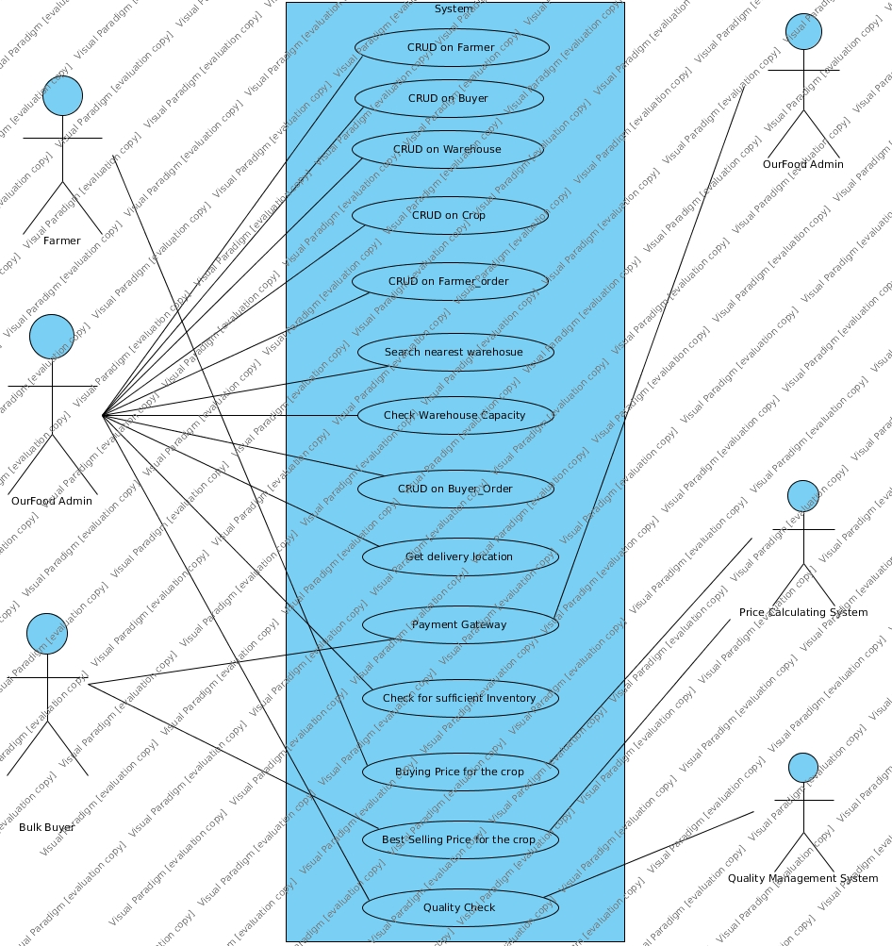

Use Case Number: | UC-1
Use Case Name: | Admin Login
Overview: | The admin is a person in OurFood with who can interact with the system we set into place. Different admins may have different access to the data we expose.
Actors: | Administrator
Pre condition: | Login request made to system
Flow: | 1. System receives a login request with username and password.  2. System checks if the data is valid.  3. System logs the admin in if it is, else returns a ‘login failed’.
Post Condition: | The admin is logged in.

Use case description

Use Case Number: | UC-2
Use Case Name: | Admin Registration
Overview: | The admin is a person in OurFood with who can interact with the system we set into place. Different admins may have different access to the data we expose. The superadmin can register other admins.
Actors: | Super administrator
Pre condition: | Admin register request made to system
Flow: | 1. System receives an admin register request with username, password, details.  2. System checks if the data is valid.  3. System saves the new administrator in the database.
Post Condition: | -

Use Case Number: | UC-3
Use Case Name: | Direct CRUD Farmer
Overview: | Farmers are the people who sell OurFood their crops. This use case allows an OurFood admin to create a Farmer account to track all transactions with the Farmer.
Actors: | Administrator
Pre condition: | Farmer register request made to system
Flow: | 1. System receives a farmer register request with username, password and other details.  2. System checks if the data is valid.  3. System stores the farmer in the database.
Post Condition: | -

Use Case Number: | UC-4
Use Case Name: | Farmer Registration
Overview: | Farmers are the people who sell OurFood their crops. This use case allows a Farmer to create a Farmer account to track all his transactions with the OurFood, place orders, etc.
Actors: | Farmer
Pre condition: | Farmer register request made to system
Flow: | 1. System receives a farmer register request with username, password and other details.  2. System checks if the data is valid.  3. System stores the farmer in the database.
Post Condition: | -

Use Case Number: | UC-5
Use Case Name: | Farmer Login
Overview: | Farmers are the people who sell OurFood their crops. This use case allows a Farmer to login to perform certain actions.
Actors: | Farmer
Pre condition: | Farmer login request made to system
Flow: | 1. System receives a farmer login request with username and password.  2. System checks if the data is valid.  3. System logs the farmer in.
Post Condition: | Farmer is logged in.

Use Case Number: | UC-6
Use Case Name: | Direct CRUD CropType
Overview: | Crops are of various predefined types. No farmer can sell a crop that is not predefined by an admin.  Eg: wheat, rice, etc.
Actors: | Administrator
Pre condition: | CropType register request made to system
Flow: | 1. System receives a crop-type register request with crop name and other details.  2. System stores the crop-type in the database.
Post Condition: | -

Use Case Number: | UC-7
Use Case Name: | Direct CRUD Farmer’s Order
Overview: | When a farmer is ready to sell his crops, he can contact OurFood offline. The admin then generates an order and passes it to the system.
Actors: | Administrator
Pre condition: | CropType register request made to system
Flow: | 1. System receives a crop-type register request with crop name and other details.  2. System stores the crop-type in the database.
Post Condition: | -

