Product Design
Team | 30  SSAD 22  Moin Hussain Moti  Bakhtiyar Syed  Nitin John Raj  Rachana Konigari

BuyerOrder | - This class deals with the order placed by the bulk buyers.  - It consists the information of Bulk Buyer and the location where the order is to be shipped  - It comprises of many BuyerOrderItem instances  - It has basic CRUD functionality
BuyerOrderItem | - BuyerOrderItem determines the product and product grade of the item ordered  - It has basic CRUD functionality
Product | - Product class consists of many BuyerOrderItem instances  - It is what stored in the inventory after the processing of the produces  - It has basic CRUD functionality
Seller Acccount | - This class deals with the seller accounts of the farmers.  - It consists of the information of Seller Accounts along with their location and pinCode and other details.  - It has provisions to edit and delete the seller accounts at the expense of the power administrator.
Buyer Account | - This class deals with the buyer accounts of the farmers.  - It consists of the information of Buyer Accounts along with their location and pinCode and other details.  - It also has provisions to edit and delete the buyer accounts at the expense of the power administrator.
Produce | - Produce class consists of many SellerOrderItem instances  - It is what is stored in the inventory when the farmers place their order  - It has basic CRUD functionality
SellerOrderItem | - SellerOrderItem determines the produce the farmer wants to sell.  - Has basic CRUD functionality.

Sequence Diagram(s)
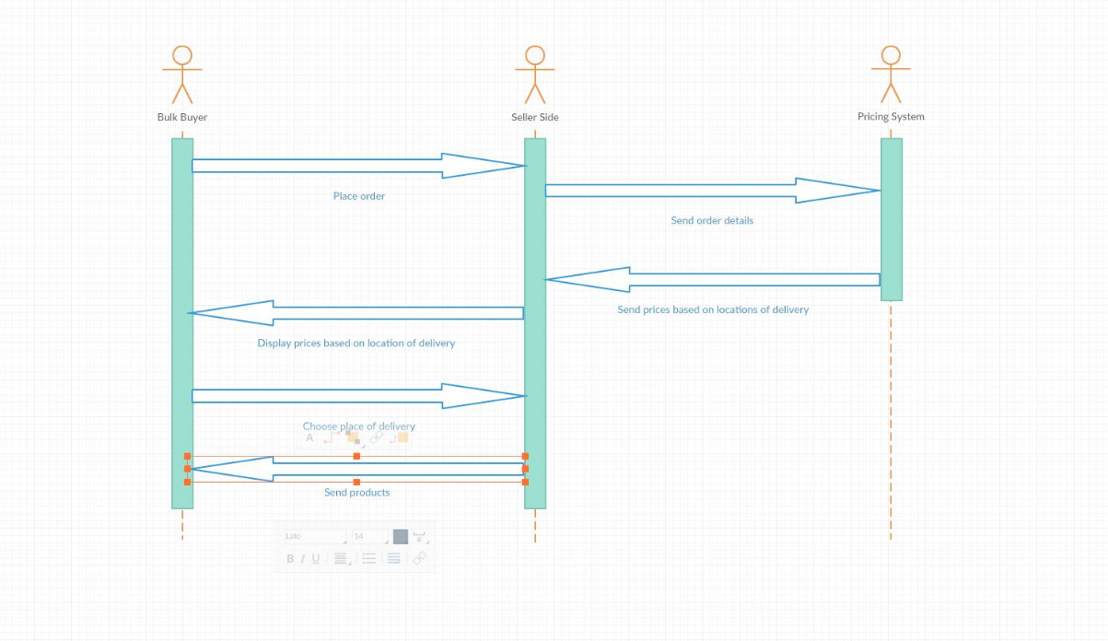
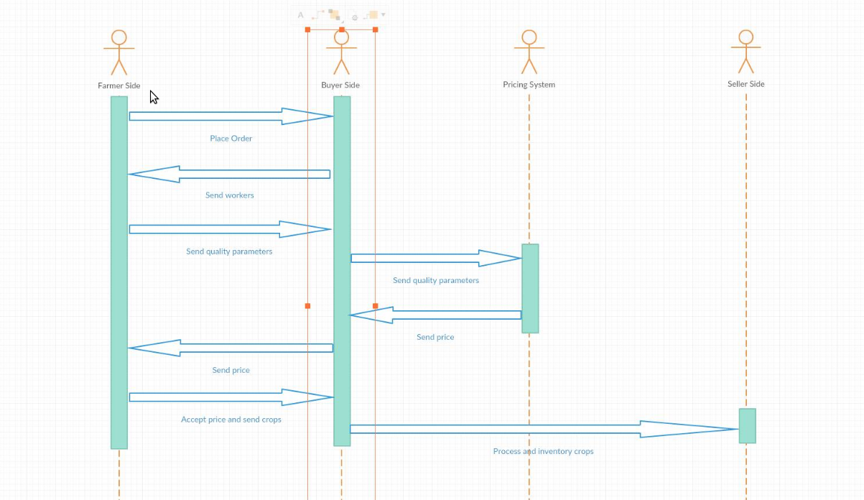

Design Rationale
- There is a ProduceCategory enum for Produce model where various categories of the produce is defined. Similarly there exist a Product model and it is also has an attribute of category but instead of making a separate ProductCategory enum, client wants us to use ProduceCategory enum only for Product too.

