

# **NORTH SOUTH UNIVERSITY** DEPARTMENT OF ELECTRICAL & COMPUTER ENGINEERING

**Project proposal**

**Fall 2020**

**CSE327: Software Engineering**

**Section: 05**

**Group Members**

|  |  |
| --- | --- |
| **ID** | **Name** |
| 1621759042 | MoinUddin Md. Tareq |
| 1722195642 | Saif Mohammad Talukder |
| 1813477042 | Arijeet Roy |

**Project title**

A book sharing platform

**Introduction**

There are numerous book lovers in our country who are constantly searching for new and different books. To meet the consumers demand this website we’re making facilitates trades of books; to simplify buy, sell, rent and exchange of books. Our website works as a platform for everyone. The Users are individual sellers and buyers who are not associated with any shops, then there are Verified Vendors, who are mainly using this platform to sell their shop’s books online. We, along with the Verified Vendors, provide a vast collection of books that can be bought. The Users can chat with each other and can engage in buying/selling/exchanging/renting of their own books; after confirmation of buy, sell or exchange by the involved Users, the books will be delivered by our deliverymen for which we’ll only charge a very small commission. Verified Vendors who can sell books through our website have to sign up here with a subscription fee, unlike the Users. Verified Vendors can also engage in buying old books from the Users. The website will feature a very large collection of used and new book such that books of all categories will be available for all types of users.

**Objective**

The community our website will serve mainly comprises of students or any educational people, and of course, book lovers. As students are big part of our target community, the exchange/sell/rent feature will serve them greatly. Students who sometimes can’t afford expensive books, or has to buy books frequently, they can just exchange or rent books now. So the main objective of our project are to ensure ways to help the students as well as the book lovers all around the country, deliver books at a affordable rate, to make a large collection of rare books.

**Target User**

Our Target are mainly focused on students and professors, but also will encompass all the book lovers of the country. Not to mention, the vendors are also in our segments.

**Functionalities**

1. Sell/rent/exchange

2. Post

3. Comment

5. Blog

4. Cart

**Technologies:**

Technologies we used in this project are given below:

* **Programming language:** Python
* **Design:** HTML5, CSS3, Bootstrap4
* **Framework:** Django
* **API:** SSLCOMMERZ payment gateway API.
* **Github –** Version Control System.

1. Use Case Diagram:

1.1 Use Cases for Customer

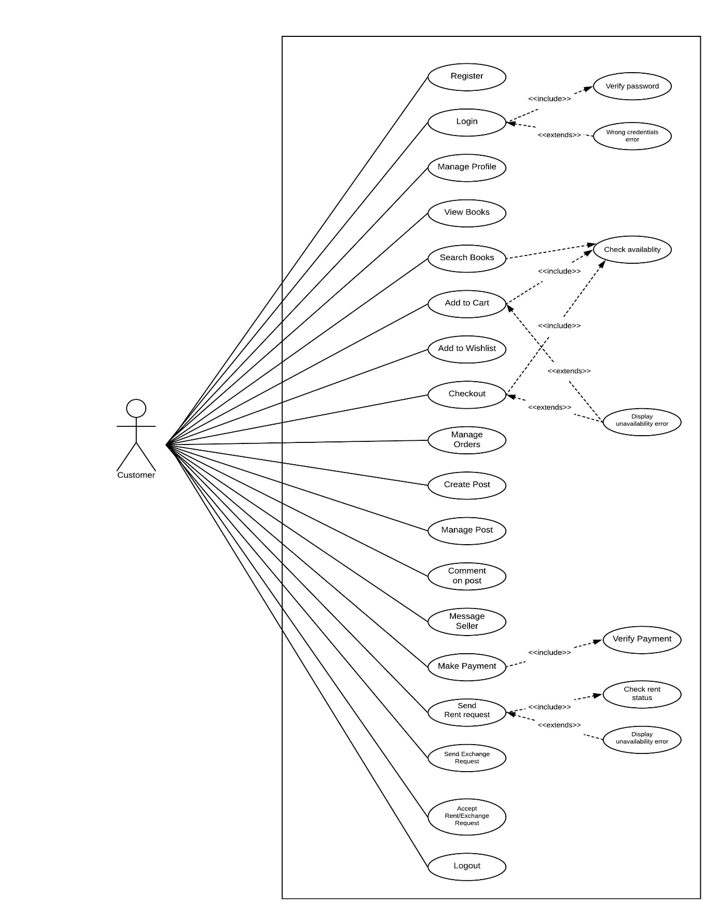

1.2 Use Cases for Admin

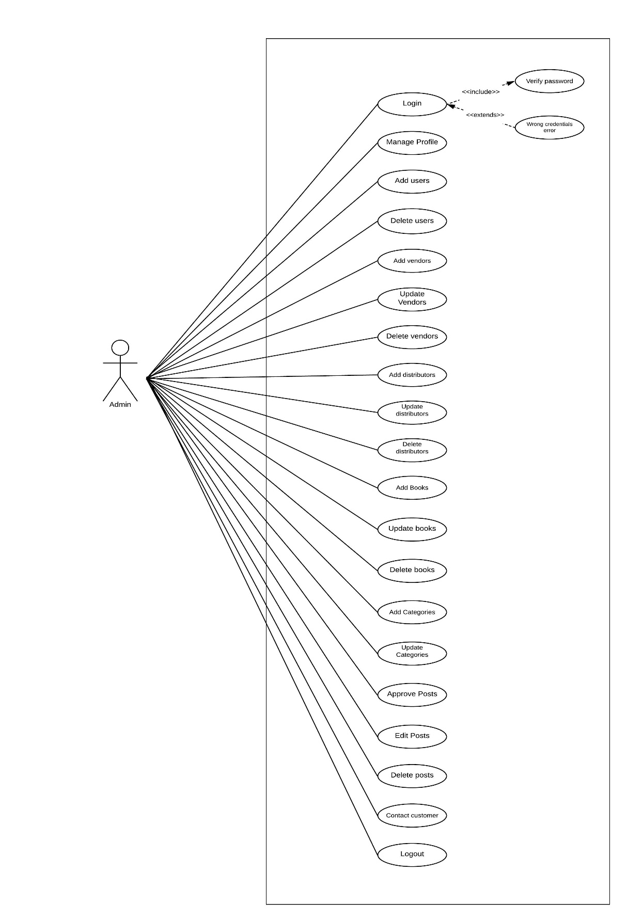

1. Class diagram

