Homework 3

1. Design and test a sequential logic circuit for the snail that detects 3 consecutive '1' bits using Digital.

#scans

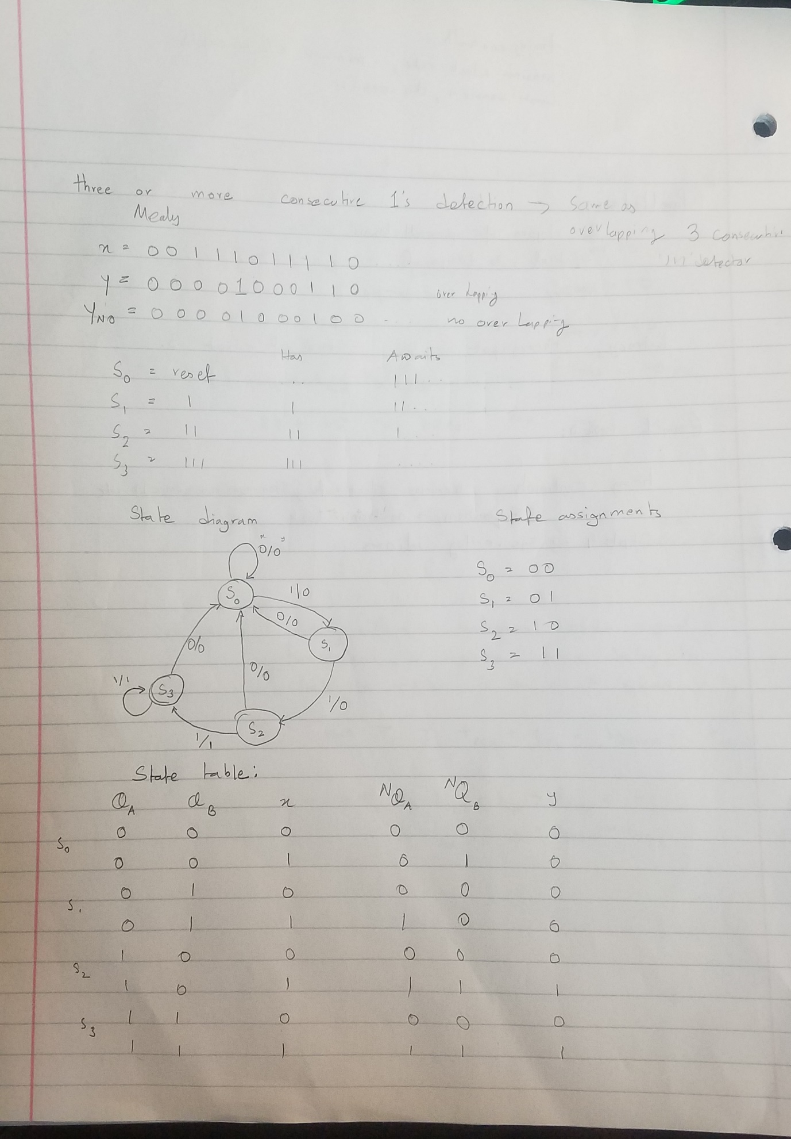

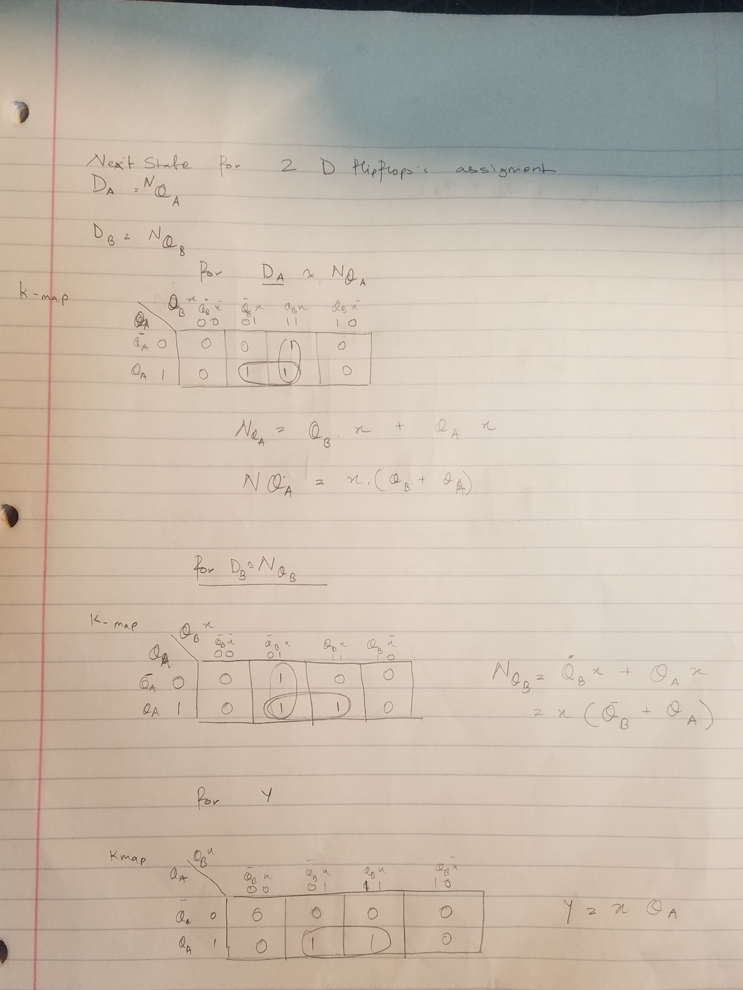

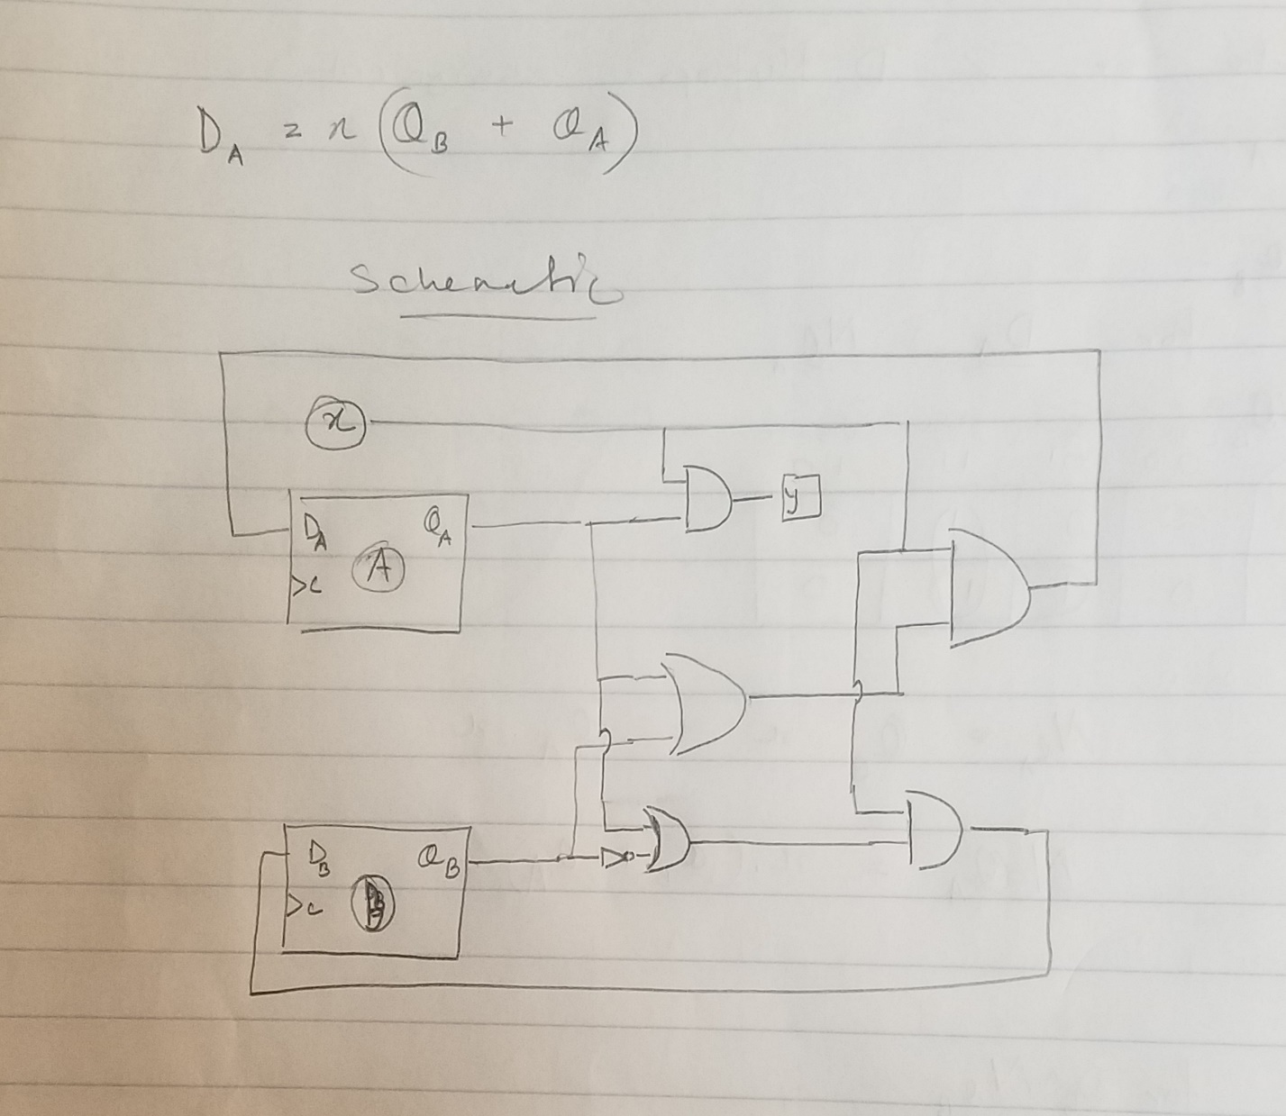

#showmeasurement graph and schematic.

