CS 4341.001  
Mxa166030

Moin Ahmed

Homework 2

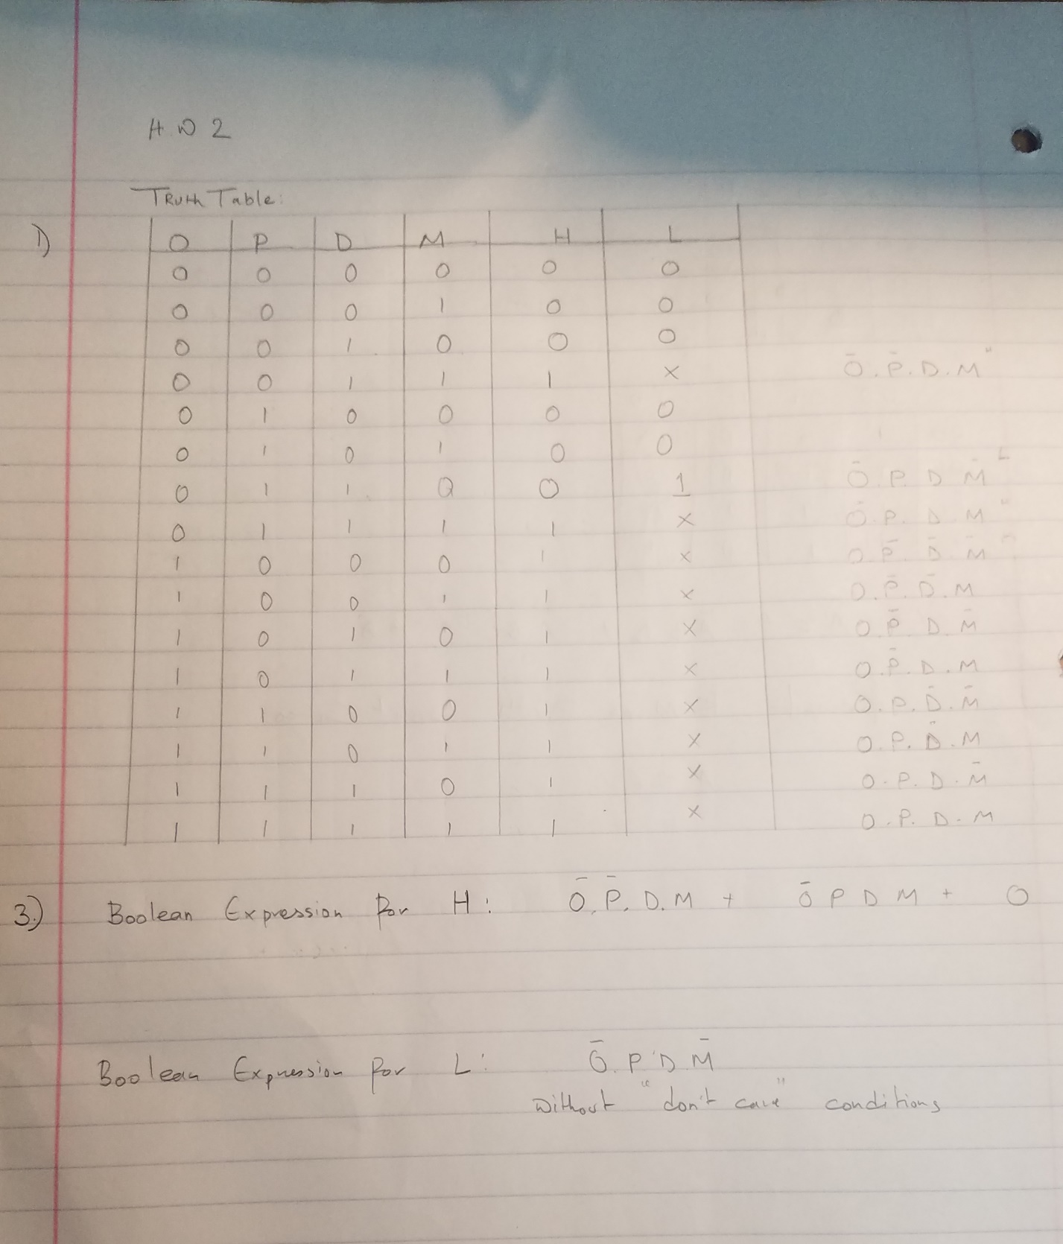

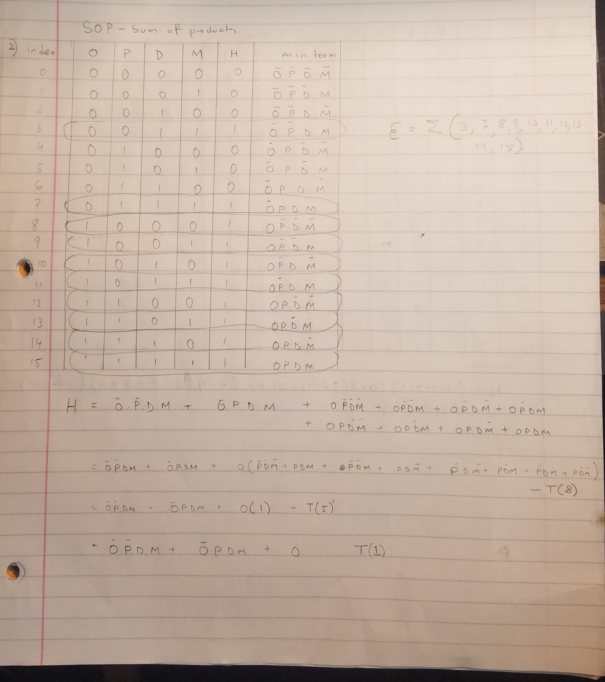

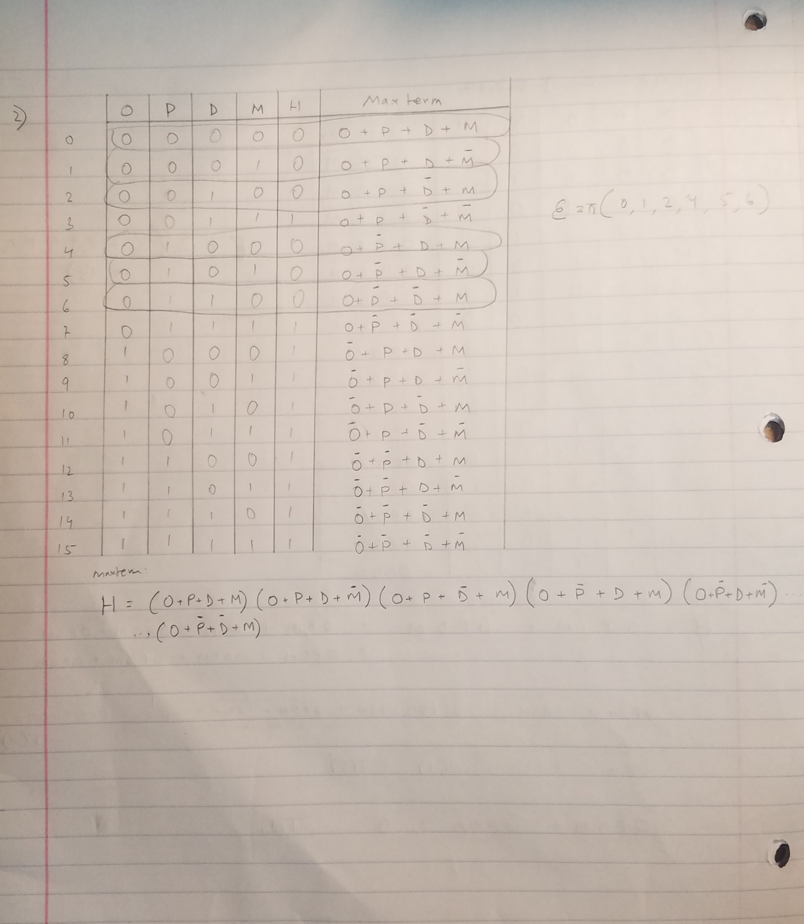

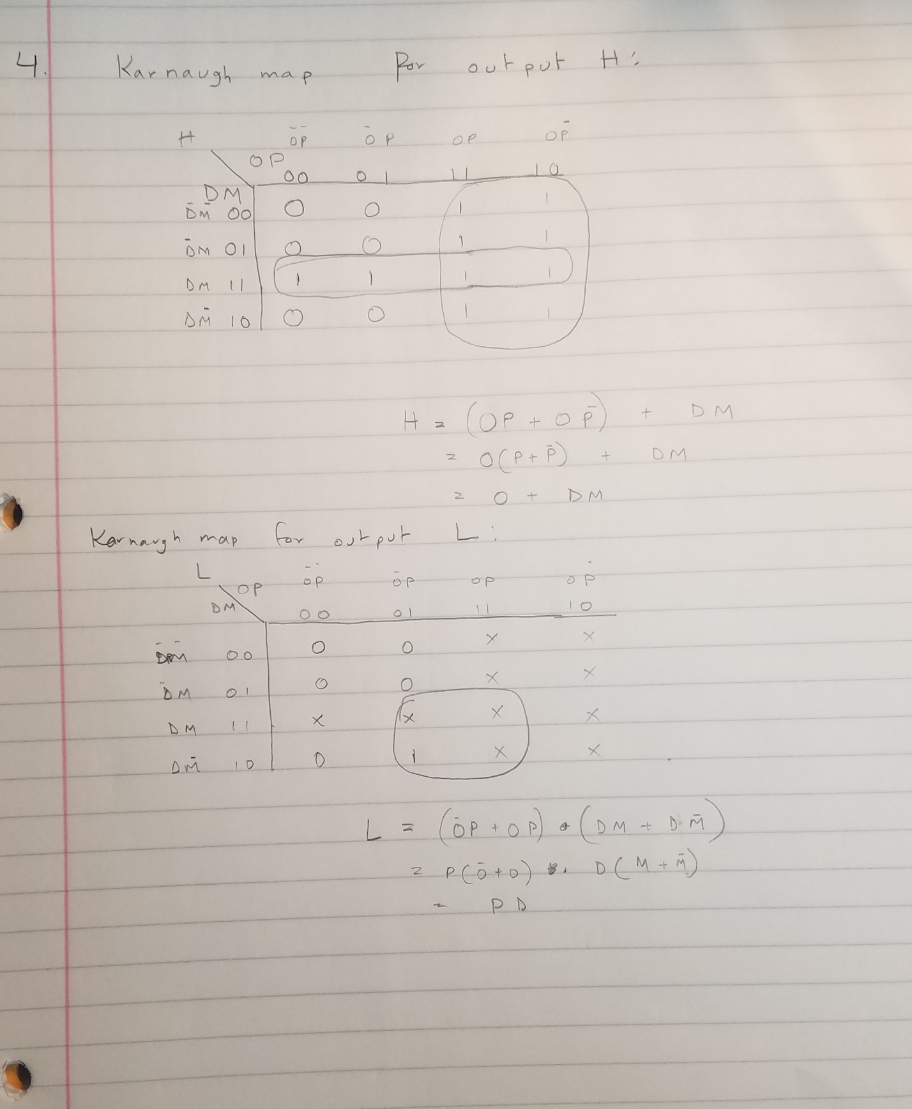

5. The schematic of the circuit: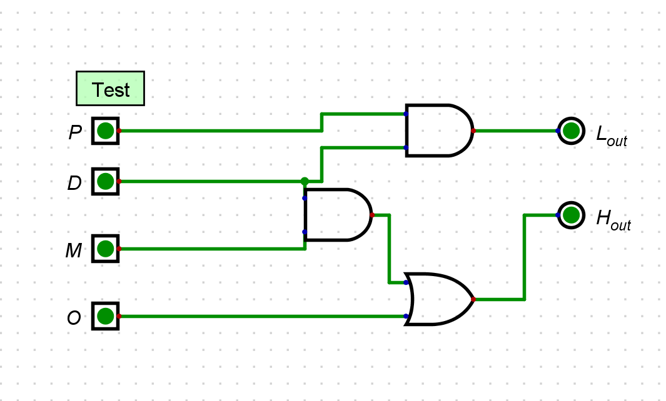

Manual verification:

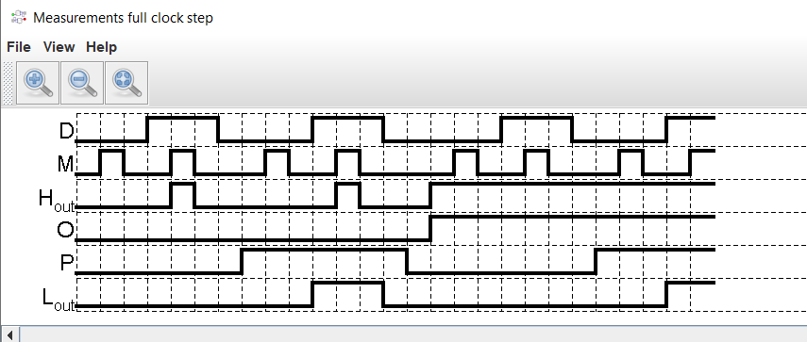

6.Test results:

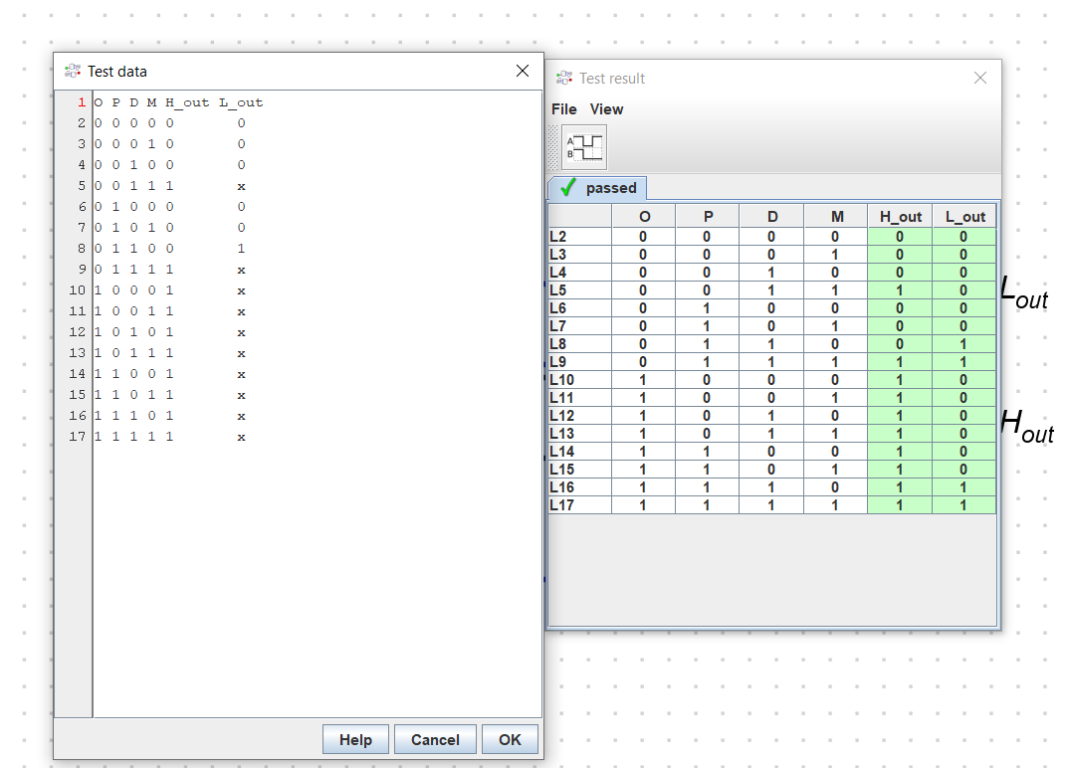

7.verilog code:

(Opdm_main.v )

module opdm

(

i_O,

i_P,

i_D,

i_M,

o_H,

o_L

);

input i_O;

input i_P;

input i_D;

input i_M;

output o_H;

output o_L;

wire w_WIRE_1;

wire w_WIRE_2;

wire w_WIRE_3;

assign w_WIRE_1 = i_P & i_D;

assign w_WIRE_2 = i_D & i_M;

assign w_WIRE_3 = i_O | w_WIRE_2;

assign o_L = w_WIRE_1;

assign o_H = w_WIRE_3;

endmodule

(opdm_testbench)

module opdm_tb();

reg i_o,i_p,i_d,i_m;

wire o_h,o_l;

reg [3:0] A [15:0];

integer i;

opdm opdm_dut(.i_O(i_o), .i_P(i_p), .i_D(i_d), .i_M(i_m), .o_H(o_h), .o_L(o_l));

initial begin

$monitor("Value of O=$b,P=$b,D=$b,M=$b,H=$b,L=$b",i_o ,i_p ,i_d ,i_m ,o_h ,o_l);

i_o= 0; i_p=0; i_d=0; i_m=0;

#50 i_o= 0; i_p=0; i_d=0; i_m=1;

#50 i_o= 0; i_p=0; i_d=1; i_m=0;

#50 i_o= 0; i_p=0; i_d=1; i_m=1;

#50 i_o= 0; i_p=1; i_d=0; i_m=0;

#50 i_o= 0; i_p=1; i_d=0; i_m=1;

#50 i_o= 0; i_p=1; i_d=1; i_m=0;

#50 i_o= 0; i_p=1; i_d=1; i_m=1;

#50 i_o= 1; i_p=0; i_d=0; i_m=0;

#50 i_o= 1; i_p=0; i_d=0; i_m=1;

#50 i_o= 1; i_p=0; i_d=1; i_m=0;

#50 i_o= 1; i_p=0; i_d=1; i_m=1;

#50 i_o= 1; i_p=1; i_d=0; i_m=0;

#50 i_o= 1; i_p=1; i_d=0; i_m=1;

#50 i_o= 1; i_p=1; i_d=1; i_m=0;

#50 i_o= 1; i_p=1; i_d=1; i_m=1;

end

endmodule

Waveform graph from ModelSim:

