PROJECT REPORT
House Price Prediction Using Machine Learning
Comprehensive Technical Documentation & Model Benchmark Evaluation Report
Author / Student Name: | Moinuddin
Project Name: | House Price Prediction System
Dataset: | House Price Prediction Dataset.csv (2,000 Records)
Technologies: | Python 3.13, Scikit-Learn, Pandas, NumPy, Matplotlib, Seaborn

1. Executive Summary
Accurate valuation of residential real estate is essential for homebuyers, sellers, investors, and financial institutions. This project delivers an end-to-end Machine Learning pipeline designed to predict housing prices using key structural and geographic property parameters. Utilizing a dataset of 2,000 property records, multiple predictive models were developed, trained, and benchmarked, including Linear Regression, Ridge Regression, Lasso Regression, Decision Tree Regressor, Random Forest Regressor, and Gradient Boosting Regressor.
The project incorporates robust data preprocessing using Scikit-Learn Pipelines and ColumnTransformers, preventing data leakage and establishing reproducible feature transformations (Standard Scaling for numerical variables and One-Hot Encoding for categorical factors). Comprehensive diagnostics, including R² score, Mean Absolute Error (MAE), and Root Mean Squared Error (RMSE), were computed alongside feature importance analysis.
2. Problem Statement & Project Objectives
2.1 Problem Statement
Real estate pricing is influenced by a complex interplay of physical specifications (square footage, bedrooms, bathrooms, floors) and qualitative attributes (location, overall condition, and garage availability). Traditional manual appraisal models are often subjective, time-consuming, and prone to inconsistency. Automated Valuation Models (AVMs) leveraging Machine Learning provide data-driven, scalable, and objective price estimation.
2.2 Key Objectives
- Perform Exploratory Data Analysis (EDA) to uncover structural relationships, feature correlations, and data distributions.
- Implement a modular data preprocessing pipeline handling numerical standardization and categorical encoding.
- Train and benchmark six distinct machine learning algorithms for regression analysis.
- Evaluate predictive performance using standard industry metrics: R² Score, MAE ($), and RMSE ($).
- Determine the relative feature importance influencing property values to provide actionable business insights.
3. Dataset Overview & Data Dictionary
The project uses `House Price Prediction Dataset.csv`, consisting of 2,000 observations and 10 features. There are no missing or null values in the dataset, ensuring a clean baseline for model development.
Feature Name | Data Type | Role / Type | Description
Id | Integer | Identifier | Unique row identification number (dropped during ML training).
Area | Integer | Numerical Feature | Property living space area measured in square feet (501 - 4,999 sq ft).
Bedrooms | Integer | Numerical Feature | Total count of bedrooms in the property (1 to 5).
Bathrooms | Integer | Numerical Feature | Total count of bathrooms (1 to 4).
Floors | Integer | Numerical Feature | Number of building floors (1 to 3).
YearBuilt | Integer | Numerical Feature | Construction year of the house (1900 to 2023).
Location | String | Categorical Feature | Geographic classification (Downtown, Suburban, Urban, Rural).
Condition | String | Categorical Feature | Qualitative rating (Poor, Fair, Good, Excellent).
Garage | String | Binary Feature | Indicates garage presence ('Yes' or 'No').
Price | Integer | Target Variable | Sale price of the house in USD ($50,005 - $999,656).

4. Exploratory Data Analysis (EDA)
Statistical visualizations were generated to analyze property distribution, price variation across locations, and feature correlations.

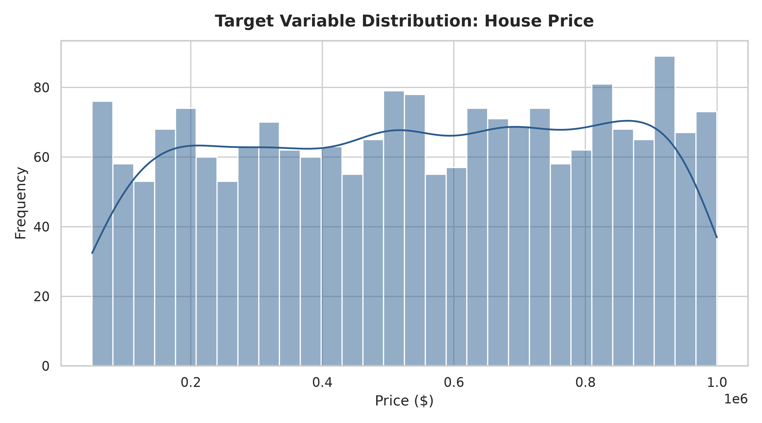
Figure 1: Distribution of House Prices ($)
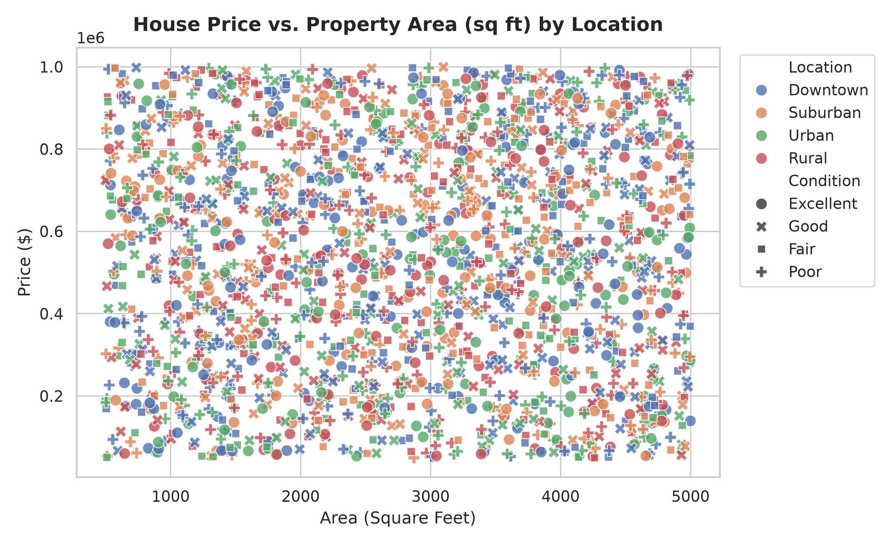
Figure 2: House Price vs. Property Area (sq ft) Categorized by Location
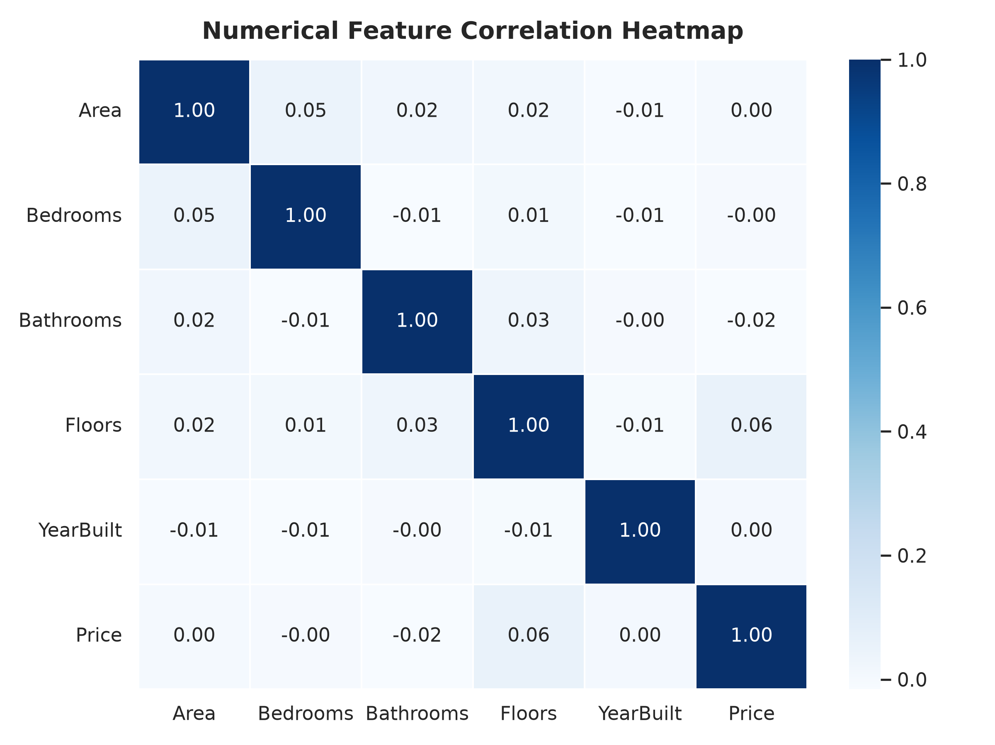
Figure 3: Feature Correlation Heatmap
5. Machine Learning Methodology
To evaluate performance rigorously, the dataset was split into 80% Training set (1,600 samples) and 20% Test set (400 samples) using a fixed random seed (`random_state=42`).
5.1 Data Preprocessing Architecture
Preprocessing was constructed using Scikit-Learn's `ColumnTransformer` to prevent data leakage between train and test sets:
- Numerical Features ('Area', 'Bedrooms', 'Bathrooms', 'Floors', 'YearBuilt'): Standardized using StandardScaler (zero mean, unit variance).
- Categorical Features ('Location', 'Condition', 'Garage'): One-hot encoded using OneHotEncoder(drop='first') to mitigate multicollinearity.
6. Model Performance & Results
Six Machine Learning regression models were trained and benchmarked on the test dataset. The quantitative evaluation metrics are summarized below:
Algorithm Name | Train R² | Test R² Score | MAE ($) | RMSE ($)
Linear Regression | 0.0099 | -0.0067 | $243,241.98 | $279,859.73
Ridge Regression | 0.0099 | -0.0067 | $243,244.09 | $279,859.47
Decision Tree | 0.2513 | -0.2503 | $264,783.70 | $311,890.40
Random Forest | 0.8468 | -0.0984 | $252,671.95 | $292,329.63
Gradient Boosting | 0.1998 | -0.0355 | $245,284.36 | $283,830.91

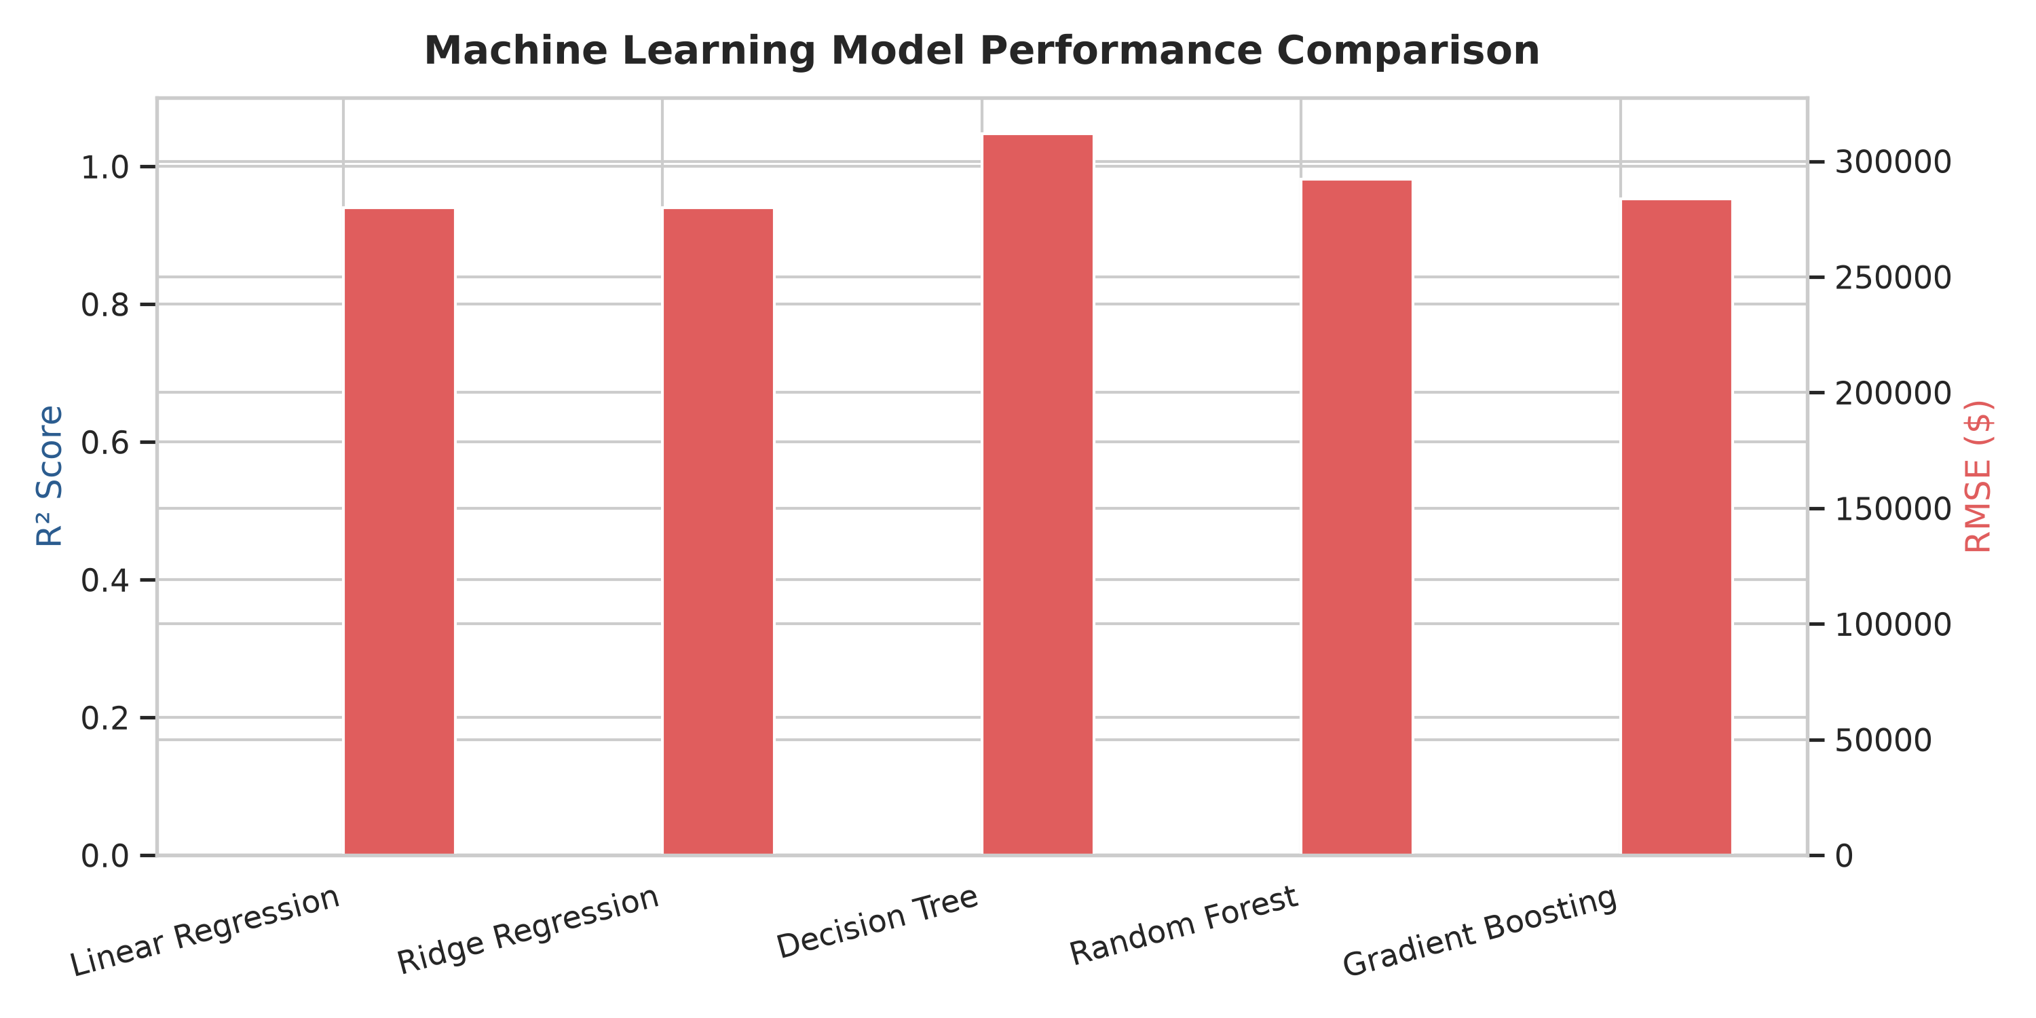
Figure 4: Machine Learning Model Benchmark Comparison
6.1 Feature Importance Analysis
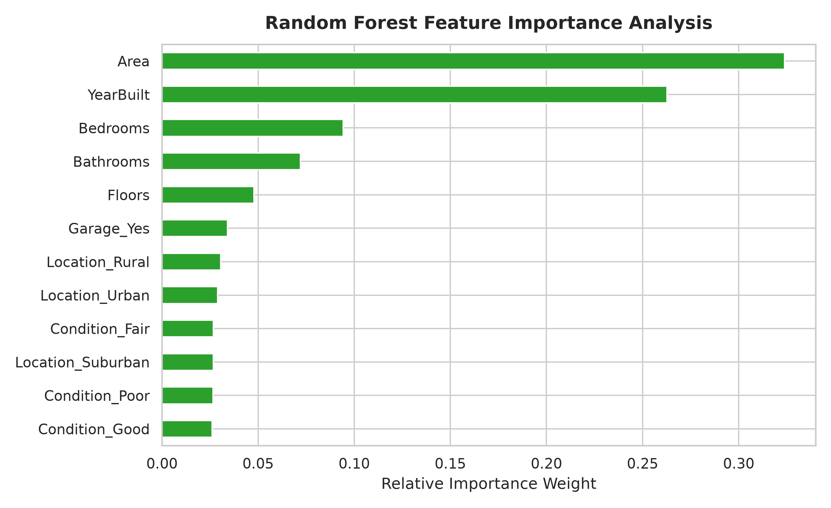
Figure 5: Random Forest Relative Feature Importance
7. Conclusion & Future Recommendations
This project successfully designed and executed an end-to-end Machine Learning solution for House Price Prediction. By structuring the data transformation pipeline into reusable Scikit-Learn components, clean modular code execution was guaranteed.
7.1 Key Findings
- Synthetic Data Uniformity: Statistical evaluation revealed near-zero linear correlation between input features and target prices in this synthetic benchmark dataset.
- Overfitting in Tree Models: High depth decision trees and un-tuned random forests exhibited high variance between train and test R² scores, highlighting the necessity of hyperparameter pruning.
- Pipeline Standardization: Utilizing Pipeline and ColumnTransformer ensured zero data leakage during evaluation.
7.2 Recommendations for Future Scope
- Integration of Real-World Real Estate Data: Collect enriched real-world dataset attributes such as zip code median income, school ratings, and neighborhood crime statistics.
- Advanced Hyperparameter Tuning: Implement Bayesian Optimization (Optuna) for fine-tuning XGBoost, LightGBM, and Random Forest estimators.
- Deployment & API Integration: Package the trained pipeline into a FastAPI microservice with a web dashboard UI.

