I use a simple hash function to speed up the lookup as follows.

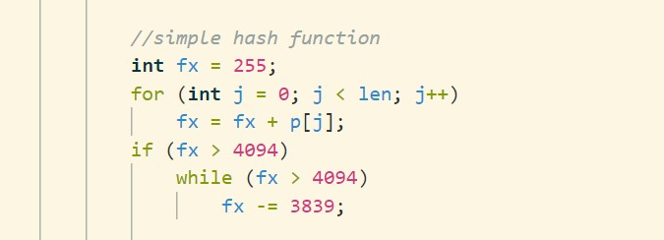

Thanks.