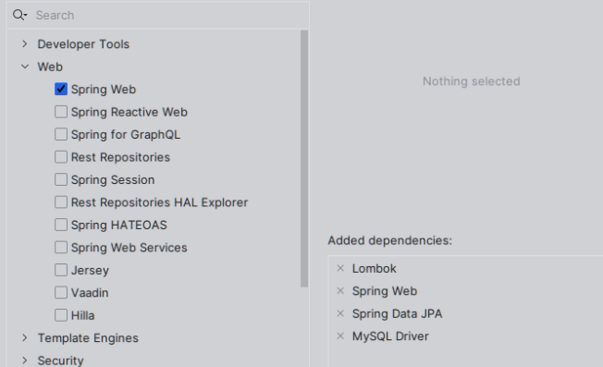1.DEPENDENCIAS:

Pero igual por si acaso toma el pom.xml

<?xml version="1.0" encoding="UTF-8"?>  
<project xmlns="http://maven.apache.org/POM/4.0.0" xmlns:xsi="http://www.w3.org/2001/XMLSchema-instance"  
 xsi:schemaLocation="http://maven.apache.org/POM/4.0.0 https://maven.apache.org/xsd/maven-4.0.0.xsd">  
 <modelVersion>4.0.0</modelVersion>  
  
 <parent>  
 <groupId>org.springframework.boot</groupId>  
 <artifactId>spring-boot-starter-parent</artifactId>  
 <version>3.1.3</version> <!-- Actualiza con la versión de Spring Boot que estás usando -->  
 <relativePath/> <!-- lookup parent from repository -->  
 </parent>  
  
 <groupId>com.example</groupId>  
 <artifactId>ms_ventas</artifactId>  
 <version>0.0.1-SNAPSHOT</version>  
 <name>ms_ventas</name>  
 <description>ms_ventas</description>  
  
 <properties>  
 <java.version>17</java.version>  
 <spring-cloud.version>2022.0.2</spring-cloud.version> <!-- Versión compatible de Spring Cloud -->  
 </properties>  
  
 <dependencies>  
 <!-- Spring Boot Starter Data JPA -->  
 <dependency>  
 <groupId>org.springframework.boot</groupId>  
 <artifactId>spring-boot-starter-data-jpa</artifactId>  
 </dependency>  
  
 <!-- Spring Boot Starter Web for RESTful services -->  
 <dependency>  
 <groupId>org.springframework.boot</groupId>  
 <artifactId>spring-boot-starter-web</artifactId>  
 </dependency>  
  
 <!-- H2 Database for in-memory storage (for testing or development) -->  
 <dependency>  
 <groupId>com.h2database</groupId>  
 <artifactId>h2</artifactId>  
 <version>2.1.214</version> <!-- Puedes reemplazar con la versión más reciente -->  
 <scope>runtime</scope>  
 </dependency>  
  
 <!-- Lombok for reducing boilerplate code -->  
 <dependency>  
 <groupId>org.projectlombok</groupId>  
 <artifactId>lombok</artifactId>  
 <optional>true</optional>  
 </dependency>  
  
 <!-- OpenAPI documentation with SpringDoc -->  
 <dependency>  
 <groupId>org.springdoc</groupId>  
 <artifactId>springdoc-openapi-starter-webmvc-ui</artifactId>  
 <version>2.0.2</version>  
 </dependency>  
  
 <!-- Spring Boot Starter Validation for bean validation -->  
 <dependency>  
 <groupId>org.springframework.boot</groupId>  
 <artifactId>spring-boot-starter-validation</artifactId>  
 </dependency>  
  
 <!-- Spring Boot Starter Test for unit testing -->  
 <dependency>  
 <groupId>org.springframework.boot</groupId>  
 <artifactId>spring-boot-starter-test</artifactId>  
 <scope>test</scope>  
 </dependency>  
  
 <!-- Spring Cloud Config to manage centralized configurations -->  
 <dependency>  
 <groupId>org.springframework.cloud</groupId>  
 <artifactId>spring-cloud-starter-config</artifactId>  
 <version>4.0.4</version>  
 </dependency>  
  
 <!-- Eureka Client for service discovery -->  
 <dependency>  
 <groupId>org.springframework.cloud</groupId>  
 <artifactId>spring-cloud-starter-netflix-eureka-client</artifactId>  
 <version>4.0.3</version> <!-- Actualiza con la versión adecuada -->  
 </dependency>  
  
 <!-- Spring Boot DevTools for faster development -->  
 <dependency>  
 <groupId>org.springframework.boot</groupId>  
 <artifactId>spring-boot-devtools</artifactId>  
 <scope>runtime</scope>  
 </dependency>  
 </dependencies>  
  
 <build>  
 <plugins>  
 <!-- Maven Compiler Plugin to configure Java version and Lombok annotation processor -->  
 <plugin>  
 <groupId>org.apache.maven.plugins</groupId>  
 <artifactId>maven-compiler-plugin</artifactId>  
 <configuration>  
 <annotationProcessorPaths>  
 <path>  
 <groupId>org.projectlombok</groupId>  
 <artifactId>lombok</artifactId>  
 </path>  
 </annotationProcessorPaths>  
 </configuration>  
 </plugin>  
  
 <!-- Spring Boot Maven Plugin to package the app and create an executable JAR -->  
 <plugin>  
 <groupId>org.springframework.boot</groupId>  
 <artifactId>spring-boot-maven-plugin</artifactId>  
 <configuration>  
 <excludes>  
 <exclude>  
 <groupId>org.projectlombok</groupId>  
 <artifactId>lombok</artifactId>  
 </exclude>  
 </excludes>  
 </configuration>  
 </plugin>  
 </plugins>  
 </build>  
  
</project>

2.ESTRCUTURA:

