Project 2 – CS 320
Moises Sanchez
Summary and Reflection
How did the testing approach aligned with the requirements?
First, I made sure to read the rubric requirements before typing the code. The guidelines specified that the strings should not be longer than 10 characters for example. Other guidelines required the strings could not be Null and that the specified string must be able to add, delete and update tasks.
Let’s look at the ContactClass.java for phone length:
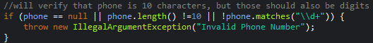
This will throw an IllegalArgumentException if the phone is Null (phone == null), the length of the phone is not 10 digits (phone.length() !=10), in addition to ensuring the phone number contains digits only (\\d+)
On the ContactClassTest.java, we used assertions to test these, in the below example, we test if the phone is Null:
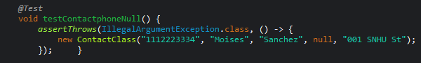
Another example is found in the following assertion used on TaskClassTest.java, which can be used to test if the ID is longer than the requirement previously defined in the TaskClass.java (taskID.length()>10)
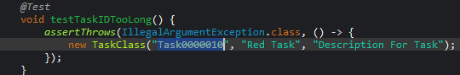

To comply with the requirement that both the TaskID and ContactID shall not be updatable, both were declared as final, so referencing them can’t be changed after initializing.
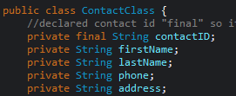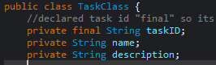
More testing could be applied to test more edge cases, however, the assertions used were sufficient to accomplish the requirements and focus on their quality rather than introducing unwanted complexity.
Effectiveness of Junit Testing
The JUnits tests for Contact and Task services are effective as they cover the functionality of their operations and validation of inputs. The higher the coverage percentage, the more the code is covered to ensure quality and reliability.
These tests validated the requirements and included error handling for edge cases. They are essential to meet the requirements. While more testing can be done, the existing tests provide a solid foundation to see how these classes behave, prior to presenting them.
Code’s Sound Technicality
I verified that the code works as expected under different scenarios, such as add, update and delete operations using Junit assertions from the TaskServiceTest.java :
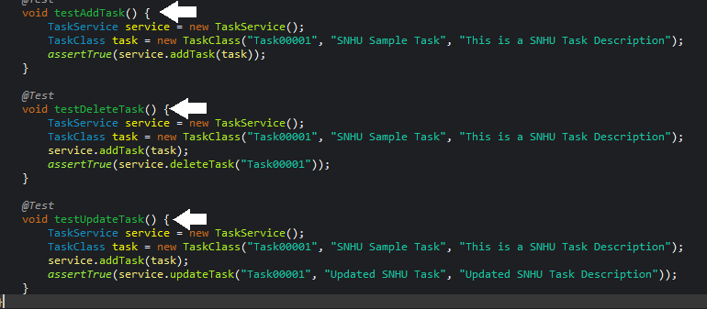

More specifically, to align with code’s sound technicality, the following ensures that TaskID is true when the object is created:
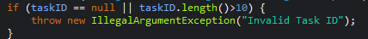
I used consistent naming and structural code for both milestones, in addition to adding comments for better understanding.
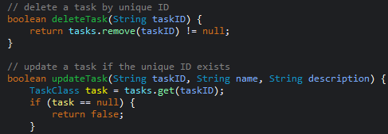
IllegalArgumentExceptions were used to easily identify invalid statements
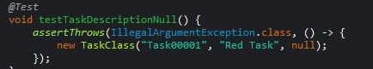
Overall, these techniques will ensure the code is readable, efficient and most importantly reliable. Having a well-structured code will help if the requirements change in the future.
Code Efficiency
The architecture of the code is my priority, based on the requirements, I can always trace back and forward to what areas need to improve and updated. Logics used in the constructors are simple, yet effective:
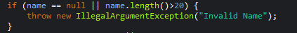
Tests perform the necessary requirements to verify their functionality, avoiding complex operations:
Junit tests cover the scenarios required, and I demonstrate good input validation practices, also keeping a simple and maintainable code, which will help me debug later if necessary.
Testing Techniques Employed
Techniques were used for the testing of these services using Junit testing, assertions, null testing, boundary testing, adding, deleting and updating. Let’s look at those examples from the Milestones:
Assertions to verify the expected behavior using the assertTrue() and assertThrows(). The example below verify that Moises and Sanchez are the valid first and last names.
Null testing will test when the input is null value and will throw an exception when it is. In the example below, an exception will be thrown if the address is null.
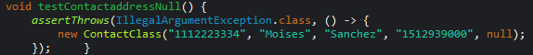
Boundary Testing will verify if the input value is either too long or too short. In the example below, if the taskID is longer than the character set on the Task Class, then the assertThrow method will catch the exception, passing the required test for being too long.
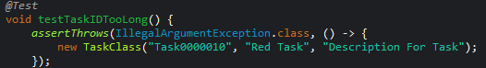
Add operations were used for adding appointments, for example. This can be seen in the AppointmentClass method
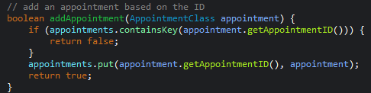

Delete operations were also used through the milestones. On the following, we can see that we can delete a Task based on the taskID. The assertTrue statement ensures that the deletion was completed.
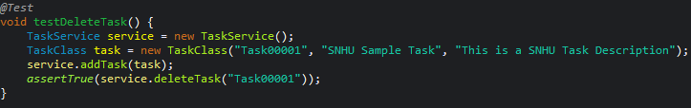
Update operations were used on the first 2 milestones. Let’s look at the Contact Service Class. The contact is first added, then the last name is updated to Williams using the update method, based on the contactID.
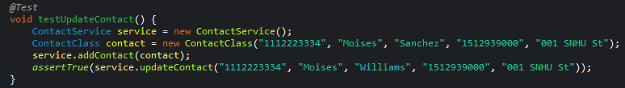
Another boundary test can be found in the 3rd milestone, where an IllegalArgumentException is thrown when trying to create an appointment that has a past date. This example is setting the date to 1 second ago, indicating that the appointment cannot be created.
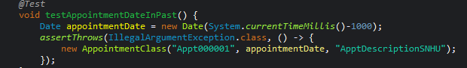

Additional Techniques
I could use empty testing to see how classes handle empty strings. For example, inserting “” instead of null.
Invalid input testing such as checking for the wrong format could also help improve the efficiency of these tests, especially for the Appointment class. That would imply adding format validation within the class.

Uses and Implications
Assertions can help us test and identify problems with the code early. I can see the importance of these techniques on a banking application, where we can test if the checking account balance is negative, to then throw an exception that shows the user if their account has insufficient funds.
Boundary testing can check for values that are within a controlled environment. An example can be found in the password requirement for any website, if the value is too short or too long, then the user is asked to provide a password with the required characters.
Null testing and Empty testing can also help determine what fields are required to fill out. In the same website, a user might be asked to fill out the entirety of the form before submitting, otherwise it will not let them submit.
Adding, deleting and updating testing can fulfill requirements where the values can change. For example, a company’s employee database where the employees can change shifts, pay or even quit the company. These databases can be updated easily and keep only the current employees to avoid having unnecessary data.
Date boundaries can help test if the date is current or expired. In milestone 5, we are asked to be able to determine if the date is in the past, then an appointment cannot be made. These tests can be adjusted accordingly and are essential to ensure that appointments are not wrongfully created.
Requirements will determine what tests and techniques need to be made. In order to fulfill those, we must ensure that we follow them before developing improvements that may require additional time and cost.

Caution
When working on this project, I had to ensure all the requirements were fully covered to the extent that I didn’t overdo the code. Keeping it simple, yet effective was my mindset. For example, when testing using the Test coverage, I found some percentages falling below 80%, which meant I was not fulfilling the bare minimum requirements, and I had to commit some more time to get it covered efficiently. This example shows that my tests cover the required guidelines for the contact class:
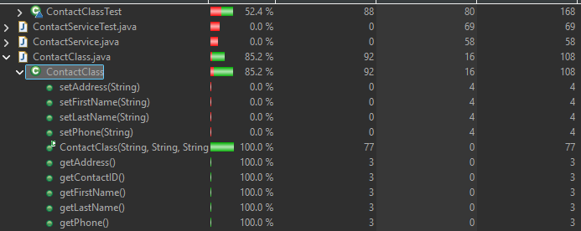

Bias
As a software developer in this project, I limited the bias by primarily using Junit testing, however, I also made sure to add specific comments within each code where I document what it does, more specifically, what it should do. To review this code, it was important to me that anyone could be able to understand it, and that it was straight forward – making a more complex code would imply expertise that may be seemed differently and would raise questions or concerns to the customer who setup the requirements. One example of my in-line comment is found in my appointment class – anyone can code this line and make it more efficient, but they can also find it easily:
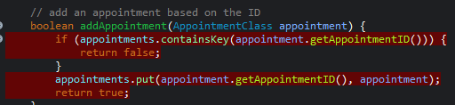

Discipline
I followed the same coding technique and structure. By doing this, I can easily trace back to my code and find any missing pieces or add extra layers of protection. Committing to the quality of your code first will ensure that is understandable and professional, rather than having random lines of code with minimal comments that “kind-of” make sense. The structure of my codes is followed equally through the project and reviewing it will be easy, and can even help others edit it in the future. Finally, if the company I worked for has limited budget, they wouldn’t risk hiring a developer who does not follow the simplest forms of quality, such as cleanliness and presentation. If that developer moves out or gets fired, then the whole structure becomes unusable, and no other person can understand it. I plan on keeping my code architecture as organized and clean as possible to avoid technical debt and help me get more recognized for it.
The structure below is organized, has appropriate and useful comments, in addition to proper indentation:
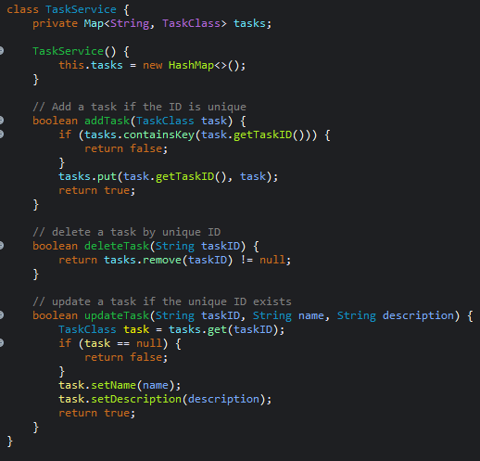
Citations
Boni Garcia. (2017). Mastering Software Testing with JUnit 5 : Comprehensive Guide to Develop High Quality Java Applications. Packt Publishing.
Hambling, B., Morgan, P., Samaroo, A., Thompson, G., & Williams, P. (2019). Software testing: An ISTQB-BCS certified tester foundation guide (4th ed.). BCS, The Chartered Institute for IT.
SNHU Media. (2020, September 11). JUnit tutorial. YouTube. http://youtube.com/watch?v=KbXhK9HUng4

