CS 340 README

About the Project/Project Title
Our newest client Grazioso Salvare is an international animal rescue company that partners with nonprofit shelters located around Austin, Texas. Their goal is to identify dogs that are suitable for their search and rescue training. According to the company, the training is more efficient for dogs that are less than two years old, and their training program is strongly based on each dog’s breed due to their natural instincts. The project implements the Create and Read portion of the CRUD as the full-stack foundation that we’ll use in Global Rain Solutions. Since the code is open source and will be on GitHub, companies seeking a similar solution can reuse and adapt it to their needs.

Motivation
Our team at Global Rain’s Solutions proposes a solution to efficiently search within the existing five shelters by utilizing CRUD operations. We understand that manually reviewing thousands of records is inefficient and non-sustainable. Our project’s scope is to automate the search while providing reusable Python modules for the CRUD operations, which will be the foundation of the main dashboard.

Getting Started
To get a copy and run it, follow these simple steps:

1. Clone the GitHub repository to a local PC
2. Make sure the MongoDB is running locally and import the AAC database
3. Update the password in the Python file (CRUD_Python_Module.py) for the existing environment
4. Run the Jupyter Notebook to efficiently test the Create and Read operations

Installation
The following tools will be needed for the creation of the module:

1. Python 3.x
This must be installed on the local PC to run the project. One way to verify if it’s already installed
Is by opening the local PC’s terminal and typing python –version . If nothing appears, it can be downloaded from python.org. This is required since our AnimalShelter class and CRUD logic are written in Python.

2. PyMongo library
This is the communication between Python and MongoDB. It can be installed by running the following command in the terminal: pip install pymongo. PyMongo provides direct access to all MongoDB CRUD operations which are used for this solution

3. MongoDB Server running on localhost: 27017 with aac database and collection called animals
This NoSQL database will store the shelter data. Inside MongoDB, aac is the database name for the Austin Animal Center data and uses animals as the collection where each animal is a document.

3a. The following example verifies that MongoDB server is running on localhost:27017 with 10,000 documents that were imported into the aac database under our animals collection:
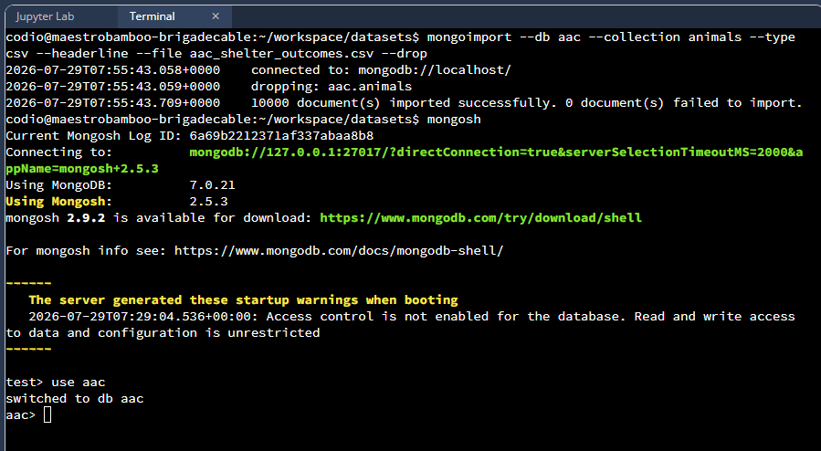

For reusability, update the configuration values for –db, --collection and –file. The –drop makes the script run repeatedly without duplicating duplicates.

3b. Secure user authentication and role verification: User securely created using passwordPrompt() and assigning read and write role onto the aac database. Then authenticating the role via mongosh as well as confirming connection status.
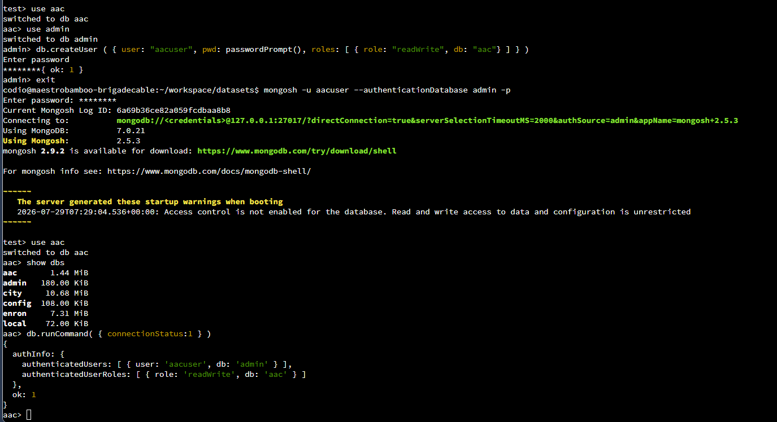

For reusability, update the username, password and user roles to align with the company’s goals.
4. Jupyter Notebook to run tests
If not installed already, it can be installed by typing pip install notebook on the PC’s terminal. Jupyter Notebook helps us test cell by cell, rather than standard python script where the entire code crashes after a test failed.

5. Python Module containing the AnimalShelter class
This is the main file “CRUD_Python_Module.py”. Ensure it’s on the same folder as the Jupyter Notebook as it contains the AnimalShelter class with the database logic. This module is provided in the GitHub portfolio where this README file exists. To use, import it with from CRUD_Python_Module import AnimalShelter

6. Jupyter Notebook Dashboard
This is the main executable file that launches the Dash application. It handles the view layout and callbacks for the filter buttons, and links to the CRUD model for operations. This file can also be found in the GitHub portfolio.

Usage
The AnimalShelter class within the Python module will handle the user authentication and access to the database. The class uses MongoClient with a connection to MongoDB (USER,PASS,HOST,PORT). In the following example, the aacuser account gets authenticated against the aac database. For another business to be able to reproduce this, a new database user can be created in MongoDB with specific roles.

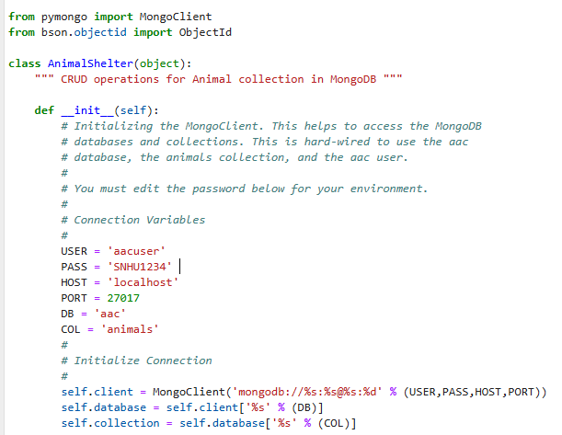

Creating a user and assigning the role in MongoDB can be achieved by using db.CreateUser. Make sure to use passwordPrompt() rather than hard coding the password to avoid having security concerns and accidentally leaking the password in the terminal.

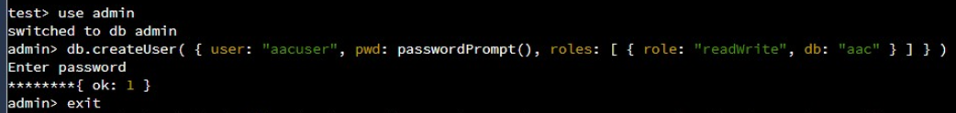

Code Example

The following methods were implemented within the Python module. The comments follow code best practices and explain each function accordingly. These methods address the client’s needs by allowing insertion of new records and having flexibility filtering.

Create Method
Takes dictionary data then validates whether is empty or not to call self.collection.insert_one(data). Returning True if new data has been inserted and false otherwise. Additional exception case for data validation.
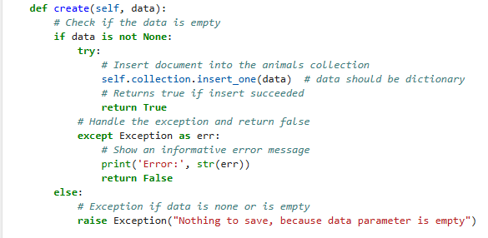

Read Method
Takes a dictionary query as input, and when it validates that is None it will call self.collection.find(query) to return the list of the found records. When there’s no match it will return an empty list. Additionally, it raises an exception when the query is None.
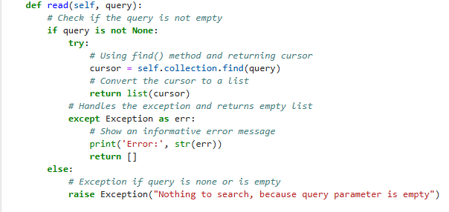

Update Method
Takes two dictionaries, a query to find the documents and new_data for updates. Uses self.collection.update_many(query, { “$set”: new_data}) and returns the modified count from the collection, otherwise returns 0.
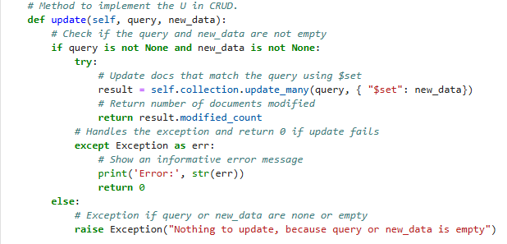

Delete Method
Takes a dictionary query and uses self.collection.delete_many(query) to return number of deleted documents from the collection upon success, otherwise returns 0.

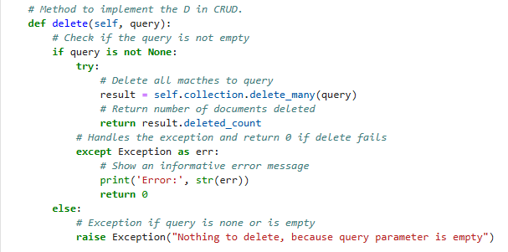

Tests
Tests are performed withing Jupyter Notebook. We use Jupyter Notebook as it lets us better identify the output of each test without crashing the entire file if any test fails. This makes it easier to identify the weaknesses and show the client what each method does and what to expect.

The following Create test inserts a new record with a unique animal ID. In the following example, TestDoggie calls shelter.create(new_record) and the method returns either True when successful, false if unsuccessful or an error with details. Additionally, after a successful creation, we can see the new record’s keys and values.

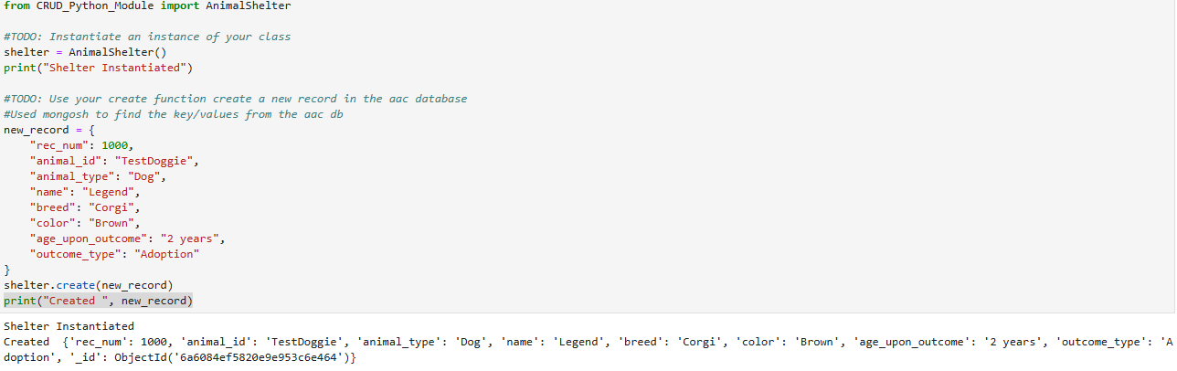

The following Read test calls shelter.read({“animal_id”: “TestDoggie”}) after creation. This function returns a list that contains the Legend document that was previously inserted into the database. If no records match, then there will be an empty list of our previously mentioned Read’s function in the .py file.

Exception and Error handling are used thorough the module for each method to better understand each function.
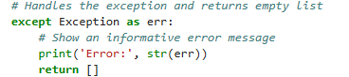

The following test Updates the existing document containing animal_id: “TestDoggie” to color: Black and name: Legandarious as their key/value pairs. We can see the test returns the document quantity after successfully running. If there are no values found for animal_id, then the test will return 0.
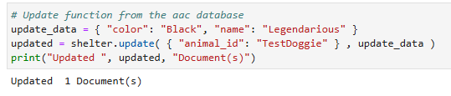
The following test Deletes the existing document containing animal_id: “TestDoggie” from the aac database. If there is no value for this key, the test will return 0 documents.
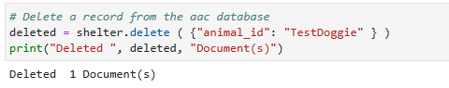

The Dashboard
A dashboard was designed to fulfill Grazioso’s requirements. The team implemented filtering options, so the search is more intuitive to navigate.
The Python Framework utilized was Dash as it provided the view and controllers for this application. The view consisted of HTML components such as html.H1 for the headers and html.Img for the logo, the Table used dash_table.DataTable, and the containers used graph-id and map-id. This makes it user friendly and minimizes clutter data. The callbacks are the interaction between the user and the dashboard. When the user clicks a button to filter the data, the callback filters the MongoDB data via our CRUD model and updates the table displaying the results.
Three filtering options, including a reset button, were added in the dashboard python module (can be downloaded from the GitHub portfolio). These buttons are following Grazioso’s requirements for each filter, making it effortless to filter the database’s queries more efficiently.
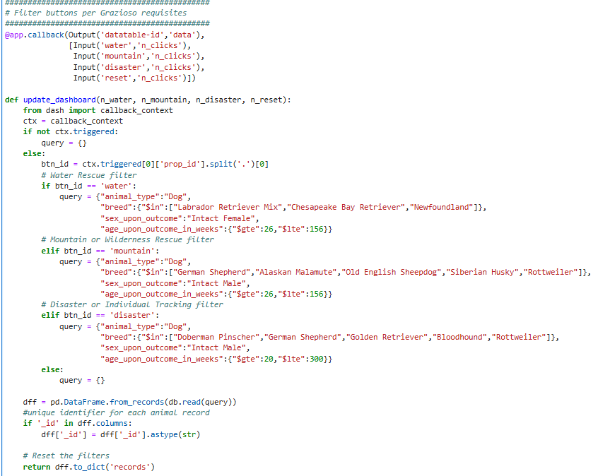

The initial layout contains a table that can be filtered upon each column’s content, in addition to each button as previously mentioned.
The initial layout looks as follows;
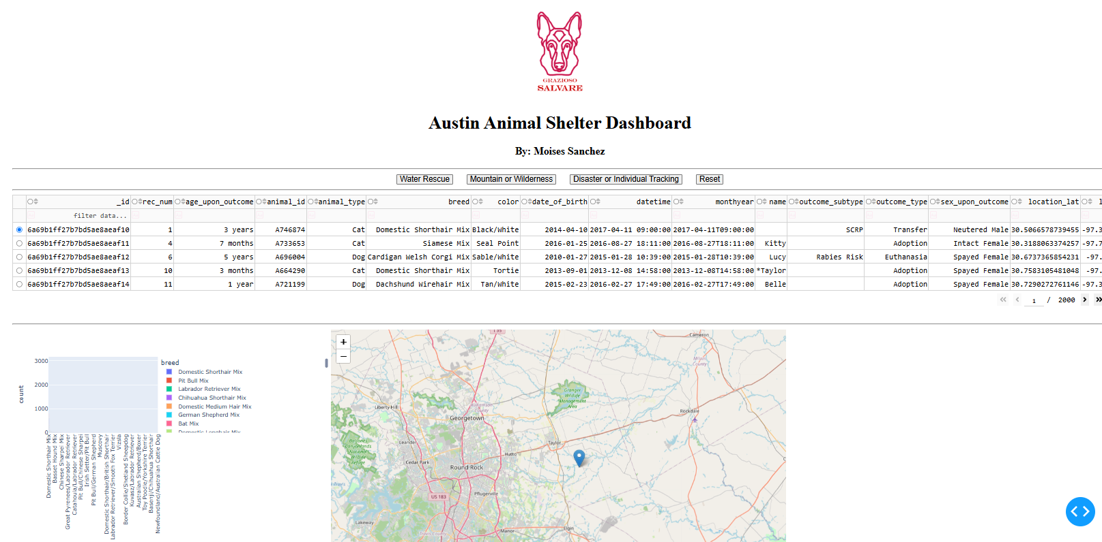
The buttons will filter the data on the table and update both, the graph containing the breed count and breed type, with an additional visual location map. After filtering, the user can select a row and the map will update according to its coordinates, along with the graph displaying the breed and count for each filtered result:
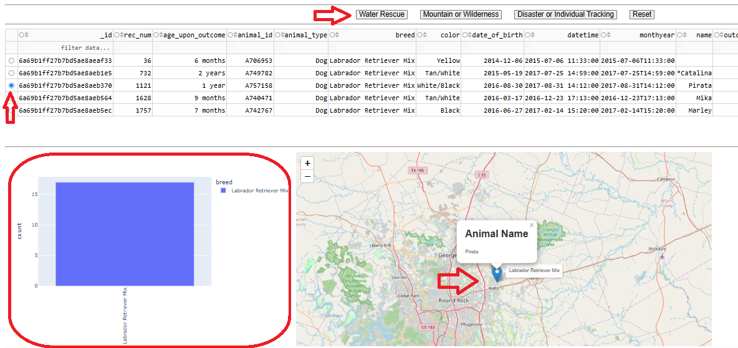

A graph was utilized to show the filtered data, but a different model can be used instead, such as a pie- chart. Notice how we utilized an ascending order and color=’breed’ to better illustrate the graph and make it more visually appealing.
Additionally, a tick angle was set to 90 degrees, so the breed data doesn’t overlap on the x-axis.

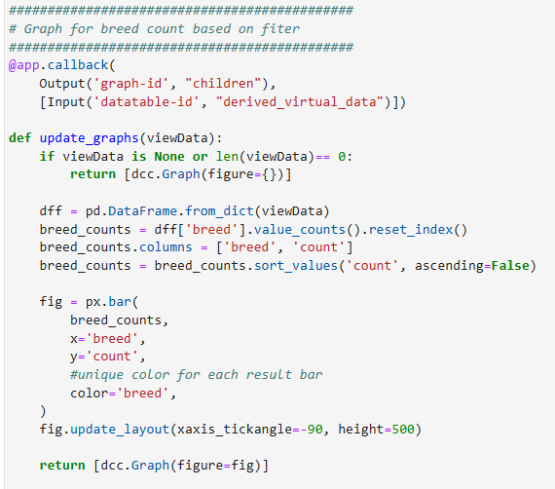

We can see similar results when we click on a different filter button:
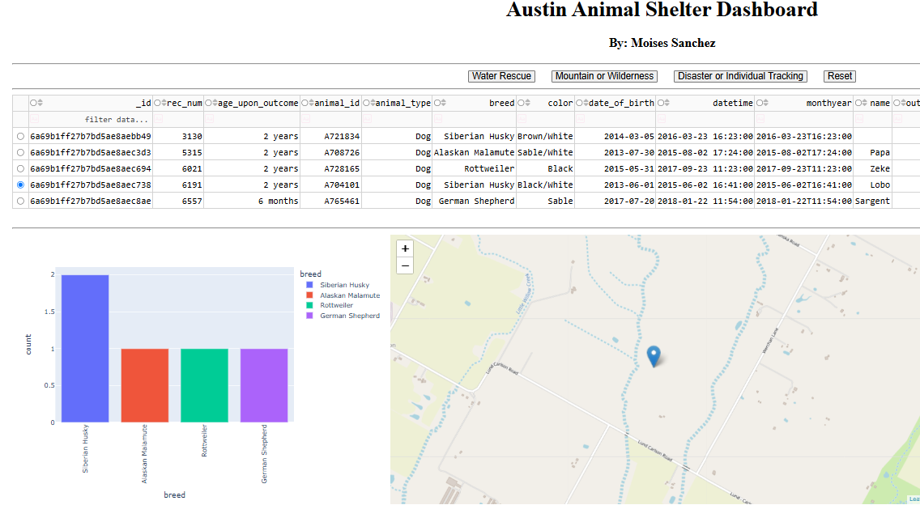

Grazioso required to include the Logo in the main dashboard, however, for reproduction, this image can be replaced by updating the following line. Positioning and size can be adjusted accordingly to meet customer needs.

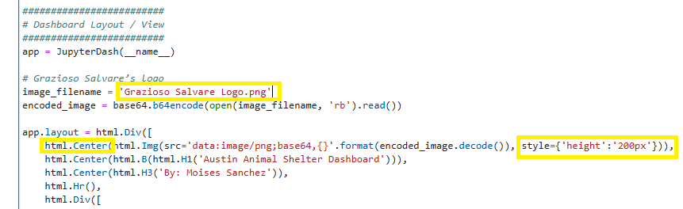

Contact
For further information and/or questions please contact:

Moises Sanchez
Moises.sanchez1@snhu.edu

