CS340 Module 7 – Project Screenshots
Moises Sanchez
Dashboard Starting State
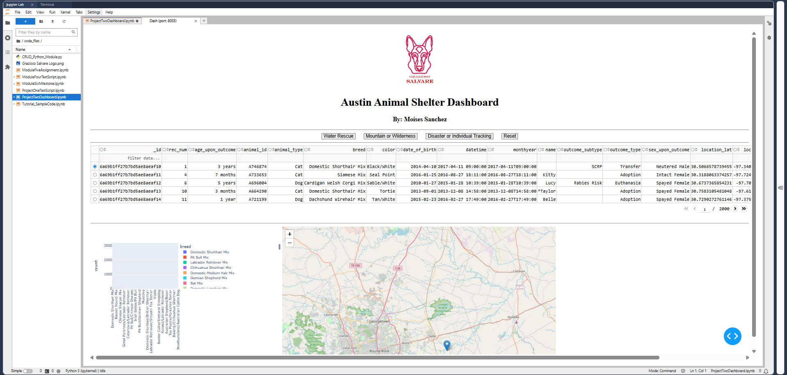

Water Rescue Filter Button
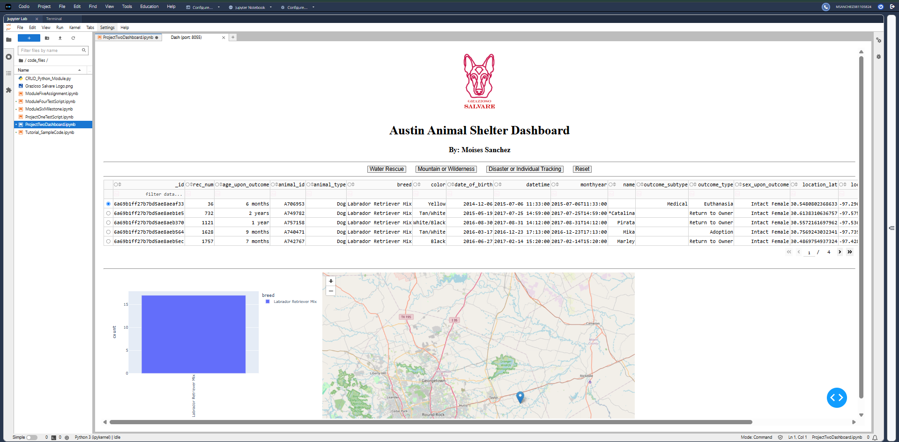

Mountain or Wilderness Filter Button
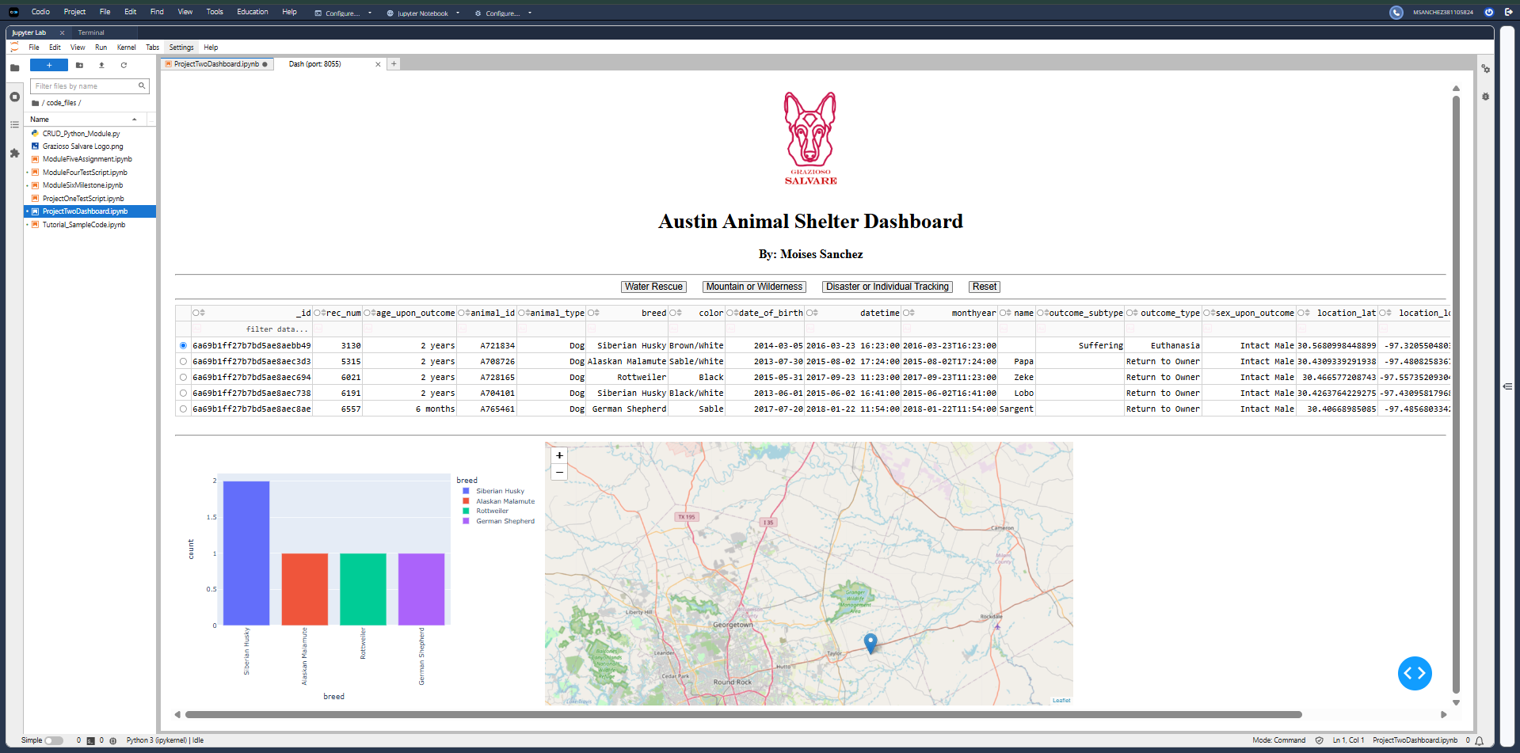

Disaster or Individual Tracking Filter Button
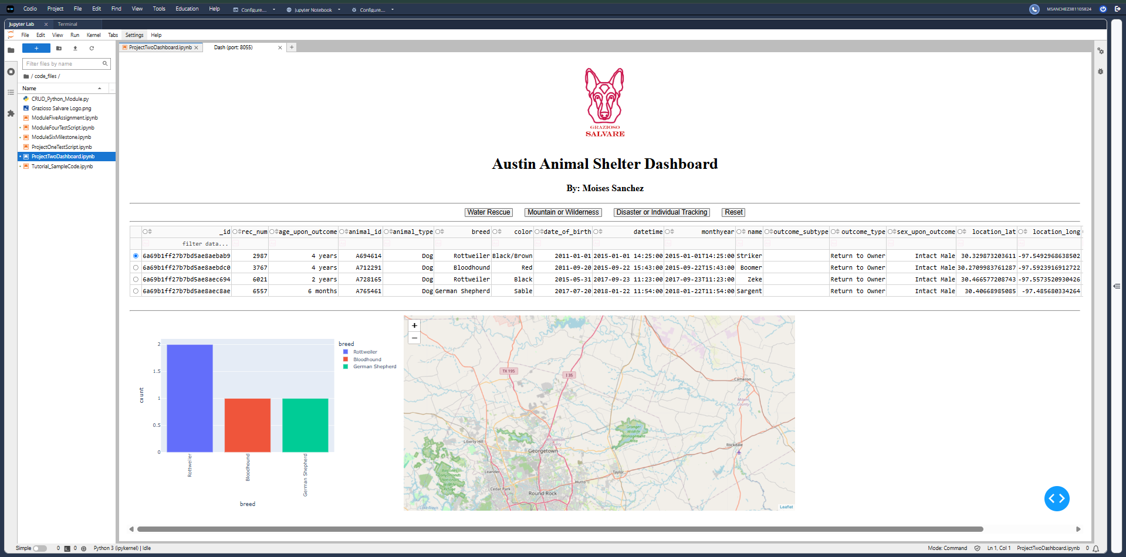

Reset Button
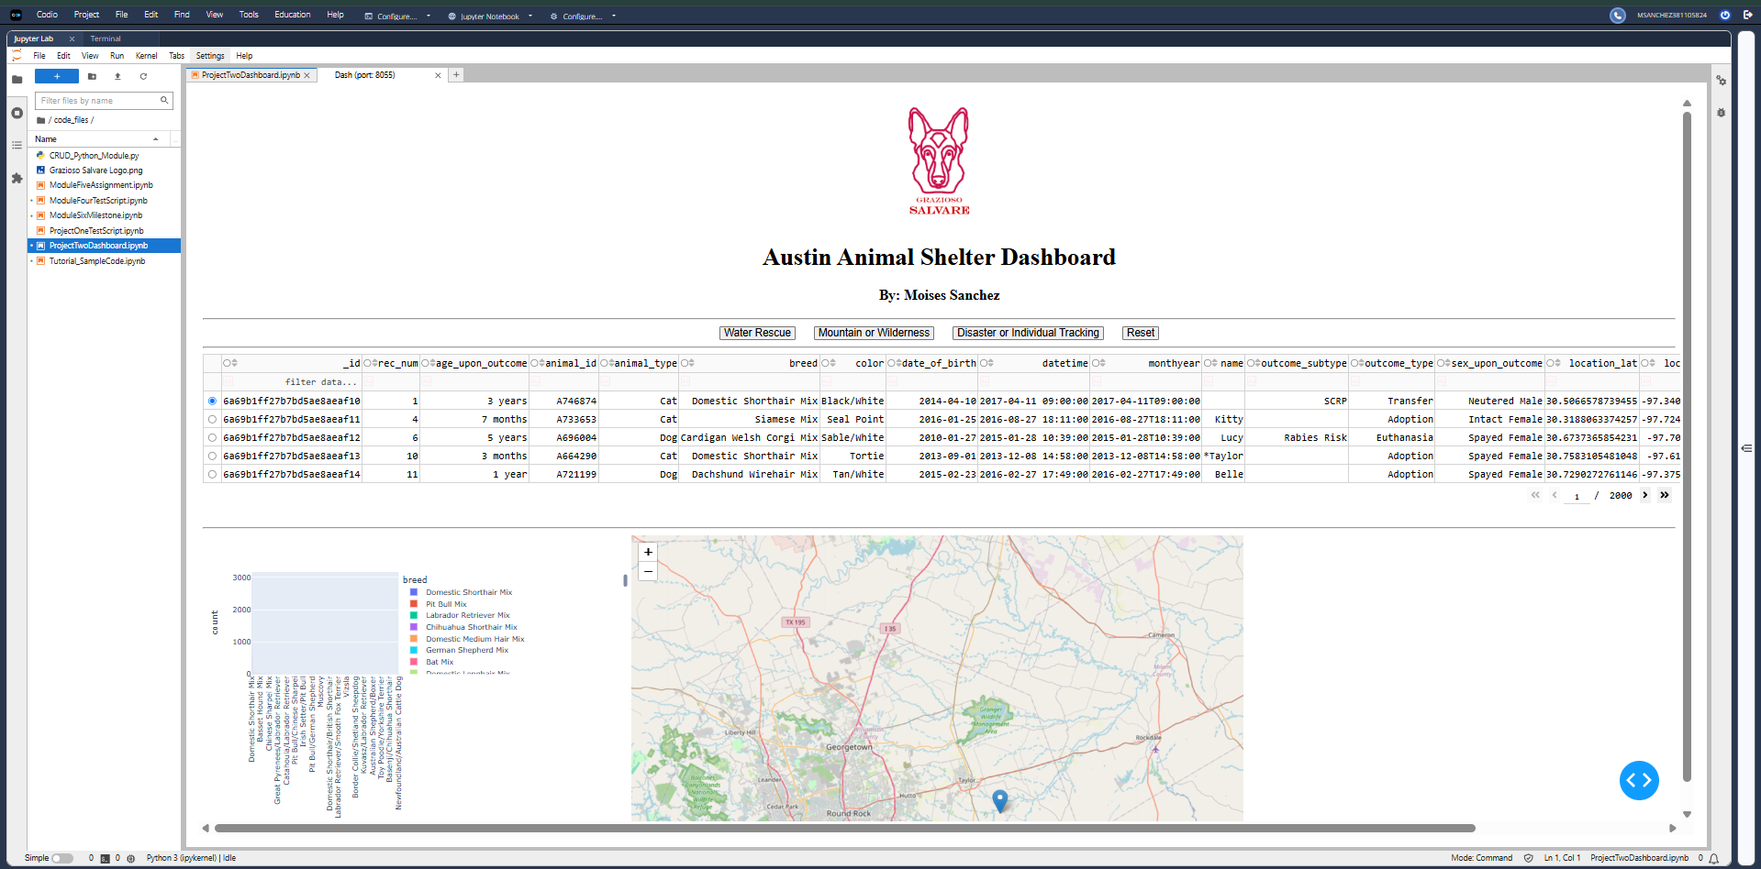

Map updates data (Animal name and Breed type) upon row selection
