**---- RETOS 1 -----**

**#1**

SELECT nombre, apellido_paterno, apellido_materno

FROM empleado WHERE id_puesto IN (SELECT id_puesto FROM puesto WHERE salario < 10000 );

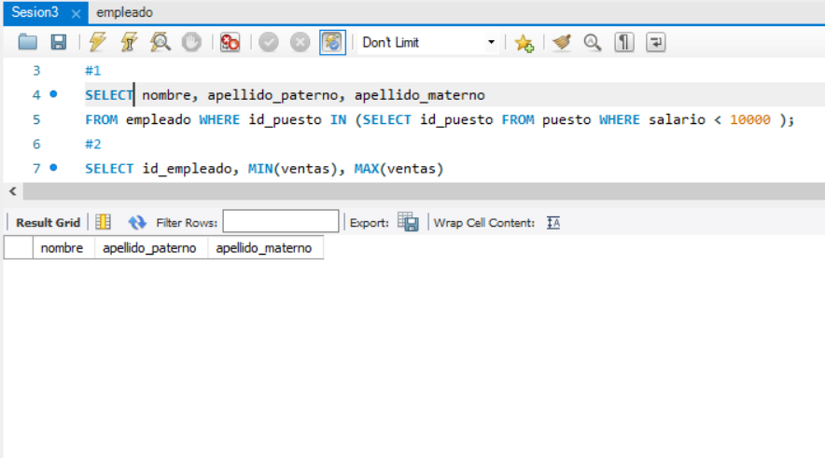

**#2**

SELECT id_empleado, MIN(ventas), MAX(ventas)

FROM (

SELECT clave, id_empleado, COUNT(*) AS ventas

FROM venta

GROUP BY clave, id_empleado) AS cantidades

GROUP BY id_empleado ORDER BY id_empleado;

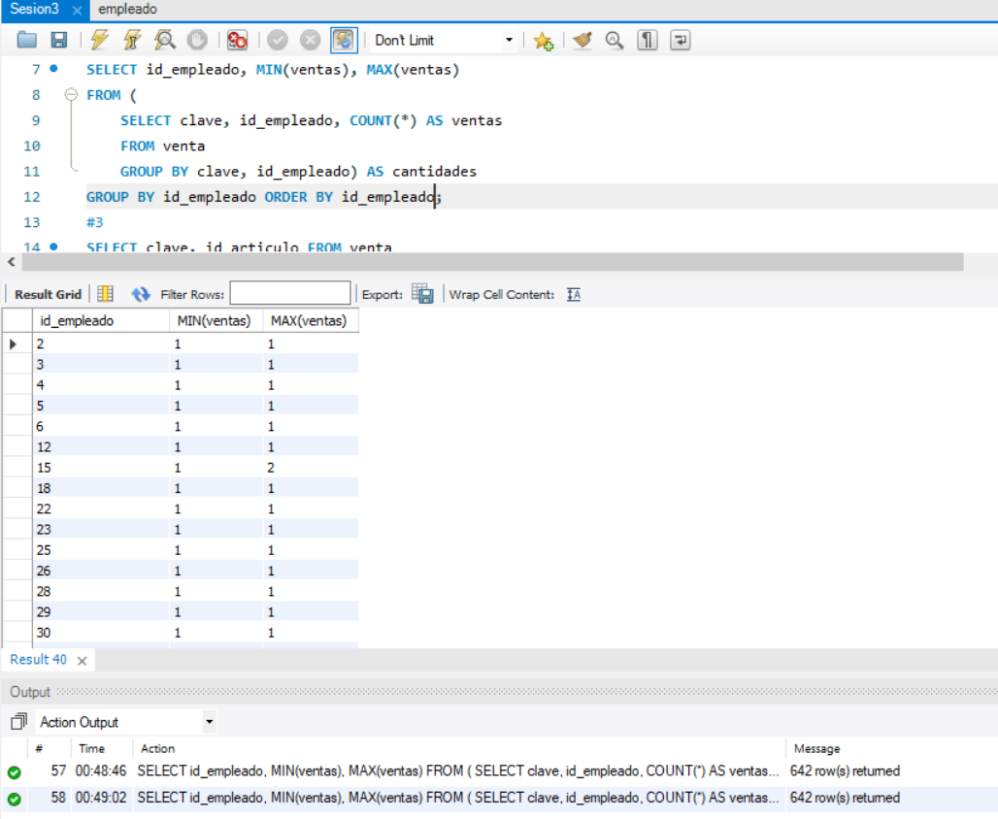

**#3**

SELECT clave, id_articulo FROM venta

WHERE id_articulo IN (SELECT id_articulo FROM articulo WHERE precio > 5000) ORDER BY clave;

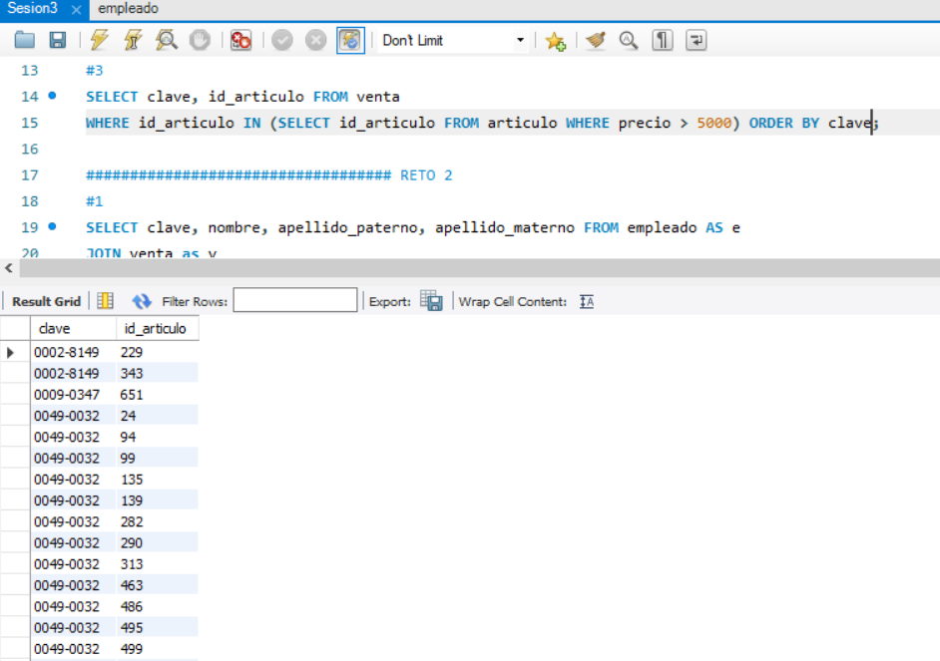

**---- RETOS 2 -----**

**#1**

SELECT clave, nombre, apellido_paterno, apellido_materno FROM empleado AS e

JOIN venta as v

USING(id_empleado) ORDER BY clave;

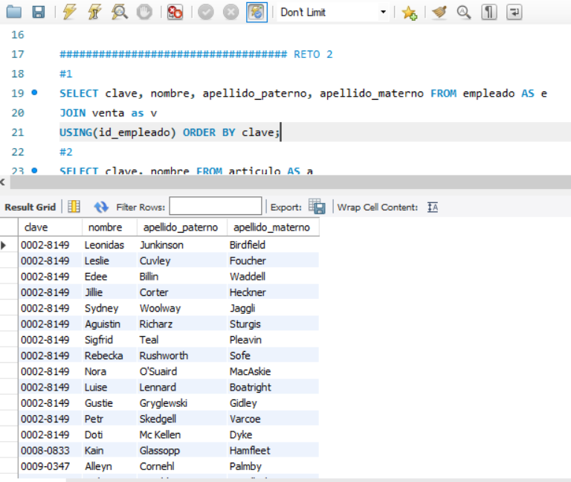

**#2**

SELECT clave, nombre FROM articulo AS a

JOIN venta as v

USING(id_articulo) ORDER BY clave;

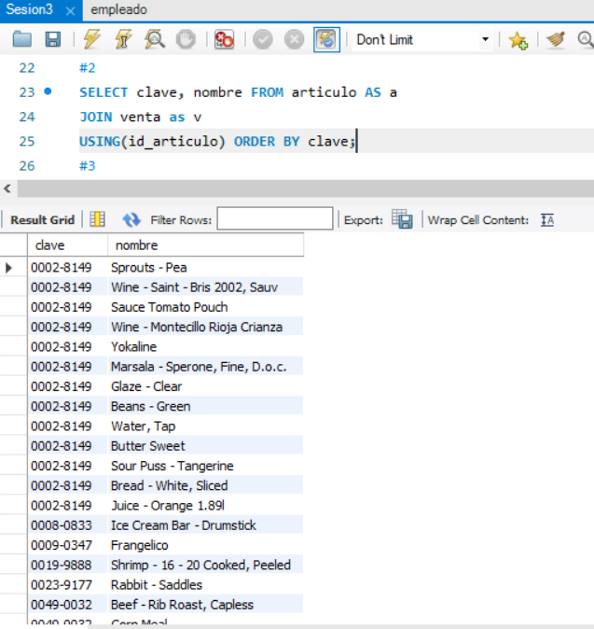

**#3**

SELECT clave, sum(precio) AS total FROM venta AS v

JOIN articulo AS a

USING (id_articulo)

GROUP BY clave ORDER by clave;

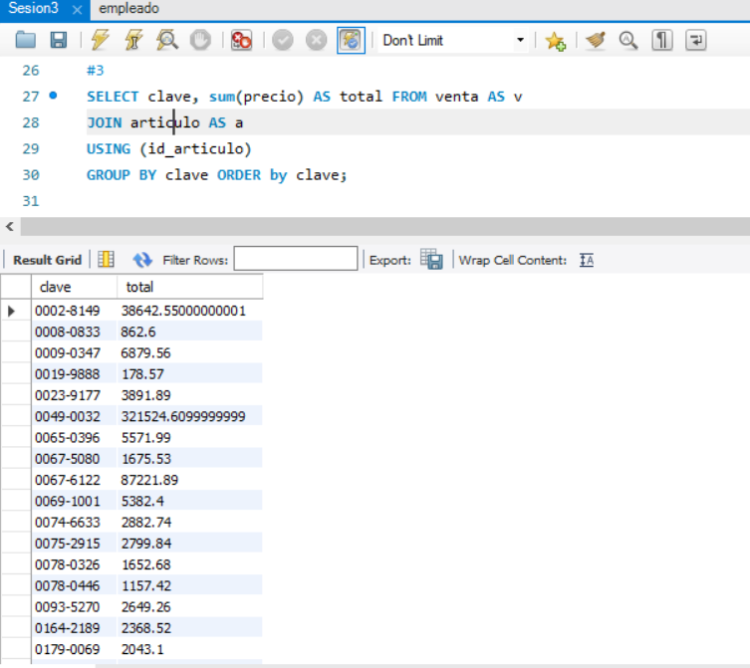

**---- RETOS 3 -----**

**#1**

CREATE VIEW puestos_083 AS

SELECT concat(e.nombre, ' ', e.apellido_paterno, ' ', e.apellido_materno), p.nombre FROM empleado AS e

JOIN puesto AS p

USING(id_puesto);

SELECT * FROM puestos_083;

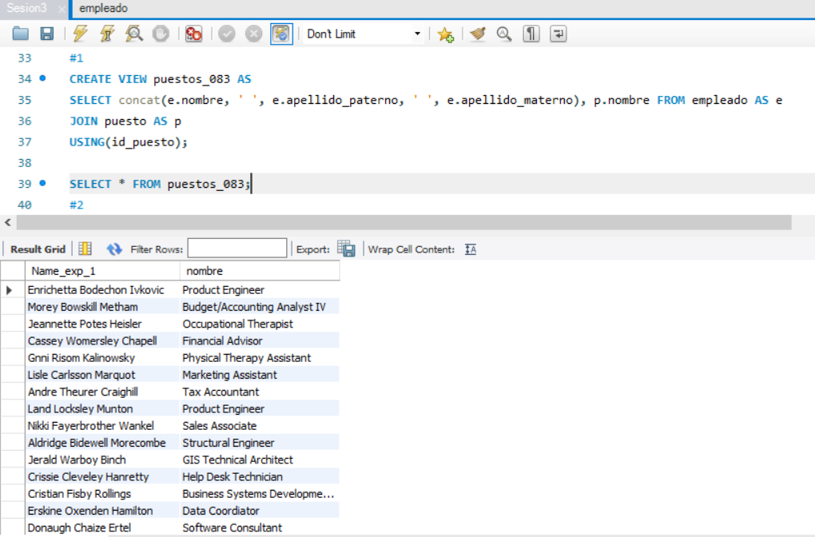

**#2**

SELECT v.clave, concat(e.nombre, ' ', e.apellido_paterno, ' ', e.apellido_materno) AS nombre_empleado, a.nombre as articulo_vendido

FROM venta AS v JOIN empleado AS e

USING(id_empleado)

JOIN articulo as a

USING(id_articulo);

SELECT * FROM articulos_vendidos_083 ORDER BY clave;

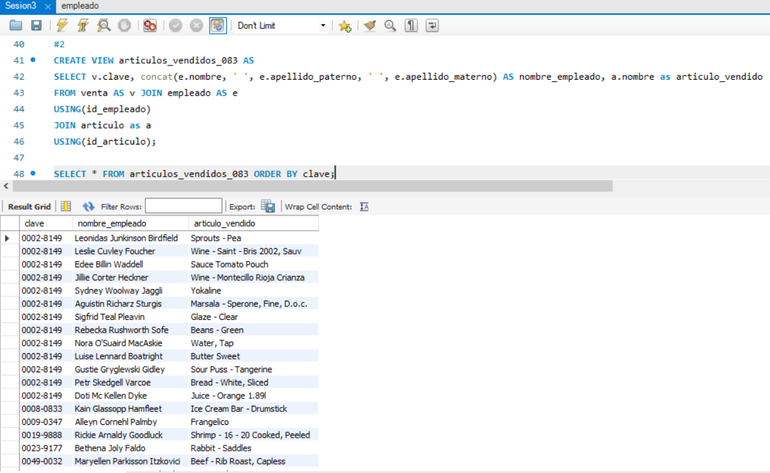

**#3**

CREATE VIEW puesto_mas_ventas_083 AS

SELECT p.nombre, count(v.clave) as total_ventas

FROM venta AS v JOIN empleado AS e

USING(id_empleado)

JOIN puesto as p

USING(id_puesto)

GROUP BY p.nombre ORDER BY total_ventas DESC LIMIT 1;

SELECT * FROM puesto_mas_ventas_083;

