**Gadget licensing**

1. Zoom collimator application uses **SpotSymmetry** gadget, which doesn’t work if license is not installed on computer. This license is tied to the computer system.

License init procedure is as following:

1. When gadget is started first time, it creates Registry string called "SystemID" with initial value “No ID" placed in **Computer\HKEY_CURRENT_USER\Software\TheFileX\ZoomCollimator\ProcessingParams.**
2. For create legal license, necessary to open regedit.exe application and to replace string in "SystemID" for CURRENT date in format YYYYMMDD (for example, 20231126).
3. After that necessary to restart graph running application (SHStudio or GraphDeploy or other application which does use SpotSymmetry gadget) and licensing update will be finished.
4. The “SystemID” registry variable will hold hexadecimal string which is necessary for license checking.

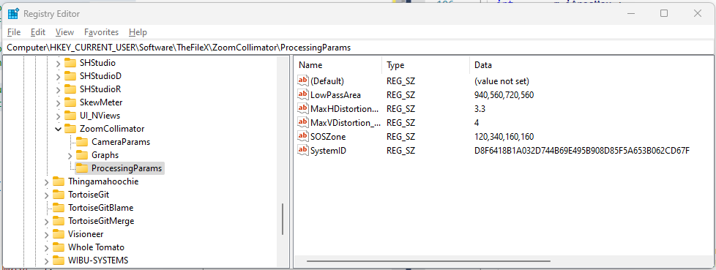

1. There is function bool Tvdb400_CheckSetLicense( *LPCTSTR* pAppName , *LPCTSTR* pDirName ) defined in gadbase.h file.

This function does necessary licensing operations in the same manner as for ZoomCollimator above:

* 1. When this function is started first time, it creates Registry string called "SystemID" with initial value “No ID" placed in **Computer\HKEY_CURRENT_USER\Software\TheFileX\<AppName> \<DirName>**
  2. For create legal license, necessary to open regedit.exe application and to replace string in "SystemID" for CURRENT date in format YYYYMMDD (for example, 20231126).
  3. After that necessary to restart application (SHStudio or GraphDeploy or other application which does use Tvdb400_CheckSetLicense with proper application name and directory name) and licensing update will be finished.
  4. The “SystemID” registry variable will hold hexadecimal string which is necessary for license checking.