**Screen Fragment Gadget**

Screen Fragment gadget does capture of computer screen content and converts it into video frame.



Input Format: any type.

Output format: Video Frame.

Grouped by types: Filters \ Video \ Capture \ **ScreenFrag**.  
Grouped by descriptions: Video\ Capture \ **ScreenFrag**.

Setup dialog of ScreenFrag gadget shown below

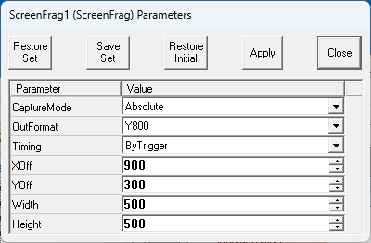

Field “CaptureMode” controls what part of computer desktop will be converted to video frame.

There is only one absolute working mode in existent version of gadget , when coordinates of captured rectangular should be assigned manually - look at last 4 parameters on shown dialog: desktop rectangle (900,300)-(1400,800) will be captured and sent to gadget output.

Field “OutFormat” consists of selected output video frame compression: Y800 (mono 8 bits), YUV9, YUV12 and RGB.

Field “Timing” controls frames generation process: by external trigger and by timer. When “ByTimer” is selected, additional field for frames period entering will be shown (look at dialog on picture below, which shows captured fragment of web browser in Float window 1).

