**GraphDeploy application initial instruction**

GraphDeploy.exe should be placed in Debug or Release directory of SHStudio (the same directory, where SHSTudio.exe could be placed (but not necessary).

There are important conditions:

1. All SHStudio DLLS should be placed in the same directory.
2. Graph LANControl.tvg should be placed in the same directory.
3. All necessary hardware support DLLs (interfaces to drivers) should be placed in the same directory.
4. Plugins subdirectory should have all DLLs with necessary gadgets for your running graphs.

Command line:

GraphDeploy <optional keys>

The keys are:

/lp <LAN server listening port>

[/r]<Graph file name>

/min - application dialog will be minimized

Keys could be presented in any combination

If LAN listening port is not present, port 5050 will be used for TCP protocol server listening.

If file name is presented, correspondent graph will be load.

If flag -r is presented, loaded graph will be started. Otherwise, graph will be loaded, but not started.

When application is closing by button “Close” or by right-upper window close button (cross), the application saves dialog position. Saved data will be used for application dialog position restore. Position is tied to graph name without full directories path. All graphs with the same name from different directories will be loaded into application when the same dialog position will be used. This rule work for application start only: loading new graph when GraphDeploy is running will not change dialog position.

Application dialog shown below

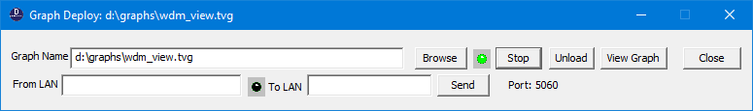

Graph for loading could be selected by button “Browse” clicking. If another graph already was loaded, it will be unloaded.

Graph could be stopped or started by button “Stop/Start” clocking (button does correspondent caption change).

Upper indicator (it is green on picture) shows graph status:

1. When graph is not loaded, indicator is black.
2. When graph is loaded and not running, indicator will be red.
3. When graph is running, indicator has green color (like on picture).

Graph could be viewed by “View Graph” button pressing.

GraphDeploy has internal LAN control server. Listening port is shown under button “Stop”.

If TCP server receives text message, it will be shown in “From LAN” field.

If TCP server sends message, it will be shown in “To LAN” field.

Indicator shows LAN activity: yellow light when message received, red light when message sent.

When some client does connection to LAN server, answer “OK” will be sent back;

Commands, which could be received through LAN and processed.

1. Setview <Gadget Name> point <X> <Y>\n

This command will lead to video stream viewing in top window which covers point (X,Y) on desktop. Keep in the mind, that X and Y could be positive or negative on multimonitor desktop (dependent on monitor order and placement).

1. Setview <Gadget Name> handle <window handle>\n

This command will lead to video stream viewing in window with appointed handle.

1. Setproperty <Gadget Name> <Property Name> <Property Value>\n

When command is normally processed, word “OK” with some data will be send back;

When error happened on command processing, word “ERROR” with explanation will be sent back.