**Label Filter Gadget**

Label Filter gadget does filtration of arrived on input frames and passing to the output pin only assigned types with assigned labels.

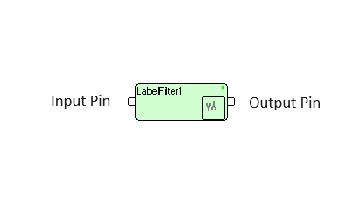

Input Format: any type.

Output format: any type.

Grouped by types: Filters \ Generic \ **LabelFilter**.  
Grouped by descriptions: Generic \ **LabelFilter**.

Setup dialog of Label Filter gadget shown below

Field “Label” consists of labels for selected frames. Several labels separated by slash (‘/’).

Field “Type” consists of selected frames type. Only one type could be selected.

Field “Compare” is for labels comparison rules, which could be as following:

1. Exact, i.e. frame label should be exactly as written in “Label” field.
2. Begin, i.e. any label which begins with assigned in “Label” field will be marked as selected.
3. Any Place, i.e. any label holding assigned in “Label” field in any place will be marked as selected.
4. With Prefix, i.e. label which has colon symbol (‘:’) exactly before assigned in “Label” field. Before colon and after assigned label can be any symbols.

Compare operation is case sensitive.

Field “InverseRule” defines what to do with selected frames: if this field is settled to “No”, selected files simply transferred to the output pin. If this field is settled to “Yes”, than selected frames will be deleted, but not selected fields will be transferred to the output pin.

Field “Attributes” is ASCII string which will be written into Attributes property of every frame transferred to the output pin.

If several frames are selected for transfer to the output, then the container frame will be created and all selected frames will be added to it. If only one frame is selected, this frame will be transferred as is.

If “Type” is Container, then containers with matching labels will be transferred to output as is. If “Type” is not container, all containers will be inspected for types and labels and all matching frames will be transferred to output.

Example of LabelFilter shown below: TVObjects gadget produces container with image (VideoFrame), graphics (FigureFrame), rectangle ROI, and two text frames (measurement results with label “Data_Spot:black_spot_RW” and text on image with label “CoordView:black_spot_0_cent”).

LabelFilter extracts text on image by label beginning with “Coord”.

