Label Filter gadget manual

Table of Contents

1. What is a Label Filter gadget? 3

1.1. Input and output pins. 3

1.2. Label Filter gadget properties. 4

1.3. Sample of Label Filter gadget using. 5

# What is a Label Filter gadget?

Label Filter gadget does filtration of arrived on input frames and passing to the output pin only assigned types with assigned labels.

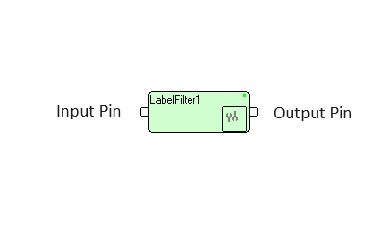

Figure 1: Label Filter gadget

Position in gadget tree:

When grouped by types: Filters \ Generic \ **LabelFilter**.  
When grouped by descriptions: Generic \ **LabelFilter**.

## Input and output pins.

Gadget receives any type of data frames to input pin and transfers to output pin(s) without any changes.

## Label Filter gadget properties.

Double left click on Label Filter gadget creates the following dialog box:

Figure 2. Label Filter gadget Setup Dialog

Field “Label” consists of labels for selected frames. Several labels separated by slash (‘/’).

Field “Type” consists of selected frames type. Only one type could be selected.

Field “Compare” is for labels comparison rules, which could be as following:

1. Exact, i.e. frame label should be exactly as written in “Label” field.
2. Begin, i.e. any label which begins with assigned in “Label” field will be marked as selected.
3. Any Place, i.e. any label holding assigned in “Label” field in any place will be marked as selected.
4. With Prefix, i.e. label which has colon symbol (‘:’) exactly before assigned in “Label” field. Before colon and after assigned label can be any symbols.

Compare operation is case sensitive.

Field “InverseRule” defines what to do with selected frames: if this field is settled to “No”, selected files simply transferred to the output pin. If this field is settled to “Yes”, than selected frames will be deleted, but not selected fields will be transferred to the output pin.

Field “Attributes” is ASCII string which will be written into Attributes property of every frame transferred to the output pin.

If several frames are selected for transfer to the output, then the container frame will be created and all selected frames will be added to it. If only one frame is selected, this frame will be transferred as is.

If “Type” is Container, then containers with matching labels will be transferred to output as is. If “Type” is not container, all containers will be inspected for types and labels and all matching frames will be transferred to output.

# Sample of Label Filter gadget using.

Example of LabelFilter using shown on Figure 3.

TVObjects gadget produces container with image (VideoFrame is last in container preview), container with rectangle ROI, and container “ResultRes” with two text frames (measurement results with label “Data_Spot:black_spot_RW” and text on image with label “CoordView:black_spot_0_cent”) and figures for graphics presentation.

Only “ResultRes” container is expanded for preview.

LabelFilter extracts text on image by label beginning with “Coord” (not necessary to fill full label of text frame).

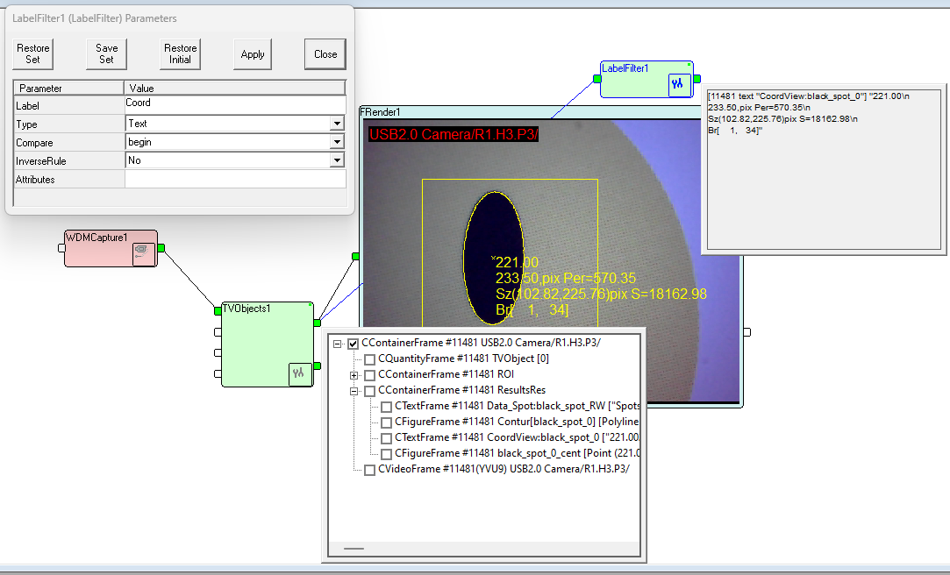

Figure 3. Label Filter gadget example in graph