GMarking gadget manual

Table of Contents

1. What is a Port gadget? 3

1.1. Input and output pins 3

1.2. To which gadgets can Port gadget be connected? 3

1.3. Port gadget properties 4

# What is a GMarking gadget?

GMarking gadget provides possibility for graphics adding over images.

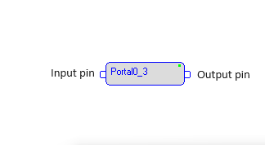

Figure 1: Portal gadget

## Input and output pins

Gadget receives any type of data frames to input pin and transfers to output pin(s) without any changes.

## To which gadgets can Port gadget be connected?

Fragment of graph with two Port gadgets shown below (Port gadgets have light grey body). Data from WDMCapture gadget (video frames) are passed to upper Port gadget and transfers to outputs of both gadgets. These Port gadgets have the same *Portal Name.* This name is**Portal0** and shown on gadget instead of gadget name. Number 3 shows that there are 3 Port gadgets in graph with portal name **Portal0** (two of them are on picture).

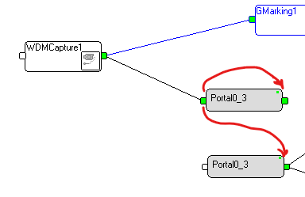

Figure 2. Port gadgets in graph

## Port gadget properties

Double left click on Port gadget creates the following dialog box:

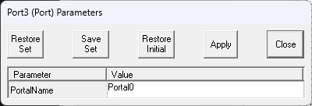

Figure 5. Port Setup Dialog

*Portal Name* should be simple typed in setup dialog. Changing this name will disconnect Port gadget from the old portal and connect to another portal.

If the *Portal Name* field is empty the gadget will be disconnected from all portals. The gadget in this case will not transfer data from input to output.

If the new name doesn’t exist in other gadgets, the new portal will be created, and gadget will transfer data from input to output but will not transfer to outputs of other gadgets.

If the new name exists in another gadget, the gadget will be transferring input data to the outputs of all gadgets with this name.

The following picture shows graph fragments with two Port gadgets on **Portal0** and one gadget on **Portal1**. Frames from WDMCapture are going to Frender2 through two Port gadgets with **Portal0** as *Portal Name* (green pins shows data passing; input pin of marked by red gadget is white, i.e. data are going from another port). The third Port gadget connected to **Portal1** doesn’t transfer data (pins are white).

