Software Requirements and Design Document
for
NEX COMMERCE
Prepared by I220617 Muhammad Moiz
I220787 Asim Iqbal
I220987 Aniq Noor
I220903 Shayan Rauf
NEXTEC
Table of Contents
Table of Contents ii
1. Introduction 1
1.1 Purpose 1
1.2 Product Scope 1
1.3 Title 1
1.4 Objectives 1
1.5 Problem Statement 1
2. Overall Description 1
2.1 Product Perspective 1
2.2 Product Functions 2
2.3 Extended Use Cases 2
2.4 Use Case Diagram 2
3. Other Nonfunctional Requirements 2
3.1 Performance Requirements 2
3.2 Safety Requirements 2
3.3 Security Requirements 2
3.4 Software Quality Attributes 2
3.5 Business Rules 3
3.6 Operating Environment 3
3.7 User Interfaces 3
4. Domain Model 3
5. System Sequence Diagram 3
6. Sequence Diagram 3
7. Class Diagram 4
8. Component Diagram………………………………………………………………………………………………………..4
9. Package Diagram 4

Introduction

Purpose
The purpose of this document is to specify the software requirements for Nex Commerce, a supermarket management system developed by NexTec. The primary objective of this project is to provide a comprehensive, user-friendly platform that facilitates seamless management of supermarket operations. Nex Commerce addresses the needs of both customers and administrators by offering features such as product browsing, cart management, category management, and delivery oversight. This system is designed for scalability and adaptability, ensuring that it remains effective as supermarkets expand their operations. This document details the software requirements for Nex Commerce, outlining its features, architecture, and user interface elements.

Product Scope
Nex Commerce aims to provide an efficient solution for managing supermarket operations. It includes modules for product browsing, cart management, user registration, order tracking, and delivery management. Nex Commerce is a JavaFX-based application tailored to modern supermarkets' operational requirements. By automating tasks such as inventory management, order processing, and delivery tracking, it alleviates the workload on administrators and reduces the scope for manual errors. Customers benefit from an intuitive interface that simplifies product browsing, cart management, and order placement. The system also supports a review mechanism, enabling customers to provide feedback on products and services. The platform aligns with NexTec's vision of leveraging technology to create solutions that boost efficiency and enhance customer satisfaction. Nex Commerce also incorporates features to address the growing demand for digital solutions in the retail sector, setting the stage for future enhancements such as analytics and personalized recommendations.

Title
Nex Commerce: A Supermarket Management Solution by NexTec
This project aims to offer a practical solution to supermarkets by digitizing operations and creating a smooth interaction flow between customers and service providers. Nex Commerce stands out as an affordable and scalable software tailored to meet the specific challenges faced by supermarkets, from inventory handling to order fulfillment.

Objectives
- Develop an easy-to-use platform that integrates core supermarket functionalities into a cohesive system.
- Enable efficient inventory management and minimize stock discrepancies through automated processes.
- Enhance customer engagement by providing seamless features such as product browsing, cart updates, and order tracking.
- Support delivery operations with assignment of delivery personnel.
- Facilitate data-driven decision-making through detailed order and customer reviews.
- Facilitate seamless interaction between customers and supermarket services.
- Automate inventory, order, and delivery management processes.
- Enhance the user experience through a robust and intuitive JavaFX-based user interface.
- Provide a scalable platform that adapts to the needs of growing supermarkets.

Problem Statement.
Supermarkets often struggle to manage inventory, handle customer orders, and oversee deliveries, especially during peak hours. These challenges can lead to errors, delays, and customer dissatisfaction. Furthermore, the lack of a unified digital platform results in inefficiencies, increasing operational costs and hindering scalability. Nex Commerce addresses these issues by providing a comprehensive solution that integrates all key operations into a single system. This reduces the dependency on manual processes, enhances operational efficiency, and ensures a better experience for customers. The project's feasibility lies in its use of scalable technology (JavaFX) and modular architecture, making it suitable for small to medium-sized supermarkets with room for expansion.

Overall Description

Product Perspective
Nex Commerce is a standalone application developed to address the specific needs of supermarket operations. It is not built as an extension or replacement of any existing systems but designed as an independent solution. The platform's modular structure ensures that it can be integrated with external systems if required in the future. The software features distinct modules for customers, administrators, and delivery personnel. For instance, customers can browse products, add items to their carts, and place orders, while administrators can manage inventory, monitor orders, and assign delivery personnel. Delivery personnel, in turn, can view their assigned tasks and update order statuses. The system also includes a review mechanism, allowing customers to provide feedback on products and services, which administrators can use for continuous improvement.

Product Functions
The major functions of Nex Commerce include:

Nex Commerce supports the following key functions:
- User Management: Handles customer registration, login, and profile updates. It ensures secure access and user-specific experiences.
- Product Browsing: Displays the entire product catalog with options to search items based on categories and pricing.
- Cart Management: Provides users with the ability to add or remove items from their cart, view total costs, and proceed to checkout.
- Order Management: Allows customers to place orders, track their statuses, and view order history. For administrators, this includes monitoring all orders and managing their fulfillment.
- Delivery Setup: Enables administrators to assign orders to delivery personne.
- Review System: Facilitates customers in providing feedback, which is displayed in the product section and aids in improving customer satisfaction.
- Admin Panel : Offers tools for managing categories, products, users, orders and generating reports.

Extended Use Cases

FAST University

Muhammad Moiz | 22i-0617
Asim Iqbal | 22i-0787
Aniq Noor | 22i-0987
Shayan Rauf | 22i-0903

MUHAMMAD MOIZ (22I-0617) AND ANIQ NOOR (22I-0987)

1. Use Case: User Registration and Authentication

1. Use case name:
User Registration and Authentication

2. Scope:
Super Market Management System (SMMS)

3. Level:
User goal

4. Primary actor:
Customer, Cashier

5. Stakeholders and interests:
- Customer: Wants to register and log in easily to access personalized features.
- Super Market Management: Wants to secure customer data and control access to the system.

6. Preconditions:
- Customer is on the registration/login page.
- Customer is not logged in (for registration).
- Customer has internet access.

7. Success guarantee (postcondition):
Customer is successfully registered and/or authenticated to access their account.

8. Main success scenario:
User Actions  1. User opens the registration/login page.  2. User chooses to either register or log in.  - If registering, the user provides the required information (name, email, password, etc.).  - If logging in, the customer enters credentials.  3. If successful, the user is either registered or logged into their account. | System Responses  2. System verifies credentials and authenticates the user.  3. System grants access to the user’s dashboard.

9. Extensions:

- 2a. Invalid input during registration:
- 2a1. System notifies the user about the errors (e.g., password too short, email already in use) and requests corrections.
- 2b. Invalid login credentials:
- 2b1. System informs the user of invalid credentials and allows retries.

10. Special requirements:
- Password must meet security criteria (e.g., minimum length, special characters).
- Emails should be unique and valid.

11. Technology and data variations list:
- Email verification via different email service providers.
- OAuth-based login (e.g., Google, Facebook) can be used.

---

2. Use Case: Product Browsing

1. Use case name:
Product Browsing

2. Scope:
Super Market Management System (SMMS)

3. Level:
User goal

4. Primary actor:
Customer

5. Stakeholders and interests:
- Customer: Wants to browse the product catalog to find items to purchase.
- Super Market Management: Wants an organized and user-friendly interface to boost product visibility and sales.

6. Preconditions:
- Customer is logged in or accessing the platform anonymously.
- Product catalog is available.

7. Success guarantee (postcondition):
Customer can browse the product categories and individual product listings without errors.

8. Main success scenario:
User Actions  1. Customer navigates to the product catalog.  2. User selects a category or applies filters (price, brand).  3. Customer selects a product to view details or adds the product to the cart. | System Responses  2. System filters products and updates the display.

9. Extensions:
- 2a. Customer does not find desired products:
- 2a1. System provides suggestions or displays a message that no products match the search/filter criteria.

10. Special requirements:
- Search and filter performance should be fast, even with a large number of products.

11. Technology and data variations list:
- Display grid or list view options.
- Search can include autocomplete and suggestion features.

---

3. Use Case: Product Details View

1. Use case name:
Product Details View

2. Scope:
Super Market Management System (SMMS)

3. Level:
User goal

4. Primary actor:
Customer

5. Stakeholders and interests:
- Customer: Wants to view detailed information about a product to make an informed purchase decision.
- Super Market Management: Wants to provide clear, informative product pages to increase sales conversion.

6. Preconditions:
- Customer is browsing products.
- Product details (e.g., price, description, availability) are available.

7. Success guarantee (postcondition):
Customer can view detailed product information.

8. Main success scenario:
User Actions  1. Customer clicks on a product from the list.  2. User reviews the product description, price, and availability.  3. User clicks on product images for a closer look. | System Responses  2. System provides all details, including customer reviews and availability status.  3. System displays a zoomable image gallery.
9. Extensions:
- 2a. Product is out of stock:
- 2a1. System displays an "Out of stock" message.
10. Special requirements:
- Product images should support zoom functionality for better view.
- The page should handle high traffic smoothly.

11. Technology and data variations list:
- Mobile-friendly responsive design.
- Data variations include dynamic pricing and real-time stock updates.

---

4. Use Case: Add to Cart

1. Use case name:
Add to Cart

2. Scope:
Super Market Management System (SMMS)

3. Level:
User goal

4. Primary actor:
Customer

5. Stakeholders and interests:
- Customer: Wants to select products for purchase and store them temporarily before checkout.
- Super Market Management: Wants a seamless and error-free cart experience to encourage purchases.

6. Preconditions:
- Customer is browsing or viewing product details.
- Product is available in stock.

7. Success guarantee (postcondition):
Product is successfully added to the customer’s cart.

8. Main success scenario:
User Actions  1. Customer clicks “Add to Cart” from the product details page. | System Responses  1. System checks product availability and if available adds the product to the customer’s cart.  2. System confirms addition with a message or cart preview.

9. Extensions:
- 1a. Product is unavailable (out of stock):
- 1a1. System notifies the customer.

10. Special requirements:
- Cart should be updated in real-time and persist across sessions.

11. Technology and data variations list:
- Persistent carts using browser cookies or customer login.
- Data variation for availability (stock levels, limited-time offers).

---

5. Use Case: Manage Cart

1. Use case name:
Manage Cart

2. Scope:
Super Market Management System (SMMS)

3. Level:
User goal

4. Primary actor:
Customer

5. Stakeholders and interests:
- Customer: Wants to review and manage selected products before checkout.
- Super Market Management: Wants a clear and functional cart system to reduce abandoned carts.

6. Preconditions:
- Customer has added items to their cart.

7. Success guarantee (postcondition):
Customer can view, update, or remove items from the cart before checkout.

8. Main success scenario:
User Actions  1. Customer navigates to the cart page.  2. Customer can:  - Increase or decrease item quantities.  - Remove items from the cart.  - Proceed to checkout. | System Responses  2. System updates the cart in real-time as changes are made.

9. Extensions:
- 2a. Customer tries to increase quantity beyond available stock:
- 2a1. System displays a message informing of the stock limit.

10. Special requirements:
- Cart should update prices in real-time and reflect any promotions or discounts.

11. Technology and data variations list:
- Real-time updates through WebSockets or AJAX.
- Cart can sync across devices if the customer is logged in.

---

6. Use Case: Wishlist Management

1. Use case name:
Wishlist Management

2. Scope:
Super Market Management System (SMMS)

3. Level:
User goal

4. Primary actor:
Customer

5. Stakeholders and interests:
- Customer: Wants to save products for future purchase consideration.
- Super Market Management: Wants to increase sales through targeted marketing based on customer preferences.

6. Preconditions:
- Customer is logged in and browsing products.

7. Success guarantee (postcondition):
Customer can successfully add or remove products from their wishlist.

8. Main success scenario:
User Actions  1. Customer views a product and clicks “Add to Wishlist.”  2. Customer can view their wishlist at any time, displaying saved products.  3. Customer can remove products from the wishlist as needed. | System Responses  1. System confirms the product is added to the wishlist.  3. System confirms the removal of the product from the wishlist.

9. Extensions:
- 2a. Customer tries to add an item already in the wishlist:
- 2a1. System informs the customer the item is already in their wishlist.

10. Special requirements:
- Wishlist should persist across sessions and be easily accessible from the user dashboard.

11. Technology and data variations list:
- Data variations for product availability (e.g., alerting customer when a wishlist item is on sale).

---

7. Use Case: Checkout Process

1. Use case name:
Checkout Process

2. Scope:
Super Market Management System (SMMS)

3. Level:
User goal

4. Primary actor:
Customer

5. Stakeholders and interests:
- Customer: Wants a straightforward, secure, and fast checkout experience.
- Super Market Management: Aims to minimize cart abandonment and streamline the payment process.

6. Preconditions:
- Customer has items in their cart.

7. Success guarantee (postcondition):
Customer successfully completes the purchase and receives an order confirmation.

8. Main success scenario:
User Actions  1. Customer clicks “Proceed to Checkout.”  2. Customer enters or confirms payment method.  3. Customer reviews and confirms the order. | System Responses  1. System prompts for billing information.  2. System displays order summary for confirmation.  3. System processes the payment and generates an order confirmation.

9. Extensions:
- 2a. Payment fails:
- 2a1. System notifies the customer of the payment issue and allows retries or alternative payment methods.
- 2b. Customer wants to modify order before finalizing:
- 2b1. System allows the customer to return to the cart for modifications.

10. Special requirements:
- Secure payment processing to protect customer financial information.
- Responsive design for mobile users.

11. Technology and data variations list:
- Support for multiple payment gateways (credit card, PayPal, etc.).
- Dynamic shipping options based on address and selected items.

---

.
- Notifications via email or SMS for order status changes.

SHAYAN RAUF (22I-0903)
- Use Case: Sales Reporting

Use case name:
Sales Reporting
Scope:
Supermarket Management System
Level:
User Goal
Primary actor:
Admin (User)
Stakeholders and Interests:
Admin: Needs to access accurate sales data to monitor performance.
Preconditions:
Admin is logged into the system.
Success Guarantee (Postcondition):
Sales reports are generated, providing accurate and up-to-date sales data.
Main Success Scenario:
1. Admin navigates to the "Sales Reporting" section. System displays options for generating sales
reports.
2. Admin selects report filters. System generates a sales report

based on the
selected filters.
3. Admin views the report or exports it.
Extensions:
1a. Admin enters invalid filters (e.g., future dates). System prompts an error message for invalid input.
Special Requirements:
- The system must handle large datasets without performance issues.
Technology and Data Variations List:
- Reports should display sales breakdown by categories, regions, etc.

- Use Case: Category Deletion

Use case name:
Category Deletion
Scope:
Supermarket Management System
Level:
User Goal
Primary actor:
Admin
Stakeholders and Interests:
Admin: Needs to manage product categories to keep the system organized.
Preconditions:
Admin is logged into the system.
Success Guarantee (Postcondition):
The category is deleted successfully without affecting related data integrity.
Main Success Scenario:
1. Admin navigates to the
"Category Management" section. System displays all available categories.
2. Admin selects a category to delete. System confirms if the category has related products

and shows
a warning.
3. Admin confirms deletion. System deletes the category and updates related product

listings.
Extensions:
2a. Admin attempts to delete a category
in use by active products. System prevents deletion and suggests reassignment.

Special Requirements:
- System must ensure that deletion does not affect product listings or sales history.
Technology and Data Variations List:
- The system should allow deletion only when not in use by other features.

- Use Case: Category Creation

Use case name:
Category Creation
Scope:
Supermarket Management System
Level:
User Goal
Primary actor:
Admin
Stakeholders and Interests:
Admin: Needs to add new product categories to organize the store inventory.
Preconditions:
Admin is logged into the system.
Success Guarantee (Postcondition):
The new category is created and visible to users for product assignment.
Main Success Scenario:
1. Admin navigates to the
"Category Management" section. System provides fields for entering new
category details (name, description).
2. Admin enters category details System validates the input and saves the
new category.
3. Admin confirms creation. System confirms the successful creation and updates the
category list.

Extensions:
2a. Admin enters a duplicate
category name. System prompts an error for duplicate categories.
Special Requirements:
- System should ensure unique category names to avoid confusion.
Technology and Data Variations List:
- The category data should be compatible with product management modules.

4. Use Case: Deliver Order
Use case name:
Deliver Order
Scope:
Super Market Management System (SMMS)
Level:
User goal
Primary actor:
Delivery Boy
Stakeholders and interests:
Delivery Boy: Wants a clear and accurate list of orders to deliver and a system that helps track delivery progress efficiently.
Customer: Wants timely delivery of orders and the ability to track delivery status.
Super Market Management: Aims to ensure orders are delivered on time and accurately, improving customer satisfaction and operational efficiency.
Preconditions:
Customer has placed an order, and the order has been assigned to the delivery boy.
Delivery boy is logged into the system and has access to the list of assigned deliveries.
Success guarantee (postcondition):
The delivery boy successfully delivers the order, and the system marks the order as delivered with a confirmation from the customer.
Main success scenario:
User Actions | System Response
1. Delivery boy logs into the SMMS and navigates to the "Assigned Deliveries" section. | 1. System displays a list of all pending deliveries assigned to the delivery boy, including customer details and delivery address.
2. Delivery boy selects an order from the list to view detailed order information (items, payment status, and delivery instructions).
3. Delivery boy delivers the order to the customer’s address.
4. Customer confirms receipt of the order by signing on the delivery boy’s device (either physically or digitally).
5. Delivery boy marks the order as "Delivered" in the system. | 5. System updates the order status to "Delivered" in the customer's account and sends a confirmation notification to the customer.
Extensions:
  - 2a. Order cancellation by customer before delivery:
    - 2a1. System notifies the delivery boy that the order has been canceled.
    - 2a2. Delivery boy no longer needs to deliver the order, and the system removes it from the assigned delivery list.
  - 5a. Delivery boy is unable to reach the customer:
    - 5a1. Delivery boy attempts to contact the customer via phone or SMS.
    - 5a2. If the customer does not respond within a certain timeframe, the system allows the delivery boy to mark the order as "Failed Attempt," and notifies the customer to reschedule delivery.
  - 6a. Customer disputes the delivered order (e.g., incorrect items):
    - 6a1. Delivery boy reports the issue in the system.
    - 6a2. System flags the order for review by the support team, and the delivery boy follows further instructions.
Special requirements:
  - The system should be mobile-friendly and easy to use on handheld devices.
  - GPS integration for optimized route planning and real-time updates.
  - Ability to capture the customer's digital signature as proof of delivery.
Technology and data variations list:
  - The delivery app could use GPS to track real-time delivery status and provide the customer with live updates.
  - Integration with payment gateways to check if the customer has fully paid (if applicable to COD orders).
  - Notifications to the customer for delivery updates, including delays.

ASIM IQBAL (22I-0787)

Use Case: Rate Delivery Boy

Scope:
Supermarket Management System
Level:
User goal
Primary Actor:
Customer
Stakeholders and Interests:
- Customer: Wants to provide feedback on the delivery experience to help improve service.
- Delivery Boy: Wants to receive positive feedback and improve based on constructive criticism.
- Supermarket Admin: Wants to monitor delivery performance and address customer concerns.
Preconditions:
- The customer has successfully received the order.
- The delivery boy is associated with the delivered order in the system.
Success Guarantee (Postconditions):
- The feedback is recorded in the system and associated with the delivery boy.
- Customer satisfaction data is updated for analysis.

User Actions System Response

Customer opens the app and navigates to "Order History." System displays recent

orders with delivery details.

Customer selects the recently delivered order. System shows order details

and a "Rate Delivery Boy"

option.

Customer clicks on "Rate Delivery Boy." System presents a rating

interface (e.g., stars and

comments).

Customer provides a rating and optional comments. System saves the feedback and

associates it with the delivery

boy.

Customer confirms the rating submission. System displays a "Thank You"

message and updates the feedback

database.

Extensions:

Condition System Response

If the customer submits without rating. System prompts, "Please provide a

rating to proceed."

If the feedback submission fails. System notifies the customer and

requests a retry.

Use Case: Add Products
Scope:
Supermarket Management System
Level:
User goal
Primary Actor:
Admin
Stakeholders and Interests:
- - Admin: Wants to add products efficiently to the system.
- - Customer: Wants accurate product listings.
Preconditions: Admin is logged into the system.
Success Guarantee (Postconditions):
New product is added to the system.
Main Success Scenario:
User Actions | System Responses
Admin selects 'Add Product' option. | System displays product entry form.
Admin enters product details. | System validates and saves product information.
Admin submits product. | System adds product to the inventory.
Extensions:
Condition | System Response
If validation fails, | System shows an error message and prompts admin to correct it.
If product already exists, | System prevents duplication and notifies admin.

Special Requirements:
Real-time validation of product details.
Technology and Data Variations List:
Admin portal for product management.

Use Case: Remove Products
Scope:
Supermarket Management System
Level:
User goal
Primary Actor:
Admin
Stakeholders and Interests:
- Admin: Wants to remove outdated or incorrect products efficiently.
- Customer: Wants an up-to-date and accurate product catalog.
Preconditions:
Admin is logged into the system and has access to product management features.
Success Guarantee (Postconditions):
Product is removed from the system.
Main Success Scenario:
User Actions | System Responses
Admin navigates to the 'Remove Product' section.
Admin selects a product to remove.
Admin confirms the removal. | System removes the product from the inventory and updates the catalog.
Extensions:
- Condition: If the product is linked to active orders
- System Response: System warns the admin about the dependencies and blocks removal until resolved.
Special Requirements:
Ensure the product is not part of ongoing customer orders or promotions.
Technology and Data Variations List:
Admin portal for product management, database for product inventory.

Use Case: Handle Employees

Scope:
Supermarket Management System
Level:
User goal
Primary Actor:
Admin
Stakeholders and Interests:
- Admin: Wants to manage employees efficiently, including adding, updating, or removing employee records.
- Employees: Want accurate records of their roles and responsibilities.
Preconditions:
Admin is logged into the system and has employee management permissions.
Success Guarantee (Postconditions):
Employee records are updated successfully in the system.
Main Success Scenario:
User Actions | System Responses
Admin selects the 'Manage Employees' option.
Admin adds, edits, or removes an employee. | System validates and saves Employee information.
Extensions:
- Condition: If validation fails (e.g., duplicate employee ID or missing details)
- System Response: System prompts the admin to correct the information.
Special Requirements: Must comply with employment laws and regulations.
Technology and Data Variations List: Admin portal for employee management, employee database.

Use Case: Handle Users
Scope:
Supermarket Management System
Level:
User goal
Primary Actor:
Admin
Stakeholders and Interests:
- Admin: Wants to manage user accounts efficiently, including creating, updating, or deactivating accounts.
- Users: Want secure and accurate account information.
Preconditions:
Admin is logged into the system and has user management permissions.
Success Guarantee (Postconditions):
User records are updated successfully.
Main Success Scenario:
User Actions | System Responses
Admin navigates to the 'Manage Users' section.
Admin adds, edits, or deactivates a user account. | System validates and saves information.
Extensions:
- Condition: If user information is incomplete or invalid
- System Response: System prompts the admin to correct the information.
Special Requirements:
Ensure data privacy and protection.
Technology and Data Variations List:
Admin portal for user management, user database.

Use Case: Process Orders
Scope:
Supermarket Management System
Level:
User goal
Primary Actor:
Admin
Stakeholders and Interests:
- Admin: Wants to ensure smooth and timely processing of customer orders.
- Customer: Wants the order processed and delivered efficiently.
Preconditions:
Orders have been placed by customers.
Success Guarantee (Postconditions):
Orders are processed and prepared for delivery.
Main Success Scenario:
User Actions | System Responses
Admin navigates to the 'Process Orders' section.
Admin selects an order to process. | System process the Order and assigns an available delivery boy
Extensions:
- Condition: If the order cannot be processed (e.g., out-of-stock items)
- System Response: System alerts the admin and provides options to cancel or update the order.
Special Requirements:
Real-time inventory updates to avoid order conflicts.
Technology and Data Variations List:
Admin portal for order management, real-time order processing system.

Use Case Diagram

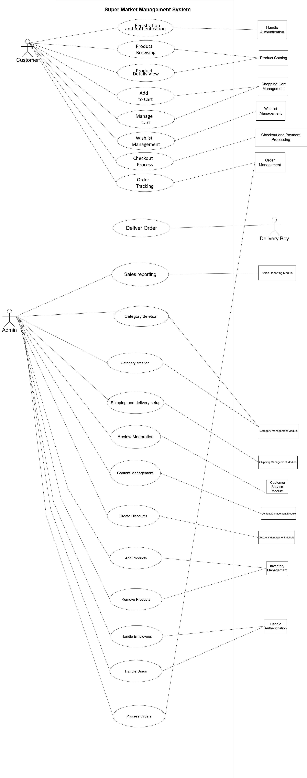

Other Nonfunctional Requirements

Performance Requirements
Nex Commerce is designed to handle a moderate workload efficiently. The platform ensures that all core functionalities, such as login, product browsing, and cart updates, execute within a few seconds. Database operations, such as querying products or orders, are designed to complete in less than ten seconds under normal conditions. This level of performance ensures that both customers and administrators experience minimal delays during critical operations.

Safety Requirements
The system includes measures to prevent data corruption and ensure the integrity of sensitive information, such as user credentials and payment details. Regular backups of key data, including user profiles and inventory records, are performed to safeguard against data loss. Furthermore, all operations that involve modifying inventory or handling sensitive orders are restricted to authorized administrators.

Security Requirements
- Implement user authentication with secure password hashing.
- Role-based access control ensures only admins can perform critical tasks like inventory management.
- Encrypt all sensitive data during transmission using SSL/TLS protocols.
- Ensure compliance with data protection standards to safeguard user information.

Software Quality Attributes
- Usability: A simple and intuitive user interface ensures ease of use for both customers and administrators.
- Reliability: The system is designed to ensure continuous availability with minimal downtime.
- Maintainability: Modular architecture facilitates easy updates and bug fixes.
- Scalability: The platform can accommodate additional users and functionalities as supermarket operations grow.
- Portability: The system runs seamlessly across multiple operating systems, provided the necessary Java environment is installed.

Business Rules
- Customers must be logged in to place orders or provide reviews.
- Only administrators can access inventory and delivery management features.
- Orders can only be placed if payment is confirmed.

Operating Environment
Nex Commerce operates on machines equipped with at least 4GB of RAM, a dual-core processor, and 20GB of free storage. It requires Java SE 11 or higher and a relational database system such as MySQL. The application is compatible with major operating systems, including Windows, macOS, and Linux.

User Interfaces
The graphical user interface is built using JavaFX, offering a clean and modern design.

- Login and Registration Screens: Secure access points for users to create accounts or log in.
- Dashboard: Displays user-specific data such as recent orders and available products.
- Product Catalog: An interactive page with search options for easy product browsing.
- Cart Page: Summarizes selected products, total cost, and checkout options.
- Admin Panel: Provides tools for managing inventory, orders, and reports.
- Wishlist page: Shows the wish listed products.
- Add product page: Can add product name, description, URL etc.

Domain Model
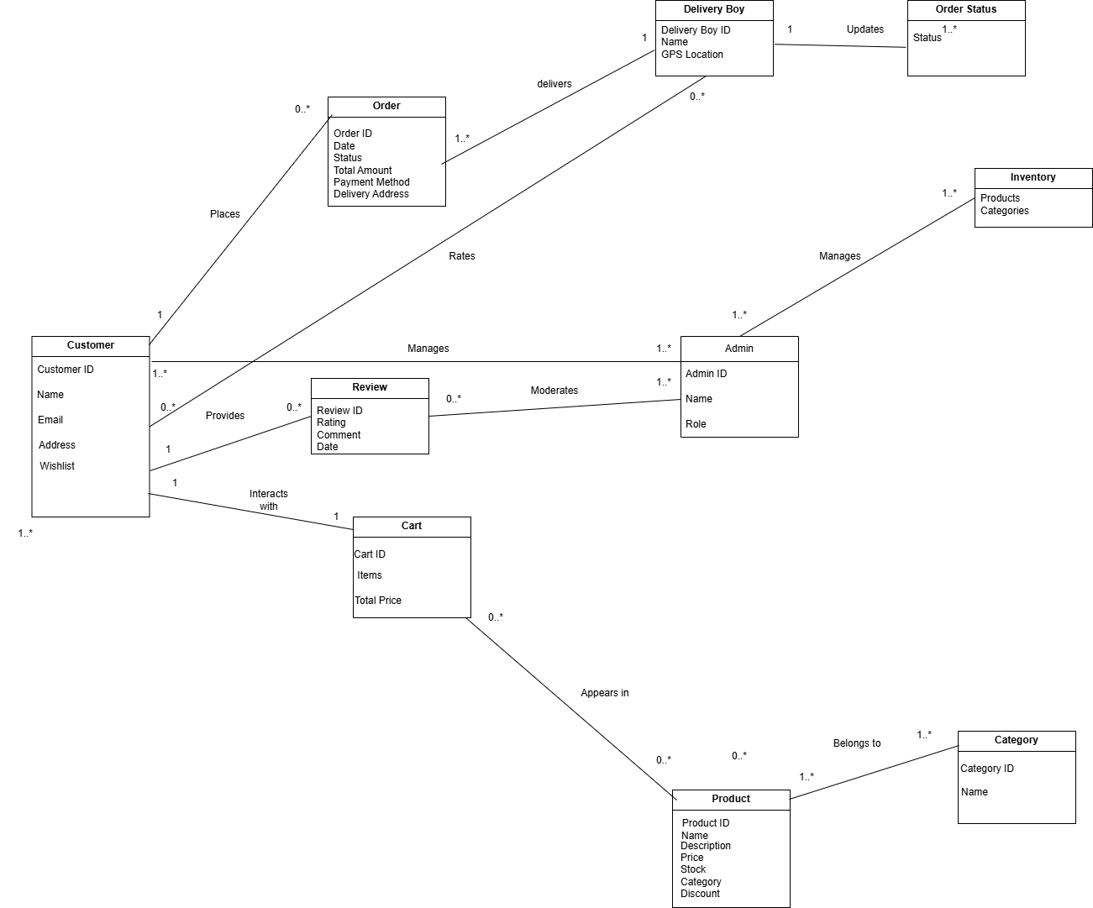

System Sequence Diagram
ADD TO CART

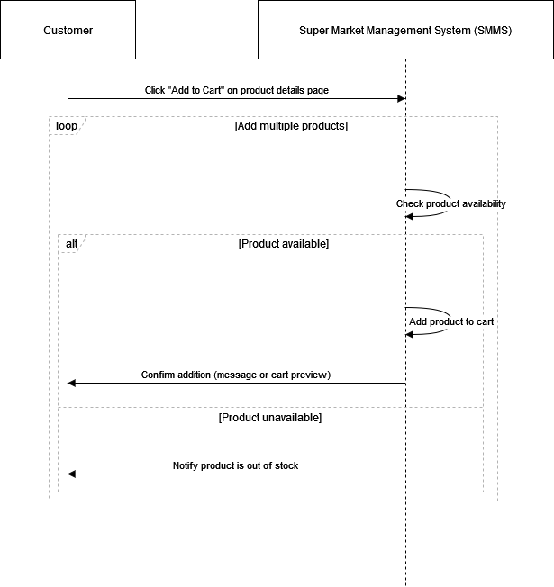

Sequence Diagram

- Add to cart
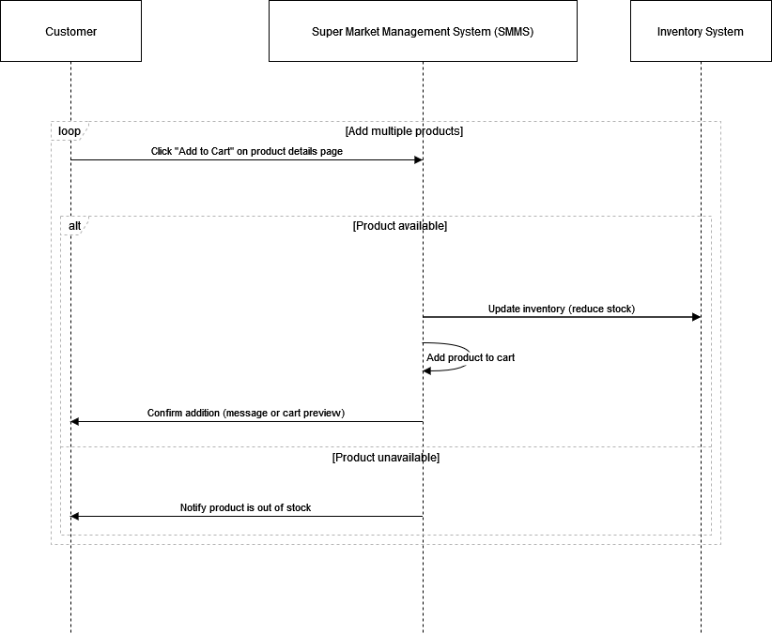

- Category Creation

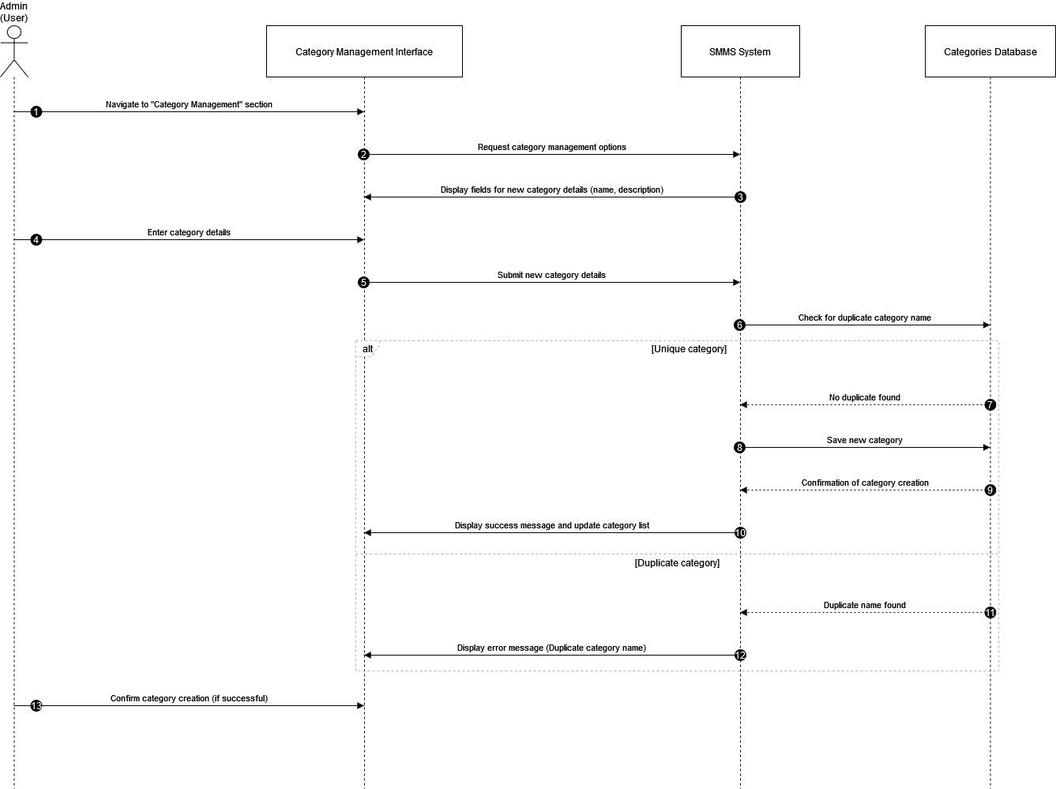

- Checkout Process

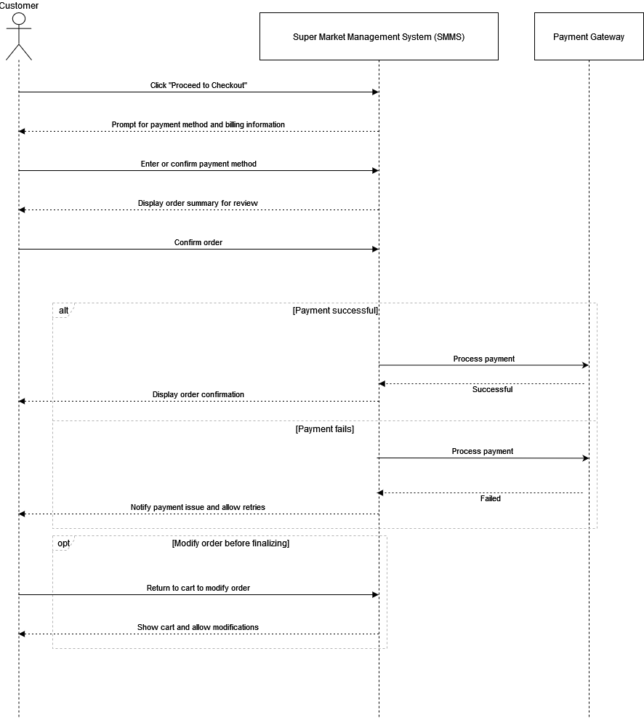

- Product Browsing

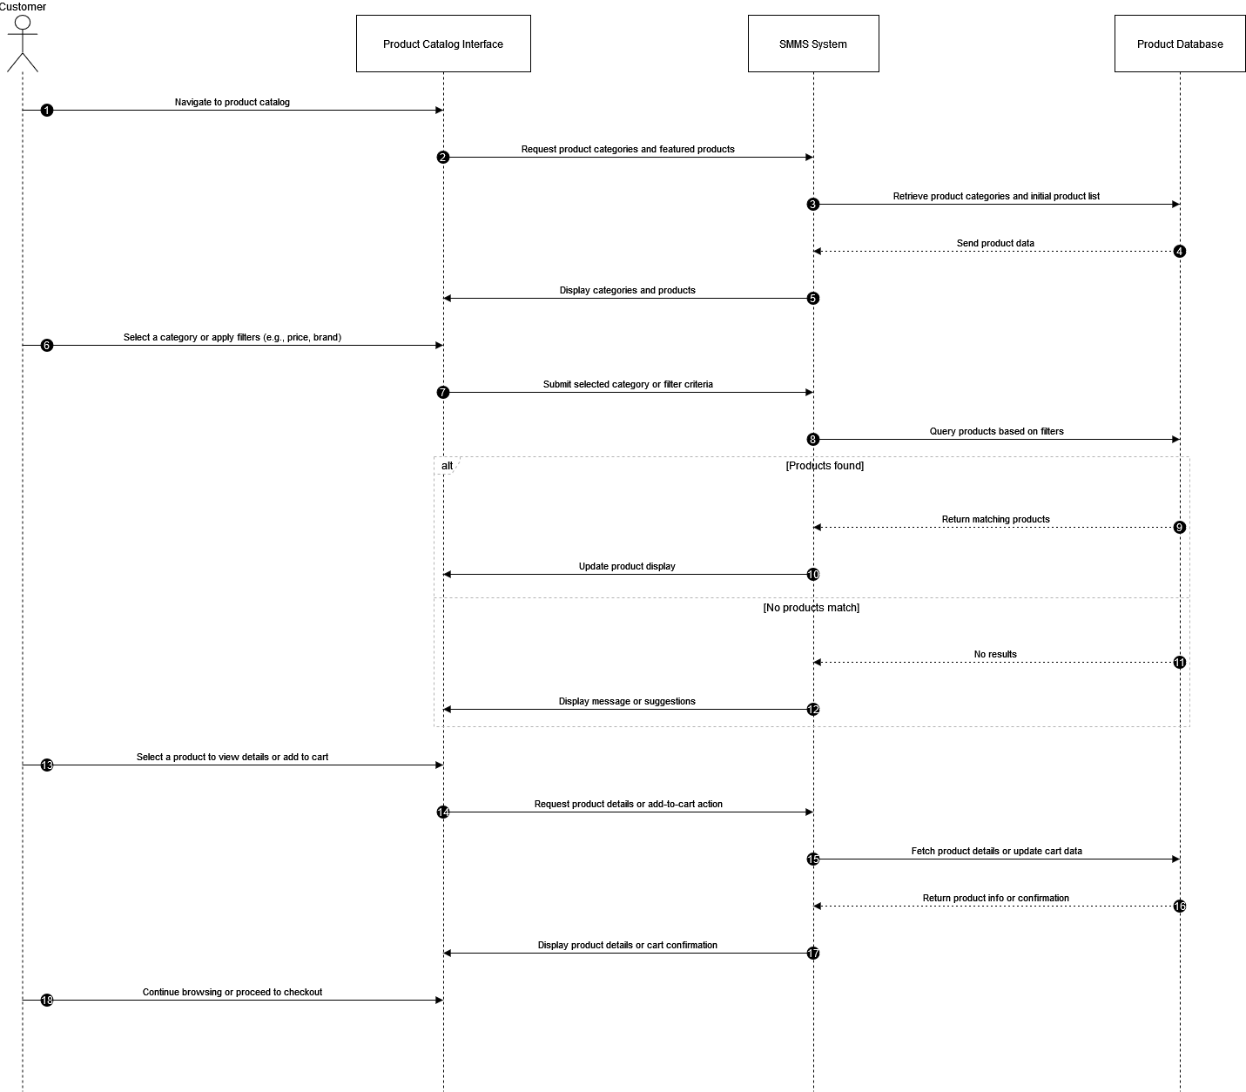

- Sales Reporting

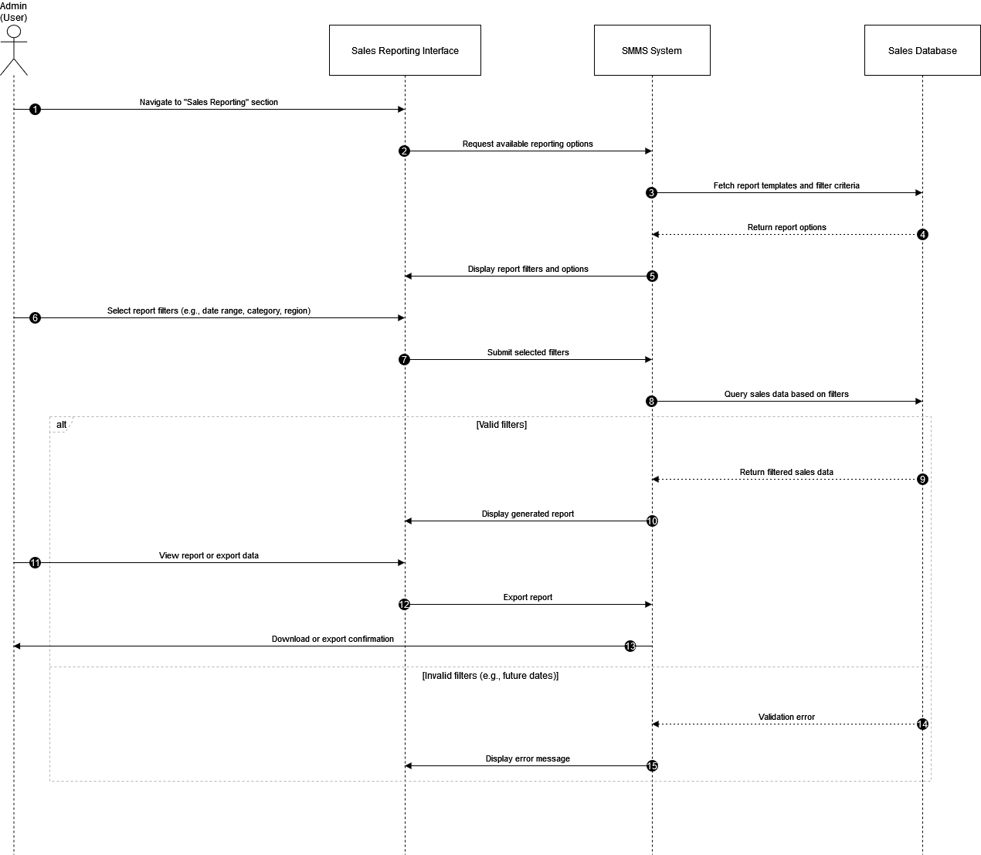

- User Authentication and Registeration

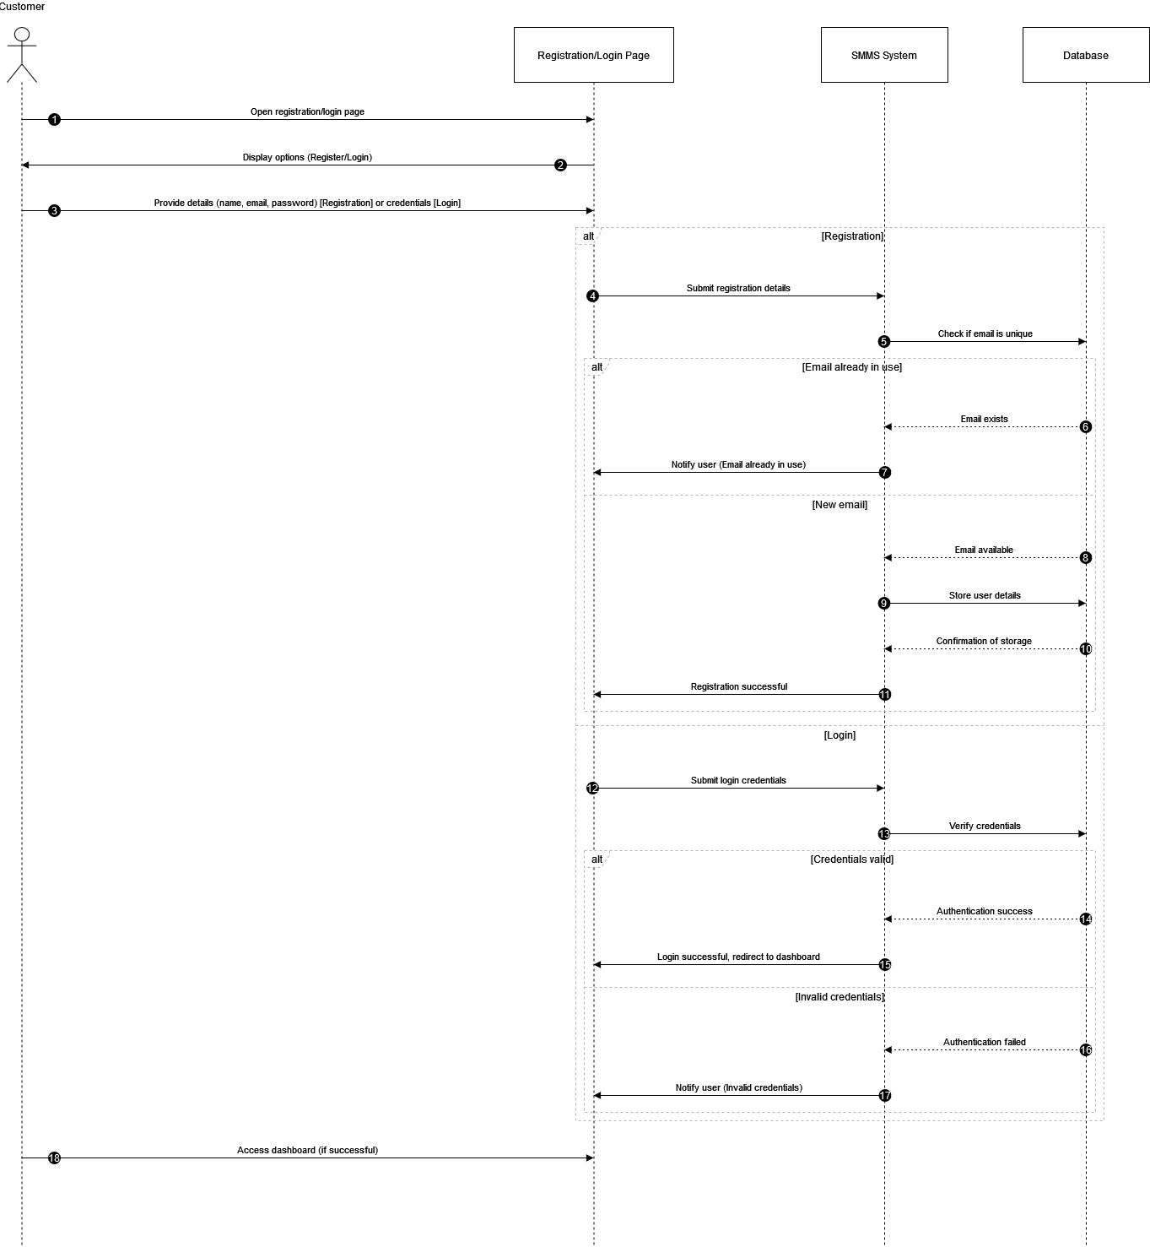

- Wishlist Management

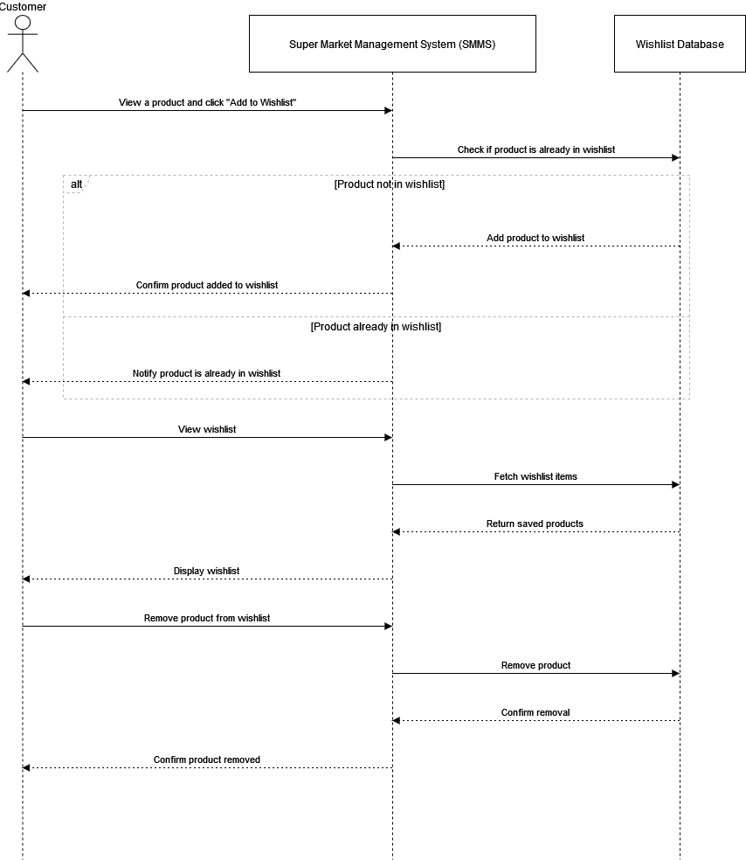

Class Diagram

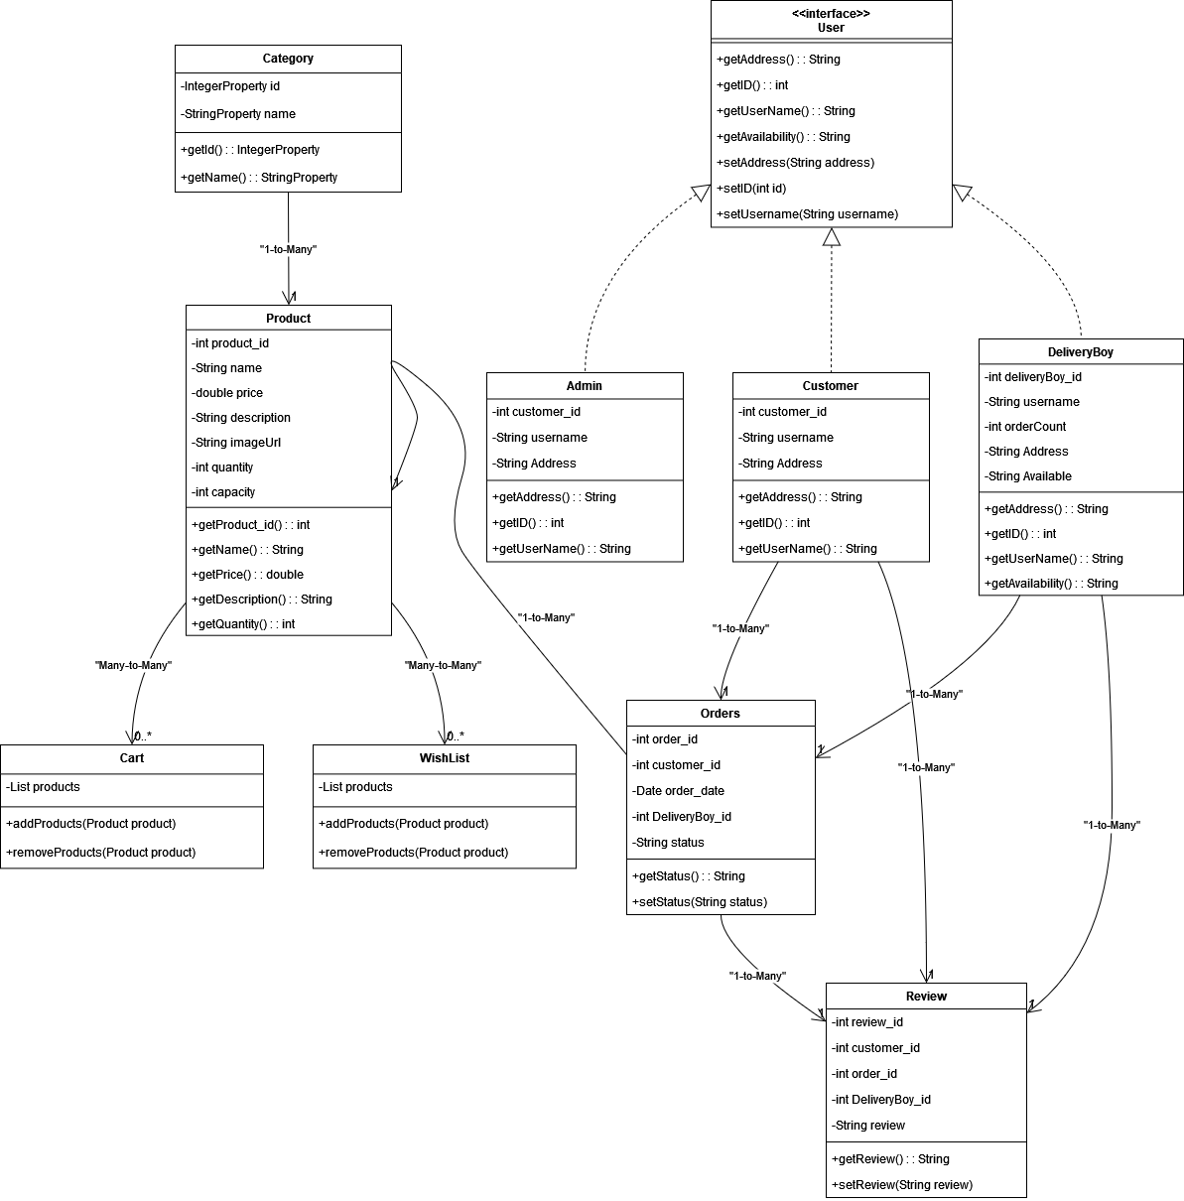

Component Diagram

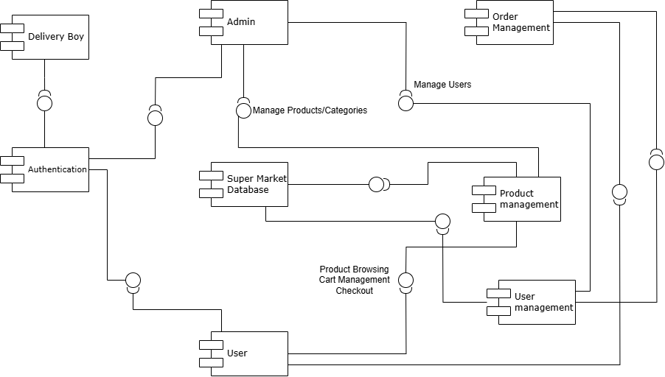

Package Diagram

