**LAB # 01:**

**INTRODUCTION TO STRING POOL, LITERALS, AND WRAPPER CLASSES**

**Lab Task 1 :**

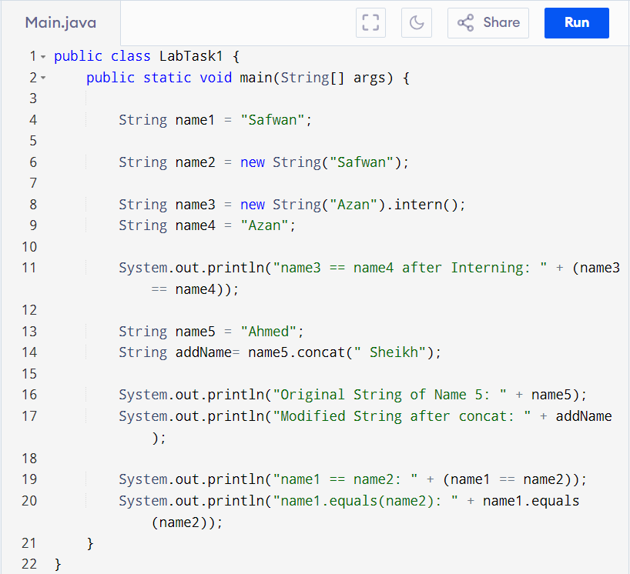

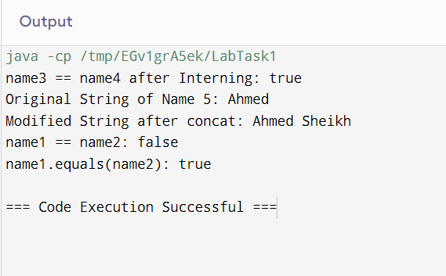

**Lab Task 2 :**

Input :

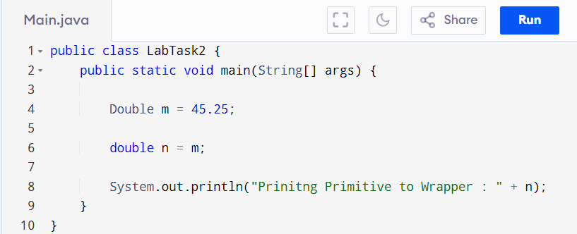

Output :

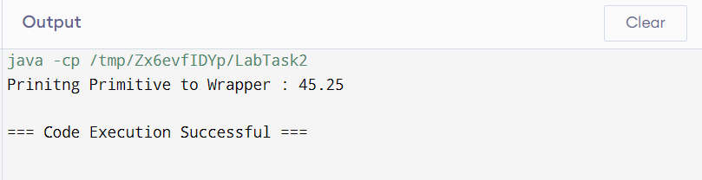

**Lab Task 3 :**

Input:

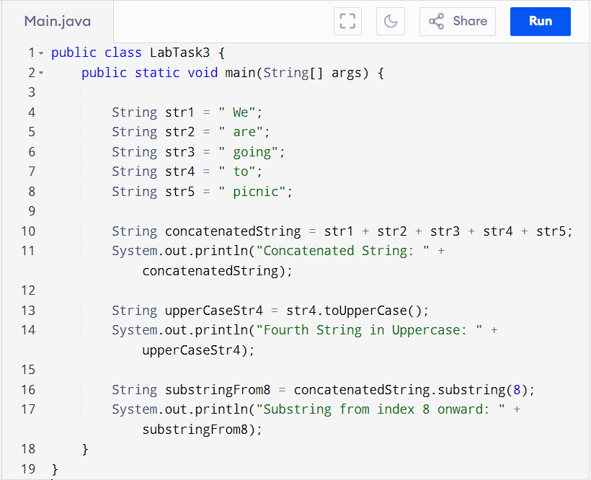

Output:

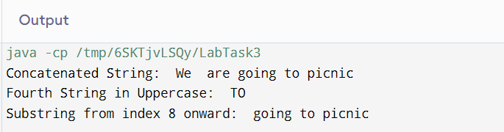

**Lab Task 5 :**

Input:

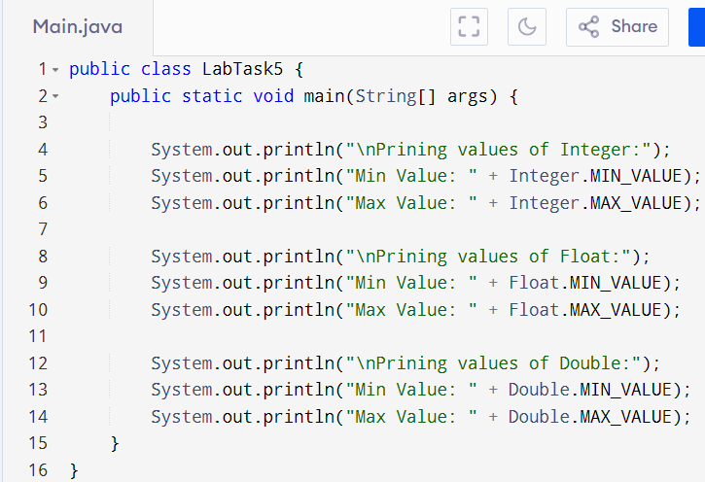

Output:

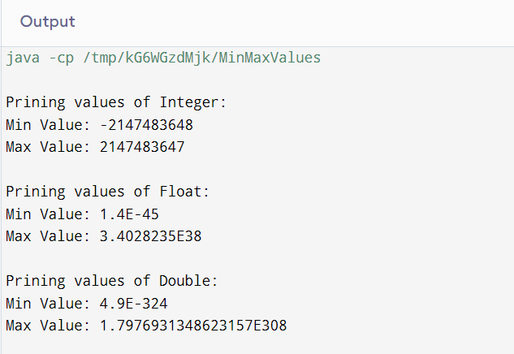

**Home Task 1 :**

Input:

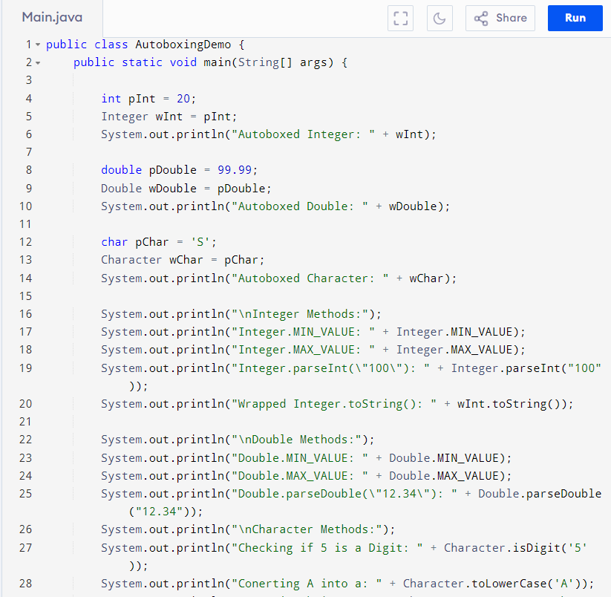

Output:

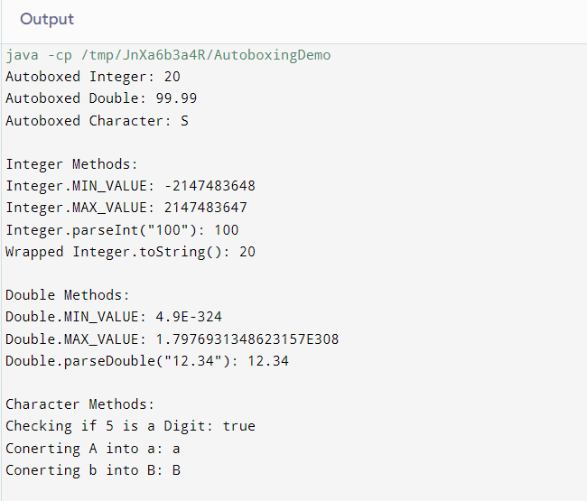

**Home Task 2 :**

Input:

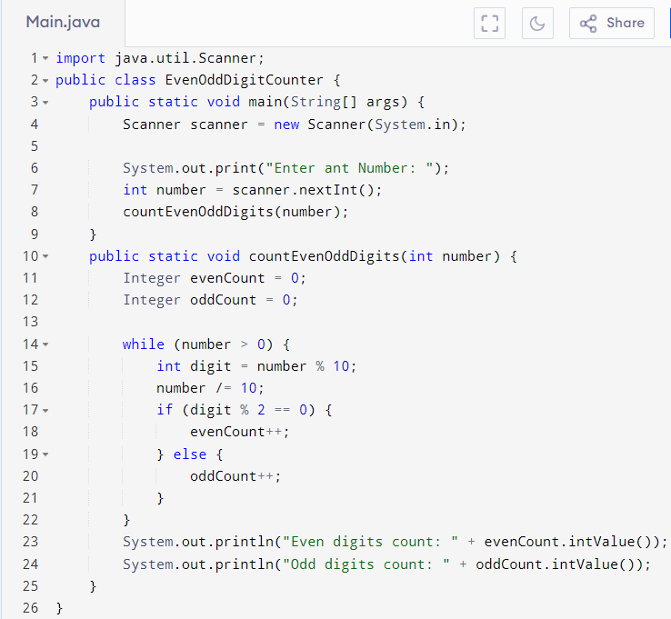

Ouput: 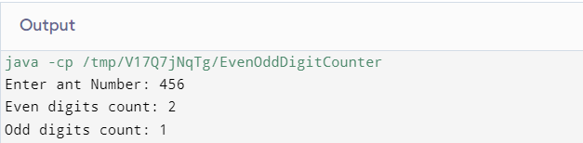

**Home Task 3 :**

Input: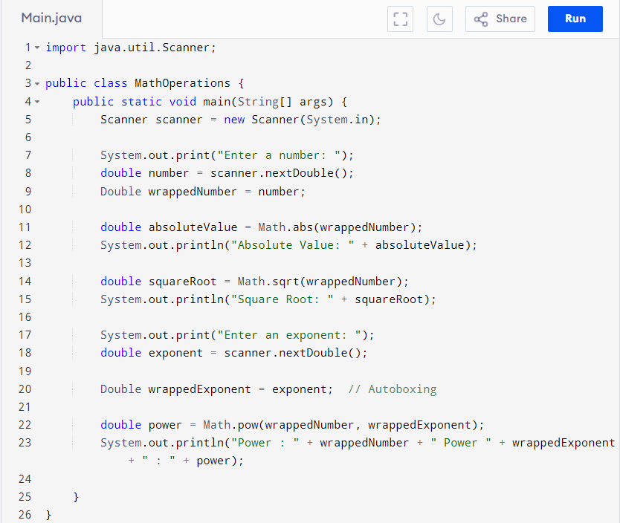Output: 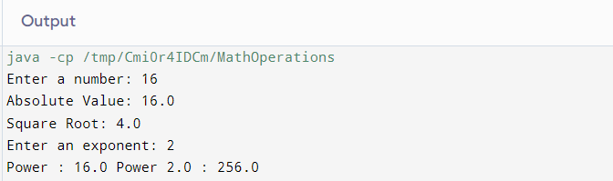

**Home Task 5 :**

Input:

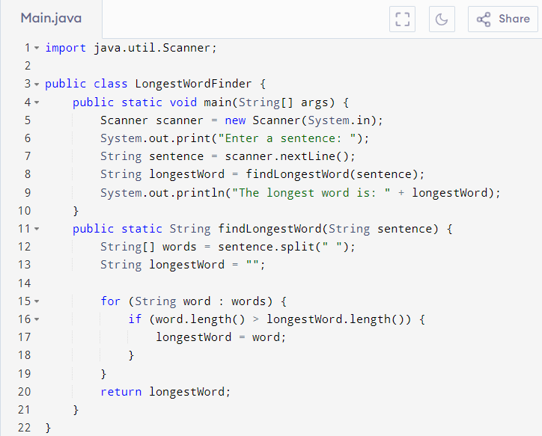

Output:

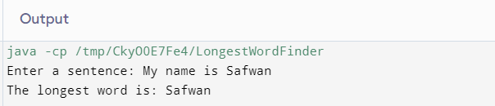

**Home Task 4 :**

Input:

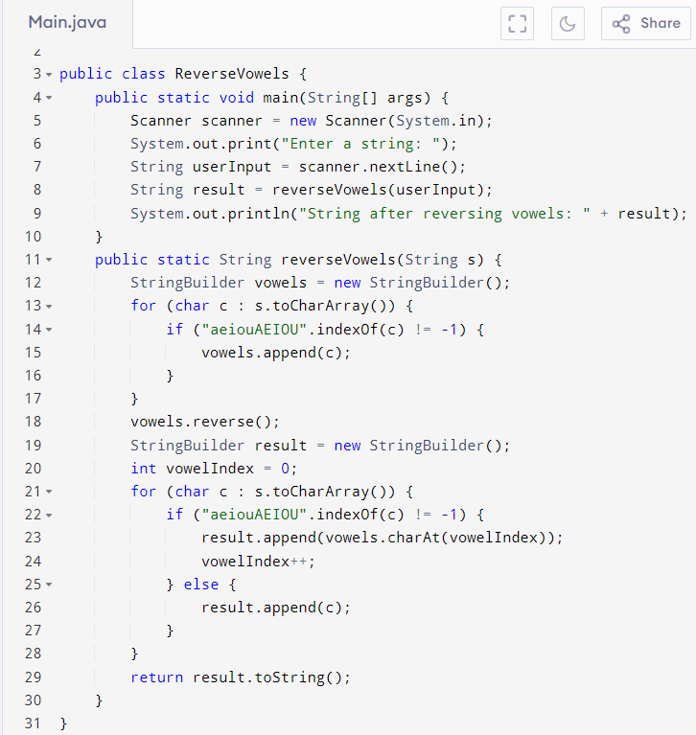

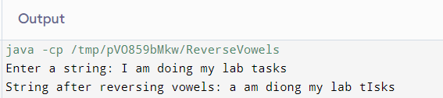Output:

**Lab Task 4 :**

Input:

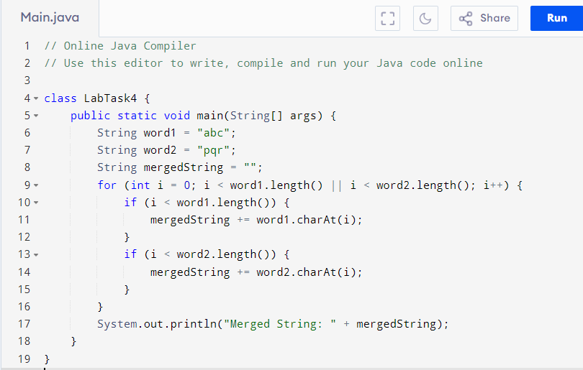

Output:

