LAB # 03

**RECURSION**

HOME TASKS:

1.Write a java program to find the N-th term in the Fibonacci series using Memoization.

Input:

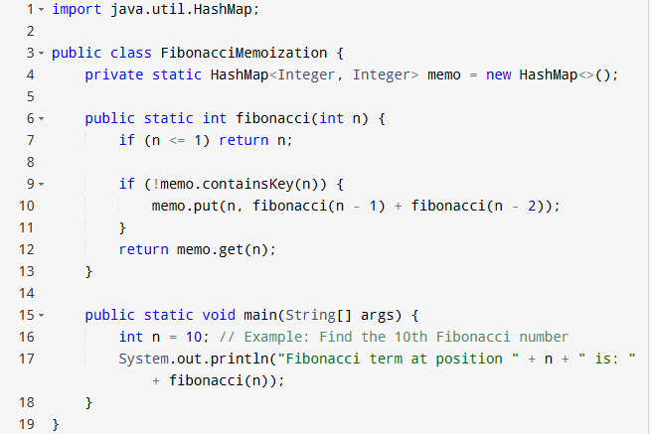

Output:

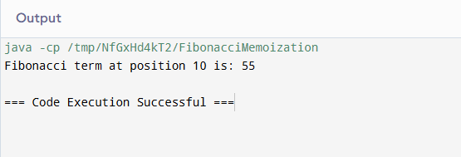

2. Write a program to count the digits of a given number using recursion

Input:

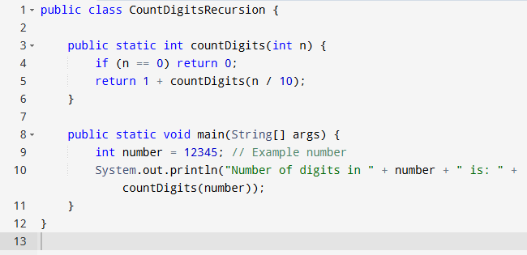

Output:

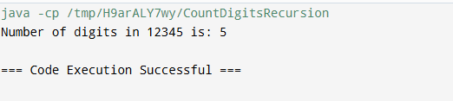

3. Write a java program to check whether a given string is a palindrome or not. A palindrome is a string that reads the same forwards and backwards.Print "YES" if the string is a palindrome, otherwise print "NO".

Input:

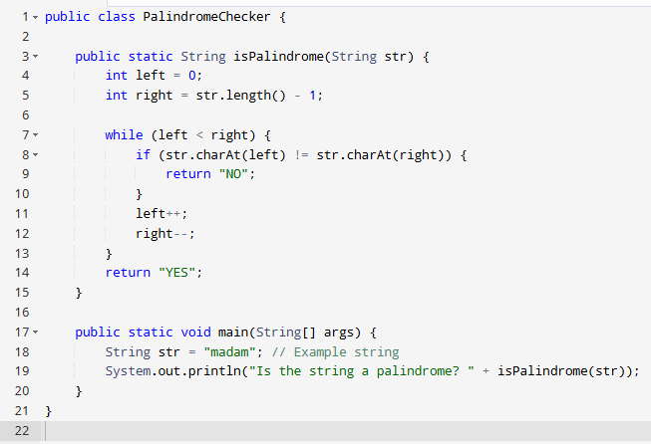

Output:

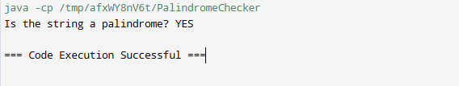

4. Write a recursive program to find the greatest common divisor (GCD) of two numbers using Euclid's algorithm.

Input:

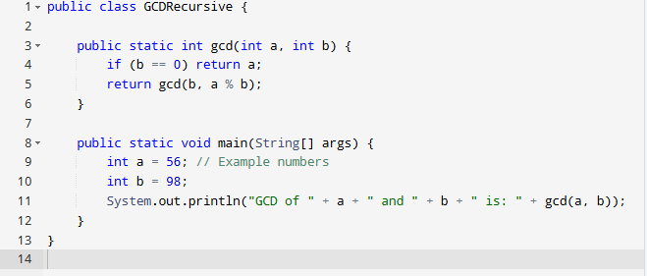

Output:

