**YOLOv5 Project**

**SETUP:**

*Note: Please install Agisoft Metashape Pro before continuing*

1. Downloading Dependencies:

* Open YOLOv5-UAV-master directory in terminal. Type ***"%programfiles%\Agisoft\Metashape Pro\python\python.exe"*** ***pip install -r requirements.txt***
* Open ITMAT-T-main directory in terminal. Type ***"%programfiles%\Agisoft\Metashape Pro\python\python.exe"*** ***pip install -r requirements.txt***
* To install GDAL, open YOLOv5-UAV-master directory in terminal. Type ***"%programfiles%\Agisoft\Metashape Pro\python\python.exe"*** ***pip install GDAL-3.4.3-cp310-cp310-win_amd64.whl***
* To install Metashape, open imagedir directory. Type ***pip install Metashape-1.8.4-cp35.cp36.cp37.cp38-none-win_amd64.whl***
* To install itamt, open ITAMT-T-main in terminal. Type ***"%programfiles%\Agisoft\Metashape Pro\python\python.exe"*** ***python setup.py develop***

1. Configuring Agisoft:

* The imagedir directory contains a folder named “normal”. Normal folder holds the data for processing. Paste the images, that you want to process, there.
* The imagedir directory contains a folder named “monitor”. Monitor folder has a json file that contains information about the normal folder. if the name is “***example.json.DONE***” change it to “***example.json***”.
* Open example.json and change paths to “***normaldir***”, “***projectdir***” and “***savedir***” to relevant path on your PC.

1. Configuring YOLOv5-UAV-master:

* In the YOLOv5-UAV-master directory, open “predict.py”. Go to line 40 and edit:

“***device=torch.device(“cpu”)***” if you want to process in CPU or

“***device=torch.device(“cuda”)***” if you want to process in GPU

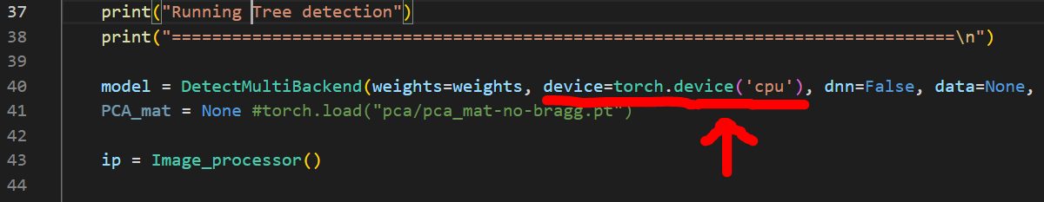

* In the YOLOv5-UAV-master directory, open “***sendEmail.py***”. Go to line 17 and enter the user’s email. Go to line 18 and enter the app generated password for corresponding email. Password can be generated from the link: <https://myaccount.google.com/apppasswords>

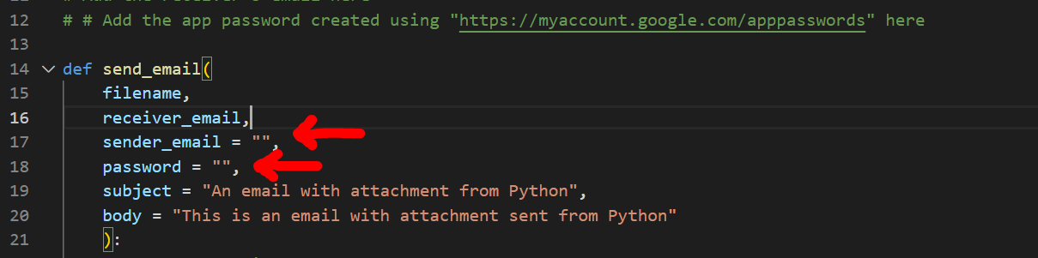

* You can also change email subject and body message from line 19 and 20.

**Running Program:**

* Open the directory where Agisoft Metashape Pro was installed. Make show the directory contains metashape.exe file as highlighted below:
* Open this directory in terminal. You can simply do this by typing “***cmd***” in address bar and hitting enter (as shown below):

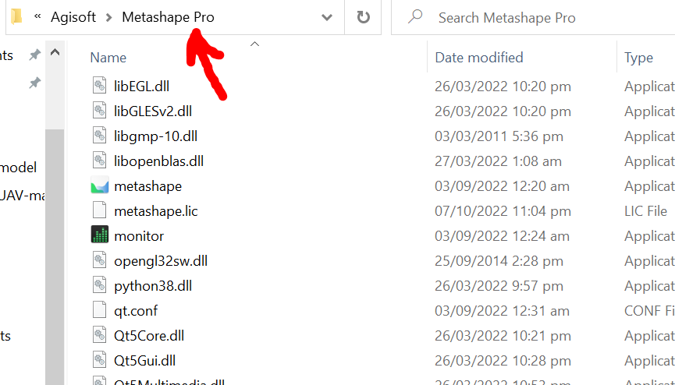

*Type “cmd” here*

* Once the terminal is open in the correct folder, Type ***“metashape.exe -r <path to agisoft_script.py>”***. Example shown below:

