Jobs Salary Dashboard
Interactive salary analysis of 32,672 data and tech job postings in Microsoft Excel
Author: Abdul Moiz Waheed
Repository: github.com/MoizWaheed80/Excel-jobs-sales-dashbord
Tool: Microsoft Excel (Microsoft 365)
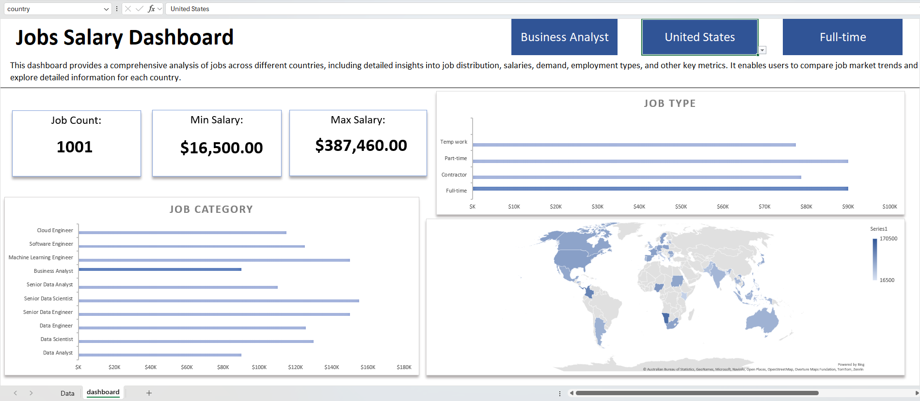
Jobs Salary Dashboard with Business Analyst, United States, and Full-time selected

Overview
An interactive Excel dashboard that analyzes 32,672 data and tech job postings from 2023 across 111 countries. Users pick a job title, country, and job type, and every KPI and chart updates to show salary ranges, pay by role, pay by employment type, and how salaries vary around the world.
Item | Detail
Tool | Microsoft Excel (Microsoft 365)
Dataset | 32,672 job postings, January to December 2023
Coverage | 111 countries, 10 job titles
Output | Single page interactive dashboard

Questions It Answers
- How many postings exist for a given role, and what is the salary range?
- Which roles pay the most in a selected country?
- How does pay differ between full-time, part-time, contract, and temp work?
- Which countries pay the most for a selected role?

Dashboard Features

Interactive Selectors
Three dropdown selectors at the top drive the whole dashboard:
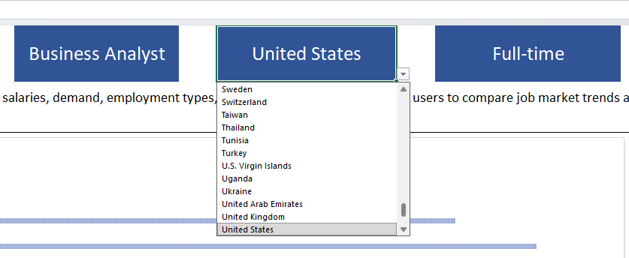
- Job Title: Data Analyst, Data Scientist, Data Engineer, Business Analyst, Machine Learning Engineer, Software Engineer, Cloud Engineer, and senior variants
- Country: any of the 111 countries in the dataset
- Job Type: Full-time, Part-time, Contractor, Temp work

KPI Cards
- Job Count: number of postings for the selection
- Min Salary: lowest yearly salary
- Max Salary: highest yearly salary

Visuals
Visual | What It Shows
Job Category bar chart | Median yearly salary for every job title in the selected country, with the selected title highlighted
Job Type bar chart | Median yearly salary by employment type, with the selected type highlighted
World Map | Filled map of median salary by country for the selected role

Dataset
Source file: source/Jobs Data.xlsx, with one row per job posting.
Column | Description
job_title_short | Standardized job title (10 categories)
job_title | Original posting title
job_country | Country of the job
job_schedule_type | Employment type (Full-time, Contractor, Part-time, etc.)
job_work_from_home | Remote flag
job_posted_date | Posting date (2023)
salary_rate | Yearly or hourly
salary_year_avg | Yearly salary
salary_hour_avg | Hourly salary
company_name | Hiring company
job_skills | Skills listed in the posting
job_via | Platform the job was posted on

Data Preparation
- Converted the raw data into a structured Excel Table for dynamic references
- Grouped 26 mixed schedule values (for example, "Full-time and Part-time") into four clean job types
- Used yearly salary as the main measure for consistent comparisons
- Built a list of unique titles, countries, and job types to feed the dropdowns

Excel Features Used
- Data Validation dropdowns as dashboard selectors
- Named ranges for selector values
- Dynamic formulas that recalculate KPIs and chart data from the selections
- Bar charts with conditional highlighting of the selected item
- Filled Map chart for geographic salary comparison
- KPI cards and a clean single page layout
- Sheet protection so users can only change the selectors

How to Use
- Download final/Jobs Data Final.xlsx from the repository.
- Open it in Excel for Microsoft 365 (needed for the Map chart and dynamic array formulas).
- Use the three dropdowns at the top to pick a job title, country, and job type.
- Read the KPIs and charts as they update.

Skills Demonstrated
Advanced Excel, Dashboard Design, Data Cleaning, Dynamic Formulas, Data Validation, Data Visualization, Map Charts, Business Reporting

Contact
Abdul Moiz Waheed, Data Analyst and Analytics Engineer
LinkedIn: linkedin.com/in/abdul-moiz-s2402
GitHub: github.com/MoizWaheed80
Email: moizwaheed80@gmail.com

