The University of Da Nang
The University of Science and Technology
Faculty of Electronic and Telecommunication Engineering

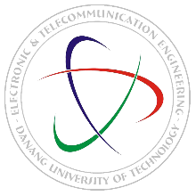

PROJECT REPORT
TITLE:
DESK LIGHT

Group’s name: Zero2Embedded
Members: Tran Viet Thang – 106220234
Tran Anh Toan – 106220237
Trinh Minh Viet – 106220241
Tran Le Long Vu – 106220242
Instructor: MSc. Ho Viet Viet

Danang, 12/2025

1. Introduction
A desk lamp is an essential device in the learning process of pupils and students. While studying, maintaining concentration and effective time management is extremely important. However, most conventional lighting devices currently available on the market only provide basic illumination and do not integrate advanced functions such as scheduling or time management based on the Pomodoro technique.
In this semester, our group studied and practiced with the ESP32-C3 microcontroller. Based on the acquired knowledge, we developed a smart desk lamp system aimed at supporting time management and improving learning efficiency through practical functions and an intuitive user interface.

2. Project Objectives
The project focuses on achieving the following objectives:
- Controlling the lamp on/off with three different color modes.
- Displaying real-time clock information and Pomodoro countdown on an OLED screen.
- Monitoring and controlling the system through a software application

3. System Overview
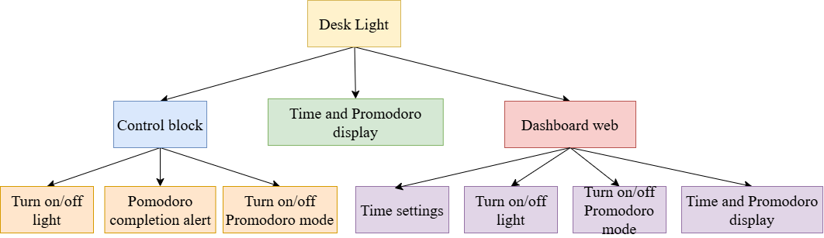
Figure 1: Functional Block Diagram
Figure 1 illustrates the functional block diagram of the smart desk lamp system, including control, time display, and a web-based dashboard. The system allows users to turn the lamp on/off, manage Pomodoro mode, display time, and perform remote control through a web interface.

4. Components and Technologies Used

4.1. Hardware Components
- ESP32-C3 microcontroller
- OLED display
- RTC (Real-Time Clock) module
- Touch sensor module
- Buzzer
- WS2812B LED

4.2. Technologies
- ESP-IDF for ESP32-C3 firmware development
- Flutter for web application development

5. Smart Desk Lamp Design

5.1. Hardware Connection Diagram
The system is designed following a remote-control architecture consisting of three main blocks: the Flutter application, the central controller, and peripheral modules. The Flutter application provides a user interface that allows users to turn the lamp on/off, set the time, and configure countdown parameters via WiFi. The ESP32-C3 receives and processes control commands while managing real-time data from the RTC module. The information read from the RTC is displayed on the OLED via the SPI protocol. The hardware connection diagram is shown in Figure 2.
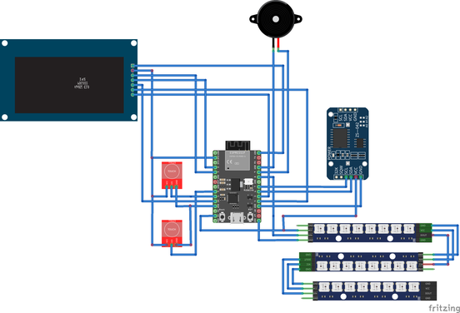
Figure 2: Hardware Connection Diagram of the Smart Desk Lamp

5.2. Operation Flowcharts
The microcontroller performs three main tasks to control the lamp, manage Pomodoro settings, and display information on the OLED.
Figure 3.1 illustrates the flow of the Manual Switch Task, which reads signals from the touch sensor to change the lamp’s operating mode. Each state change updates the mode variable sequentially, corresponding to the states: lamp off, white light, yellow light, or blue light.
Figure 3.2 presents the Display Task, responsible for reading time data from the RTC and displaying it on the OLED. The task alternately displays date (day/month/year) and time (hour/minute/second), while also showing the Pomodoro status when this mode is active.
Figure 3.3 describes the Manual Pomodoro task, which controls the state of the Pomodoro timer via a touch sensor. This task allows the user to start/stop or reset the Pomodoro timer by switching between control states.
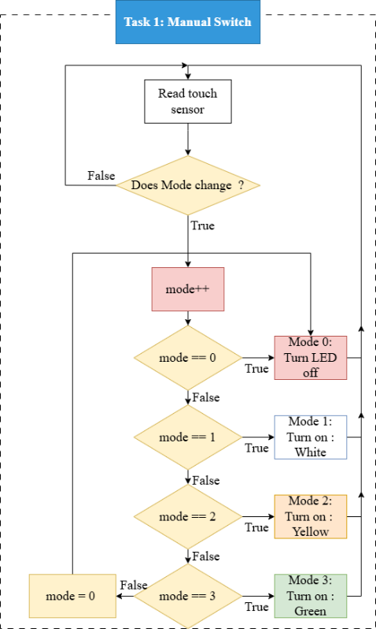 | 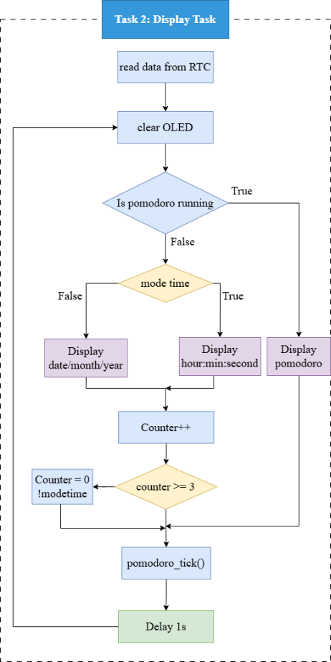 | 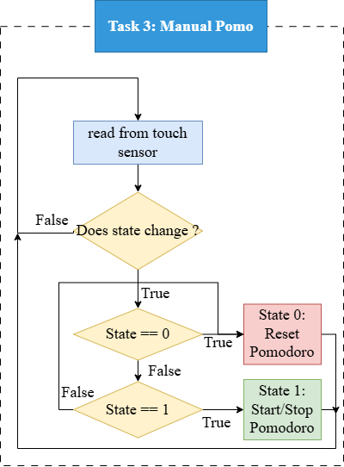
Figure 3.1. Switch task | Figure 3.2. Display Task | Figure 3.3. Pomodoro Task

6. System Implementation

6.1. System Model
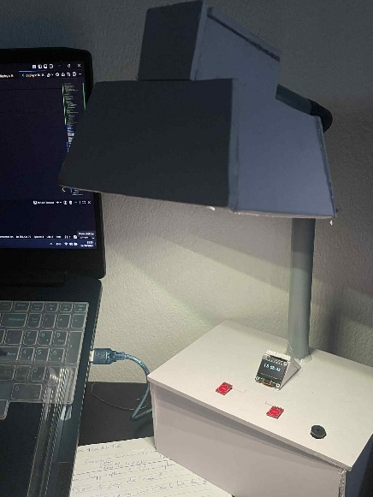
Figure 4: Actual Prototype of the System
Figure 4 illustrates the study desk lamp prototype developed by the project team, in which the OLED display alternately shows the current date and time. When the user activates the Pomodoro mode via the touch sensor, the OLED displays the countdown timer for the Pomodoro session. Upon completion of the countdown, a buzzer is triggered to notify the user, and the system automatically switches to the break-time countdown. Using the touch sensor for lamp control, the user can sequentially switch the light modes from white to yellow, then light yellow, and finally turn the lamp off.

6.2. Software Implementation
To further enhance the project, a software application developed using Flutter and based on the HTTP protocol was integrated. This allows users to remotely control the desk lamp, as well as monitor the current time and Pomodoro countdown. Figure 5 illustrates the web dashboard interface of the project. In addition, the application was also developed for mobile devices to improve user convenience. However, to operate correctly, the ESP32-C3 and the device running the application (phone or computer) must be connected to the same WiFi network, and the IP address of the ESP32-C3 is required for connection.
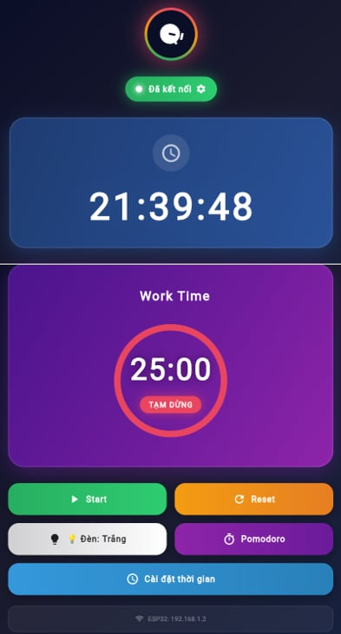
Figure 5: Web Dashboard Interface
Figure 5 illustrates the dashboard interface of the study desk lamp system. The interface displays the current time of day and the Pomodoro timer at the center, and allows users to control functions such as start/stop, timer reset, and lamp on/off. In addition, the web interface enables users to reconfigure the RTC module time as well as set the work and break durations for the Pomodoro mode.

7. Conclusion
The project successfully developed a smart desk lamp system based on a microcontroller, combining MCU hardware with an application-based control interface. The system fulfills its main functions, including turning the lamp on/off, adjusting lighting modes, displaying real-time clock information, managing study time using the Pomodoro technique, and providing alerts when a session ends. These features help improve users’ learning efficiency.
During the implementation process, students applied knowledge of microcontroller programming, embedded system design, and web interface development. The system was successfully deployed on both physical hardware and a web platform. The results demonstrate that the proposed solution is feasible, stable in operation, and well-aligned with the project objectives.

