League Name in Referee Emai Notification - Need another variable (league name) available so that the referee knows that league added that referee

Change Active to Yes / No on teams/{id} page – currently shows 1 or 0 – needs to show Yes for 1 and No for 0

Players - authorised / unauthorised

Need to restrict access to the players/{id} screens as can currently view all players – Players are linked to a team - teams are linked to a league – a league is linked to this user

Incomplete Reason

On results page, need to be able to select an incomplete reason (page built), save id against fixture, and show first letter of reason in result

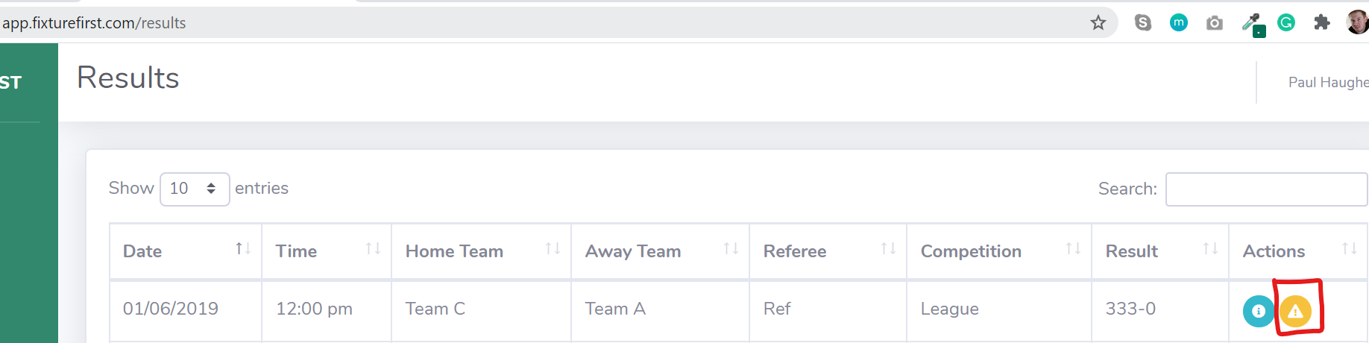

When the incomplete reason is added (Abandoned, for example), the first letter should appear in the result column – e.g. A

Player Fixture History

Return records from teamline table

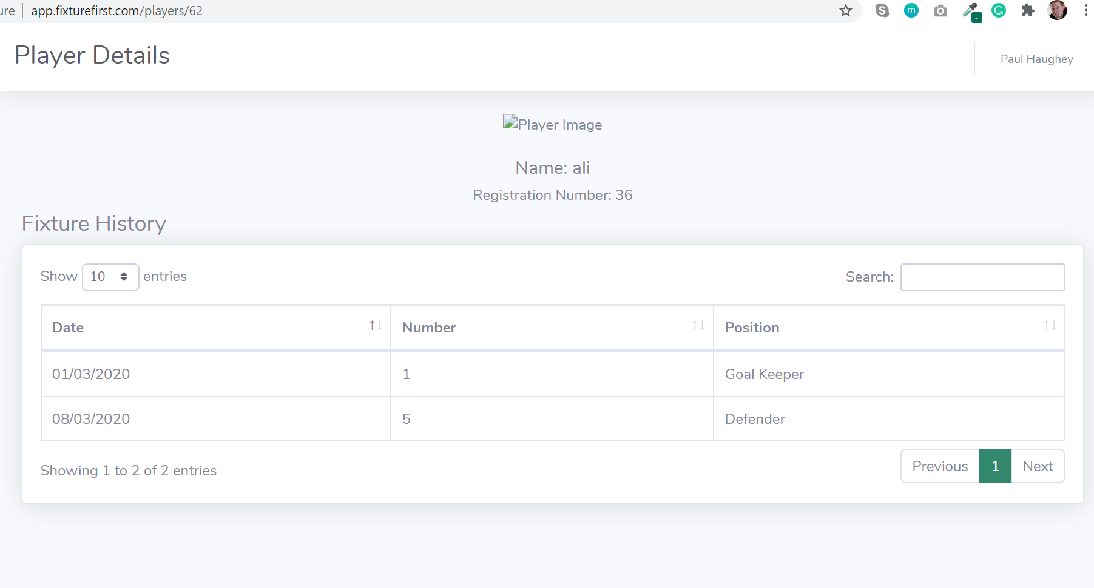

Fixture history will come from Teamline table – (where playerid matches id) – this should return date, number, position and opposition – we will need to use the fixture id to work out the opposing team.