The Augmented Museum
Final Project Report

Course: Augmented Reality
Project: The Augmented Museum
Student(s): [Add names]
Repository: [Add GitHub repository link]
Demonstration video: [Add video link]

1. Project overview
We built an augmented museum: an AR application that recognises paintings on a wall and adds a virtual guide beside each one. When the visitor walks up to a painting, the application recognises the image, spawns a guide character standing on the floor next to the frame, turns that character to face the visitor, and shows a panel with the title, the artist, the date and a short description of the work.
The application was written in Unity 6 with AR Foundation, and we tested it in XR Simulation. XR Simulation runs the whole AR stack inside the Unity Editor against a virtual room, so we could walk through the museum with the mouse and keyboard and watch tracked images, detected planes and spawned characters appear in the runtime hierarchy, without building to a phone for every change.
The museum room is the Office environment that ships with Unity's XR Simulation environment package. We hung the paintings on its existing walls and added three extra walls in front of the windows, because the office does not have enough flat wall surface for twelve pictures. Every painting is a simulated tracked image, so the simulator reports it to AR Foundation the same way a phone camera would report a real painting.
The finished application covers twelve paintings, arranged in the room roughly by century:
- Maesta by Duccio di Buoninsegna, 1308-1311
- The Tribute Money by Masaccio, about 1425-1427
- Adoration of the Mystic Lamb by Hubert and Jan van Eyck, 1432
- The Arnolfini Portrait by Jan van Eyck, 1434
- The Lamentation over the Dead Christ by Andrea Mantegna, about 1480
- The Hunters in the Snow by Pieter Bruegel the Elder, 1565
- Bacchus by Leonardo da Vinci, about 1510-1515
- The Calling of Saint Matthew by Caravaggio, 1599-1600
- Judith Beheading Holofernes by Artemisia Gentileschi, about 1612-1620
- Self-Portrait with Beret and Turned-Up Collar by Rembrandt, 1659
- The Swing by Jean-Honore Fragonard, 1767
- The Blue Boy by Thomas Gainsborough, about 1770
Each painting has its own guide prefab carrying its own information panel, so the text changes with the artwork while the character model stays the same.

2. Objectives
We set the following targets before starting:
- Recognise many different paintings from a single reference image library.
- Detect horizontal planes and work out where the floor is.
- Stand the guide character on that floor instead of letting it float.
- Place the character beside the painting, not in front of it, so it never hides the artwork.
- Keep the character turned toward the visitor as the visitor moves.
- Show the title, artist, date and a short description for the painting being looked at.
- Wake the character up only when the visitor is close enough.
- Never show two guides or two panels at the same time.
- Test the result with a reasonable number of visual features, as the project brief asks. We settled on twelve paintings.
- Record a video of the finished application running in XR Simulation.

3. Tools, libraries and SDKs

Unity
We used Unity 6, editor version 6000.0.40f1. Unity gives us the scene, the prefab workflow, C# scripting, the UI system and the AR packages in one place, so the museum room, the tracked paintings, the characters, the panels and the AR managers all live in the same project.

AR Foundation 6.0.7
AR Foundation is the AR framework of the project. As the course states, AR Foundation itself contains only the interfaces: a provider plug-in supplies the actual tracking. We used four of its features:
- Image tracking, through ARTrackedImageManager and an XR reference image library.
- Plane detection, through ARPlaneManager, restricted to horizontal planes.
- Camera pose tracking, through the XR Origin and its AR camera.
- AR raycasting, through ARRaycastManager. This was our first attempt at finding the floor and we later replaced it, as explained in section 11.
Because AR Foundation hides the provider behind a common trackable API, the same scene and the same script can run against XR Simulation on a desktop and against ARCore on an Android phone.

XR Simulation
XR Simulation is the provider we actually developed against. It feeds AR Foundation with tracking data generated from a virtual environment prefab: floors, walls, furniture, lighting and simulated tracked images. Everything runs in Play Mode in the Editor.
This choice saved a large amount of time. An Android build takes minutes, and a museum is not something we could reproduce on a desk. In XR Simulation we could move around the room with the Game view controls and check within seconds whether a painting had produced an ARTrackedImage, whether the floor plane had been found, and whether the character was standing on it.

Google ARCore XR Plugin 6.0.7
We installed the ARCore plug-in so the same scene can be built for Android without touching the code. All the results reported here come from XR Simulation, so the ARCore path is prepared rather than tested.

XR Simulation environments 2.0.1
This package supplies the ready-made simulation environments. We installed it from a local package file kept in ContentPackages and used its Office environment as the museum room.

TextMeshPro
The information panels use TextMeshPro rather than the basic Unity text component, because we needed control over wrapping, margins, alignment and font size on a small world-space panel that the visitor reads from two or three metres away.

Why AR Foundation rather than Vuforia
The course covers both. Vuforia is very strong at image and object targets, and for pure marker tracking it would have worked. The requirement that decided it for us was the combination: we needed image tracking and plane detection together, because the guide has to stand on a real floor next to a recognised painting. AR Foundation exposes both through one trackable API, and its XR Simulation provider let us test both without a phone and without a physical museum.

4. Project structure
We kept the assets in separate folders:
Assets
├── Characters
│ └── Models
├── Materials
├── Paintings
│ ├── Images
│ └── Libraries
├── Prefabs
├── Scenes
├── Scripts
├── Simulation
├── TextMesh Pro
└── UI
The application scene is Assets/Scenes/MuseumAR.unity. Its hierarchy is deliberately small:
MuseumAR
├── Directional Light
├── XR Origin
├── AR Session
└── MuseumController
No character is placed in the scene. The controller creates them at runtime, when their painting is tracked and the visitor is close enough.

5. AR scene setup

AR Session
The AR Session object owns the lifecycle of the AR subsystems. It starts, pauses and stops the session with the application.

XR Origin
The XR Origin holds the AR camera and converts session space into Unity world space. We attached the managers to it:
- AR Tracked Image Manager, with the MuseumPaintingLibrary reference image library.
- AR Plane Manager, with the detection mode set to horizontal, because the floor is the only plane the placement logic needs.
- AR Raycast Manager.
- The Main Camera, which is the visitor's viewpoint.
One setting on the tracked image manager deserves a note, because we spent a long time on it and the answer turned out to be the opposite of what we assumed. Max Number of Moving Images is still at its default of 5 in the submitted scene, and all twelve paintings track anyway. The reason is in the AR Foundation source: the XR Simulation image tracking provider does not enforce the limit at all, and its own code comment says so, that the value is currently unused and all images in a simulated environment can move regardless of a requested maximum. It is not a bug in our project, but it is a trap for the Android build, because ARCore does enforce it. Section 17 explains what the real cause was.

MuseumController
MuseumController is an empty GameObject carrying the MultiPaintingCharacterSpawner script, which is the only script we wrote. It holds references to the tracked image manager, the plane manager and the AR camera, plus the list of twelve painting entries.

6. Building the virtual museum
The Office environment already has walls, windows, a floor, furniture and lighting, which is close enough to a small gallery. We turned it into a museum by hanging paintings on the existing walls.
Two of the office sides are mostly glass, so there was not enough usable wall for twelve pictures. We added three flat wall objects in front of the windows, grouped under an object called virtual walls and named north-wall, east-wall and west-wall. We tried both Quad and Cube primitives; the final walls act simply as visible surfaces that cover the glass and create new hanging space.
Each painting sits a few centimetres in front of its wall surface. Placing the two exactly coplanar caused z-fighting, the flicker you get when the depth buffer cannot decide which of two surfaces at the same depth is in front.
Every painting object carries a Simulated Tracked Image component with the matching source texture, so XR Simulation reports it to AR Foundation as a trackable image.

7. The reference image library
The tracked image manager reads from an XR Reference Image Library asset called MuseumPaintingLibrary, at Assets/Paintings/Libraries. It has twelve entries:
1_maesta_14th 7_bacchus_16th
2_tribute_15th 8_calling_17th
3_adoration_15th 9_judith_beheading_17th
4_arnolfini_15th 10_self_portrait_17th
5_lamentation_of_christ_15th 11_the_swing_18th
6_hunters_16th 12_blue_boy_18th
The same names are used in four places: the reference image library, the simulated tracked image objects in the Office environment, the painting list on the controller, and the names of the character objects the script creates at runtime. That consistency is not cosmetic. The script looks each painting up by trackedImage.referenceImage.name, so a single typo silently removes a painting from the experience.
We ticked Specify Size on every entry and gave each image a real physical size in metres. The values come from the aspect ratio of the source file scaled to a plausible gallery size, for example 1.8 by 0.886875 metres for the Maesta and 0.9 by 1.2309375 metres for the Arnolfini Portrait. The same numbers were then copied into the Simulated Tracked Image component of the matching painting object.
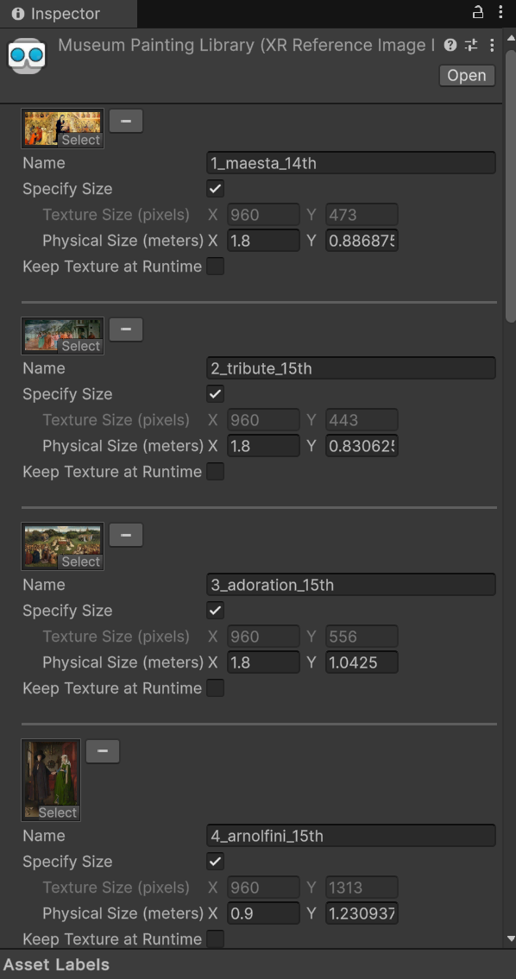
Figure 1. The MuseumPaintingLibrary asset. Specify Size is ticked and each entry carries its physical size in metres.

8. Painting orientation
A tracked image in XR Simulation uses its own local axis convention, and it is not the convention of a Unity Quad. For a tracked image:
- Local X runs horizontally across the painting.
- Local Z points toward the top of the painting.
- Local Y points away from the wall, into the room. This is the surface normal.
Our first paintings lay flat like tabletops instead of hanging on the wall, because we had rotated them as if they were Quads. We fixed each one by rotating the tracked image object in clean 90, -90 or 180 degree steps until its local axes matched that convention. Paintings on different walls need different rotations, because the walls face different directions.
This is not only a visual detail. The placement code reads the tracked image transform directly: it takes transform.right as the direction along the wall and transform.up as the wall normal. If a painting is rotated wrongly, the guide is placed inside the wall or off to one side, and the symptom looks like a placement bug rather than an orientation bug.
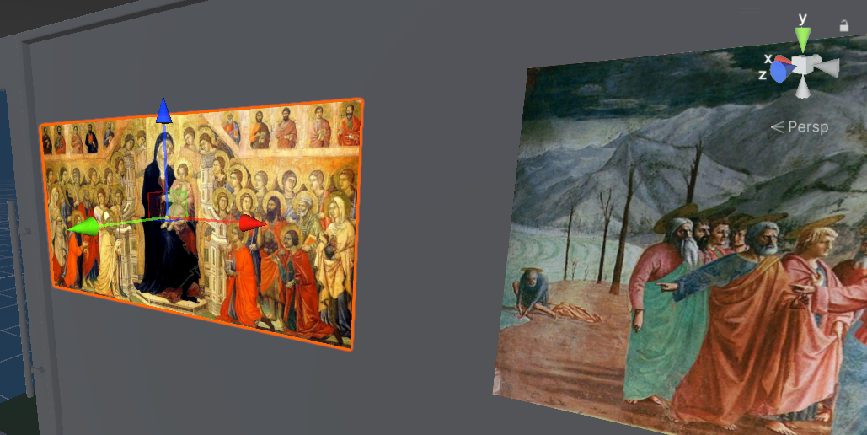
Figure 2. Two tracked paintings in the Scene view with their local gizmos visible. The blue Z arrow points to the top of the picture and the green Y arrow points out of the wall.

9. The guide character
The first guide was a plain capsule. Using a primitive first was a deliberate choice: it let us verify the whole AR chain before adding an imported model with its own problems. With the capsule we confirmed that the painting was recognised, that a character was created, that it appeared beside the painting, that it sat on the floor and that it turned toward the camera.
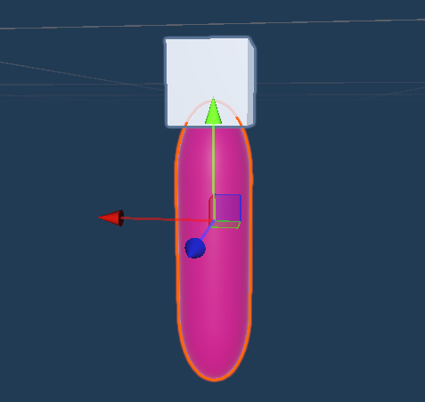
Figure 3. The capsule stand-in used to test placement and rotation before the real model was imported.
We then replaced the capsule with a child character model, kidBoy.fbx. Unity refused to build a Humanoid Avatar for it, reporting that a humanoid rig needs at least fifteen bones and the model did not have them. Since animation was not one of our objectives, we imported the model with a Generic rig instead. The guide is therefore a static figure rather than an animated one. Section 20 lists this as the first thing we would change.

10. The character prefab and the pivot fix
The imported model had its geometry a long way from its root transform. The first time the script rotated the guide toward the visitor, the model swung around a wide circle instead of turning on the spot, like a figure on the end of an invisible arm.
We solved it with a wrapper object. Each character prefab has an empty root, and the imported model is its child:
0 (prefab root, the logical pivot)
├── GuideCharacter_KidBoy (the imported model)
└── Canvas
└── Panel
└── Text (TMP)
The root is what the placement and rotation code moves and turns. To line the model up with it, we dropped a temporary marker at the root origin and moved the child until the pivot sat between the character's shoes, the shoes were at ground level, and the model was centred horizontally on the pivot. After that, rotating the root turns the character in place.
The root also carries a uniform scale of 0.6, which sets the guide's size in the room, while the imported model keeps its own scale of 1. Putting the scale on the wrapper means the visual size can be tuned without disturbing the pivot we just fixed.
The twelve prefabs are named 0 to 11 in Assets/Prefabs, one per painting, in the same order as the library. Prefab 0 belongs to painting 1_maesta_14th, prefab 11 to painting 12_blue_boy_18th. The off-by-one between the two numbering schemes is the one piece of naming in the project we would change if we started again.

11. Finding the floor
One of the main requirements was that the guide stands on the floor rather than hovering.
Our first implementation cast a ray straight down from the intended character position with ARRaycastManager. It did not work. The runtime hierarchy was full of AR planes, but the downward raycast frequently returned no hit at all in XR Simulation. We added a temporary fallback that dropped the character to a fixed world Y value, and that was worse than useless: the correct value depends on where the simulated environment origin happens to be, so the guide floated in one room and sank into the floor in another.
The version we shipped ignores raycasting and reads the tracked planes directly from ARPlaneManager. For each candidate plane the script keeps only planes that are currently tracking, that face upward, and that lie below the painting. Among those it picks the one with the largest area:
facesUp = plane.alignment == PlaneAlignment.HorizontalUp
|| Vector3.Dot(plane.transform.up, Vector3.up) > 0.9f
area = plane.size.x * plane.size.y
character.y = floorY + characterGroundOffset
In an office the largest upward-facing plane below a painting is the floor, not a chair seat, a shelf or a desk. Testing the alignment and the dot product together also protects us against a plane that is reported as horizontal but whose normal is not quite vertical.
Once this was in place the Console started confirming each placement, for example with a floor height of Y = -0.997, and the guides stopped drifting between runs.

12. Placing the character beside the painting
The character position is built from the tracked image transform and three tunable offsets.

Side offset
This slides the character along the wall, away from the centre of the painting, using the image's own horizontal axis projected onto the ground plane. A positive value puts the guide on one side and a negative value on the other. All twelve paintings use 1.15 metres, which clears even the widest picture in the room.

Wall offset
This pushes the character away from the wall and into the room, along the wall normal. We use 0.35 metres. The normal is flipped when it points away from the visitor, so the guide always appears on the side of the wall the visitor is standing on:
if (Vector3.Dot(wallNormal, directionToCamera) < 0f)
wallNormal = -wallNormal;

Ground offset
This is a final vertical nudge relative to the detected floor. After the prefab pivot was moved to the character's feet, it could stay at 0 for every painting.
The complete calculation is short:
characterPosition = imagePosition
+ sideDirection * sideOffset
+ wallNormal * wallOffset;
characterPosition.y = floorY + characterGroundOffset;
sideDirection and wallNormal are both projected onto the horizontal plane before use, so a painting that is a degree or two off vertical does not tip the guide into the floor.

13. Turning the character toward the visitor
The guide always faces the visitor, but only around the vertical axis. Before working out the look direction the script copies the character's own Y into the target position, which removes the vertical component:
targetPosition = arCamera.position;
targetPosition.y = character.transform.position.y;
lookDirection = targetPosition - character.transform.position;
Without this the guide would tilt back and lean forward as the visitor crouched or stood, which looks wrong for a person and is a known way to make a virtual character feel unnatural.
Each painting entry also has a yaw offset for models whose natural forward direction is not Unity's positive Z. It accepts 0, 90, -90 or 180 degrees. Our model faces along positive Z, so all twelve entries use 0, but the field stays in the inspector because it costs nothing and saves a re-export if the model is ever replaced.
Position and rotation are treated differently on purpose. The position is locked after the first successful placement and never recomputed; only the rotation keeps updating. Section 17 explains why.

14. The information panel
Each character prefab carries a world-space Canvas, so the panel behaves like a physical object standing next to the guide rather than a heads-up overlay stuck to the screen.
The Canvas RectTransform is 600 by 300 units at a scale of 0.004, which works out to roughly 2.4 by 1.2 metres in the room. Inside it, a Panel gives the dark background and a TextMeshPro object holds the text.
The panel shows the title, the artist, the date and a short description of the painting.
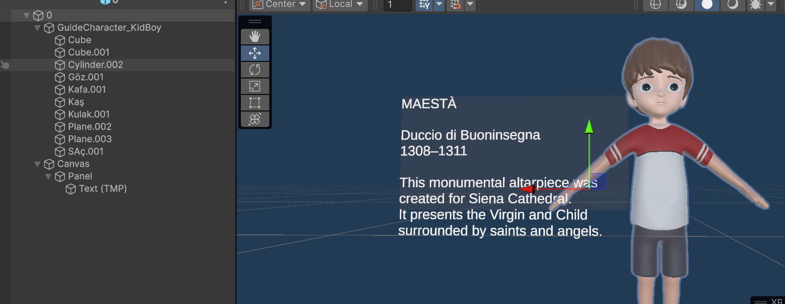
Figure 4. A character prefab in the Editor. The hierarchy on the left shows the wrapper root, the imported model and the Canvas; the Game view shows the panel beside the guide.
The first version was unreadable. The text came out as a narrow vertical column of one or two words per line, because the TextMeshPro RectTransform was only about 200 by 50 units and its rotation was wrong as well. We fixed it by resetting the text rotation to zero, stretching the text object across the panel, adding margins, enlarging the Canvas, turning on word wrapping, moving the Canvas to the side of the character, and darkening the panel background so white text reads against it.
The panel lives inside the prefab rather than in a shared UI object. That was the simplest way to give every painting its own text while reusing one character model, and it means adding a thirteenth painting is a matter of duplicating a prefab and editing one text field.

15. Handling twelve paintings at once
Our first controller handled a single painting. Replacing it with a controller that takes a list was the change that turned the prototype into an application.
MultiPaintingCharacterSpawner holds a serialisable PaintingEntry per artwork, so everything a painting needs is edited in the inspector rather than in code:
- Reference image name
- Character prefab
- Activation distance
- Side offset
- Wall offset
- Ground offset
- Yaw offset
A filled entry looks like this:
Image Name: 4_arnolfini_15th
Character Prefab: 3.prefab
Activation Dist.: 3.5
Side Offset: 1.15
Wall Offset: 0.35
Ground Offset: 0
Yaw Offset: 0
The first three paintings use an activation distance of 4 metres and the remaining nine use 3.5 metres, which suits how close the visitor can physically get to each wall in the Office environment.
The script keeps three collections: a dictionary of tracked images keyed by reference image name, a dictionary of the characters it has created, and a set of the paintings whose placement is already locked. It subscribes to trackablesChanged, the AR Foundation 6 event that reports added, updated and removed trackables in one callback.
Every frame the controller does the same three things. It measures the distance from the AR camera to each tracked painting and picks the nearest one that is inside its own activation distance. It places that painting's character if it has not been placed yet, shows it, and turns it toward the camera. Then it hides every other character.
The result is that exactly one guide and one panel are visible at any moment. Without this rule, the paintings on a single wall would produce a row of overlapping characters and unreadable stacked panels, since several of them are within four metres of each other. When the visitor walks away from a painting its guide disappears; when they reach the next one, that guide appears.

16. Testing
We tested in XR Simulation with all twelve paintings placed around the virtual museum.

Image recognition
We approached each painting in the Game view and watched the runtime hierarchy for a new ARTrackedImage object. This is the check that separates a tracking problem from a placement problem, so it always came first.

Multiple images at once
We walked the full circuit of the room with all twelve paintings enabled and confirmed that each one produces its own ARTrackedImage, not only the first few. This is the test that disproved our Max Number of Moving Images theory: the limit is still 5 and twelve paintings track.

Floor placement
We looked at each spawned guide from several camera angles, including from floor level, to confirm the feet met the detected floor rather than hovering above it or sinking into it.

Activation distance
We tried 2.5, 4 and 5 metres. Larger values were convenient while debugging because the character appeared before we reached the wall. Smaller values feel more like a museum, where a guide reacts when you actually stop in front of a picture. We settled on 3.5 and 4 metres.

Character orientation
We circled the camera around a guide and moved it up and down to confirm the character kept facing us and never tilted.

Switching between paintings
We walked the full route through the room and checked that only the nearest guide was ever visible, including on the walls where several paintings hang close together.

The added walls
The paintings on the three new walls were tested separately, because their physical sizes, orientations, reference names and tracking settings were all configured after the original walls and were the most likely place for a copy and paste mistake.

Information panels
Each panel was checked for readable text, correct wrapping, sensible size and no overlap with the character model.

17. Problems we hit and how we solved them

Finding our way around Unity
At the start, moving between the Hierarchy, the Inspector, the Project window, the Scene view, the Game view, Prefab Mode and the XR Environment overlay was the slowest part of the work. What helped was working in small steps and inspecting one branch of the hierarchy at a time, plus a folder structure and naming scheme we agreed on early.

Edits vanishing after Play Mode
Values we had carefully tuned kept resetting. The cause is that anything changed while Unity is in Play Mode is discarded when Play Mode ends. Once we understood this we did all final configuration outside Play Mode and saved it into the scene or the prefab. During tuning we used Play Mode to find a good value, wrote it down, then entered it again after stopping.

The painting drawn twice
At one point each painting was rendered twice, once by the tracked image object itself and once by a child Quad we had added as a visual. Removing the Mesh Filter from the parent was not an option, because the Simulated Tracked Image component depends on the mesh visualisation components. We removed the duplicate child instead and let the built-in tracked image mesh be the only visible surface.

Paintings lying flat
Some tracked images appeared horizontal, like tables. This was the Quad versus tracked image axis convention described in section 8, and the fix was to rotate each tracked image object in clean steps until its local axes matched what the simulator expects.

Size mismatches between the library and the simulator
Some simulated images had rounded physical sizes that did not exactly match the reference library entry, for instance 0.89 against 0.886875. A mismatch changes the apparent scale of the trackable and makes the simulation results unreliable. We copied the exact values into both places.

The floor raycast that never hit
Described in section 11. The downward ARRaycastManager query kept returning no hit even with planes visible in the hierarchy. We replaced it by scanning the planes from ARPlaneManager and choosing the largest upward-facing one below the painting.

The character that would not stay still
The character position was originally recomputed on every tracked image update, and part of that calculation used the live camera direction. The effect was a guide that shuffled sideways as the visitor moved, and that ended up in a slightly different spot every time the tracking updated. We split the two behaviours: the position is computed once and then locked, and only the rotation keeps following the camera. This is the single change that made the placement feel stable.

The character orbiting an invisible point
The imported model's offset pivot, solved with the wrapper prefab described in section 10.

A guide that was too big and slightly airborne
The imported model came in oversized and floating just above the floor. We scaled the wrapper down to 0.6 and moved the child model's local Y until the shoes touched the wrapper origin, which is the point the placement code puts on the floor.

Unity refusing to build a Humanoid Avatar
The model does not contain the fifteen bones Unity requires for a humanoid rig. We changed the rig type to Generic and accepted a static guide, since animation was never one of the objectives.

Text in a narrow column
The TextMeshPro object had a tiny RectTransform and an incorrect rotation, so the text wrapped after one or two words. Fixed by resetting the rotation, stretching the object, and setting margins, font size, wrapping and Canvas dimensions properly.

The later paintings never activating
This one took the longest, and it is also the one where we were wrong for a while. The first paintings we configured produced guides and the ones we added later produced nothing at all. Our first theory was Max Number of Moving Images, since it sits at 5 by default and 5 was roughly where things stopped working.
It was not that. The setting is still at 5 in the submitted scene and all twelve paintings track, and the reason is written into AR Foundation itself: the XR Simulation image tracking provider ignores the value, and the comment on that property in SimulationImageTrackingSubsystem says the requested maximum is currently unused because all images in a simulated environment can move regardless. The real causes were the ordinary ones, and they clustered on the later paintings simply because those were configured last and in a hurry: a reference name that did not match in all three places, a physical size rounded in the simulated image but not in the library, and an orientation still using Quad axes.
What actually fixed the problem was giving up on guessing and working down a fixed checklist, and that checklist is the thing we would hand to anyone repeating this project:
- Does an ARTrackedImage exist in the runtime hierarchy? If not, the fault is tracking and nothing downstream matters.
- Does the reference image name match exactly, in the library, the simulated image and the controller entry?
- Do the physical dimensions match exactly between the library and the simulated tracked image, with no rounding?
- Is the local orientation of the tracked image correct, X across, Z up, Y out of the wall?
- Is the activation distance large enough to reach the painting from where the camera can actually stand?
- For an Android build only, is Max Number of Moving Images high enough? The simulator ignores it, ARCore does not.

18. Results
The finished application does everything we set out to do. It:
- tracks twelve different painting images from one reference library;
- runs inside a virtual museum built from the Office simulation environment and three walls we added;
- detects horizontal planes and picks out the floor;
- spawns the correct guide beside the correct painting;
- keeps that guide standing on the floor;
- turns it toward the visitor without tilting;
- shows the title, artist, date and description of that specific painting;
- activates content by distance, so the room is quiet until the visitor approaches something;
- shows one guide at a time, so panels never overlap;
- works on walls facing four different directions, including the three we added.
It is a small application, but it is a complete one: a visitor can walk the whole room and every painting responds.

19. Limitations
The guide is static. The model has no usable humanoid skeleton, so there is no idle animation, no gesture and no pointing at the painting being described.
Everything was tested in XR Simulation. A real Android build will need retuning, because real tracking depends on lighting, glare on varnish and glass, camera quality and the true physical size of each painting, none of which the simulator models. Reflections on framed paintings in particular are a known difficulty for image tracking that our virtual room does not reproduce.
One difference between the two providers is already known and documented above: Max Number of Moving Images is ignored by the simulator and enforced by ARCore. It sits at 5 in the submitted scene, which is correct for the simulation we tested and wrong for a twelve-painting phone build. Raising it is the first change anyone should make before building to Android.
The floor detection assumes that the largest upward-facing plane below a painting is the floor. That holds in this office. In a large hall with wide benches, low platforms or a mezzanine it could pick the wrong surface, and a more careful method would compare the candidate height against the camera height as well as the area.
The side offset has a fixed sign per painting, chosen by hand. The guide therefore always stands on the same side of its painting, which is fine in this room but would need a rule if two paintings hung very close together.
The information is read, not heard. There is no narration and no audio description, which limits accessibility.

20. Future improvements
- Use a fully rigged character and add idle, talking and pointing animations.
- Add text-to-speech narration and audio description, which would also make the guide useful to visually impaired visitors.
- Offer more than one language.
- Use different guides for different periods, so the fourteenth-century room and the eighteenth-century room feel distinct.
- Let the visitor tap the guide for more detail, and add subtitles.
- Build and test on an Android phone with ARCore, and tune the tracking against real printed paintings.
- Replace the office with a purpose-built museum, with frames and gallery lighting.
- Remember which paintings the visitor has already seen.
- Fade the characters and panels in and out instead of switching them on and off.

21. Conclusion
The Augmented Museum brings together image recognition, plane detection, virtual character placement, distance-based activation and world-space UI in one AR application.
It started as one tracked painting and a capsule. It ended as a twelve-painting museum with custom walls, a virtual guide and an information panel for every artwork.
The hard parts were not the ones we expected. Modelling the room and importing a character were straightforward. What consumed the time was the relationship between things: the axis convention of a tracked image against the axis convention of a Quad, the pivot of an imported model against the point the placement code treats as the feet, a plane subsystem that reports planes a raycast cannot hit, and a tracking limit that silently drops the paintings past a certain count.
What got us out of each of those was the same habit: separate the responsibilities and test them one at a time. Image recognition identifies the artwork. The plane manager provides the floor. The controller decides who is nearest and who should be visible. The prefab carries the guide and its text. When something broke, that separation told us which of the four to look at, and the capsule stand-in and the runtime hierarchy told us whether the fault was upstream or downstream of the code we had written.

22. Running the project
The repository contains the complete Unity project. To run it:
- Open the project in Unity 6000.0.40f1. The AR Foundation, ARCore and XR Simulation environment packages resolve from the manifest.
- Open Assets/Scenes/MuseumAR.unity.
- In the XR Environment view, select the Office environment.
- Enter Play Mode and move through the room with the Game view navigation controls.
- Walk up to any painting. Within its activation distance the guide appears beside it with the panel for that artwork.
For an Android build, switch the build target to Android and enable the Google ARCore plug-in in XR Plug-in Management. No code changes are needed, but the tracking parameters will need retuning against real paintings.

