Car Item Component
1. Render the text (Model, etc.)
2. Render the Background Image
3. Create a separate component for CarItem
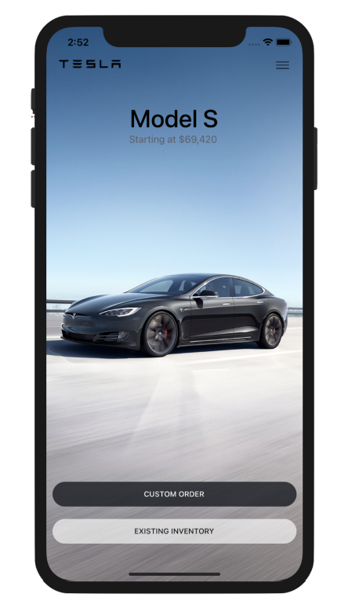

Button Component
1. Create a separate component
2. Receive props
3. Style The button based on ‘type’ prop
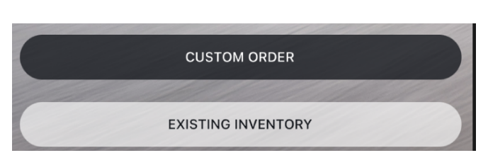

Finish Car Item Component
1. Use buttons
2. Implement props

Render a scrollable list of Cars
1. Use the dummy data
2. Render the FlatList
3. Setup Snap to view

Render the header of the app
