Horsham Solar Farm and BESS

Steady State Grid Impact Assessment

3rd April 2024

|  |  |
| --- | --- |
| **Document Information** | |
| **File Ref:** | 20240403-HORSFBESS_SteadyStateReport.docx |
| **Version:** | Version F1 |
| **Distribution:** | For distribution to Ausgrid as part of connection application |

|  |
| --- |
| COPYRIGHT  This document is copyright. Other than for the purposes and subject to the conditions prescribed under the Copyright Act 1968 (Commonwealth), no part of it may in any form or by any means (electronic, mechanical, micro-copying, photocopying, recording or otherwise) be reproduced, stored in a retrieval system or transmitted without prior written permission. |
| DISCLAIMER  This report has been prepared for a specific purpose stated within the introduction and is not to be used for any other purpose or by any other person or corporation. OX2 Australia accepts no responsibility for any loss or damage suffered howsoever arising to any person or corporation who may use or rely on this report in contravention of the terms of this disclaimer.  Due consideration has been given to appropriate legislation and documentation available at the time of preparation of the report. As these elements are liable to change over time, the report should be considered current at the time of preparation only. The document relies on information supplied by subcontractors and findings obtained during the assessment process.  While due care was taken during the report preparation, OX2 Australia accepts no responsibility for any omissions that may have occurred during the assessment process. |

# Revision History

|  |  |  |  |  |  |
| --- | --- | --- | --- | --- | --- |
| **Revision** | **Description** | **Author** | **Review** | **Approval** | **Date** |
| F0 | For submission to AEMO | Mani S | Dao V | Mervin K | 27/01/2023 |
| F1 | Updated model and results with BESS plant included | Michael M | Dao V | Mervin K | 03/04/2024 |

# Defined Terms

|  |  |
| --- | --- |
| **Term** | **Definition** |
| AC | Alternating Current |
| AVR | Automatic Voltage Regulator |
| DC | Direct Current |
| HV | High Voltage |
| kV | Kilovolt, equivalent to 103 volts |
| LV | Low voltage |
| MVA | Megavolt-ampere, equivalent to 106 volt ampere |
| MVAr | Megavolt-ampere reactive, equivalent to 106 volt-amperes reactive |
| MW | Megawatt, equivalent to 106 watts |
| OH | Overhead Conductor |
| OLTC | Onload Tap Changing/Changers |
| ONAN | Oil Natural Air Natural cooling method |
| OOS | Out of Service |
| PCS | Power Conversion System |
| PF | Power Factor |
| POC | Point of Connection |
| PSS®E | Power System Simulator for Engineering from SIEMENS |
| pu | Per Unit |
| SLD | Single Line Diagram |
| Tx | Transformer |
| UG | Underground Cable |
| UGOH | Underground to Overhead Connection |
| VC | Voltage Control |
| VDC | Voltage Drop Control |
| Vk | Impedance Voltage |
| V1 | Positive Sequence Voltage |
| VnLL | Nominal Line to Line Voltage |
| ZS | Zone Substation |

# Generators Nomenclature

|  |  |
| --- | --- |
| Generator Name | Nomenclature in the report |
| HORSFBESS | Horsham Solar Farm – 119MWac |
| GLWWSF | Glenrowan West Solar Farm |
| GLWSF | Glenrown Solar Farm |
| STCKHWF | Stockyard Hill Wind Farm |
| VBB | Victorian Big Battery |
| MUR1WF | Murra Warra 1 Wind Farm |
| MUR2WF | Murra Warra 2 Wind Farm |
| YTPSF | Yatpool Solar Farm |
| YNDWF | Yendon Wind Farm |
| WTNSF | Winton Solar Farm |

# Executive Summary

OX2 Australia is proposing to connect Horsham Solar Farm (HORSFBESS) into the AEMO network in Horsham Victoria. The proposed plant will have a maximum export capacity (active power) of 119 MWac at PoC. The Horsham Solar Farm will be directly connected to the existing 220kV busbar in the Horsham 220/66 kV Zone Substation.

This report forms a part of the HORSFBESS connection application to the AEMO. This report aims to assess the steady state requirements for the proposed power plant. The studies were conducted in PSS®E v34.5.1 version using the data provided in the AEMO data pack [1]. This includes thermal loadings, voltage levels, generation change and loss of line voltage fluctuations, and short circuit calculations. The studies were set up so that the HORSF was operating in a voltage droop control with a droop of 3.9% on 47.005 MVAr base and a voltage setpoint of 1.02 pu at the PoC.

The aim of the report is to:

* Provide network modelling and study execution details.
* Demonstrate the compliance of HORSF to reactive power capability requirements
* Analyze the impacts of the proposed plant on the current network

The study results shows that the Horsham Solar Farm is able to meet the automatic access standard NER clause S5.2.5.1 for reactive power capability at 35°C and 50°C; thus, providing and absorbing 47.005 MVAr at the PoC which is 0.395x119 MWac.

Furthermore, there are no thermal constraints identified under system normal and the considered contingency conditions on the network with the addition of HORSF. Overall voltage fluctuations on the network due to change in generation (i.e., cloud cover and trip of generating units) and due to loss of line contingency are within 3% (for generation change) and 5% (for generator trip and loss of line contingency). The only exception occurs at the Kiamal 220kV bus (3KIAMAL_220A) when losing the Kiamal to Redcliff 220 kV line. For this case4, the existing voltage fluctuation is above 5% i.e., 5.047% and the addition of HORSF this voltage fluctuation increases to 5.6 %. Due to the small magnitude of this exacerbation i.e., 0.6% and the long distance between HORSF and 3KIAMAL_220A bus this is deemed acceptable. This exacerbation is not expected to impact system security and the limit is slightly exceeded with and without HORSF present. In fact, Horsham is not causing the fluctuation and under slightly different network conditions the plant would likely mitigate the fluctuation rather than exacerbate it, given it stabilizes the voltage at HOTS 220 kV. No further issues have been identified in the Horsham Solar Farm and BESS steady state analysis.

Overall, the inclusion of HORSF 118.8 MWac will enhance flexibility to system operators by providing reactive power capability of +47.005 MVAr/-47.005 MVAr. Also, the plants fast acting droop capability will allow to reduce voltage steps on the network.

Table of Contents

Revision History 2

Defined Terms 3

Generators Nomenclature 4

Executive Summary 5

1 Introduction 8

1.1 Project Details 8

1.2 Site Information 9

1.3 Connection Details 9

2 Model Construction 10

2.1 Input Data 10

2.2 Horsham Solar Farm and BESS Plant Model 11

2.3 Integration of the HORSFBESS Plant into the Network 14

3 Generators within proximity 15

4 Study Execution 16

4.1 Monitored Elements 16

4.2 Study requirements 18

4.3 HORSFBESS steady state grid impact assessment summary 21

5 HORSFBESS Plant Control Strategy and Optimisation 22

6 Simulation Results 23

6.1 Reactive Power Capability Curve 23

6.2 Voltage Levels 24

6.2.1 Summary of findings 24

6.2.2 Plots 25

6.3 Line and Transformer Loadings 26

6.3.1 Summary of findings 26

6.3.2 Plots 28

6.4 Voltage Fluctuations for Change of Generation 30

6.4.1 Summary of findings 30

6.4.2 Plots 31

6.5 Voltage fluctuations due to contingencies 33

6.5.1 Summary of findings 33

6.5.2 Plots 35

6.6 Fault Level Analysis 38

6.6.1 HighLoad 38

7 Conclusion 39

8 References 39

9 Appendices 40

9.1.1 Appendix 1 40

9.1.2 Appendix 2 49

9.1.3 Appendix 3 52

9.1.4 Appendix 4 61

9.1.5 Appendix 5 65

# Introduction

## Project Details

OX2 Australia is proposing to develop Horsham Solar Farm (HORSFBESS) with maximum active power output of 119 MWac in Horsham Victoria connecting to Ausnet’s network. This report presents the steady state analysis consisting of the following assessment:

1. Reactive power capability
2. Thermal loading assessment
3. Load flow and voltage analysis under system normal and N-1 conditions
4. Fault level calculation for three-phase faults and single phase to ground faults.

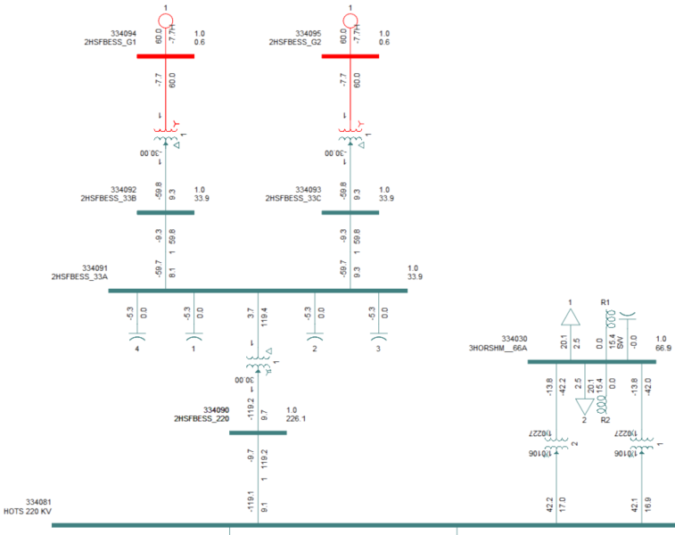

Figure 1 Proposed location of the Horsham Solar Farm connecting to existing 220 kV bus at the 220/66 kV Horsham ZS.

## Site Information

Table 1 Site Information

|  |  |
| --- | --- |
| Variable | Value |
| Lot/DP | Multiple Lots |
| Address | Horsham-Lubeck Road, Riverside, VIC 3401 |
| LGA | Horsham Rural City Council |

## Connection Details

Table 2 Connection Details

|  |  |
| --- | --- |
| Variable | Value |
| NSP | Ausnet |
| Supply Area | Horsham |
| Point of Connection Voltage | 220 kV |
| Feeder Name | N/A |
| Relevant Zone Substation | Horsham 220/66 kV Terminal Station |

# Model Construction

This chapter’s emphasis is on the input data required and the methodology used to construct the network model integrated with Horsham Solar Farm. Software used for the network modelling and the analysis is PSS/E v34.5.1.

## Input Data

The network models and the steady state studies are based upon the AEMO summer high and spring low cases together with data outlined in the table below.

Table 3 Input data references

|  |  |  |
| --- | --- | --- |
| Variable | Value | Source |
| Enquiry Response | Horsham Data Pack  VIC runback schemes, fault levels, breaker clearing times. | AEMO |
| PSS®E Models | High: 20210124-180000-SystemNormal.sav  Low: 20210328-110152-SystemNormal.sav | AEMO |
| RUGS | VIC RUGS as specified in section 3 | AEMO |
| Inverter Plant Model | SMA SC 4200 UP | SMA |

## Horsham Solar Farm and BESS Plant Model

To conduct the steady state studies the HORSFBESS was modelled as two aggregated generators. The graphical representation of the solar and BESS plant is shown in Figure 2. The two aggregated generators have the combined capacity of inverter plant as follows:

* 1 aggregated PV inverter (representing 36 x SMA SC 4200-UP)
* 1 aggregated BESS inverter (representing 37 x SMA SCS3600 UP-XT)
* 1 aggregated PV transformer (representing 36 x 4200kVA - 33 kV/0.63 kV transformers)
* 1 aggregated BESS transformer (representing 37 x 3600kVA - 33 kV/0.63 kV transformers)
* 33kV cable reticulation system modeled as an aggregated equivalent
* 4 x 5 MVAr capacitor banks located on the 33kV buses
* 1 x 170 MVA 220/33 kV power transformer

The aggregated load flow model is shown in figure below:

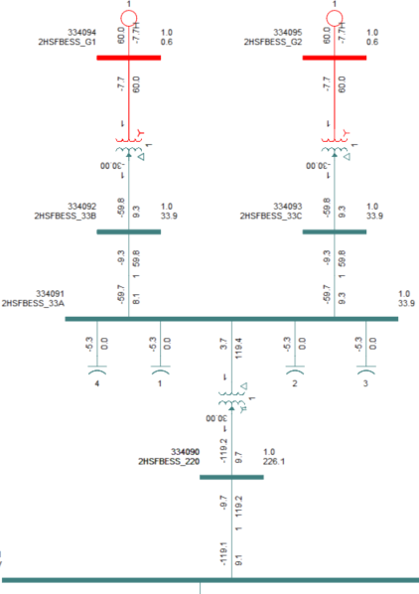

Figure 2 HORSFBESS graphical representation in PSS®E

Table 4 Aggregated HORSFBESS inverter parameters

|  |  |  |  |
| --- | --- | --- | --- |
| Description | Value INV1 - PV | Value INV2 - BESS | Unit |
| Individual inverter rated capacity | 4.2 | 3.6 | MVA |
| Rated voltage | 0.63 | 0.63 | kV |
| Number of inverters | 36 | 37 | Qty |
| Lumped generator rating | 151.2 | 133.2 | MVA |
| Maximum active power at inverter terminal | 120 | 101 | MW |
| Minimum active power at inverter terminal | 0.3 | -101 | MW |
| Maximum reactive power at inverter terminal | 60.48 | 43.2 | MVAr |
| Minimum reactive power at inverter terminal | -60.48 | -43.2 | MVAr |
| R Source | 0 | 0.0378 | pu on 151.2/133.2MVA |
| X Source | 10000 | 0.2048 | pu on 151.2/133.2MVA |
| Positive sequence resistance | 0.23 | 0.23 | pu on 100.8/64.8MVA |
| Sub transient reactance | 0.74 | 0.74 | pu on 100.8/64.8MVA |
| Transient reactance | 0.74 | 0.74 | pu on 100.8/64.8MVA |
| Synchronous reactance | 0.89 | 0.89 | pu on 100.8/64.8MVA |
| Negative sequence resistance | 0.1 | 0.1 | pu on 100.8/64.8MVA |
| Negative sequence reactance | 0.89 | 0.89 | pu on 100.8/64.8MVA |
| Zero sequence resistance | 0 | 0 | pu on 100.8/64.8MVA |
| Zero sequence reactance | 99999 | 99999 | pu on 100.8/64.8MVA |

Table 5 Equivalent 33/0.63 kV transformer parameters

|  |  |  |  |
| --- | --- | --- | --- |
| Description | Value Tx1 | Value Tx2 | Unit |
| Aggregated transformer rating | 151.2 | 151.2 | MVA |
| Winding 1 nominal voltage | 33 | 33 | kV |
| Winding 2 nominal voltage | 0.63 | 0.63 | kV |
| Impedance (%) | 6.5 | 6.5 | % |
| No Load Losses | 90.72 | 90.72 | kW |
| Short circuit losses |  |  | kW |
| Positive resistance (R+) | 0.0065 | 0.0065 | pu on 151.2MVA |
| Positive reactance (X+) | 0.065 | 0.065 | pu on 151.2MVA |
| Zero resistance (R0) |  |  | pu on 100MVA |
| Zero reactance (X0) |  |  | pu on 100MVA |
| Vector group | Dy11 | Dy11 | Text |
| HV-LV winding angle | -30 | -30 | degree |
| Connection Code | 4 | 4 | Text |
| Tap change type | Off-load | Off-load | Text |
| Number of taps | 5 | 5 | Qty |
| Tap changer step size | 2.5 | 2.5 | % |
| R1 max | 1.1 | 1.05 | pu |
| R1 min | 0.9 | 0.95 | pu |
| Tap ratio (HV:LV) | 1:1 | 1:1 | pu |

Table 6 Equivalent 33kV cable parameters

|  |  |  |  |
| --- | --- | --- | --- |
| Description | Value PV | Value BESS | Unit |
| Specified R | 0.001732 | 0.000176 | pu on 100 MVA base |
| Specified X | 0.002928 | 0.000120 | pu on 100 MVA base |
| Specified B | 0.012510 | 0.000130 | pu on 100 MVA base |
| R-Zero | 0.015621 | 0.000213 | pu on 100 MVA base |
| X-Zero | 0.002559 | 0.000029 | pu on 100 MVA base |
| B-Zero | 0.011436 | 0.000122 | pu on 100 MVA base |

Table 7 Capacitor bank parameters

|  |  |  |
| --- | --- | --- |
| Description | Value | unit |
| Capacitor – 1 | 5 | MVAr |
| Capacitor - 2 | 5 | MVAr |
| Capacitor – 3 | 5 | MVAr |
| Capacitor - 4 | 5 | MVAr |

Table 8 220/33 kV Grid interface main transformer data

|  |  |  |
| --- | --- | --- |
| Description | Value | unit |
| Transformer rating | 170 | MVA |
| Winding 1 nominal | 220 | kV |
| Winding 2 nominal | 33 | kV |
| Specified R | 0.003529 | pu |
| Specified X | 0.168 | pu |
| Vector group | Ynd1 | Text |
| HV – LV winding angle | 30 | ° |
| Tap change type | On load | Text |
| Number of taps | 1 | Qty |
| Tap changer step size | 1.25 | % |
| R1 max | 1.1 | pu |
| R1 min | 0.9 | pu |
| Tap setting (HV:LV) | 1:1 | Text |

## Integration of the HORSFBESS Plant into the Network

The Horsham Solar Farm and BESS is connected directly to the existing 220 kV busbar at Horsham 220/ 66 kV Zone Substation. In the PSS®E model this happens on the bus number 334081 (3HORSHM_220B). The figure below shows the integration of HORSF at bus number 334081 i.e., Horsham ZS 220 kV terminal.



Figure 3 Integration of HORSFBESS into the network

# Generators within proximity

The following committed generators are identified within HORSFBESS proximity.

Table 9 Generators within Horsham Solar Farm proximity

|  |  |
| --- | --- |
| Name | Shor Name |
| Glenrowan West Solar Farm | GLWWSF |
| Glenrown Solar Farm | GLWSF |
| Stockyard Hill Wind Farm | STCKHWF |
| Victorian Big Battery | VBB |
| Murra Warra 1 Wind Farm | MUR1WF |
| Murra Warra 2 Wind Farm | MUR2WF |
| Yatpool Solar Farm | YTPSF |
| Yendon Wind Farm | YNDWF |
| Winton Solar Farm | WTNSF |

Each of them is added to the high and low load snapshots as per their RUG and the steady state analysis have been with the inclusion of these generators.

# Study Execution

This chapter outlines the steady state assessment criteria and the methodology employed by the proposed generator to fulfill the criteria.

## Monitored Elements

Following network elements were monitored during the steady state analysis

Table 10 Monitored Buses

|  |  |  |
| --- | --- | --- |
| Bus Name | PSS®E Bus Number | Comments |
| 3ARAR_T_220A | 306580 | ARART 220 kV |
| 3ARAR_T_220F | 306585 | ARART 220 kV |
| 3BULGTS_220A | 316580 | BULGANA 220 kV |
| HOTS 220 KV_POC | 334081 | HORSHAM 220 kV |
| 3KIAMAL_220A | 342280 | KIAMAL 220 kV |
| 3ARAR_T_220B | 306581 | ARART 220 kV |
| 3CROWLA_220A | 321580 | CROWNLANDS 220 KV |
| 3MURRAW_220A | 355880 | MURRA WARRA 220 kV |
| 3REDCLF_220A | 364080 | RED CLIFF 220 kV |
| 3BALRAT_220A | 309080 | BALARAT 220 kV |
| 3WAUBRA_220A | 384080 | WAUBRA 220 kV |

Table 11 Monitored Branches

|  |  |  |  |  |
| --- | --- | --- | --- | --- |
| Branch Name | Branch from | Branch to | Branch id | Branch Code |
| 3BALRAT_220A - 3WAUBRA_220A | 309080 | 384080 | 1 | 3BALRAT_220A - 3WAUBRA_220A |
| 3ARAR_T_220B - 3WAUBRA_220A | 306581 | 384080 | 1 | 3ARAR_T_220B - 3WAUBRA_220A |
| 3ARAR_T_220F - 3CROWLA_220A | 306585 | 321580 | 1 | 3ARAR_T_220F - 3CROWLA_220A |
| 3BULGTS_220A - 3CROWLA_220A | 316580 | 321580 | 1 | 3BULGTS_220A - 3CROWLA_220A |
| 3BULGTS_220A - HOTS 220 KV | 316580 | 334081 | 1 | 3BULGTS_220A - HOTS 220 KV |
| 3HORSHM__66A - HOTS 220 KV | 334030 | 334081 | 1 | 3HORSHM__66A - HOTS 220 KV |
| 3HORSHM__66A - HOTS 220 KV | 334030 | 334081 | 2 | 3HORSHM__66A - HOTS 220 KV |
| HOTS 220 KV - 3MURRAW_220A | 334081 | 355880 | 1 | HOTS 220 KV - 3MURRAW_220A |
| 3KIAMAL_220A -3MURRAW_220A | 342280 | 355880 | 1 | 3KIAMAL_220A - 3MURRAW_220A |
| 3KIAMAL_220A - 3REDCLF_220A | 342280 | 364080 | 1 | 3KIAMAL_220A - 3REDCLF_220A |

## Study requirements

The steady state consists of four key components, each of which illustrate the findings of the respective part of the study:

1. Plant reactive power capability
   1. This criterion is based on the reactive power requirement from the automatic access standard S5.2.5.1(a) i.e. that the proposed plant should be capable of supplying or absorbing the reactive power which is at least 0.395 of its intended active power value.
2. Impact on thermal network capability for standard configuration and contingency events
   1. This part of the steady state analysis investigates line loading and transformer loading under network normal and N-1 conditions, with and without the proposed generator. This reveals the pre-existing issues as well as issues caused by the inclusion of the proposed generator.
3. Impact on network voltage capability for standard configuration and contingency events. This part further divided into three parts:
   1. The first part looks at Bus voltages under system normal conditions (i.e. no line outages or other contingencies. Adding generation to a bus or a line may shift the voltage levels at that bus or surrounding buses due to the impact it has on the power flows in the area. The normal operating band of the NEM is between 0.9 p.u. voltage and 1.1 p.u. voltage. The results presented in results section will highlight the changes in relevant bus voltages due to the addition of the newly proposed generator.
   2. The second part of this assessment explores voltage fluctuations for a change in the generation output. This includes voltage fluctuations due to generation output variation considering a change from 100% output to 75%, 50% and 25% with all network transformer taps locked. This also includes voltage fluctuations due to trip of the proposed plant, considering a change from 100%, 75%, 50% and 25% output to no output (plant trip) with all the network transformer taps locked. This is quantified and compared against the Table6 IEC 61000.3.7:2012 (p.33) applicable thresholds.
   3. The third part of this assessment focusses on voltage stability under credible contingencies. The voltage changes due to loss of line with fixed tap load flows on the network should not be worse than the system without the proposed plant.
4. The last part of the Steady State analysis investigates Fault current at buses of interest. These fault levels are required to not exceed planning levels. This item is unlikely to be problematic in most instances as the contribution from inverter-based resources behind transformer and cable impedances is generally normally small compared against existing headroom.

Following table provides the summary of different test scenarios performed on Horsham Solar Farm as per the above test types in accessing the steady state analysis. The Case Reference column in the table below corresponds to the cases/contingencies being studied, For instance

* Network Normal case reference refers to the network normal conditions case. The corresponding Voltage levels test type will consider voltage levels deviation with and without HORSF as well as voltage levels to be remain within 0.9 to 1.1pu.
* ARTS-CWTS (ARARAT to CROWNLANDS) 220kV line OOS refers to the contingency where ARARAT to CROWNLANDS 2200kV line is out of service. The Contingency test type will consider line loadings with and without HORSFBESS while that contingency is in place. The voltage fluctuation will also be measured when the network is going from network normal to that contingency. This voltage fluctuations will be assessed against with and without HORSFBESS in service. Furthermore, during these line contingencies, inter trip schemes have been placed thus tripping the required committed generators as per the contingency. These inter trip schemes have been implemented as per the provided document 2g_Western Vic Generation Fast trip Schemes and Murraylink VFRB.docx [2]
* HORSF_GenChng 100% to 75% refers to the case where generation of HORSFBESS is changed from 100% to 75%.
* HORSF_GenTrip 75% to 0% refers to the case where HORSFBESS is tripped while generating at 75%. The Gen Change and Gen Trip will observe voltage fluctuations before and after the event and the plant itself is required for this test to be performed.

Table 12 Case Reference and the corresponding Test Types used in HORSFBESS SS Analysis

|  |  |
| --- | --- |
| **Case Reference** | **TestType** |
| **Network Normal** | Voltage levels |
| **ARTS-WBTS-BATS (ARARAT to WAUBRA to BALLARAT) 220kV line OOS** | Contingency |
| **ARTS-CWTS (ARARAT to CROWNLANDS) 220kV line OOS** | Contingency |
| **CWTS-BGTS-HOTS (CROWNLANDS to BULGANA to HORSHAM) 220kV line OOS** | Contingency |
| **HOTS-MRTS-KMTS (HORSHAM to MURRAWARRA to KIAMAL) 220kV line OOS** | Contingency |
| **KMTS-RCTS (KIAMAL to REDCLIFF) 220kV line OOS** | Contingency |
| **HOTS220 - HOTS66 kV Tx OOS** | Contingency |
| **HORSFBESS_GenChng 119MW to 89.25MW (100% to 75%)** | GenChange |
| **HORSFBESS_GenChng 119MW to 59.5MW (100% to 50%)** | GenChange |
| **HORSFBESS_GenChng 119MW to 29.75MW (100% to 25%)** | GenChange |
| **HORSFBESS_GenChng -100MW to -75MW (-100% to -75%)** | GenChange |
| **HORSFBESS_GenChng -100MW to -50MW (-100% to -50%)** | GenChange |
| **HORSFBESS_GenChng -100MW to -25MW (-100% to -25%)** | GenChange |
| **HORSFBESS_GenTrip 119MW to 0MW (100% to 0%)** | GenTrip |
| **HORSFBESS_GenTrip 89.25MW to 0MW (75% to 0%)** | GenTrip |
| **HORSFBESS_GenTrip 59.5MW to 0MW (50% to 0%)** | GenTrip |
| **HORSFBESS_GenTrip 19.75MW to 0MW (25% to 0%)** | GenTrip |
| **HORSFBESS_GenTrip -100MW to 0MW (-100% to 0%)** | GenTrip |
| **HORSFBESS_GenTrip -50MW to 0MW (-50% to 0%)** | GenTrip |
| **HORSFBESS_GenTrip -25MW to 0MW (-25% to 0%)** | GenTrip |
| **Network Normal High Load** | Fault Levels |

## HORSFBESS steady state grid impact assessment summary

Table 13 HORSFBESS steady state grid impact assessment summary

|  |  |  |  |
| --- | --- | --- | --- |
| Assessment | Assessment criteria | Notes | Assessment results |
| Generator reactive power capability | Automatic access standard | Tap changers enabled | **Criterion met** |
| Impact on thermal network capability for standard configuration and contingency events | ≤ 100% Thermal limit; or not exacerbated by given exacerbation value from NSP where already>100% | Tap changers enabled | **Criterion met** |
| Impact on network voltage capability for standard configuration and contingency events | 1. Voltage levels between 0.9 to 1.1pu 2. ≤ 3% voltage fluctuations GenChange 3. ≤ 5% voltage fluctuations GenTrip 4. ≤ 5% Voltage fluctuations due to loss of line contingencies   Note: Existing out of bound voltage fluctuations are not exacerbated by a given limit provided by the NSP. | Tap changers disabled | 1. **Criterion met** 2. **Criterion met** 3. **Criterion met** 4. **Criterion met** |
| Fault level studies | ≤ Provided fault level limits | NCSFCC for current source generators and ASCC function in PSS®E | **Criterion met** |

# HORSFBESS Plant Control Strategy and Optimisation

To assess the steady state studies of Horsham Solar Farm and BESS, the following PSS®E sav cases have been used. The raw snapshots were integrated with committed generators and the HORSFBESS SMIB model. This results in creation of HORSFBESS_high_genon.sav and HORSFBESS_low_genon.sav. After that HORSFBESS is deactivated, resulting in the creation of HORSFBESS_high_genoff.sav and HORSFBESS_low_genoff.sav.

Table 14 PSS®E sav cases used for steady state analysis

|  |
| --- |
| Sav cases |
| HORSFBESS_high_genon.sav |
| HORSFBESS_high_genoff.sav |
| HORSFBESS_Low_genon.sav |
| HORSFBESS_Low_genoff.sav |

Initial assessment of HORSFBESS operating at voltage setpoint of 1.02pu in a voltage droop control mode with a droop of 3.9% on 47.005 MVAr base shows compliance in steady state analysis. No further assessment was required, therefore Horsham solar farm is operated in the above settings.

# Simulation Results

## Reactive Power Capability Curve

Based on the reactive power requirement from the automatic access standard S5.2.5.1(a), HORSFBESS is required to supply and absorb at least 47.005 MVAr at the connection point (CP) for a rated active power output of 119 MW.

The calculation for the required reactive power is given below:

𝑄𝑝𝑜𝑐 = ±0.395 × 𝑃𝑟𝑎𝑡𝑒𝑑,𝑃𝑂𝐶 = ±0.395 × 119 = ±47.005 𝑀𝑉𝐴𝑟

To assess the reactive power capability of HORSF, active power output at inverter terminal has been incrementally increased from its minimum to 119 MW; and at each level of the active power generation, reactive power has been changed till it reaches the maximum and minimum capacity of the plant. This process is repeated at different voltage level 0.9pu, 1.0pu and 1.1pu. The active power and reactive power were measured at the POC, which was used as an estimate of the reactive power capability of the aggregated plant.

It is important to note that the method used here has not taken the plant controller operation into consideration which has been addressed in dynamic analysis in the connection study i.e., PPC is disabled for this study.

Figures below shows that HORSF has sufficient leading and lagging reactive power capability at all levels of active power and it is able to comply with the automatic access standard S5.2.5.1(a) for 119 MW active power output at the CP at an ambient temperature of 35°C.

## 

Figure 4 HORSFBESS reactive power capability at 35°C (AAS)

Figure 5 HORSFBESS reactive power capability at 50°C (AAS)

## Voltage Levels

The voltage levels at buses of interest have been analysed for system normal conditions (no contingencies) with Horsham Solar Farm in service and compared to the voltage levels prior to adding the HORSF. The normal operating voltage band of each considered bus is defined as 0.9 p.u. to 1.1 p.u.

### Summary of findings

The results for each bus before and after the inclusion of Horsham Solar Farm and BESS are listed in the tables below. There are no issues observed in the voltage levels with the addition of HORSFBESS into the network.

#### HighLoad

|  |  |  |
| --- | --- | --- |
| Bus Name | Voltage Level(pu) GenOFF | Voltage Level(pu) GenON |
| 3ARAR_T_220A | 1.026 | 1.018 |
| 3ARAR_T_220F | 1.026 | 1.018 |
| 3BULGTS_220A | 1.026 | 1.02 |
| HOTS 220 KV_POC | 1.028 | 1.028 |
| 3KIAMAL_220A | 1.024 | 1.022 |
| 3ARAR_T_220B | 1.026 | 1.018 |
| 3CROWLA_220A | 1.025 | 1.018 |
| 3MURRAW_220A | 1.04 | 1.04 |
| 3REDCLF_220A | 1.004 | 1.004 |
| 3BALRAT_220A | 1.038 | 1.033 |
| 3WAUBRA_220A | 1.031 | 1.024 |

#### LowLoad

|  |  |  |
| --- | --- | --- |
| Bus Name | Voltage Level(pu) GenOFF | Voltage Level(pu) GenON |
| 3ARAR_T_220A | 1.033 | 1.019 |
| 3ARAR_T_220F | 1.033 | 1.019 |
| 3BULGTS_220A | 1.027 | 1.015 |
| HOTS 220 KV_POC | 1.022 | 1.021 |
| 3KIAMAL_220A | 1.009 | 1.008 |
| 3ARAR_T_220B | 1.033 | 1.019 |
| 3CROWLA_220A | 1.03 | 1.017 |
| 3MURRAW_220A | 1.04 | 1.04 |
| 3REDCLF_220A | 0.998 | 0.998 |
| 3BALRAT_220A | 1.054 | 1.047 |
| 3WAUBRA_220A | 1.043 | 1.03 |

### Plots

The scatter plots show the absolute voltage level in the reference case(s) analysed in this study.

#### HighLoad

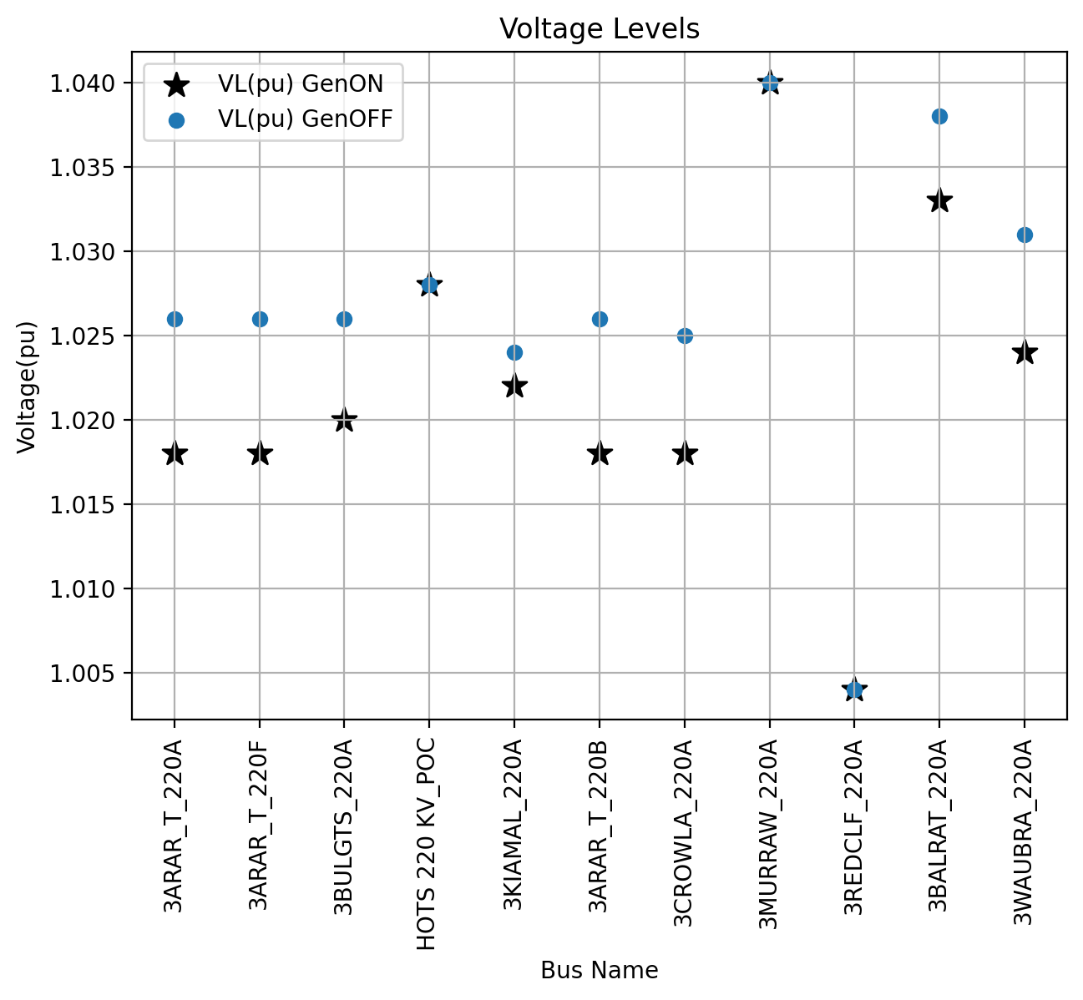

#### LowLoad

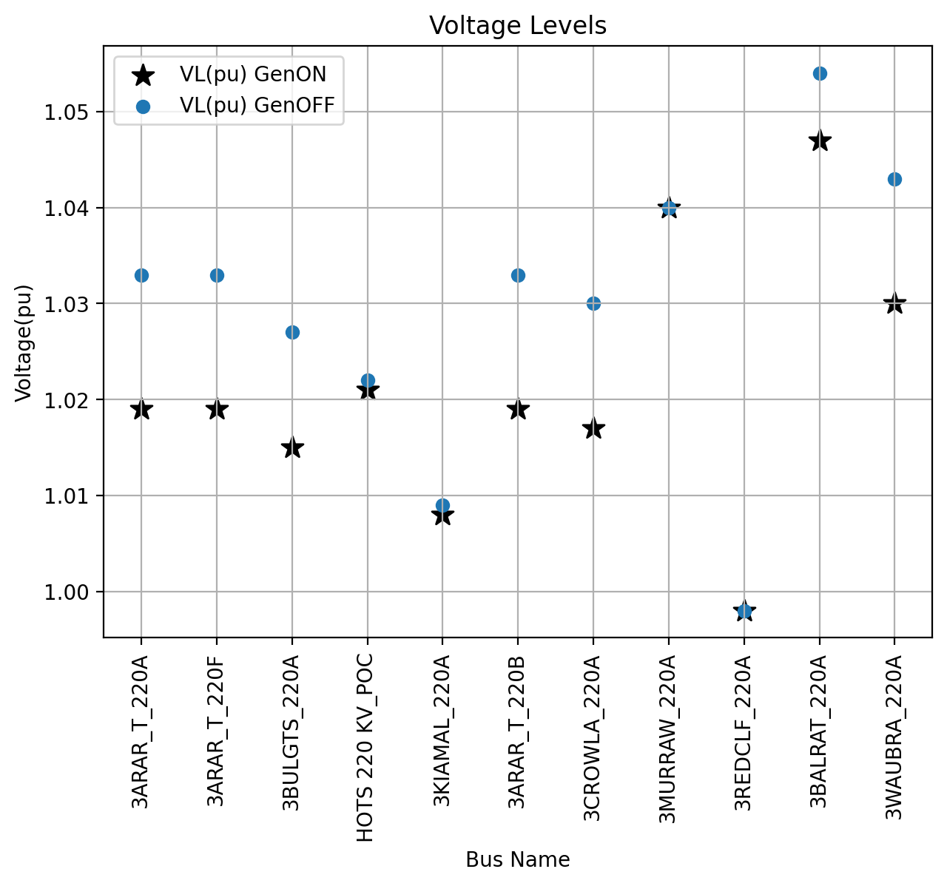

## Line and Transformer Loadings

Line and transformer loading in the area around Horsham has been analysed under various conditions, including relevant N-1 scenarios. For each scenario, the analysis is conducted in two cases which are with and without the inclusion of HORSF by using the GenOn and GenOff cases created earlier.

### Summary of findings

The maximum loading levels for each contingency or case reference including network normal before and after addition of Horsham Solar Farm and BESS are listed in the tables below. The Case Reference column in the table below represents contingency or network normal and the corresponding row represents the maximum loading branch. Full results are provided in Appendix 1.

#### HighLoad

|  |  |  |  |
| --- | --- | --- | --- |
| Case Reference | Branch Name | Loading(%) GenOFF | Loading(%) GenON |
| ARTS-CWTS (ARARAT to CROWNLANDS) 220kV line OOS | 3KIAMAL_220A - 3REDCLF_220A | 35.4 | 59.71 |
| ARTS-WBTS-BATS (ARARAT to WAUBRA to BALLARAT) 220kV line OOS | 3KIAMAL_220A - 3REDCLF_220A | 35.21 | 59.51 |
| CWTS-BGTS-HOTS (CROWNLANDS to BULGANA to HORSHAM) 220kV line OOS | 3KIAMAL_220A - 3REDCLF_220A | 35.49 | 59.81 |
| GenTrip (-100% to 0%) | HOTS 220 KV - 3MURRAW_220A | 75.31 | 70.43 |
| GenTrip (-25% to 0%) | HOTS 220 KV - 3MURRAW_220A | 75.31 | 70.43 |
| GenTrip (-50% to 0%) | HOTS 220 KV - 3MURRAW_220A | 75.31 | 70.43 |
| GenTrip (100% to 0%) | HOTS 220 KV - 3MURRAW_220A | 75.31 | 75.58 |
| GenTrip (25% to 0%) | HOTS 220 KV - 3MURRAW_220A | 75.31 | 70.43 |
| GenTrip (50% to 0%) | HOTS 220 KV - 3MURRAW_220A | 75.31 | 70.43 |
| GenTrip (75% to 0%) | HOTS 220 KV - 3MURRAW_220A | 75.31 | 75.58 |
| HOTS-MRTS-KMTS (HORSHAM to MURRAWARRA to KIAMAL) 220kV line OOS | 3BALRAT_220A - 3WAUBRA_220A | 12.49 | 34.01 |
| HOTS220 - HOTS66 kV Tx OOS | 3BALRAT_220A - 3WAUBRA_220A | 60.54 | 74.59 |
| KMTS-RCTS (KIAMAL to REDCLIFF) 220kV line OOS | 3BALRAT_220A - 3WAUBRA_220A | 51.79 | 71.74 |
| Network normal | 3BALRAT_220A - 3WAUBRA_220A | 60.04 | 73.99 |

#### LowLoad

|  |  |  |  |
| --- | --- | --- | --- |
| Case Reference | Branch Name | Loading(%) GenOFF | Loading(%) GenON |
| ARTS-CWTS (ARARAT to CROWNLANDS) 220kV line OOS | 3KIAMAL_220A - 3REDCLF_220A | 43.06 | 62.58 |
| ARTS-WBTS-BATS (ARARAT to WAUBRA to BALLARAT) 220kV line OOS | 3KIAMAL_220A - 3REDCLF_220A | 42.98 | 62.51 |
| CWTS-BGTS-HOTS (CROWNLANDS to BULGANA to HORSHAM) 220kV line OOS | 3KIAMAL_220A - 3REDCLF_220A | 43.11 | 62.62 |
| GenTrip (-100% to 0%) | 3BALRAT_220A - 3WAUBRA_220A | 70.31 | 77.1 |
| GenTrip (-25% to 0%) | 3BALRAT_220A - 3WAUBRA_220A | 70.31 | 77.1 |
| GenTrip (-50% to 0%) | 3BALRAT_220A - 3WAUBRA_220A | 70.31 | 77.1 |
| GenTrip (100% to 0%) | HOTS 220 KV - 3MURRAW_220A | 72.6 | 73.22 |
| GenTrip (25% to 0%) | 3BALRAT_220A - 3WAUBRA_220A | 70.31 | 77.1 |
| GenTrip (50% to 0%) | 3BALRAT_220A - 3WAUBRA_220A | 70.31 | 77.1 |
| GenTrip (75% to 0%) | HOTS 220 KV - 3MURRAW_220A | 72.6 | 73.22 |
| HOTS-MRTS-KMTS (HORSHAM to MURRAWARRA to KIAMAL) 220kV line OOS | 3BALRAT_220A - 3WAUBRA_220A | 9.41 | 26.56 |
| HOTS220 - HOTS66 kV Tx OOS | 3BALRAT_220A - 3WAUBRA_220A | 70.59 | 84.38 |
| KMTS-RCTS (KIAMAL to REDCLIFF) 220kV line OOS | 3BALRAT_220A - 3WAUBRA_220A | 52.11 | 70.36 |
| Network normal | 3BALRAT_220A - 3WAUBRA_220A | 70.31 | 84.07 |

### Plots

The scatter plots show the results for the line loadings with and without HORSFBESS in service in network normal conditions.

#### HighLoad

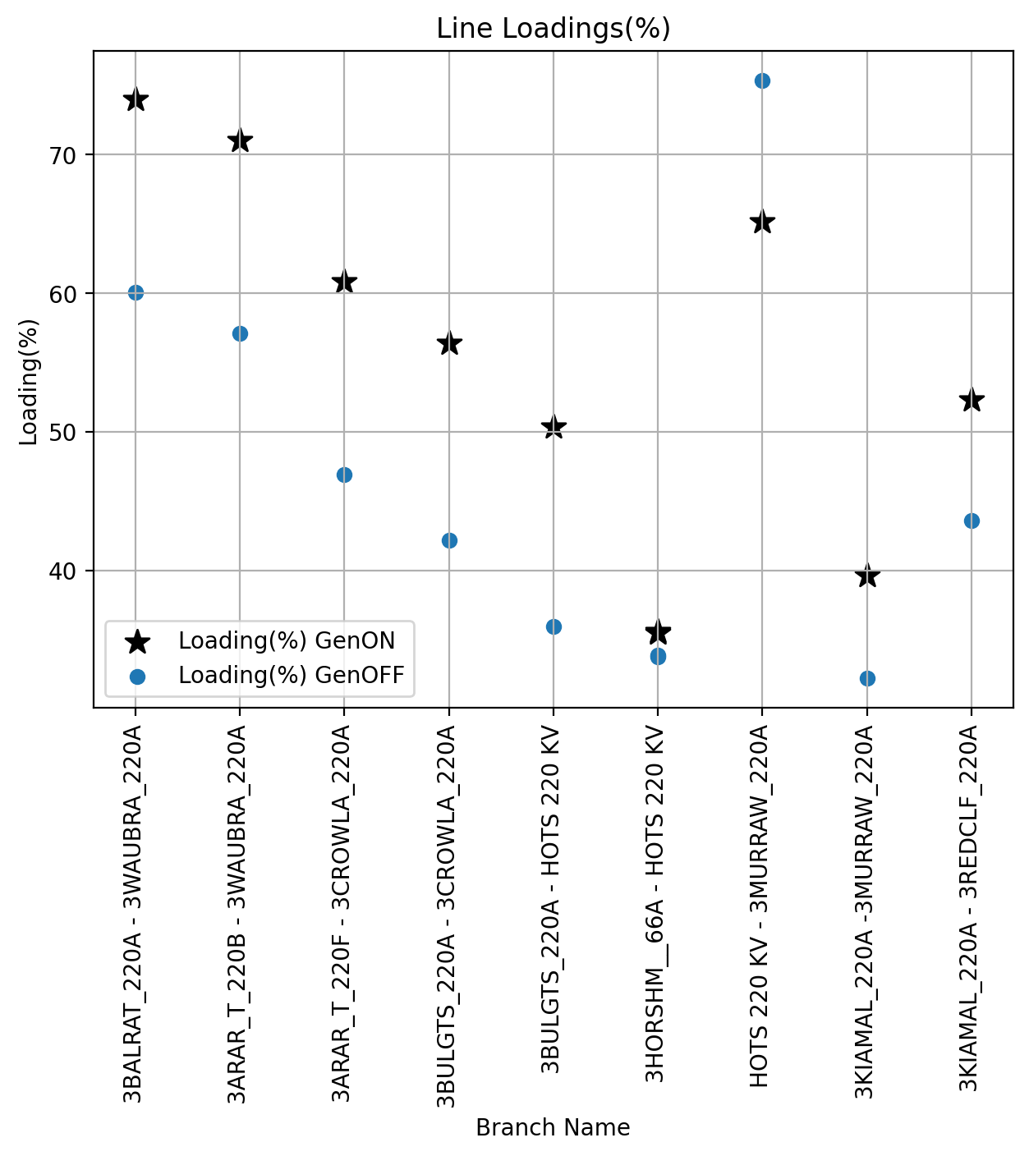

#### LowLoad

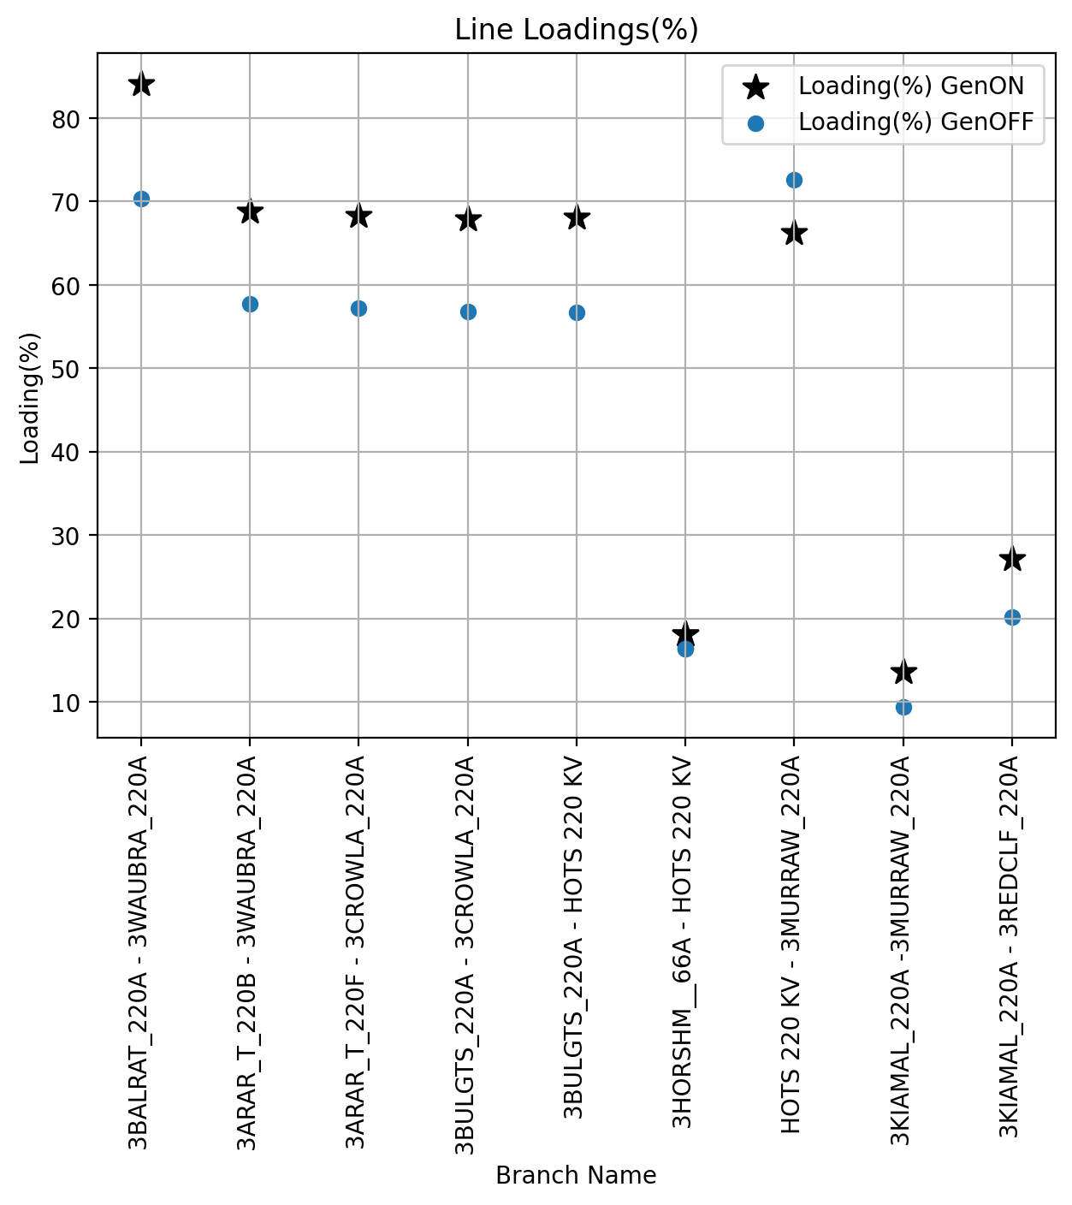

## Voltage Fluctuations for Change of Generation

This section explores the impact of a sudden loss of generation on the bus voltages at the buses of interest. The output of Horsham Solar Farm can suddenly change due to unexpected tripping of the plant or weather-related circumstances such as a change in cloud cover. A sudden change in the output of the plant must not cause a voltage disturbance larger than 3% due to loss of generation.

### Summary of findings

The maximum voltage fluctuation for each generation change case are listed in the tables below. The Case Reference column in the table below represents generation change and the corresponding row represents the maximum voltage fluctuation busbar. Full results are provided in Appendix 2. The results show that voltage fluctuations for change of generation are within the acceptable range.

#### HighLoad

|  |  |  |
| --- | --- | --- |
| Case Reference | Bus Name | Volt Fluc(%) |
| GenChange (-100% to -25%) | 3ARAR_T_220A | 0.299 |
| GenChange (-100% to -50%) | 3WAUBRA_220A | 0.262 |
| GenChange (-100% to -75%) | 3WAUBRA_220A | 0.126 |
| GenChange (100% to 25%) | 3ARAR_T_220A | 0.697 |
| GenChange (100% to 50%) | 3WAUBRA_220A | 0.519 |
| GenChange (100% to 75%) | 3WAUBRA_220A | 0.268 |

#### LowLoad

|  |  |  |
| --- | --- | --- |
| Case Reference | Bus Name | Volt Fluc(%) |
| GenChange (-100% to -25%) | 3CROWLA_220A | 0.607 |
| GenChange (-100% to -50%) | 3CROWLA_220A | 0.322 |
| GenChange (-100% to -75%) | 3BALRAT_220A | 0.067 |
| GenChange (100% to 25%) | 3ARAR_T_220A | 1.298 |
| GenChange (100% to 50%) | 3ARAR_T_220A | 0.889 |
| GenChange (100% to 75%) | 3ARAR_T_220A | 0.458 |

### Plots

The scatter plots shows the voltage profile of the network during loss of generation events prior and after connecting the proposed plant.

#### HighLoad

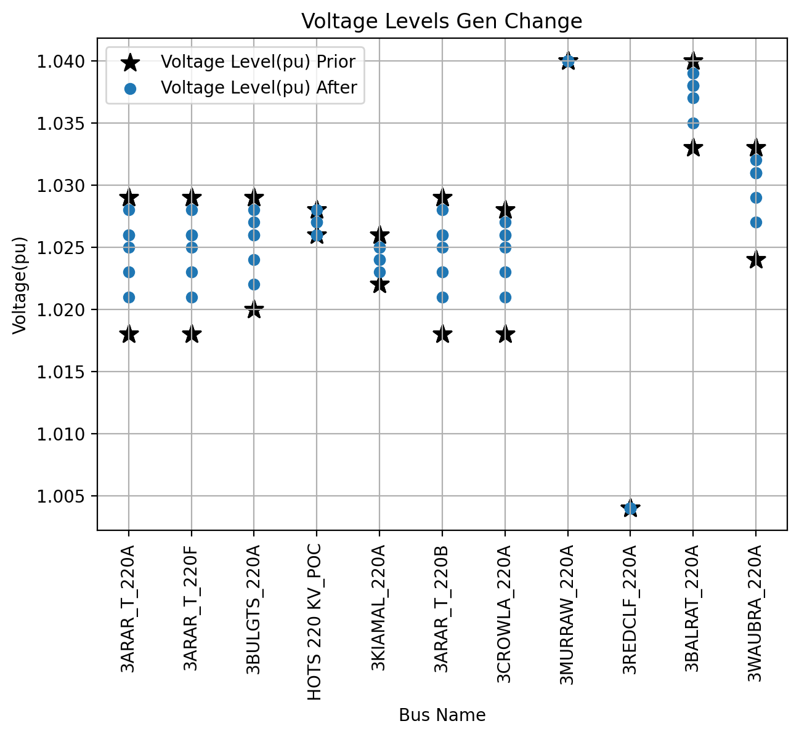

#### LowLoad

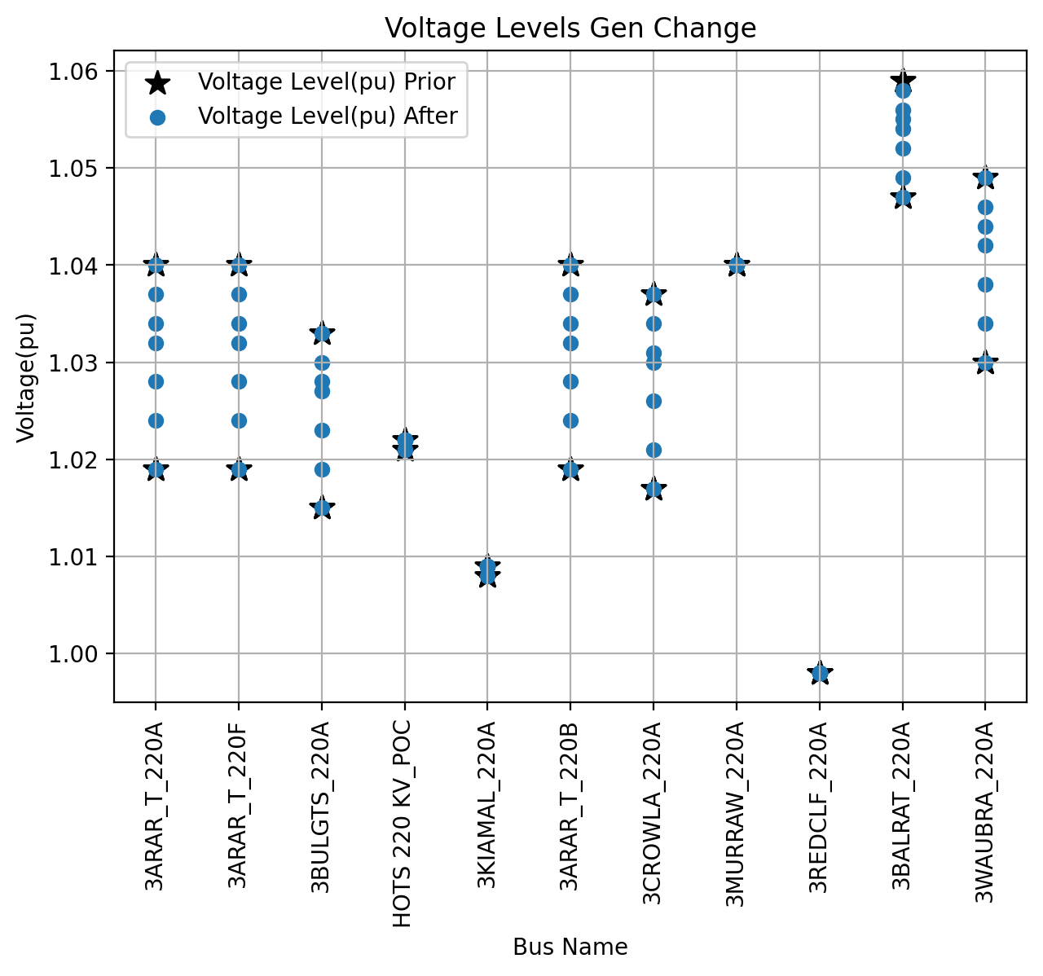

## Voltage fluctuations due to contingencies

This section explores voltage fluctuations at the buses of interest due to loss of line, loss of transformer, and generator trip contingencies. These voltage fluctuations are then compared with the existing voltage fluctuations i.e. prior connecting the proposed plant. The voltage fluctuations should not be above 5% or should not exacerbate by a value provided by the NSP.

### Summary of findings

The maximum voltage fluctuation for each bus under the given scenarios are listed in the tables below. Full results are provided in Appendix 3.

The results show that with the inclusion of HORSFBESS, the voltage fluctuations are within the acceptable range in most of the credible contingency scenarios except at the Kiamal 220kV bus (3KIAMAL_220A) due to loss of Kiamal to Redcliff 220 kV line. The existing voltage fluctuation is 5.047 % and with the addition of HORSF the voltage fluctuation exceeds to 5.6 %. Due to the small magnitude of this exacerbation i.e., 0.553% and the long distance between HORSFBESS and 3KIAMAL_220A bus, this is deemed acceptable. This exacerbation is not expected to impact system security and the limit is slightly exceeded with and without HORSFBESS present. In fact, Horsham is not causing the fluctuation and under slightly different network conditions the plant would likely mitigate the fluctuation rather than exacerbate it, given it stabilizes the voltage at HOTS 220 kV.

There are no other voltage fluctuation issues.

Table 15 Voltage fluctuation above 5% in high load scenario

|  |  |  |  |  |  |
| --- | --- | --- | --- | --- | --- |
| Case Reference | Bus Name | Voltage Level(pu) GenON | Volt Fluc(%) GenON | Voltage Level(pu) GenOFF | Volt Fluc(%) GenOFF |
| KMTS-RCTS (KIAMAL to REDCLIFF) 220kV line OOS | 3KIAMAL_220A | 1.022 | 5.6 | 1.024 | 5.047 |

#### HighLoad

|  |  |  |  |
| --- | --- | --- | --- |
| Case Reference | Bus Name | Volt Fluc(%) GenON | Volt Fluc(%) GenOFF |
| ARTS-CWTS (ARARAT to CROWNLANDS) 220kV line OOS | 3ARAR_T_220A | 3.248 | 2.548 |
| ARTS-WBTS-BATS (ARARAT to WAUBRA to BALLARAT) 220kV line OOS | 3ARAR_T_220A | 2.084 | 1.217 |
| CWTS-BGTS-HOTS (CROWNLANDS to BULGANA to HORSHAM) 220kV line OOS | 3ARAR_T_220A | 1.958 | 1.238 |
| GenTrip (-100% to 0%) | 3ARAR_T_220A | 0.62 | 0.0 |
| GenTrip (-25% to 0%) | 3ARAR_T_220A | 0.62 | 0.0 |
| GenTrip (-50% to 0%) | 3ARAR_T_220A | 0.62 | 0.0 |
| GenTrip (100% to 0%) | 3ARAR_T_220A | 0.859 | 0.0 |
| GenTrip (25% to 0%) | 3ARAR_T_220A | 0.62 | 0.0 |
| GenTrip (50% to 0%) | 3ARAR_T_220A | 0.62 | 0.0 |
| GenTrip (75% to 0%) | 3ARAR_T_220A | 0.859 | 0.0 |
| HOTS-MRTS-KMTS (HORSHAM to MURRAWARRA to KIAMAL) 220kV line OOS | 3ARAR_T_220A | 1.667 | 0.968 |
| HOTS220 - HOTS66 kV Tx OOS | 3BULGTS_220A | 0.056 | 0.028 |
| KMTS-RCTS (KIAMAL to REDCLIFF) 220kV line OOS | 3KIAMAL_220A | 5.6 | 5.047 |

#### LowLoad

|  |  |  |  |
| --- | --- | --- | --- |
| Case Reference | Bus Name | Volt Fluc(%) GenON | Volt Fluc(%) GenOFF |
| ARTS-CWTS (ARARAT to CROWNLANDS) 220kV line OOS | 3ARAR_T_220A | 3.439 | 2.425 |
| ARTS-WBTS-BATS (ARARAT to WAUBRA to BALLARAT) 220kV line OOS | 3MURRAW_220A | 3.0 | 3.0 |
| CWTS-BGTS-HOTS (CROWNLANDS to BULGANA to HORSHAM) 220kV line OOS | 3CROWLA_220A | 3.122 | 2.151 |
| GenTrip (-100% to 0%) | 3ARAR_T_220A | 1.051 | 0.0 |
| GenTrip (-25% to 0%) | 3ARAR_T_220A | 1.051 | 0.0 |
| GenTrip (-50% to 0%) | 3ARAR_T_220A | 1.051 | 0.0 |
| GenTrip (100% to 0%) | 3ARAR_T_220A | 1.997 | 0.0 |
| GenTrip (25% to 0%) | 3ARAR_T_220A | 1.051 | 0.0 |
| GenTrip (50% to 0%) | 3ARAR_T_220A | 1.051 | 0.0 |
| GenTrip (75% to 0%) | 3ARAR_T_220A | 1.997 | 0.0 |
| HOTS-MRTS-KMTS (HORSHAM to MURRAWARRA to KIAMAL) 220kV line OOS | 3BULGTS_220A | 3.541 | 1.632 |
| HOTS220 - HOTS66 kV Tx OOS | 3ARAR_T_220A | 0.036 | 0.025 |
| KMTS-RCTS (KIAMAL to REDCLIFF) 220kV line OOS | 3MURRAW_220A | 3.0 | 3.0 |

### Plots

The scatter plots show the voltage fluctuations due to loss of line, loss of transformer, and generator trip contingencies.

#### HighLoad

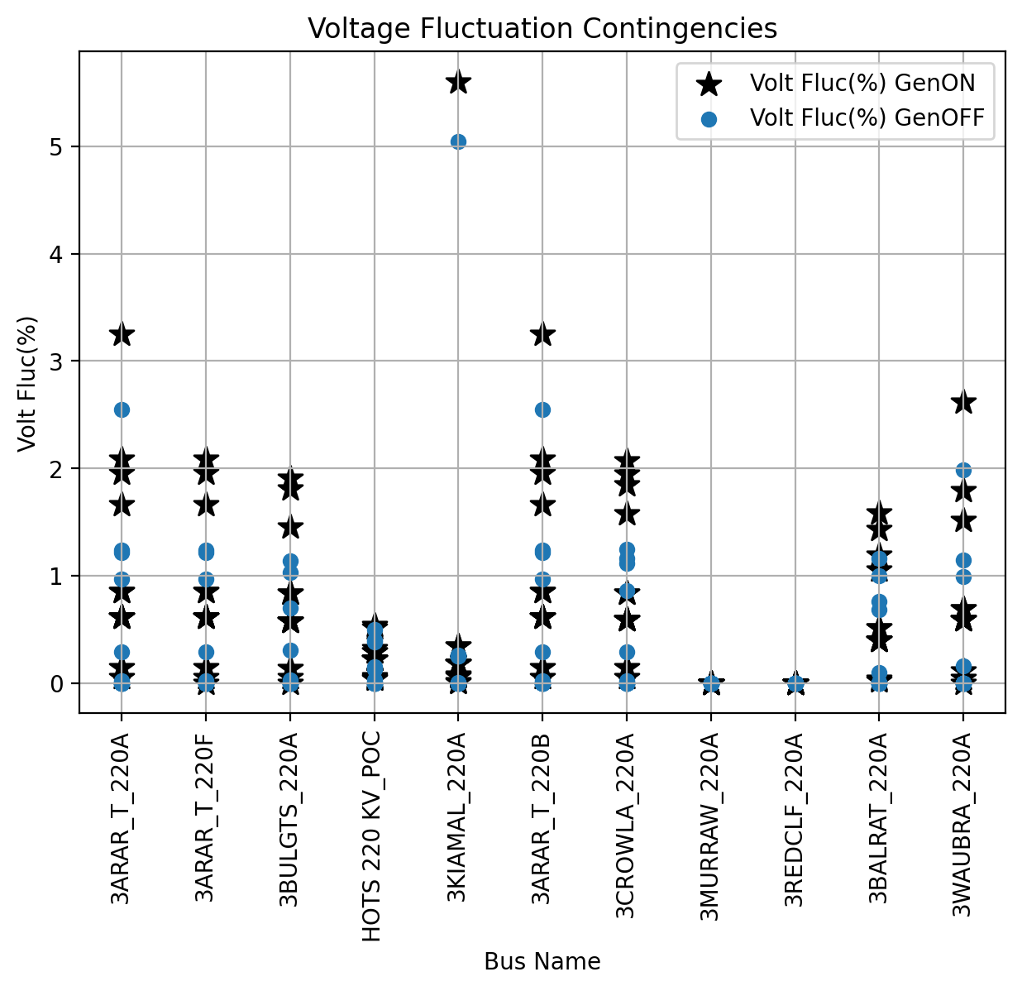

#### LowLoad

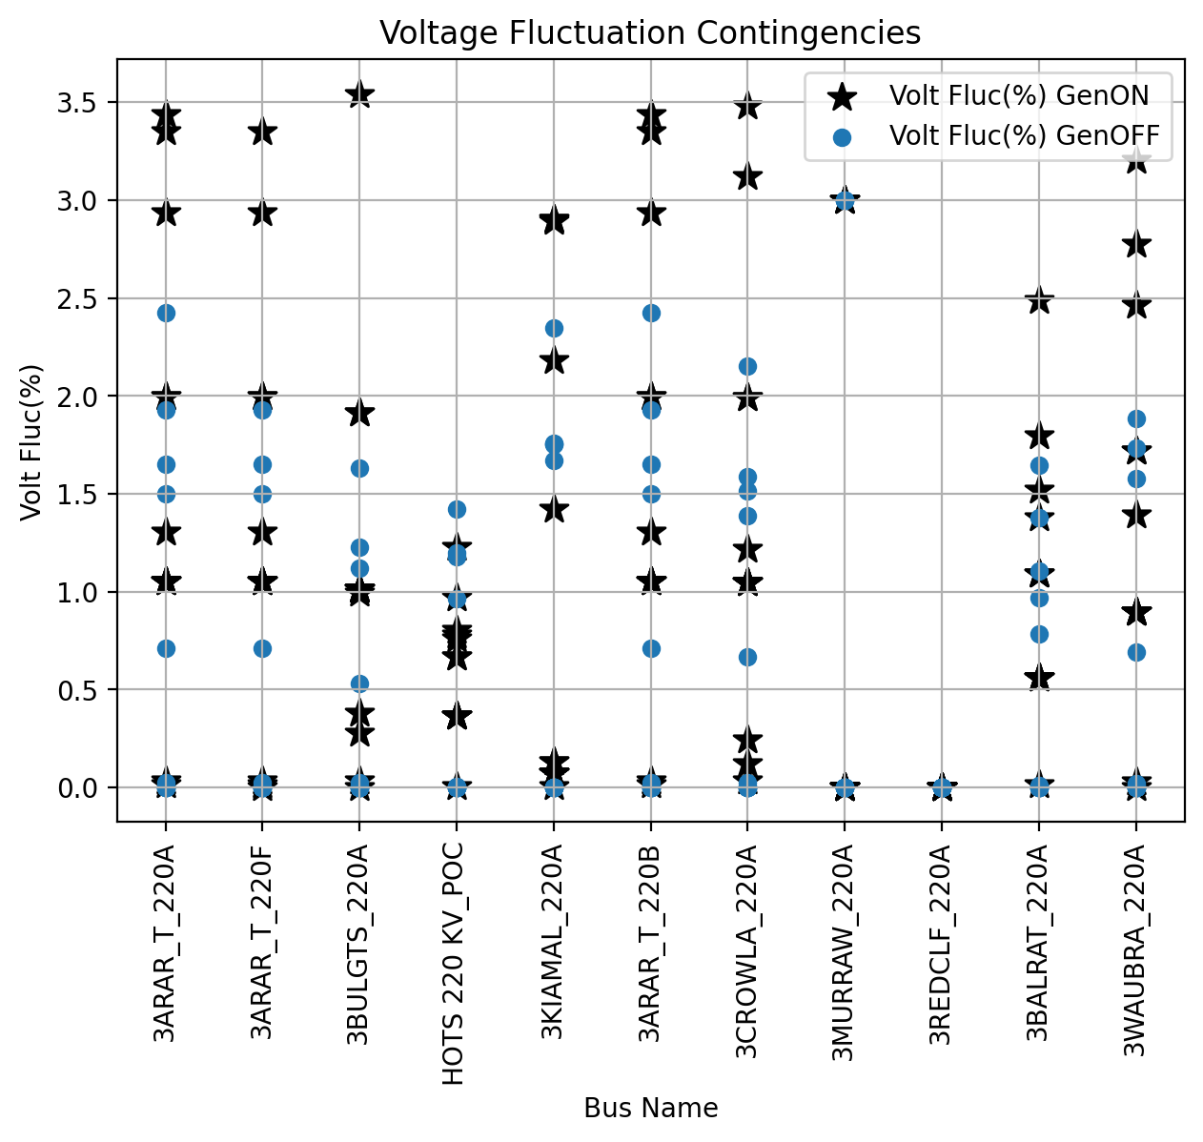

## Fault Level Analysis

The fault levels were calculated using the NCSFCC (for current source generators) and ASCC function in PSSE) for both 3 phase and phase to ground faults. The short circuit current studies have been performed on the maximum load case. Following table shows the fault levels on the monitored buses.

### HighLoad

|  |  |  |  |  |  |
| --- | --- | --- | --- | --- | --- |
| Bus Name | Bus No. | 1ph Fault (MVA) GenOFF | 1ph Fault (MVA) GenON | 3ph Fault (MVA) GenOFF | 3ph Fault (MVA) GenON |
| 3ARAR_T_220A | 306580 | 1409.74 | 1942.06 | 1478.17 | 2193.7 |
| 3ARAR_T_220F | 306585 | 1409.74 | 1942.06 | 1478.17 | 2193.7 |
| 3BULGTS_220A | 316580 | 974.27 | 1606.22 | 1177.83 | 2012.84 |
| HOTS 220 KV_POC | 334081 | 974.27 | 2072.31 | 1177.83 | 2186.6 |
| 3KIAMAL_220A | 342280 | 1887.54 | 1997.41 | 1999.38 | 2164.56 |
| 3ARAR_T_220B | 306581 | 1409.74 | 1942.06 | 1478.17 | 2193.7 |
| 3CROWLA_220A | 321580 | 1223.85 | 1784.68 | 1358.62 | 2113.02 |
| 3MURRAW_220A | 355880 | 1630.63 | 2595.19 | 1405.33 | 2290.25 |
| 3REDCLF_220A | 364080 | 2651.87 | 2697.42 | 2068.78 | 2116.17 |
| 3BALRAT_220A | 309080 | 4650.09 | 4905.09 | 4603.65 | 5043.83 |
| 3WAUBRA_220A | 384080 | 2339.81 | 2681.45 | 2388.54 | 2957.64 |

# Conclusion

Steady state study has been carried out with consideration of various test scenarios for different assessments including voltage levels and thermal loading assessments, and the results show that no issues have been identified in these assessments. In addition, the inclusion of HORSFBESS provides a reactive power support of +-47.005 MVar to enhance the stability and controllability of the existing network.

In summary, Horsham Solar Farm and BESS will improve the network with respect to voltage stability and the plant operation will be in voltage droop control mode with 3.9% droop on 47.005 MVar and a voltage setpoint of 1.02pu.

# References

|  |  |
| --- | --- |
| [1] | AEMO, "Horsham Data Pack and VIC runback schemes, fault levels, breaker clearing times". |
| [2] | AEMO, *2g_Western Vic Generation Fast trip Schemes and Murraylink VFRB,* VIC: AEMO, 2020. |

# Appendices

This section provides the detailed results where applicable for the assessments performed in this steady state analysis.

### Appendix 1

The thermal loadings for all the monitored branches in network normal and N-1 contingencies as per section 6.3.

#### HighLoad

|  |  |  |  |
| --- | --- | --- | --- |
|  |  | max |  |
| Case Reference | Branch Name | Loading(%) GenOFF | Loading(%) GenON |
| ARTS-CWTS (ARARAT to CROWNLANDS) 220kV line OOS | 3ARAR_T_220B - 3WAUBRA_220A | 9.98 | 9.98 |
|  | 3BALRAT_220A - 3WAUBRA_220A | 12.72 | 12.72 |
|  | 3BULGTS_220A - 3CROWLA_220A | 0.66 | 0.66 |
|  | 3BULGTS_220A - HOTS 220 KV | 0.66 | 0.66 |
|  | 3HORSHM__66A - HOTS 220 KV | 34.1 | 40.16 |
|  | 3KIAMAL_220A - 3REDCLF_220A | 35.4 | 59.71 |
|  | 3KIAMAL_220A -3MURRAW_220A | 25.34 | 46.02 |
|  | HOTS 220 KV - 3MURRAW_220A | 23.27 | 13.14 |
| ARTS-WBTS-BATS (ARARAT to WAUBRA to BALLARAT) 220kV line OOS | 3ARAR_T_220F - 3CROWLA_220A | 0.0 | 0.0 |
|  | 3BULGTS_220A - 3CROWLA_220A | 1.01 | 1.01 |
|  | 3BULGTS_220A - HOTS 220 KV | 1.02 | 1.02 |
|  | 3HORSHM__66A - HOTS 220 KV | 34.39 | 40.51 |
|  | 3KIAMAL_220A - 3REDCLF_220A | 35.21 | 59.51 |
|  | 3KIAMAL_220A -3MURRAW_220A | 25.18 | 45.85 |
|  | HOTS 220 KV - 3MURRAW_220A | 23.42 | 12.8 |
| CWTS-BGTS-HOTS (CROWNLANDS to BULGANA to HORSHAM) 220kV line OOS | 3ARAR_T_220B - 3WAUBRA_220A | 15.85 | 15.83 |
|  | 3ARAR_T_220F - 3CROWLA_220A | 6.32 | 6.28 |
|  | 3BALRAT_220A - 3WAUBRA_220A | 18.28 | 18.27 |
|  | 3HORSHM__66A - HOTS 220 KV | 33.97 | 40.0 |
|  | 3KIAMAL_220A - 3REDCLF_220A | 35.49 | 59.81 |
|  | 3KIAMAL_220A -3MURRAW_220A | 25.42 | 46.1 |
|  | HOTS 220 KV - 3MURRAW_220A | 24.07 | 15.39 |
| GenTrip (-100% to 0%) | 3ARAR_T_220B - 3WAUBRA_220A | 57.07 | 64.15 |
|  | 3ARAR_T_220F - 3CROWLA_220A | 46.93 | 53.98 |
|  | 3BALRAT_220A - 3WAUBRA_220A | 60.04 | 66.89 |
|  | 3BULGTS_220A - 3CROWLA_220A | 42.15 | 49.32 |
|  | 3BULGTS_220A - HOTS 220 KV | 35.97 | 43.25 |
|  | 3HORSHM__66A - HOTS 220 KV | 33.89 | 34.72 |
|  | 3KIAMAL_220A - 3REDCLF_220A | 43.56 | 47.85 |
|  | 3KIAMAL_220A -3MURRAW_220A | 32.24 | 35.88 |
|  | HOTS 220 KV - 3MURRAW_220A | 75.31 | 70.43 |
| GenTrip (-25% to 0%) | 3ARAR_T_220B - 3WAUBRA_220A | 57.07 | 64.15 |
|  | 3ARAR_T_220F - 3CROWLA_220A | 46.93 | 53.98 |
|  | 3BALRAT_220A - 3WAUBRA_220A | 60.04 | 66.89 |
|  | 3BULGTS_220A - 3CROWLA_220A | 42.15 | 49.32 |
|  | 3BULGTS_220A - HOTS 220 KV | 35.97 | 43.25 |
|  | 3HORSHM__66A - HOTS 220 KV | 33.89 | 34.72 |
|  | 3KIAMAL_220A - 3REDCLF_220A | 43.56 | 47.85 |
|  | 3KIAMAL_220A -3MURRAW_220A | 32.24 | 35.88 |
|  | HOTS 220 KV - 3MURRAW_220A | 75.31 | 70.43 |
| GenTrip (-50% to 0%) | 3ARAR_T_220B - 3WAUBRA_220A | 57.07 | 64.15 |
|  | 3ARAR_T_220F - 3CROWLA_220A | 46.93 | 53.98 |
|  | 3BALRAT_220A - 3WAUBRA_220A | 60.04 | 66.89 |
|  | 3BULGTS_220A - 3CROWLA_220A | 42.15 | 49.32 |
|  | 3BULGTS_220A - HOTS 220 KV | 35.97 | 43.25 |
|  | 3HORSHM__66A - HOTS 220 KV | 33.89 | 34.72 |
|  | 3KIAMAL_220A - 3REDCLF_220A | 43.56 | 47.85 |
|  | 3KIAMAL_220A -3MURRAW_220A | 32.24 | 35.88 |
|  | HOTS 220 KV - 3MURRAW_220A | 75.31 | 70.43 |
| GenTrip (100% to 0%) | 3ARAR_T_220B - 3WAUBRA_220A | 57.07 | 56.88 |
|  | 3ARAR_T_220F - 3CROWLA_220A | 46.93 | 46.74 |
|  | 3BALRAT_220A - 3WAUBRA_220A | 60.04 | 60.13 |
|  | 3BULGTS_220A - 3CROWLA_220A | 42.15 | 41.97 |
|  | 3BULGTS_220A - HOTS 220 KV | 35.97 | 35.86 |
|  | 3HORSHM__66A - HOTS 220 KV | 33.89 | 33.94 |
|  | 3KIAMAL_220A - 3REDCLF_220A | 43.56 | 43.51 |
|  | 3KIAMAL_220A -3MURRAW_220A | 32.24 | 32.22 |
|  | HOTS 220 KV - 3MURRAW_220A | 75.31 | 75.58 |
| GenTrip (25% to 0%) | 3ARAR_T_220B - 3WAUBRA_220A | 57.07 | 64.15 |
|  | 3ARAR_T_220F - 3CROWLA_220A | 46.93 | 53.98 |
|  | 3BALRAT_220A - 3WAUBRA_220A | 60.04 | 66.89 |
|  | 3BULGTS_220A - 3CROWLA_220A | 42.15 | 49.32 |
|  | 3BULGTS_220A - HOTS 220 KV | 35.97 | 43.25 |
|  | 3HORSHM__66A - HOTS 220 KV | 33.89 | 34.72 |
|  | 3KIAMAL_220A - 3REDCLF_220A | 43.56 | 47.85 |
|  | 3KIAMAL_220A -3MURRAW_220A | 32.24 | 35.88 |
|  | HOTS 220 KV - 3MURRAW_220A | 75.31 | 70.43 |
| GenTrip (50% to 0%) | 3ARAR_T_220B - 3WAUBRA_220A | 57.07 | 64.15 |
|  | 3ARAR_T_220F - 3CROWLA_220A | 46.93 | 53.98 |
|  | 3BALRAT_220A - 3WAUBRA_220A | 60.04 | 66.89 |
|  | 3BULGTS_220A - 3CROWLA_220A | 42.15 | 49.32 |
|  | 3BULGTS_220A - HOTS 220 KV | 35.97 | 43.25 |
|  | 3HORSHM__66A - HOTS 220 KV | 33.89 | 34.72 |
|  | 3KIAMAL_220A - 3REDCLF_220A | 43.56 | 47.85 |
|  | 3KIAMAL_220A -3MURRAW_220A | 32.24 | 35.88 |
|  | HOTS 220 KV - 3MURRAW_220A | 75.31 | 70.43 |
| GenTrip (75% to 0%) | 3ARAR_T_220B - 3WAUBRA_220A | 57.07 | 56.88 |
|  | 3ARAR_T_220F - 3CROWLA_220A | 46.93 | 46.74 |
|  | 3BALRAT_220A - 3WAUBRA_220A | 60.04 | 60.13 |
|  | 3BULGTS_220A - 3CROWLA_220A | 42.15 | 41.97 |
|  | 3BULGTS_220A - HOTS 220 KV | 35.97 | 35.86 |
|  | 3HORSHM__66A - HOTS 220 KV | 33.89 | 33.94 |
|  | 3KIAMAL_220A - 3REDCLF_220A | 43.56 | 43.51 |
|  | 3KIAMAL_220A -3MURRAW_220A | 32.24 | 32.22 |
|  | HOTS 220 KV - 3MURRAW_220A | 75.31 | 75.58 |
| HOTS-MRTS-KMTS (HORSHAM to MURRAWARRA to KIAMAL) 220kV line OOS | 3ARAR_T_220B - 3WAUBRA_220A | 10.5 | 31.18 |
|  | 3ARAR_T_220F - 3CROWLA_220A | 4.08 | 21.16 |
|  | 3BALRAT_220A - 3WAUBRA_220A | 12.49 | 34.01 |
|  | 3BULGTS_220A - 3CROWLA_220A | 6.02 | 15.83 |
|  | 3BULGTS_220A - HOTS 220 KV | 12.48 | 9.77 |
|  | 3HORSHM__66A - HOTS 220 KV | 29.55 | 31.26 |
|  | 3KIAMAL_220A - 3REDCLF_220A | 7.13 | 7.13 |
| HOTS220 - HOTS66 kV Tx OOS | 3ARAR_T_220B - 3WAUBRA_220A | 57.64 | 71.54 |
|  | 3ARAR_T_220F - 3CROWLA_220A | 47.49 | 61.35 |
|  | 3BALRAT_220A - 3WAUBRA_220A | 60.54 | 74.59 |
|  | 3BULGTS_220A - 3CROWLA_220A | 42.72 | 56.94 |
|  | 3BULGTS_220A - HOTS 220 KV | 36.54 | 50.9 |
|  | 3HORSHM__66A - HOTS 220 KV | 65.94 | 69.05 |
|  | 3KIAMAL_220A - 3REDCLF_220A | 43.81 | 52.59 |
|  | 3KIAMAL_220A -3MURRAW_220A | 32.45 | 39.86 |
|  | HOTS 220 KV - 3MURRAW_220A | 75.0 | 64.83 |
| KMTS-RCTS (KIAMAL to REDCLIFF) 220kV line OOS | 3ARAR_T_220B - 3WAUBRA_220A | 48.57 | 68.83 |
|  | 3ARAR_T_220F - 3CROWLA_220A | 38.45 | 58.65 |
|  | 3BALRAT_220A - 3WAUBRA_220A | 51.79 | 71.74 |
|  | 3BULGTS_220A - 3CROWLA_220A | 33.55 | 54.16 |
|  | 3BULGTS_220A - HOTS 220 KV | 27.32 | 48.11 |
|  | 3HORSHM__66A - HOTS 220 KV | 33.03 | 35.31 |
|  | 3KIAMAL_220A -3MURRAW_220A | 5.18 | 5.69 |
|  | HOTS 220 KV - 3MURRAW_220A | 61.58 | 61.56 |
| Network normal | 3ARAR_T_220B - 3WAUBRA_220A | 57.07 | 70.98 |
|  | 3ARAR_T_220F - 3CROWLA_220A | 46.93 | 60.79 |
|  | 3BALRAT_220A - 3WAUBRA_220A | 60.04 | 73.99 |
|  | 3BULGTS_220A - 3CROWLA_220A | 42.15 | 56.36 |
|  | 3BULGTS_220A - HOTS 220 KV | 35.97 | 50.32 |
|  | 3HORSHM__66A - HOTS 220 KV | 33.89 | 35.57 |
|  | 3KIAMAL_220A - 3REDCLF_220A | 43.56 | 52.3 |
|  | 3KIAMAL_220A -3MURRAW_220A | 32.24 | 39.62 |
|  | HOTS 220 KV - 3MURRAW_220A | 75.31 | 65.16 |

#### LowLoad

|  |  |  |  |
| --- | --- | --- | --- |
|  |  | max |  |
| Case Reference | Branch Name | Loading(%) GenOFF | Loading(%) GenON |
| ARTS-CWTS (ARARAT to CROWNLANDS) 220kV line OOS | 3ARAR_T_220B - 3WAUBRA_220A | 4.37 | 4.37 |
|  | 3BALRAT_220A - 3WAUBRA_220A | 6.51 | 6.52 |
|  | 3BULGTS_220A - 3CROWLA_220A | 0.52 | 0.52 |
|  | 3BULGTS_220A - HOTS 220 KV | 0.52 | 0.52 |
|  | 3HORSHM__66A - HOTS 220 KV | 26.1 | 33.09 |
|  | 3KIAMAL_220A - 3REDCLF_220A | 43.06 | 62.58 |
|  | 3KIAMAL_220A -3MURRAW_220A | 26.83 | 46.07 |
|  | HOTS 220 KV - 3MURRAW_220A | 11.84 | 7.35 |
| ARTS-WBTS-BATS (ARARAT to WAUBRA to BALLARAT) 220kV line OOS | 3ARAR_T_220F - 3CROWLA_220A | 0.0 | 0.0 |
|  | 3BULGTS_220A - 3CROWLA_220A | 0.8 | 0.8 |
|  | 3BULGTS_220A - HOTS 220 KV | 0.8 | 0.81 |
|  | 3HORSHM__66A - HOTS 220 KV | 26.25 | 33.25 |
|  | 3KIAMAL_220A - 3REDCLF_220A | 42.98 | 62.51 |
|  | 3KIAMAL_220A -3MURRAW_220A | 26.76 | 46.0 |
|  | HOTS 220 KV - 3MURRAW_220A | 11.95 | 7.29 |
| CWTS-BGTS-HOTS (CROWNLANDS to BULGANA to HORSHAM) 220kV line OOS | 3ARAR_T_220B - 3WAUBRA_220A | 5.37 | 5.38 |
|  | 3ARAR_T_220F - 3CROWLA_220A | 1.11 | 1.12 |
|  | 3BALRAT_220A - 3WAUBRA_220A | 7.33 | 7.35 |
|  | 3HORSHM__66A - HOTS 220 KV | 26.04 | 33.02 |
|  | 3KIAMAL_220A - 3REDCLF_220A | 43.11 | 62.62 |
|  | 3KIAMAL_220A -3MURRAW_220A | 26.88 | 46.11 |
|  | HOTS 220 KV - 3MURRAW_220A | 11.61 | 7.49 |
| GenTrip (-100% to 0%) | 3ARAR_T_220B - 3WAUBRA_220A | 57.7 | 63.28 |
|  | 3ARAR_T_220F - 3CROWLA_220A | 57.25 | 62.75 |
|  | 3BALRAT_220A - 3WAUBRA_220A | 70.31 | 77.1 |
|  | 3BULGTS_220A - 3CROWLA_220A | 56.79 | 62.36 |
|  | 3BULGTS_220A - HOTS 220 KV | 56.69 | 62.59 |
|  | 3HORSHM__66A - HOTS 220 KV | 16.39 | 17.28 |
|  | 3KIAMAL_220A - 3REDCLF_220A | 20.19 | 23.53 |
|  | 3KIAMAL_220A -3MURRAW_220A | 9.43 | 11.04 |
|  | HOTS 220 KV - 3MURRAW_220A | 72.6 | 69.71 |
| GenTrip (-25% to 0%) | 3ARAR_T_220B - 3WAUBRA_220A | 57.7 | 63.28 |
|  | 3ARAR_T_220F - 3CROWLA_220A | 57.25 | 62.75 |
|  | 3BALRAT_220A - 3WAUBRA_220A | 70.31 | 77.1 |
|  | 3BULGTS_220A - 3CROWLA_220A | 56.79 | 62.36 |
|  | 3BULGTS_220A - HOTS 220 KV | 56.69 | 62.59 |
|  | 3HORSHM__66A - HOTS 220 KV | 16.39 | 17.28 |
|  | 3KIAMAL_220A - 3REDCLF_220A | 20.19 | 23.53 |
|  | 3KIAMAL_220A -3MURRAW_220A | 9.43 | 11.04 |
|  | HOTS 220 KV - 3MURRAW_220A | 72.6 | 69.71 |
| GenTrip (-50% to 0%) | 3ARAR_T_220B - 3WAUBRA_220A | 57.7 | 63.28 |
|  | 3ARAR_T_220F - 3CROWLA_220A | 57.25 | 62.75 |
|  | 3BALRAT_220A - 3WAUBRA_220A | 70.31 | 77.1 |
|  | 3BULGTS_220A - 3CROWLA_220A | 56.79 | 62.36 |
|  | 3BULGTS_220A - HOTS 220 KV | 56.69 | 62.59 |
|  | 3HORSHM__66A - HOTS 220 KV | 16.39 | 17.28 |
|  | 3KIAMAL_220A - 3REDCLF_220A | 20.19 | 23.53 |
|  | 3KIAMAL_220A -3MURRAW_220A | 9.43 | 11.04 |
|  | HOTS 220 KV - 3MURRAW_220A | 72.6 | 69.71 |
| GenTrip (100% to 0%) | 3ARAR_T_220B - 3WAUBRA_220A | 57.7 | 57.6 |
|  | 3ARAR_T_220F - 3CROWLA_220A | 57.25 | 57.08 |
|  | 3BALRAT_220A - 3WAUBRA_220A | 70.31 | 70.06 |
|  | 3BULGTS_220A - 3CROWLA_220A | 56.79 | 56.68 |
|  | 3BULGTS_220A - HOTS 220 KV | 56.69 | 56.98 |
|  | 3HORSHM__66A - HOTS 220 KV | 16.39 | 16.46 |
|  | 3KIAMAL_220A - 3REDCLF_220A | 20.19 | 19.99 |
|  | 3KIAMAL_220A -3MURRAW_220A | 9.43 | 9.26 |
|  | HOTS 220 KV - 3MURRAW_220A | 72.6 | 73.22 |
| GenTrip (25% to 0%) | 3ARAR_T_220B - 3WAUBRA_220A | 57.7 | 63.28 |
|  | 3ARAR_T_220F - 3CROWLA_220A | 57.25 | 62.75 |
|  | 3BALRAT_220A - 3WAUBRA_220A | 70.31 | 77.1 |
|  | 3BULGTS_220A - 3CROWLA_220A | 56.79 | 62.36 |
|  | 3BULGTS_220A - HOTS 220 KV | 56.69 | 62.59 |
|  | 3HORSHM__66A - HOTS 220 KV | 16.39 | 17.28 |
|  | 3KIAMAL_220A - 3REDCLF_220A | 20.19 | 23.53 |
|  | 3KIAMAL_220A -3MURRAW_220A | 9.43 | 11.04 |
|  | HOTS 220 KV - 3MURRAW_220A | 72.6 | 69.71 |
| GenTrip (50% to 0%) | 3ARAR_T_220B - 3WAUBRA_220A | 57.7 | 63.28 |
|  | 3ARAR_T_220F - 3CROWLA_220A | 57.25 | 62.75 |
|  | 3BALRAT_220A - 3WAUBRA_220A | 70.31 | 77.1 |
|  | 3BULGTS_220A - 3CROWLA_220A | 56.79 | 62.36 |
|  | 3BULGTS_220A - HOTS 220 KV | 56.69 | 62.59 |
|  | 3HORSHM__66A - HOTS 220 KV | 16.39 | 17.28 |
|  | 3KIAMAL_220A - 3REDCLF_220A | 20.19 | 23.53 |
|  | 3KIAMAL_220A -3MURRAW_220A | 9.43 | 11.04 |
|  | HOTS 220 KV - 3MURRAW_220A | 72.6 | 69.71 |
| GenTrip (75% to 0%) | 3ARAR_T_220B - 3WAUBRA_220A | 57.7 | 57.6 |
|  | 3ARAR_T_220F - 3CROWLA_220A | 57.25 | 57.08 |
|  | 3BALRAT_220A - 3WAUBRA_220A | 70.31 | 70.06 |
|  | 3BULGTS_220A - 3CROWLA_220A | 56.79 | 56.68 |
|  | 3BULGTS_220A - HOTS 220 KV | 56.69 | 56.98 |
|  | 3HORSHM__66A - HOTS 220 KV | 16.39 | 16.46 |
|  | 3KIAMAL_220A - 3REDCLF_220A | 20.19 | 19.99 |
|  | 3KIAMAL_220A -3MURRAW_220A | 9.43 | 9.26 |
|  | HOTS 220 KV - 3MURRAW_220A | 72.6 | 73.22 |
| HOTS-MRTS-KMTS (HORSHAM to MURRAWARRA to KIAMAL) 220kV line OOS | 3ARAR_T_220B - 3WAUBRA_220A | 8.13 | 20.42 |
|  | 3ARAR_T_220F - 3CROWLA_220A | 4.56 | 16.94 |
|  | 3BALRAT_220A - 3WAUBRA_220A | 9.41 | 26.56 |
|  | 3BULGTS_220A - 3CROWLA_220A | 4.02 | 16.73 |
|  | 3BULGTS_220A - HOTS 220 KV | 6.16 | 17.33 |
|  | 3HORSHM__66A - HOTS 220 KV | 11.54 | 12.48 |
|  | 3KIAMAL_220A - 3REDCLF_220A | 17.26 | 17.08 |
| HOTS220 - HOTS66 kV Tx OOS | 3ARAR_T_220B - 3WAUBRA_220A | 57.93 | 69.04 |
|  | 3ARAR_T_220F - 3CROWLA_220A | 57.47 | 68.51 |
|  | 3BALRAT_220A - 3WAUBRA_220A | 70.59 | 84.38 |
|  | 3BULGTS_220A - 3CROWLA_220A | 57.01 | 68.12 |
|  | 3BULGTS_220A - HOTS 220 KV | 56.91 | 68.31 |
|  | 3HORSHM__66A - HOTS 220 KV | 31.28 | 34.57 |
|  | 3KIAMAL_220A - 3REDCLF_220A | 20.3 | 27.26 |
|  | 3KIAMAL_220A -3MURRAW_220A | 9.47 | 13.67 |
|  | HOTS 220 KV - 3MURRAW_220A | 72.5 | 66.12 |
| KMTS-RCTS (KIAMAL to REDCLIFF) 220kV line OOS | 3ARAR_T_220B - 3WAUBRA_220A | 41.45 | 57.62 |
|  | 3ARAR_T_220F - 3CROWLA_220A | 40.92 | 57.26 |
|  | 3BALRAT_220A - 3WAUBRA_220A | 52.11 | 70.36 |
|  | 3BULGTS_220A - 3CROWLA_220A | 40.43 | 56.71 |
|  | 3BULGTS_220A - HOTS 220 KV | 40.47 | 57.1 |
|  | 3HORSHM__66A - HOTS 220 KV | 13.93 | 16.06 |
|  | 3KIAMAL_220A -3MURRAW_220A | 17.21 | 17.04 |
|  | HOTS 220 KV - 3MURRAW_220A | 52.22 | 52.31 |
| Network normal | 3ARAR_T_220B - 3WAUBRA_220A | 57.7 | 68.79 |
|  | 3ARAR_T_220F - 3CROWLA_220A | 57.25 | 68.27 |
|  | 3BALRAT_220A - 3WAUBRA_220A | 70.31 | 84.07 |
|  | 3BULGTS_220A - 3CROWLA_220A | 56.79 | 67.88 |
|  | 3BULGTS_220A - HOTS 220 KV | 56.69 | 68.07 |
|  | 3HORSHM__66A - HOTS 220 KV | 16.39 | 18.12 |
|  | 3KIAMAL_220A - 3REDCLF_220A | 20.19 | 27.14 |
|  | 3KIAMAL_220A -3MURRAW_220A | 9.43 | 13.58 |
|  | HOTS 220 KV - 3MURRAW_220A | 72.6 | 66.23 |

### Appendix 2

The voltage fluctuations due to change in generation output on all the monitored buses as per section 6.4.

#### HighLoad

|  |  |  |  |  |
| --- | --- | --- | --- | --- |
|  |  | max |  |  |
| Case Reference | Bus Name | Volt Fluc(%) | Voltage Level(pu) After | Voltage Level(pu) Prior |
| GenChange (-100% to -25%) | 3ARAR_T_220A | 0.299 | 1.026 | 1.029 |
|  | 3ARAR_T_220B | 0.299 | 1.026 | 1.029 |
|  | 3ARAR_T_220F | 0.299 | 1.026 | 1.029 |
|  | 3BALRAT_220A | 0.198 | 1.038 | 1.04 |
|  | 3BULGTS_220A | 0.25 | 1.026 | 1.029 |
|  | 3CROWLA_220A | 0.28 | 1.026 | 1.028 |
|  | 3KIAMAL_220A | 0.17 | 1.024 | 1.026 |
|  | 3MURRAW_220A | 0.0 | 1.04 | 1.04 |
|  | 3REDCLF_220A | 0.0 | 1.004 | 1.004 |
|  | 3WAUBRA_220A | 0.264 | 1.031 | 1.033 |
|  | HOTS 220 KV_POC | 0.09 | 1.026 | 1.026 |
| GenChange (-100% to -50%) | 3ARAR_T_220A | 0.252 | 1.026 | 1.029 |
|  | 3ARAR_T_220B | 0.252 | 1.026 | 1.029 |
|  | 3ARAR_T_220F | 0.252 | 1.026 | 1.029 |
|  | 3BALRAT_220A | 0.171 | 1.038 | 1.04 |
|  | 3BULGTS_220A | 0.203 | 1.027 | 1.029 |
|  | 3CROWLA_220A | 0.232 | 1.026 | 1.028 |
|  | 3KIAMAL_220A | 0.111 | 1.025 | 1.026 |
|  | 3MURRAW_220A | 0.0 | 1.04 | 1.04 |
|  | 3REDCLF_220A | 0.0 | 1.004 | 1.004 |
|  | 3WAUBRA_220A | 0.262 | 1.031 | 1.033 |
|  | HOTS 220 KV_POC | 0.055 | 1.026 | 1.026 |
| GenChange (-100% to -75%) | 3ARAR_T_220A | 0.12 | 1.028 | 1.029 |
|  | 3ARAR_T_220B | 0.12 | 1.028 | 1.029 |
|  | 3ARAR_T_220F | 0.12 | 1.028 | 1.029 |
|  | 3BALRAT_220A | 0.082 | 1.039 | 1.04 |
|  | 3BULGTS_220A | 0.096 | 1.028 | 1.029 |
|  | 3CROWLA_220A | 0.11 | 1.027 | 1.028 |
|  | 3KIAMAL_220A | 0.054 | 1.025 | 1.026 |
|  | 3MURRAW_220A | 0.0 | 1.04 | 1.04 |
|  | 3REDCLF_220A | 0.0 | 1.004 | 1.004 |
|  | 3WAUBRA_220A | 0.126 | 1.032 | 1.033 |
|  | HOTS 220 KV_POC | 0.029 | 1.026 | 1.026 |
| GenChange (100% to 25%) | 3ARAR_T_220A | 0.697 | 1.025 | 1.018 |
|  | 3ARAR_T_220B | 0.697 | 1.025 | 1.018 |
|  | 3ARAR_T_220F | 0.697 | 1.025 | 1.018 |
|  | 3BALRAT_220A | 0.483 | 1.038 | 1.033 |
|  | 3BULGTS_220A | 0.603 | 1.026 | 1.02 |
|  | 3CROWLA_220A | 0.656 | 1.025 | 1.018 |
|  | 3KIAMAL_220A | 0.266 | 1.025 | 1.022 |
|  | 3MURRAW_220A | 0.0 | 1.04 | 1.04 |
|  | 3REDCLF_220A | 0.0 | 1.004 | 1.004 |
|  | 3WAUBRA_220A | 0.69 | 1.031 | 1.024 |
|  | HOTS 220 KV_POC | 0.019 | 1.027 | 1.028 |
| GenChange (100% to 50%) | 3ARAR_T_220A | 0.511 | 1.023 | 1.018 |
|  | 3ARAR_T_220B | 0.511 | 1.023 | 1.018 |
|  | 3ARAR_T_220F | 0.511 | 1.023 | 1.018 |
|  | 3BALRAT_220A | 0.36 | 1.037 | 1.033 |
|  | 3BULGTS_220A | 0.44 | 1.024 | 1.02 |
|  | 3CROWLA_220A | 0.479 | 1.023 | 1.018 |
|  | 3KIAMAL_220A | 0.182 | 1.024 | 1.022 |
|  | 3MURRAW_220A | 0.0 | 1.04 | 1.04 |
|  | 3REDCLF_220A | 0.0 | 1.004 | 1.004 |
|  | 3WAUBRA_220A | 0.519 | 1.029 | 1.024 |
|  | HOTS 220 KV_POC | 0.003 | 1.027 | 1.028 |
| GenChange (100% to 75%) | 3ARAR_T_220A | 0.264 | 1.021 | 1.018 |
|  | 3ARAR_T_220B | 0.264 | 1.021 | 1.018 |
|  | 3ARAR_T_220F | 0.264 | 1.021 | 1.018 |
|  | 3BALRAT_220A | 0.186 | 1.035 | 1.033 |
|  | 3BULGTS_220A | 0.228 | 1.022 | 1.02 |
|  | 3CROWLA_220A | 0.248 | 1.021 | 1.018 |
|  | 3KIAMAL_220A | 0.093 | 1.023 | 1.022 |
|  | 3MURRAW_220A | 0.0 | 1.04 | 1.04 |
|  | 3REDCLF_220A | 0.0 | 1.004 | 1.004 |
|  | 3WAUBRA_220A | 0.268 | 1.027 | 1.024 |
|  | HOTS 220 KV_POC | 0.001 | 1.028 | 1.028 |

#### LowLoad

|  |  |  |  |  |
| --- | --- | --- | --- | --- |
|  |  | max |  |  |
| Case Reference | Bus Name | Volt Fluc(%) | Voltage Level(pu) After | Voltage Level(pu) Prior |
| GenChange (-100% to -25%) | 3ARAR_T_220A | 0.606 | 1.034 | 1.04 |
|  | 3ARAR_T_220B | 0.606 | 1.034 | 1.04 |
|  | 3ARAR_T_220F | 0.606 | 1.034 | 1.04 |
|  | 3BALRAT_220A | 0.436 | 1.055 | 1.059 |
|  | 3BULGTS_220A | 0.576 | 1.028 | 1.033 |
|  | 3CROWLA_220A | 0.607 | 1.031 | 1.037 |
|  | 3KIAMAL_220A | 0.036 | 1.009 | 1.009 |
|  | 3MURRAW_220A | 0.0 | 1.04 | 1.04 |
|  | 3REDCLF_220A | 0.0 | 0.998 | 0.998 |
|  | 3WAUBRA_220A | 0.556 | 1.044 | 1.049 |
|  | HOTS 220 KV_POC | 0.006 | 1.022 | 1.022 |
| GenChange (-100% to -50%) | 3ARAR_T_220A | 0.316 | 1.037 | 1.04 |
|  | 3ARAR_T_220B | 0.316 | 1.037 | 1.04 |
|  | 3ARAR_T_220F | 0.316 | 1.037 | 1.04 |
|  | 3BALRAT_220A | 0.262 | 1.056 | 1.059 |
|  | 3BULGTS_220A | 0.314 | 1.03 | 1.033 |
|  | 3CROWLA_220A | 0.322 | 1.034 | 1.037 |
|  | 3KIAMAL_220A | 0.021 | 1.009 | 1.009 |
|  | 3MURRAW_220A | 0.0 | 1.04 | 1.04 |
|  | 3REDCLF_220A | 0.0 | 0.998 | 0.998 |
|  | 3WAUBRA_220A | 0.293 | 1.046 | 1.049 |
|  | HOTS 220 KV_POC | 0.011 | 1.022 | 1.022 |
| GenChange (-100% to -75%) | 3ARAR_T_220A | 0.022 | 1.04 | 1.04 |
|  | 3ARAR_T_220B | 0.022 | 1.04 | 1.04 |
|  | 3ARAR_T_220F | 0.022 | 1.04 | 1.04 |
|  | 3BALRAT_220A | 0.067 | 1.058 | 1.059 |
|  | 3BULGTS_220A | 0.051 | 1.033 | 1.033 |
|  | 3CROWLA_220A | 0.036 | 1.037 | 1.037 |
|  | 3KIAMAL_220A | 0.009 | 1.009 | 1.009 |
|  | 3MURRAW_220A | 0.0 | 1.04 | 1.04 |
|  | 3REDCLF_220A | 0.0 | 0.998 | 0.998 |
|  | 3WAUBRA_220A | 0.017 | 1.049 | 1.049 |
|  | HOTS 220 KV_POC | 0.026 | 1.022 | 1.022 |
| GenChange (100% to 25%) | 3ARAR_T_220A | 1.298 | 1.032 | 1.019 |
|  | 3ARAR_T_220B | 1.298 | 1.032 | 1.019 |
|  | 3ARAR_T_220F | 1.298 | 1.032 | 1.019 |
|  | 3BALRAT_220A | 0.746 | 1.054 | 1.047 |
|  | 3BULGTS_220A | 1.188 | 1.027 | 1.015 |
|  | 3CROWLA_220A | 1.277 | 1.03 | 1.017 |
|  | 3KIAMAL_220A | 0.103 | 1.009 | 1.008 |
|  | 3MURRAW_220A | 0.0 | 1.04 | 1.04 |
|  | 3REDCLF_220A | 0.0 | 0.998 | 0.998 |
|  | 3WAUBRA_220A | 1.161 | 1.042 | 1.03 |
|  | HOTS 220 KV_POC | 0.128 | 1.022 | 1.021 |
| GenChange (100% to 50%) | 3ARAR_T_220A | 0.889 | 1.028 | 1.019 |
|  | 3ARAR_T_220B | 0.889 | 1.028 | 1.019 |
|  | 3ARAR_T_220F | 0.889 | 1.028 | 1.019 |
|  | 3BALRAT_220A | 0.51 | 1.052 | 1.047 |
|  | 3BULGTS_220A | 0.814 | 1.023 | 1.015 |
|  | 3CROWLA_220A | 0.875 | 1.026 | 1.017 |
|  | 3KIAMAL_220A | 0.073 | 1.009 | 1.008 |
|  | 3MURRAW_220A | 0.0 | 1.04 | 1.04 |
|  | 3REDCLF_220A | 0.0 | 0.998 | 0.998 |
|  | 3WAUBRA_220A | 0.794 | 1.038 | 1.03 |
|  | HOTS 220 KV_POC | 0.092 | 1.022 | 1.021 |
| GenChange (100% to 75%) | 3ARAR_T_220A | 0.458 | 1.024 | 1.019 |
|  | 3ARAR_T_220B | 0.458 | 1.024 | 1.019 |
|  | 3ARAR_T_220F | 0.458 | 1.024 | 1.019 |
|  | 3BALRAT_220A | 0.263 | 1.049 | 1.047 |
|  | 3BULGTS_220A | 0.42 | 1.019 | 1.015 |
|  | 3CROWLA_220A | 0.451 | 1.021 | 1.017 |
|  | 3KIAMAL_220A | 0.039 | 1.009 | 1.008 |
|  | 3MURRAW_220A | 0.0 | 1.04 | 1.04 |
|  | 3REDCLF_220A | 0.0 | 0.998 | 0.998 |
|  | 3WAUBRA_220A | 0.409 | 1.034 | 1.03 |
|  | HOTS 220 KV_POC | 0.049 | 1.021 | 1.021 |
| HSFBESS_high_genon.sav | 3ARAR_T_220A | 0.0 | 1.019 | 1.019 |
|  | 3ARAR_T_220B | 0.0 | 1.019 | 1.019 |
|  | 3ARAR_T_220F | 0.0 | 1.019 | 1.019 |
|  | 3BALRAT_220A | 0.0 | 1.047 | 1.047 |
|  | 3BULGTS_220A | 0.0 | 1.015 | 1.015 |
|  | 3CROWLA_220A | 0.0 | 1.017 | 1.017 |
|  | 3KIAMAL_220A | 0.0 | 1.008 | 1.008 |
|  | 3MURRAW_220A | 0.0 | 1.04 | 1.04 |
|  | 3REDCLF_220A | 0.0 | 0.998 | 0.998 |
|  | 3WAUBRA_220A | 0.0 | 1.03 | 1.03 |
|  | HOTS 220 KV_POC | 0.0 | 1.021 | 1.021 |

### Appendix 3

The voltage fluctuations due to contingencies on all the monitored buses as per section 6.5.

#### HighLoad

|  |  |  |  |  |  |
| --- | --- | --- | --- | --- | --- |
|  |  | max |  |  |  |
| Case Reference | Bus Name | Volt Fluc(%) GenOFF | Volt Fluc(%) GenON | Voltage Level(pu) GenOFF | Voltage Level(pu) GenON |
| ARTS-CWTS (ARARAT to CROWNLANDS) 220kV line OOS | 3ARAR_T_220A | 2.548 | 3.248 | 1.026 | 1.018 |
|  | 3ARAR_T_220B | 2.548 | 3.248 | 1.026 | 1.018 |
|  | 3ARAR_T_220F | 0.0 | 0.0 | 1.026 | 1.018 |
|  | 3BALRAT_220A | 1.16 | 1.586 | 1.038 | 1.033 |
|  | 3BULGTS_220A | 1.034 | 1.812 | 1.026 | 1.02 |
|  | 3CROWLA_220A | 1.119 | 1.95 | 1.025 | 1.018 |
|  | 3KIAMAL_220A | 0.257 | 0.069 | 1.024 | 1.022 |
|  | 3MURRAW_220A | 0.0 | 0.0 | 1.04 | 1.04 |
|  | 3REDCLF_220A | 0.0 | 0.0 | 1.004 | 1.004 |
|  | 3WAUBRA_220A | 1.988 | 2.62 | 1.031 | 1.024 |
|  | HOTS 220 KV_POC | 0.383 | 0.52 | 1.028 | 1.028 |
| ARTS-WBTS-BATS (ARARAT to WAUBRA to BALLARAT) 220kV line OOS | 3ARAR_T_220A | 1.217 | 2.084 | 1.026 | 1.018 |
|  | 3ARAR_T_220B | 1.217 | 2.084 | 1.026 | 1.018 |
|  | 3ARAR_T_220F | 1.217 | 2.084 | 1.026 | 1.018 |
|  | 3BALRAT_220A | 0.999 | 1.43 | 1.038 | 1.033 |
|  | 3BULGTS_220A | 1.141 | 1.914 | 1.026 | 1.02 |
|  | 3CROWLA_220A | 1.246 | 2.072 | 1.025 | 1.018 |
|  | 3KIAMAL_220A | 0.263 | 0.059 | 1.024 | 1.022 |
|  | 3MURRAW_220A | 0.0 | 0.0 | 1.04 | 1.04 |
|  | 3REDCLF_220A | 0.0 | 0.0 | 1.004 | 1.004 |
|  | 3WAUBRA_220A | 0.0 | 0.0 | 1.031 | 1.024 |
|  | HOTS 220 KV_POC | 0.404 | 0.536 | 1.028 | 1.028 |
| CWTS-BGTS-HOTS (CROWNLANDS to BULGANA to HORSHAM) 220kV line OOS | 3ARAR_T_220A | 1.238 | 1.958 | 1.026 | 1.018 |
|  | 3ARAR_T_220B | 1.238 | 1.958 | 1.026 | 1.018 |
|  | 3ARAR_T_220F | 1.238 | 1.958 | 1.026 | 1.018 |
|  | 3BALRAT_220A | 0.761 | 1.192 | 1.038 | 1.033 |
|  | 3BULGTS_220A | 0.0 | 0.0 | 1.026 | 1.02 |
|  | 3CROWLA_220A | 1.167 | 1.849 | 1.025 | 1.018 |
|  | 3KIAMAL_220A | 0.255 | 0.074 | 1.024 | 1.022 |
|  | 3MURRAW_220A | 0.0 | 0.0 | 1.04 | 1.04 |
|  | 3REDCLF_220A | 0.0 | 0.0 | 1.004 | 1.004 |
|  | 3WAUBRA_220A | 1.147 | 1.791 | 1.031 | 1.024 |
|  | HOTS 220 KV_POC | 0.156 | 0.323 | 1.028 | 1.028 |
| GenTrip (-100% to 0%) | 3ARAR_T_220A | 0.0 | 0.62 | 1.026 | 1.018 |
|  | 3ARAR_T_220B | 0.0 | 0.62 | 1.026 | 1.018 |
|  | 3ARAR_T_220F | 0.0 | 0.62 | 1.026 | 1.018 |
|  | 3BALRAT_220A | 0.0 | 0.399 | 1.038 | 1.033 |
|  | 3BULGTS_220A | 0.0 | 0.58 | 1.026 | 1.02 |
|  | 3CROWLA_220A | 0.0 | 0.596 | 1.025 | 1.018 |
|  | 3KIAMAL_220A | 0.0 | 0.184 | 1.024 | 1.022 |
|  | 3MURRAW_220A | 0.0 | 0.0 | 1.04 | 1.04 |
|  | 3REDCLF_220A | 0.0 | 0.0 | 1.004 | 1.004 |
|  | 3WAUBRA_220A | 0.0 | 0.592 | 1.031 | 1.024 |
|  | HOTS 220 KV_POC | 0.0 | 0.224 | 1.028 | 1.028 |
| GenTrip (-25% to 0%) | 3ARAR_T_220A | 0.0 | 0.62 | 1.026 | 1.018 |
|  | 3ARAR_T_220B | 0.0 | 0.62 | 1.026 | 1.018 |
|  | 3ARAR_T_220F | 0.0 | 0.62 | 1.026 | 1.018 |
|  | 3BALRAT_220A | 0.0 | 0.399 | 1.038 | 1.033 |
|  | 3BULGTS_220A | 0.0 | 0.58 | 1.026 | 1.02 |
|  | 3CROWLA_220A | 0.0 | 0.596 | 1.025 | 1.018 |
|  | 3KIAMAL_220A | 0.0 | 0.184 | 1.024 | 1.022 |
|  | 3MURRAW_220A | 0.0 | 0.0 | 1.04 | 1.04 |
|  | 3REDCLF_220A | 0.0 | 0.0 | 1.004 | 1.004 |
|  | 3WAUBRA_220A | 0.0 | 0.592 | 1.031 | 1.024 |
|  | HOTS 220 KV_POC | 0.0 | 0.224 | 1.028 | 1.028 |
| GenTrip (-50% to 0%) | 3ARAR_T_220A | 0.0 | 0.62 | 1.026 | 1.018 |
|  | 3ARAR_T_220B | 0.0 | 0.62 | 1.026 | 1.018 |
|  | 3ARAR_T_220F | 0.0 | 0.62 | 1.026 | 1.018 |
|  | 3BALRAT_220A | 0.0 | 0.399 | 1.038 | 1.033 |
|  | 3BULGTS_220A | 0.0 | 0.58 | 1.026 | 1.02 |
|  | 3CROWLA_220A | 0.0 | 0.596 | 1.025 | 1.018 |
|  | 3KIAMAL_220A | 0.0 | 0.184 | 1.024 | 1.022 |
|  | 3MURRAW_220A | 0.0 | 0.0 | 1.04 | 1.04 |
|  | 3REDCLF_220A | 0.0 | 0.0 | 1.004 | 1.004 |
|  | 3WAUBRA_220A | 0.0 | 0.592 | 1.031 | 1.024 |
|  | HOTS 220 KV_POC | 0.0 | 0.224 | 1.028 | 1.028 |
| GenTrip (100% to 0%) | 3ARAR_T_220A | 0.0 | 0.859 | 1.026 | 1.018 |
|  | 3ARAR_T_220B | 0.0 | 0.859 | 1.026 | 1.018 |
|  | 3ARAR_T_220F | 0.0 | 0.859 | 1.026 | 1.018 |
|  | 3BALRAT_220A | 0.0 | 0.52 | 1.038 | 1.033 |
|  | 3BULGTS_220A | 0.0 | 0.838 | 1.026 | 1.02 |
|  | 3CROWLA_220A | 0.0 | 0.841 | 1.025 | 1.018 |
|  | 3KIAMAL_220A | 0.0 | 0.346 | 1.024 | 1.022 |
|  | 3MURRAW_220A | 0.0 | 0.0 | 1.04 | 1.04 |
|  | 3REDCLF_220A | 0.0 | 0.0 | 1.004 | 1.004 |
|  | 3WAUBRA_220A | 0.0 | 0.69 | 1.031 | 1.024 |
|  | HOTS 220 KV_POC | 0.0 | 0.295 | 1.028 | 1.028 |
| GenTrip (25% to 0%) | 3ARAR_T_220A | 0.0 | 0.62 | 1.026 | 1.018 |
|  | 3ARAR_T_220B | 0.0 | 0.62 | 1.026 | 1.018 |
|  | 3ARAR_T_220F | 0.0 | 0.62 | 1.026 | 1.018 |
|  | 3BALRAT_220A | 0.0 | 0.399 | 1.038 | 1.033 |
|  | 3BULGTS_220A | 0.0 | 0.58 | 1.026 | 1.02 |
|  | 3CROWLA_220A | 0.0 | 0.596 | 1.025 | 1.018 |
|  | 3KIAMAL_220A | 0.0 | 0.184 | 1.024 | 1.022 |
|  | 3MURRAW_220A | 0.0 | 0.0 | 1.04 | 1.04 |
|  | 3REDCLF_220A | 0.0 | 0.0 | 1.004 | 1.004 |
|  | 3WAUBRA_220A | 0.0 | 0.592 | 1.031 | 1.024 |
|  | HOTS 220 KV_POC | 0.0 | 0.224 | 1.028 | 1.028 |
| GenTrip (50% to 0%) | 3ARAR_T_220A | 0.0 | 0.62 | 1.026 | 1.018 |
|  | 3ARAR_T_220B | 0.0 | 0.62 | 1.026 | 1.018 |
|  | 3ARAR_T_220F | 0.0 | 0.62 | 1.026 | 1.018 |
|  | 3BALRAT_220A | 0.0 | 0.399 | 1.038 | 1.033 |
|  | 3BULGTS_220A | 0.0 | 0.58 | 1.026 | 1.02 |
|  | 3CROWLA_220A | 0.0 | 0.596 | 1.025 | 1.018 |
|  | 3KIAMAL_220A | 0.0 | 0.184 | 1.024 | 1.022 |
|  | 3MURRAW_220A | 0.0 | 0.0 | 1.04 | 1.04 |
|  | 3REDCLF_220A | 0.0 | 0.0 | 1.004 | 1.004 |
|  | 3WAUBRA_220A | 0.0 | 0.592 | 1.031 | 1.024 |
|  | HOTS 220 KV_POC | 0.0 | 0.224 | 1.028 | 1.028 |
| GenTrip (75% to 0%) | 3ARAR_T_220A | 0.0 | 0.859 | 1.026 | 1.018 |
|  | 3ARAR_T_220B | 0.0 | 0.859 | 1.026 | 1.018 |
|  | 3ARAR_T_220F | 0.0 | 0.859 | 1.026 | 1.018 |
|  | 3BALRAT_220A | 0.0 | 0.52 | 1.038 | 1.033 |
|  | 3BULGTS_220A | 0.0 | 0.838 | 1.026 | 1.02 |
|  | 3CROWLA_220A | 0.0 | 0.841 | 1.025 | 1.018 |
|  | 3KIAMAL_220A | 0.0 | 0.346 | 1.024 | 1.022 |
|  | 3MURRAW_220A | 0.0 | 0.0 | 1.04 | 1.04 |
|  | 3REDCLF_220A | 0.0 | 0.0 | 1.004 | 1.004 |
|  | 3WAUBRA_220A | 0.0 | 0.69 | 1.031 | 1.024 |
|  | HOTS 220 KV_POC | 0.0 | 0.295 | 1.028 | 1.028 |
| HOTS-MRTS-KMTS (HORSHAM to MURRAWARRA to KIAMAL) 220kV line OOS | 3ARAR_T_220A | 0.968 | 1.667 | 1.026 | 1.018 |
|  | 3ARAR_T_220B | 0.968 | 1.667 | 1.026 | 1.018 |
|  | 3ARAR_T_220F | 0.968 | 1.667 | 1.026 | 1.018 |
|  | 3BALRAT_220A | 0.684 | 1.054 | 1.038 | 1.033 |
|  | 3BULGTS_220A | 0.7 | 1.457 | 1.026 | 1.02 |
|  | 3CROWLA_220A | 0.866 | 1.576 | 1.025 | 1.018 |
|  | 3KIAMAL_220A | 0.257 | 0.017 | 1.024 | 1.022 |
|  | 3MURRAW_220A | 0.0 | 0.0 | 1.04 | 1.04 |
|  | 3REDCLF_220A | 0.0 | 0.0 | 1.004 | 1.004 |
|  | 3WAUBRA_220A | 0.992 | 1.517 | 1.031 | 1.024 |
|  | HOTS 220 KV_POC | 0.5 | 0.061 | 1.028 | 1.028 |
| HOTS220 - HOTS66 kV Tx OOS | 3ARAR_T_220A | 0.02 | 0.055 | 1.026 | 1.018 |
|  | 3ARAR_T_220B | 0.02 | 0.055 | 1.026 | 1.018 |
|  | 3ARAR_T_220F | 0.02 | 0.055 | 1.026 | 1.018 |
|  | 3BALRAT_220A | 0.005 | 0.022 | 1.038 | 1.033 |
|  | 3BULGTS_220A | 0.028 | 0.056 | 1.026 | 1.02 |
|  | 3CROWLA_220A | 0.022 | 0.055 | 1.025 | 1.018 |
|  | 3KIAMAL_220A | 0.009 | 0.012 | 1.024 | 1.022 |
|  | 3MURRAW_220A | 0.0 | 0.0 | 1.04 | 1.04 |
|  | 3REDCLF_220A | 0.0 | 0.0 | 1.004 | 1.004 |
|  | 3WAUBRA_220A | 0.0 | 0.045 | 1.031 | 1.024 |
|  | HOTS 220 KV_POC | 0.032 | 0.038 | 1.028 | 1.028 |
| KMTS-RCTS (KIAMAL to REDCLIFF) 220kV line OOS | 3ARAR_T_220A | 0.293 | 0.147 | 1.026 | 1.018 |
|  | 3ARAR_T_220B | 0.293 | 0.147 | 1.026 | 1.018 |
|  | 3ARAR_T_220F | 0.293 | 0.147 | 1.026 | 1.018 |
|  | 3BALRAT_220A | 0.098 | 0.039 | 1.038 | 1.033 |
|  | 3BULGTS_220A | 0.308 | 0.143 | 1.026 | 1.02 |
|  | 3CROWLA_220A | 0.296 | 0.144 | 1.025 | 1.018 |
|  | 3KIAMAL_220A | 5.047 | 5.6 | 1.024 | 1.022 |
|  | 3MURRAW_220A | 0.0 | 0.0 | 1.04 | 1.04 |
|  | 3REDCLF_220A | 0.0 | 0.0 | 1.004 | 1.004 |
|  | 3WAUBRA_220A | 0.161 | 0.118 | 1.031 | 1.024 |
|  | HOTS 220 KV_POC | 0.131 | 0.048 | 1.028 | 1.028 |

#### LowLoad

|  |  |  |  |  |  |
| --- | --- | --- | --- | --- | --- |
|  |  | max |  |  |  |
| Case Reference | Bus Name | Volt Fluc(%) GenOFF | Volt Fluc(%) GenON | Voltage Level(pu) GenOFF | Voltage Level(pu) GenON |
| ARTS-CWTS (ARARAT to CROWNLANDS) 220kV line OOS | 3ARAR_T_220A | 2.425 | 3.439 | 1.033 | 1.019 |
|  | 3ARAR_T_220B | 2.425 | 3.439 | 1.033 | 1.019 |
|  | 3ARAR_T_220F | 0.0 | 0.0 | 1.033 | 1.019 |
|  | 3BALRAT_220A | 1.107 | 1.52 | 1.054 | 1.047 |
|  | 3BULGTS_220A | 1.225 | 0.277 | 1.027 | 1.015 |
|  | 3CROWLA_220A | 1.513 | 0.122 | 1.03 | 1.017 |
|  | 3KIAMAL_220A | 1.755 | 2.9 | 1.009 | 1.008 |
|  | 3MURRAW_220A | 3.0 | 3.0 | 1.04 | 1.04 |
|  | 3REDCLF_220A | 0.0 | 0.0 | 0.998 | 0.998 |
|  | 3WAUBRA_220A | 1.884 | 2.777 | 1.043 | 1.03 |
|  | HOTS 220 KV_POC | 1.2 | 0.778 | 1.022 | 1.021 |
| ARTS-WBTS-BATS (ARARAT to WAUBRA to BALLARAT) 220kV line OOS | 3ARAR_T_220A | 1.652 | 0.017 | 1.033 | 1.019 |
|  | 3ARAR_T_220B | 1.652 | 0.017 | 1.033 | 1.019 |
|  | 3ARAR_T_220F | 1.652 | 0.017 | 1.033 | 1.019 |
|  | 3BALRAT_220A | 1.378 | 1.796 | 1.054 | 1.047 |
|  | 3BULGTS_220A | 1.12 | 0.378 | 1.027 | 1.015 |
|  | 3CROWLA_220A | 1.388 | 0.244 | 1.03 | 1.017 |
|  | 3KIAMAL_220A | 1.751 | 2.894 | 1.009 | 1.008 |
|  | 3MURRAW_220A | 3.0 | 3.0 | 1.04 | 1.04 |
|  | 3REDCLF_220A | 0.0 | 0.0 | 0.998 | 0.998 |
|  | 3WAUBRA_220A | 0.0 | 0.0 | 1.043 | 1.03 |
|  | HOTS 220 KV_POC | 1.179 | 0.761 | 1.022 | 1.021 |
| CWTS-BGTS-HOTS (CROWNLANDS to BULGANA to HORSHAM) 220kV line OOS | 3ARAR_T_220A | 1.929 | 2.937 | 1.033 | 1.019 |
|  | 3ARAR_T_220B | 1.929 | 2.937 | 1.033 | 1.019 |
|  | 3ARAR_T_220F | 1.929 | 2.937 | 1.033 | 1.019 |
|  | 3BALRAT_220A | 0.968 | 1.377 | 1.054 | 1.047 |
|  | 3BULGTS_220A | 0.0 | 0.0 | 1.027 | 1.015 |
|  | 3CROWLA_220A | 2.151 | 3.122 | 1.03 | 1.017 |
|  | 3KIAMAL_220A | 1.757 | 2.904 | 1.009 | 1.008 |
|  | 3MURRAW_220A | 3.0 | 3.0 | 1.04 | 1.04 |
|  | 3REDCLF_220A | 0.0 | 0.0 | 0.998 | 0.998 |
|  | 3WAUBRA_220A | 1.577 | 2.465 | 1.043 | 1.03 |
|  | HOTS 220 KV_POC | 1.421 | 0.97 | 1.022 | 1.021 |
| GenTrip (-100% to 0%) | 3ARAR_T_220A | 0.0 | 1.051 | 1.033 | 1.019 |
|  | 3ARAR_T_220B | 0.0 | 1.051 | 1.033 | 1.019 |
|  | 3ARAR_T_220F | 0.0 | 1.051 | 1.033 | 1.019 |
|  | 3BALRAT_220A | 0.0 | 0.558 | 1.054 | 1.047 |
|  | 3BULGTS_220A | 0.0 | 1.011 | 1.027 | 1.015 |
|  | 3CROWLA_220A | 0.0 | 1.049 | 1.03 | 1.017 |
|  | 3KIAMAL_220A | 0.0 | 0.075 | 1.009 | 1.008 |
|  | 3MURRAW_220A | 0.0 | 0.0 | 1.04 | 1.04 |
|  | 3REDCLF_220A | 0.0 | 0.0 | 0.998 | 0.998 |
|  | 3WAUBRA_220A | 0.0 | 0.897 | 1.043 | 1.03 |
|  | HOTS 220 KV_POC | 0.0 | 0.364 | 1.022 | 1.021 |
| GenTrip (-25% to 0%) | 3ARAR_T_220A | 0.0 | 1.051 | 1.033 | 1.019 |
|  | 3ARAR_T_220B | 0.0 | 1.051 | 1.033 | 1.019 |
|  | 3ARAR_T_220F | 0.0 | 1.051 | 1.033 | 1.019 |
|  | 3BALRAT_220A | 0.0 | 0.558 | 1.054 | 1.047 |
|  | 3BULGTS_220A | 0.0 | 1.011 | 1.027 | 1.015 |
|  | 3CROWLA_220A | 0.0 | 1.049 | 1.03 | 1.017 |
|  | 3KIAMAL_220A | 0.0 | 0.075 | 1.009 | 1.008 |
|  | 3MURRAW_220A | 0.0 | 0.0 | 1.04 | 1.04 |
|  | 3REDCLF_220A | 0.0 | 0.0 | 0.998 | 0.998 |
|  | 3WAUBRA_220A | 0.0 | 0.897 | 1.043 | 1.03 |
|  | HOTS 220 KV_POC | 0.0 | 0.364 | 1.022 | 1.021 |
| GenTrip (-50% to 0%) | 3ARAR_T_220A | 0.0 | 1.051 | 1.033 | 1.019 |
|  | 3ARAR_T_220B | 0.0 | 1.051 | 1.033 | 1.019 |
|  | 3ARAR_T_220F | 0.0 | 1.051 | 1.033 | 1.019 |
|  | 3BALRAT_220A | 0.0 | 0.558 | 1.054 | 1.047 |
|  | 3BULGTS_220A | 0.0 | 1.011 | 1.027 | 1.015 |
|  | 3CROWLA_220A | 0.0 | 1.049 | 1.03 | 1.017 |
|  | 3KIAMAL_220A | 0.0 | 0.075 | 1.009 | 1.008 |
|  | 3MURRAW_220A | 0.0 | 0.0 | 1.04 | 1.04 |
|  | 3REDCLF_220A | 0.0 | 0.0 | 0.998 | 0.998 |
|  | 3WAUBRA_220A | 0.0 | 0.897 | 1.043 | 1.03 |
|  | HOTS 220 KV_POC | 0.0 | 0.364 | 1.022 | 1.021 |
| GenTrip (100% to 0%) | 3ARAR_T_220A | 0.0 | 1.997 | 1.033 | 1.019 |
|  | 3ARAR_T_220B | 0.0 | 1.997 | 1.033 | 1.019 |
|  | 3ARAR_T_220F | 0.0 | 1.997 | 1.033 | 1.019 |
|  | 3BALRAT_220A | 0.0 | 1.089 | 1.054 | 1.047 |
|  | 3BULGTS_220A | 0.0 | 1.914 | 1.027 | 1.015 |
|  | 3CROWLA_220A | 0.0 | 1.991 | 1.03 | 1.017 |
|  | 3KIAMAL_220A | 0.0 | 0.13 | 1.009 | 1.008 |
|  | 3MURRAW_220A | 0.0 | 0.0 | 1.04 | 1.04 |
|  | 3REDCLF_220A | 0.0 | 0.0 | 0.998 | 0.998 |
|  | 3WAUBRA_220A | 0.0 | 1.72 | 1.043 | 1.03 |
|  | HOTS 220 KV_POC | 0.0 | 0.667 | 1.022 | 1.021 |
| GenTrip (25% to 0%) | 3ARAR_T_220A | 0.0 | 1.051 | 1.033 | 1.019 |
|  | 3ARAR_T_220B | 0.0 | 1.051 | 1.033 | 1.019 |
|  | 3ARAR_T_220F | 0.0 | 1.051 | 1.033 | 1.019 |
|  | 3BALRAT_220A | 0.0 | 0.558 | 1.054 | 1.047 |
|  | 3BULGTS_220A | 0.0 | 1.011 | 1.027 | 1.015 |
|  | 3CROWLA_220A | 0.0 | 1.049 | 1.03 | 1.017 |
|  | 3KIAMAL_220A | 0.0 | 0.075 | 1.009 | 1.008 |
|  | 3MURRAW_220A | 0.0 | 0.0 | 1.04 | 1.04 |
|  | 3REDCLF_220A | 0.0 | 0.0 | 0.998 | 0.998 |
|  | 3WAUBRA_220A | 0.0 | 0.897 | 1.043 | 1.03 |
|  | HOTS 220 KV_POC | 0.0 | 0.364 | 1.022 | 1.021 |
| GenTrip (50% to 0%) | 3ARAR_T_220A | 0.0 | 1.051 | 1.033 | 1.019 |
|  | 3ARAR_T_220B | 0.0 | 1.051 | 1.033 | 1.019 |
|  | 3ARAR_T_220F | 0.0 | 1.051 | 1.033 | 1.019 |
|  | 3BALRAT_220A | 0.0 | 0.558 | 1.054 | 1.047 |
|  | 3BULGTS_220A | 0.0 | 1.011 | 1.027 | 1.015 |
|  | 3CROWLA_220A | 0.0 | 1.049 | 1.03 | 1.017 |
|  | 3KIAMAL_220A | 0.0 | 0.075 | 1.009 | 1.008 |
|  | 3MURRAW_220A | 0.0 | 0.0 | 1.04 | 1.04 |
|  | 3REDCLF_220A | 0.0 | 0.0 | 0.998 | 0.998 |
|  | 3WAUBRA_220A | 0.0 | 0.897 | 1.043 | 1.03 |
|  | HOTS 220 KV_POC | 0.0 | 0.364 | 1.022 | 1.021 |
| GenTrip (75% to 0%) | 3ARAR_T_220A | 0.0 | 1.997 | 1.033 | 1.019 |
|  | 3ARAR_T_220B | 0.0 | 1.997 | 1.033 | 1.019 |
|  | 3ARAR_T_220F | 0.0 | 1.997 | 1.033 | 1.019 |
|  | 3BALRAT_220A | 0.0 | 1.089 | 1.054 | 1.047 |
|  | 3BULGTS_220A | 0.0 | 1.914 | 1.027 | 1.015 |
|  | 3CROWLA_220A | 0.0 | 1.991 | 1.03 | 1.017 |
|  | 3KIAMAL_220A | 0.0 | 0.13 | 1.009 | 1.008 |
|  | 3MURRAW_220A | 0.0 | 0.0 | 1.04 | 1.04 |
|  | 3REDCLF_220A | 0.0 | 0.0 | 0.998 | 0.998 |
|  | 3WAUBRA_220A | 0.0 | 1.72 | 1.043 | 1.03 |
|  | HOTS 220 KV_POC | 0.0 | 0.667 | 1.022 | 1.021 |
| HOTS-MRTS-KMTS (HORSHAM to MURRAWARRA to KIAMAL) 220kV line OOS | 3ARAR_T_220A | 1.499 | 3.352 | 1.033 | 1.019 |
|  | 3ARAR_T_220B | 1.499 | 3.352 | 1.033 | 1.019 |
|  | 3ARAR_T_220F | 1.499 | 3.352 | 1.033 | 1.019 |
|  | 3BALRAT_220A | 1.644 | 2.487 | 1.054 | 1.047 |
|  | 3BULGTS_220A | 1.632 | 3.541 | 1.027 | 1.015 |
|  | 3CROWLA_220A | 1.59 | 3.482 | 1.03 | 1.017 |
|  | 3KIAMAL_220A | 2.345 | 2.184 | 1.009 | 1.008 |
|  | 3MURRAW_220A | 0.0 | 0.0 | 1.04 | 1.04 |
|  | 3REDCLF_220A | 0.0 | 0.0 | 0.998 | 0.998 |
|  | 3WAUBRA_220A | 1.734 | 3.203 | 1.043 | 1.03 |
|  | HOTS 220 KV_POC | 0.004 | 1.228 | 1.022 | 1.021 |
| HOTS220 - HOTS66 kV Tx OOS | 3ARAR_T_220A | 0.025 | 0.036 | 1.033 | 1.019 |
|  | 3ARAR_T_220B | 0.025 | 0.036 | 1.033 | 1.019 |
|  | 3ARAR_T_220F | 0.025 | 0.036 | 1.033 | 1.019 |
|  | 3BALRAT_220A | 0.01 | 0.013 | 1.054 | 1.047 |
|  | 3BULGTS_220A | 0.024 | 0.034 | 1.027 | 1.015 |
|  | 3CROWLA_220A | 0.025 | 0.036 | 1.03 | 1.017 |
|  | 3KIAMAL_220A | 0.002 | 0.003 | 1.009 | 1.008 |
|  | 3MURRAW_220A | 0.0 | 0.0 | 1.04 | 1.04 |
|  | 3REDCLF_220A | 0.0 | 0.0 | 0.998 | 0.998 |
|  | 3WAUBRA_220A | 0.021 | 0.028 | 1.043 | 1.03 |
|  | HOTS 220 KV_POC | 0.002 | 0.006 | 1.022 | 1.021 |
| KMTS-RCTS (KIAMAL to REDCLIFF) 220kV line OOS | 3ARAR_T_220A | 0.709 | 1.306 | 1.033 | 1.019 |
|  | 3ARAR_T_220B | 0.709 | 1.306 | 1.033 | 1.019 |
|  | 3ARAR_T_220F | 0.709 | 1.306 | 1.033 | 1.019 |
|  | 3BALRAT_220A | 0.786 | 1.091 | 1.054 | 1.047 |
|  | 3BULGTS_220A | 0.53 | 0.995 | 1.027 | 1.015 |
|  | 3CROWLA_220A | 0.669 | 1.22 | 1.03 | 1.017 |
|  | 3KIAMAL_220A | 1.671 | 1.422 | 1.009 | 1.008 |
|  | 3MURRAW_220A | 3.0 | 3.0 | 1.04 | 1.04 |
|  | 3REDCLF_220A | 0.0 | 0.0 | 0.998 | 0.998 |
|  | 3WAUBRA_220A | 0.693 | 1.394 | 1.043 | 1.03 |
|  | HOTS 220 KV_POC | 0.963 | 0.806 | 1.022 | 1.021 |

### Appendix 4

#### HORSFBESS high load gen on

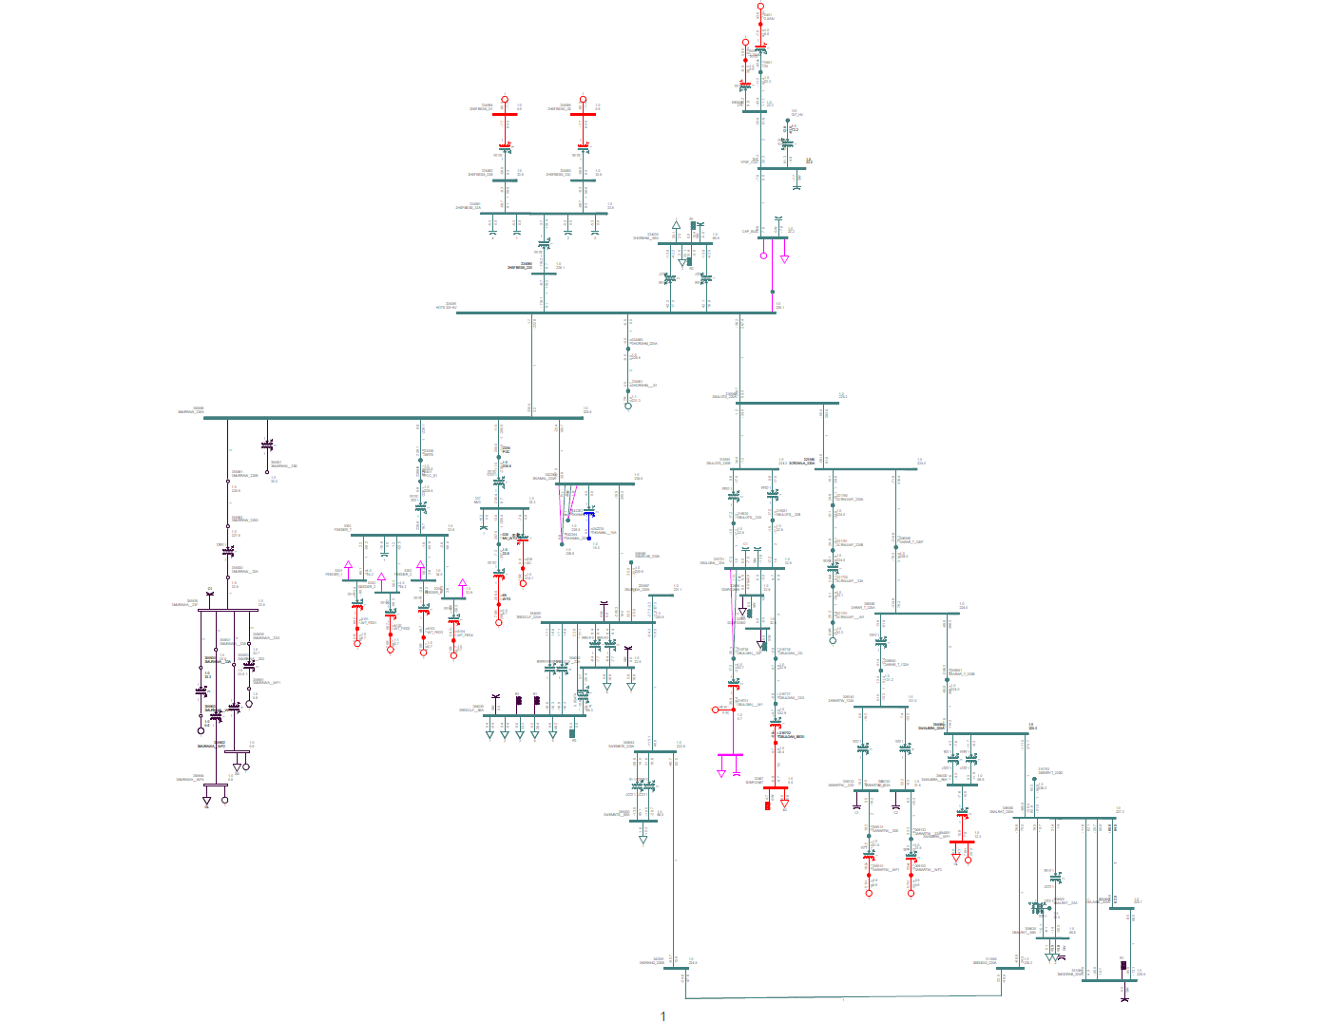

#### HORSFBESS high load gen off

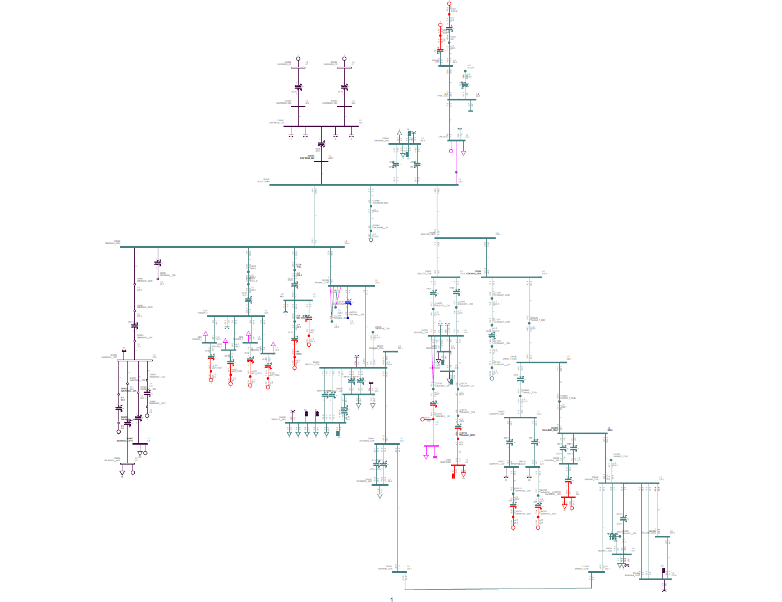

#### HORSFBESS low load gen on

#### HORSFBESS low load gen off

### Appendix 5

